Supplement
Table S1: Summary of baseline characteristics for the current analysis cohort vs. the Remainder of HERA patients
⁽*⁾Mantel-Haenszel, ^{(∱)}Fisher’s exact, ^{(∞)}Excluding category “Missing”, ^{(£)}Excluding category “Unknown”, ^{(¥)}Excluding categories “NA”, “ND” & “Missing”, ^{(€)}Excluding category “Missing/UK”,^{( ©)}Excluding category “Uncertain”, ^{( ≠)}Excluding category “Not Assessed”, ^{(≏)}Excluding category “Unknown”

Baseline characteristics | Current analysis cohort  (N=862) | Remainder of  HERA patients  (N=4237) | Total  (N=5099) | p-value
Age in yrs
Median (IQR) | 50.0 (42.0-57.0) | 49.0 (42.0-56.0) | 49.0 (42.0-56.0) | 0.13*
<35 | 56 (6.50%) | 322 (7.60%) | 378 (7.41%)
35-49 | 372 (43.16%) | 1892 (44.65%) | 2264 (44.40%)
50-59 | 288 (33.41%) | 1351 (31.89%) | 1639 (32.14%)
≥60 | 146 (16.94%) | 672 (15.86%) | 818 (16.04%)
Pathological tumor size
Median in mm (IQR) | 21.0 (15.0-30.0) | 22.0 (15.0-32.0) | 22.0 (15.0-30.0)
0-2 cm | 411 (47.68%) | 1822 (43.00%) | 2233 (43.79%) | <0.001*
>2-5 cm | 395 (45.82%) | 2022 (47.72%) | 2417 (47.40%) | 0.018*,∞
>5 cm | 44 (5.10%) | 267 (6.30%) | 311 (6.10%)
Missing | 12 (1.39%) | 126 (2.97%) | 138 (2.71%)
PgR Local
Negative (-) | 484 (56.15%) | 2614 (61.69%) | 3098 (60.76%) | <0.001∱
Positive (+) | 298 (34.57%) | 1476 (34.84%) | 1774 (34.79%) | 0.29∱,£
Unknown | 80 (9.28%) | 147 (3.47%) | 227 (4.45%)
ER Local
Negative (-) | 437 (50.70%) | 2352 (55.51%) | 2789 (54.70%) | 0.0096∱,≏
Positive (+) | 425 (49.30%) | 1884 (44.47%) | 2309 (45.28%)
Unknown | 0 (0.0%) | 1 (0.02%) | 1 (0.02%)
Tumor Grade
G1 | 15 (1.74%) | 91 (2.15%) | 106 (2.08%) | 0.30*,¥
G2 | 273 (31.67%) | 1379 (32.55%) | 1652 (32.40%)
G3 | 566 (65.66%) | 2523 (59.55%) | 3089 (60.58%)
GX | 8 (0.93%) | 217 (5.12%) | 225 (4.41%)
Not Assessed | 0(0.0%) | 4 (0.09%) | 4 (0.08%)
Not Done | 0(0.0%) | 22 (0.52%) | 22 (0.43%)
Missing | - | 1 (0.02%) | 1 (0.02%)
Menopausal status
Premenopausal | 100 (11.60%) | 617 (14.56%) | 717 (14.06%) | 0.0075∱,€
Postmenopausal | 377 (43.74%) | 1942 (45.83%) | 2319 (45.48%) | 0.14∱,€,©
Uncertain | 385 (44.66%) | 1676 (39.56%) | 2061 (40.42%)
Missing/Unknown | - | 2 (0.05%) | 2 (0.04%)
Nodal status
Not assessed (neo-adjuvant chemotherapy) | 49 (5.68%) | 514 (12.13%) | 563 (11.04%) | <0.001*,∞
Negative | 288 (33.41%) | 1358 (32.05%) | 1646 (32.28%) | 0.59*,∞,≠
1-3 nodes | 257 (29.81%) | 1207 (28.49%) | 1464 (28.71%)
≥4 nodes | 268 (31.09%) | 1157 (27.31%) | 1425 (27.95%)
Missing | - | 1 (0.02%) | 1 (0.02%)
Race
Caucasian | 798 (92.58%) | 3456 (81.57%) | 4254 (83.43%) | <0.001∱
Oriental | 56 (6.50%) | 588 (13.88%) | 644 (12.63%)
Hispanic | 0(0.0%) | 122 (2.88%) | 122 (2.39%)
Other | 8 (0.93%) | 71 (1.68%) | 79 (1.55%)
Region
Western and Northern Europe, Canada, South Africa, Australia, New Zealand | 697 (80.86%) | 2948 (69.58%) | 3645 (71.48%) | <0.001∱
Asia Pacific, Japan | 49 (5.68%) | 560 (13.22%) | 609 (11.94%)
Eastern Europe | 95 (11.02%) | 466 (11.00%) | 561 (11.00%)
Central and South America | 21 (2.44%) | 263 (6.21%) | 284 (5.57%)
Prior neo-adjuvant chemotherapy
No anthracyclines | 48 (5.57%) | 254 (5.99%) | 302 (5.92%) | 0.045∱
Anthracyclines, no taxanes | 617 (71.58%) | 2852 (67.31%) | 3469 (68.03%)
Anthracyclines and taxanes | 197 (22.85%) | 1131 (26.69%) | 1328 (26.04%)
ECOG Performance Status
0 | 782 (90.72%) | 3901 (92.07%) | 4683 (91.84%) | 0.35∱
1 | 80 (9.28%) | 334 (7.88%) | 414 (8.12%)
Missing | - | 2 (0.05%) | 2 (0.04%)

IQR: Interquartile range

Table S2: Summary of Disease-free Survival by subgroup of patients
Patient Subgroup | No. of  patients | No. (%) of  events | 8-Year DFS %  (95% CI) | HR _{Comb. Trast vs. Obs}  (95% CI)
Current analysis cohort
Observation | 301 | 99 (32.9) | 65.8 (60.1, 71.6)
Combined Trastuzumab | 561 | 150 (26.7) | 72.9 (69.1, 76.7) | 0.74 (0.57, 0.95)
Total | 862 | 249 (28.9) | 70.5 (67.3, 73.6)
Remainder of HERA pts
Observation | 1396 | 471 (33.7) | 64.5 (61.9, 67.1)
Combined Trastuzumab | 2841 | 793 (27.9) | 70.8 (69.0, 72.5) | 0.76 (0.68, 0.85)
Total | 4237 | 1264 (29.8) | 68.7 (67.3, 70.2)

Table S3: Summary of Overall Survival by subgroup of patients
Patient Subgroup | No. of  patients | No. (%) of  Deaths | 8-Year OS %  (95% CI) | HR _{Comb. Trast vs. Obs}  (95% CI)
Current analysis cohort
Observation | 301 | 53 (17.6) | 81.8 (77.3, 86.3)
Combined Trastuzumab | 561 | 76 (13.5) | 86.0 (83.1, 89.0) | 0.73 (0.51, 1.03)
Total | 862 | 129 (15.0) | 84.5 (82.0, 87.0)
Remainder of HERA pts
Observation | 1396 | 297 (21.3) | 76.4 (74.0, 78.8) | 0.75 (0.65, 0.86)
Combined Trastuzumab | 2841 | 476 (16.8) | 81.8 (80.3, 83.4)
Total | 4237 | 773 (18.2) | 80.1 (78.8, 81.4)

Table S4: Comparison of median follow-up time (based on reverse censoring for OS)
Patient Subgroup | Median follow-up time in years (IQR)
 | Current analysis cohort  (N=862) | Remainder HERA patients  (N=4237)
Observation | 7.78 (7.13, 8.47) | 7.82 (7.06, 8.35)
Combined Trastuzumab | 8.00 (7.08, 8.29) | 8.01 (7.07, 8.19)
Total | 7.99 (7.08, 8.44) | 8.00 (7.07, 8.24)
IQR: Interquartile range

Table S5: Predictive effect of p27 biomarker (Low/High) for DFS: Cox proportional hazards model without adjustment for other variables.
a.
No. of pts= 862  No. of DFS events=249 | Parameter Estimate | Std. Error | p-value
Treatment
Combined Trastuzumab vs. Observation | -0.618 | 0.199 | 0.002
p27 biomarker
High vs. Low | -0.599 | 0.218 | 0.006
Missing vs. Low | -0.334 | 0.305 | 0.27
Treatment by p27 biomarker interaction
Treatment by p27 int. (p27=High) | 0.589 | 0.281 | 0.036
Treatment by p27 int. (p27=Missing) | 0.334 | 0.408 | 0.41

b.
p27 biomarker level | HR _{Treatment:}  _{Comb.Trast vs. Obs.} | 95% C.I. | p-value
p27 Low | 0.539 | (0.365, 0.796) | 0.0019
p27 High | 0.972 | (0.659, 1.433) | 0.89
p27 Missing | 0.753 | (0.374, 1.514) | 0.43

c.
Treatment arm | HR _{p27 High vs Low} | 95% C.I. | p-value
Observation | 0.549 | (0.358, 0.843) | 0.0061
Combined Trastuzumab | 0.990 | (0.701, 1.400) | 0.96
Table S6: Predictive effect of p27 biomarker (Low/High) for DFS, adjusted for variables of clinical interest: Multivariate Cox proportional hazards model.
a.
No. of pts=862  No. of DFS events=249 | Hazard Ratio | 95% CI | p-value
Treatment
Combined Trastuzumab vs Observation | See Table below |  | <0.001
p27 biomarker
High vs Low | See Table below |  | 0.0012
Missing vs Low |  |  | 0.17
Treatment by p27 biomarker interaction
Treatment*p27 int. (p27=High) | See Table below |  | 0.0049
Treatment*p27 int. (p27=Missing) |  |  | 0.31
Nodal status
Not assessed vs. ≥4 | 1.259 | (0.766, 2.070) | 0.36
Negative vs. ≥4 | 0.328 | (0.232, 0.436) | <0.001
1-3 Positive vs. ≥4 | 0.532 | (0.389, 0.728) | <0.001
Region
Asia Pacific, Japan vs. W/N Europe, Canada, South Africa, Australia, New Zealand | 0.670 | (0.328, 1.369) | 0.27
Eastern Europe vs. W/N Europe, Canada, South Africa, Australia, New Zealand | 1.806 | (1.263, 2.583) | 0.0012
Central & South America vs. W/N Europe, Canada, South Africa, Australia, New Zealand | 1.439 | (0.699, 2.960) | 0.32
Pathological tumor size
0-2 cm vs. >5cm | 0.607 | (0.374, 0.987) | 0.044
>2-5 vs. >5 | 0.530 | (0.33, 0.850) | 0.0084
Missing vs. >5 cm | 0.367 | (0.102, 1.317) | 0.12

b.
p27 biomarker level | HR _{Treatment:}  _{Comb.Trast vs. Obs.} | 95% C.I. | p-value
p27 Low | 0.437 | (0.294,0.652) | <0.001
p27 High | 0.972 | (0.658, 1.436) | 0.88
p27 Missing | 0.665 | (0.326, 1.354) | 0.26

c.
Treatment arm | HR _{p27 High vs. Low} | 95% C.I. | p-value
Observation | 0.489 | (0.318, 0.753) | 0.012
Combined Trastuzumab | 1.087 | (0.767, 1.539) | 0.64

Table S7: Predictive effect of p27 biomarker (Low/High) for DFS, adjusted for variables of clinical interest and the predictive effect of ER Local: Multivariate Cox proportional hazards model
a.
No. of pts=862  No. of DFS events=249 | Hazard Ratio | 95% CI | p-value
Treatment
Combined Trastuzumab vs. Observation | See Table below |  | <0.001
p27 biomarker
High vs. Low | See Table below |  | 0.081
Missing vs. Low |  |  | 0.95
Treatment by p27 biomarker interaction
Treatment by p27 int. (p27=High) | See Table below |  | 0.033
Treatment by p27 int. (p27=Missing) |  |  | 0.54
ER Local
Positive vs. Negative | - |  | 0.52
ER Local by p27 biomarker interaction
ER Local by p27 int. (p27=High) | - |  | 0.19
ER Local by p27 int. (p27=Missing) | - |  | 0.12
Treatment by ER Local interaction
Treatment by ER Local int. (ER Local=Positive) | - |  | 0.033
Nodal status
Not assessed vs. ≥4 | 1.303 | (0.789, 2.152) | 0.31
Negative vs. ≥4 | 0.332 | (0.235, 0.470) | <0.001
1-3 Positive vs. ≥4 | 0.531 | (0.388, 0.725) | <0.001
Region
Asia Pacific, Japan vs. W/N Europe, Canada, South Africa, Australia, New Zealand | 0.689 | (0.337, 1.409) | 0.31
Eastern Europe vs. W/N Europe, Canada, South Africa, Australia, New Zealand | 1.799 | (1.256, 2.578) | 0.0014
Central & South America vs. W/N Europe, Canada, South Africa, Australia, New Zealand | 1.403 | (0.678, 2.906) | 0.36
Pathological tumor size
0-2 cm vs. >5cm | 0.606 | (0.372, 0.987) | 0.044
>2-5 vs. >5 | 0.531 | (0.330, 0.854) | 0.0090
Missing vs. >5 cm | 0.364 | (0.101, 1.311) | 0.12

b.
p27 biomarker level | HR _{Treatment:}  _{Comb.Trast vs. Obs.} | 95% C.I. | p-value
p27 Low | 0.363 | (0.235, 0.560) | <0.001
p27 High | 0.689 | (0.415, 1.144) | 0.15
p27 Missing | 0.468 | (0.223, 0.984) | 0.045

c.
Treatment arm | HR _{p27 High vs. Low} | 95% C.I. | p-value
Observation | 0.647 | (0.396, 1.056) | 0.081
Combined Trastuzumab | 1.223 | (0.763, 1.976) | 0.40

Table S8: Predictive effect of p27 biomarker (Low/High) for DFS, adjusted for variables of clinical interest and the predictive effect of ESR1: Multivariate Cox proportional hazards model

a.
No. of pts=862  No. of DFS events=249 | Hazard Ratio | 95% CI | p-value
Treatment
Combined Trastuzumab vs. Observation | See Table below |  | <0.001
p27 biomarker
High vs. Low | See Table below |  | 0.0055
Missing vs. Low |  |  | 0.75
Treatment by p27 biomarker interaction
Treatment by p27 int. (p27=High) | See Table below |  | 0.019
Treatment by p27 int. (p27=Missing) |  |  | 0.50
ESR1 gene expression
2nd vs. 1st tertile | - |  | 0.065
3rd vs. 1st tertile | - |  | 0.14
Missing vs. 1st tertile | - |  | 0.16
Treatment by ESR1 gene expression interaction
Treatment by ESR1 int. (ESR1=2nd tertile) | - |  | 0.24
Treatment by ESR1 int. (ESR1=3rd tertile) | - |  | 0.047
Treatment by ESR1 int. (ESR1=Missing) | - |  | 0.046
p27 biomarker by ESR1 gene expression interaction
p27 cat by ESR1 int. (p27=High, ESR1=2nd tertile) | - |  | 0.015
p27 cat by ESR1 int. (p27=High, ESR1=3rd tertile) | - |  | 0.91
p27 cat by ESR1 int. (p27=High, ESR1=Missing) | - |  | 0.29
p27 cat by ESR1 int. (p27=Missing, ESR1=1st tertile) | - |  | 0.57
p27 cat by ESR1 int. (p27=Missing, ESR1=2nd tertile) | - |  | 0.73
p27 cat by ESR1 int. (p27=Missing, ESR1=3rd tertile) | - |  | 0.44
Nodal status
Not assessed vs. ≥4 | 1.182 | (0.713, 1.961) | 0.52
Negative vs. ≥4 | 0.323 | (0.228, 0.457) | <0.001
1-3 Positive vs. ≥4 | 0.512 | (0.374, 0.702) | <0.001
Region
Asia Pacific, Japan vs. W/N Europe, Canada, South Africa, Australia, New Zealand | 0.670 | (0.325, 1.382) | 0.28
Eastern Europe vs. W/N Europe, Canada, South Africa, Australia, New Zealand | 1.878 | (1.301, 2.712) | 0.0080
Central & South America vs. W/N Europe, Canada, South Africa, Australia, New Zealand | 1.694 | (0.807, 3.554) | 0.16
Pathological tumor size
0-2 cm vs. >5cm | 0.605 | (0.369, 0.991) | 0.046
>2-5 vs. >5 | 0.522 | (0.322, 0.845) | 0.0082
Missing vs. >5 cm | 0.344 | (0.095, 1.250) | 0.10

b.
p27 biomarker level | HR _{Treatment:}  _{Comb.Trast vs. Obs.} | 95% C.I. | p-value
p27 Low | 0.269 | (0.149, 0.487) | <0.001
p27 High | 0.537 | (0.269, 1.072) | 0.078
p27 Missing | 0.358 | (0.145, 0.883) | 0.025

c.
Treatment arm | HR _{p27 High vs. Low} | 95% C.I. | p-value
Observation | 0.357 | (0.173, 0.739) | 0.0055
Combined Trastuzumab | 0.712 | (0.361, 1.402) | 0.33

Table S9: Predictive effect of cyclin D1 biomarker (continuous) for DFS: Multivariate Cox proportional hazards model without adjustment for other variables.
a.
No. of pts=757  No. of DFS events=214 | Parameter Estimate | Std. Error | p-value
Treatment
Combined Trastuzumab vs. Observation | -0.659 | 0.175 | <0.001
Cyclin D1 biomarker
Cyclin D1 | -0.034 | 0.013 | 0.0091
Treatment by cyclin D1 biomarker interaction
Treatment by Cyclin D1 int. | 0.039 | 0.014 | 0.0056

b.
Cyclin D1 biomarker | HR _{Treatment:}  _{Comb. Trast vs. Obs} | 95% C.I. | p-value
Cyclin D1=10.56* | 0.779 | (0.580, 1.045) | 0.10

*mean value of Cyclin D1
c.
Treatment arm | HR _{Cyclin D1} | 95% C.I. | p-value
Observation | 0.967 | (0.943, 0.992) | 0.0091
Combined Trastuzumab | 1.005 | (0.994, 1.016) | 0.35

Table S10: Predictive effect of cyclin D1 (continuous) biomarker for DFS, adjusted for variables of clinical interest: Multivariate Cox proportional hazards model.
a.
No. of pts=757  No. of DFS events=214 | Hazard Ratio | 95% CI | p-value
Treatment
Combined Trastuzumab vs. Observation | See Tables below |  | <0.001
Cyclin D1 biomarker
Cyclin D1 | See Tables below |  | 0.0082
Treatment by cyclin D1 biomarker interaction
Treatment by Cyclin D1 int. | See Tables below |  | 0.0046
Nodal status
Not assessed vs. ≥4 | 0.952 | (0.528, 1.716) | 0.87
Negative vs. ≥4 | 0.306 | (0.210, 0.446) | <0.001
1-3 Positive vs. ≥4 | 0.488 | (0.351, 0.680) | <0.001
Region
Asia Pacific, Japan vs. W/N Europe, Canada, South Africa, Australia, New Zealand | 0.670 | (0.312, 1.437) | 0.30
Eastern Europe vs. W/N Europe, Canada, South Africa, Australia, New Zealand | 1.858 | (1.257, 2.745) | 0.0019
Central & South America vs. W/N Europe, Canada, South Africa, Australia, New Zealand | 1.449 | (0.588, 3.567) | 0.42
Pathological tumor size
0-2 cm vs. >5cm | 0.644 | (0.383, 1.086) | 0.099
>2-5 vs. >5 | 0.530 | (0.318, 0.882) | 0.015
Missing vs. >5 cm | 0.425 | (0.115, 1.578) | 0.20

b.
Cyclin D1 biomarker | HR _{Treatment:}  _{Comb. Trast vs. Obs} | 95% C.I. | p-value
Cyclin D1=10.56* | 0.736 | (0.545, 0.993) | 0.045

c.
Treatment arm | HR _{Cyclin D1} | 95% C.I. | p-value
Observation | 0.964 | (0.939, 0.991) | 0.0082
Combined Trastuzumab | 1.005 | (0.995, 1.016) | 0.31
*mean value

Table S11: Predictive effect of cyclin D1 biomarker (continuous) for DFS, adjusted for variables of clinical interest and the predictive effect of ER Local: Multivariate Cox proportional hazards model
a.
No. of pts=757  No. of DFS events=214 | Hazard Ratio | 95% CI | p-value
Treatment
Combined Trastuzumab vs. Observation | See Tables below |  | <0.001
Cyclin D1 biomarker
Cyclin D1 | See Tables below |  | 0.10
Treatment by cyclin D1 biomarker interaction
Treatment by cyclin D1 int. | See Tables below |  | 0.028
ER Local
Positive vs. Negative | - |  | 0.028
Treatment by ER Local interaction
Treatment by ER Local int. (ER Local=Positive) | - |  | 0.0025
Cyclin D1 biomarker by ER Local interaction
Cyclin D1 by ER local int. (ER Local=positive) | - |  | 0.45
Nodal status
Not assessed vs. ≥4 | 0.962 | (0.533, 1.737) | 0.90
Negative vs. ≥4 | 0.307 | (0.211, 0.447) | <0.001
1-3 Positive vs. ≥4 | 0.486 | (0.349, 0.676) | <0.001
Region
Asia Pacific, Japan vs. W/N Europe, Canada, South Africa, Australia, New Zealand | 0.655 | (0.304, 1.409) | 0.28
Eastern Europe vs. W/N Europe, Canada, South Africa, Australia, New Zealand | 1.894 | (1.276, 2.811) | 0.0015
Central & South America vs. W/N Europe, Canada, South Africa, Australia, New Zealand | 1.471 | (0.596, 3,630) | 0.40
Pathological tumor size
0-2 cm vs. >5cm | 0.630 | (0.372, 1.065) | 0.084
>2-5 vs. >5 | 0.527 | (0.315, 0.880) | 0.014
Missing vs. >5 cm | 0.454 | (0.122, 1.689) | 0.12

b.
Cyclin D1 biomarker | HR _{Treatment:}  _{Comb. Trast vs. Obs} | 95% C.I. | p-value
Cyclin D1=10.56* | 0.472 | (0.321, 0.714) | <0.001

c.
Treatment arm | HR _{Cyclin D1} | 95% C.I. | p-value
Observation | 0.978 | (0.952, 1.005) | 0.10
Combined Trastuzumab | 1.009 | (0.992, 1.027) | 0.31
*mean value

Table S12: Predictive effect of cyclin D1 biomarker (continuous) for DFS, adjusted for variables of clinical interest and the predictive effect of ESR1: Multivariate Cox proportional hazards model
a.
No. of pts=757  No. of DFS events=214 | Hazard Ratio | 95% CI | p-value
Treatment
Combined Trastuzumab vs Observation | See Tables below |  | <0.001
Cyclin D1 biomarker
Cyclin D1 | See Tables below |  | 0.16
Treatment by cyclin D1 biomarker interaction
Treatment by cyclin D1 int. | See Tables below |  | 0.038
ESR1 gene expression
2nd vs. 1st tertile | - |  | 0.26
3rd vs. 1st tertile | - |  | 0.053
Missing vs. 1st tertile | - |  | 0.21
Treatment by ESR1 gene expression interaction
Treatment by ESR1 int. (ESR1=2nd tertile) | - |  | 0.12
Treatment by ESR1 int. (ESR1=3rd tertile) | - |  | 0.0083
Treatment by ESR1 int. (ESR1=Missing) | - |  | 0.019
Cyclin D1 biomarker by ESR1 gene expression interaction
Cyclin D1 by ESR1 int. (ESR1=2nd tertile) | - |  | 0.57
Cyclin D1 by ESR1 int. (ESR1=3rd tertile) | - |  | 0.58
Cyclin D1 by ESR1 int. (ESR1=Missing) | - |  | 0.50
Nodal status
Not assessed vs. ≥4 | 0.873 | (0.481, 1.583) | 0.65
Negative vs. ≥4 | 0.292 | (0.200, 0.427) | <0.001
1-3 Positive vs. ≥4 | 0.470 | (0.337, 0.665) | <0.001
Region
Asia Pacific, Japan vs. W/N Europe, Canada, South Africa, Australia, New Zealand | 0.658 | (0.302, 1.435) | 0.29
Eastern Europe vs. W/N Europe, Canada, South Africa, Australia, New Zealand | 1.983 | (1.331, 2.593) | <0.001
Central & South America vs. W/N Europe, Canada, South Africa, Australia, New Zealand | 1.598 | (0.640, 3.989) | 0.31
Pathological tumor size
0-2 cm vs. >5cm | 0.662 | (0.393, 1.116) | 0.12
>2-5 vs. >5 | 0.520 | (0.311, 0.869) | 0.013
Missing vs. >5 cm | 0.415 | (0.112, 1.544) | 0.20

b.
Cyclin D1 biomarker | HR _{Treatment:}  _{Comb. Trast vs Obs} | 95% C.I. | p-value
Cyclin D1=10.56* | 0.348 | (0.189, 1.011) | <0.001

c.
Treatment arm | HR _{Cyclin D1} | 95% C.I. | p-value
Observation | 0.974 | (0.938, 1.011) | 0.17
Combined Trastuzumab | 1.004 | (0.973, 1.036) | 0.81
*mean value

Figure S1. A: Histogram of TOPO2A biomarker
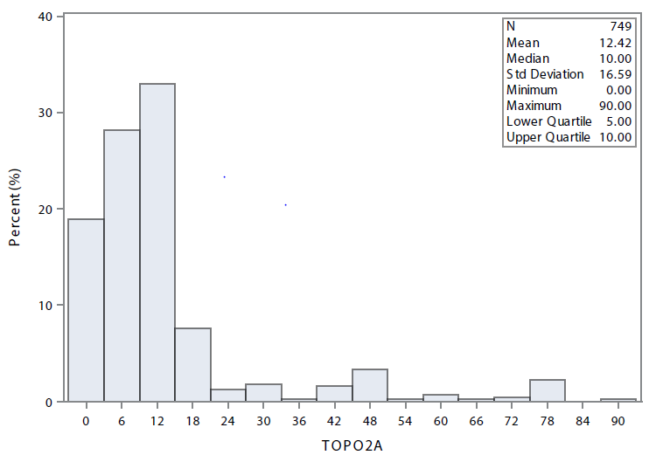

Figure S1.B Histogram of Ki67 biomarker
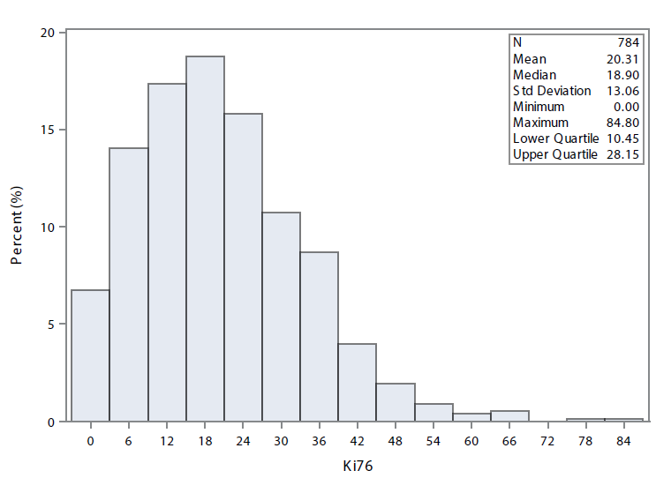

Figure S1.C: Histogram of Cyclin D1 biomarker
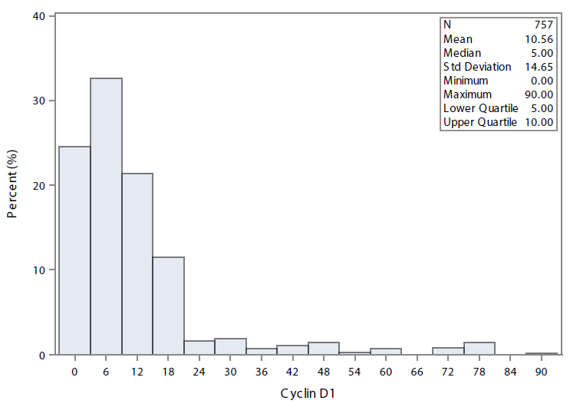

Figure S1.D: Histogram of p27 biomarker
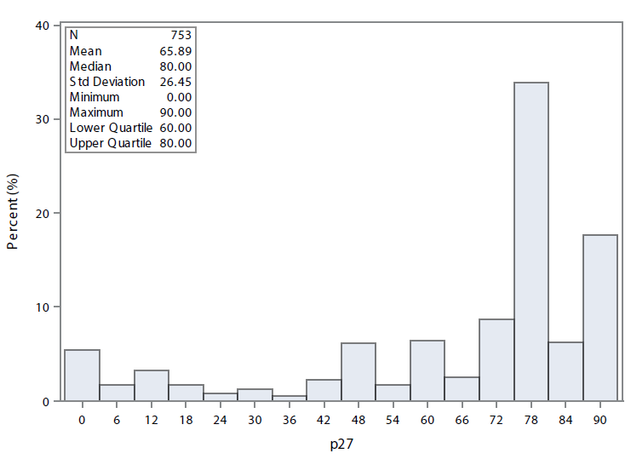

Figure S2.A: Ki67 distribution by TOPO2A level
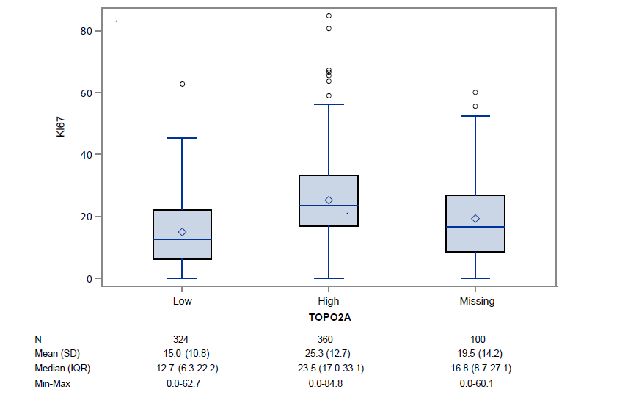

Figure S2.B: Cyclin D1 distribution by TOPO2A level

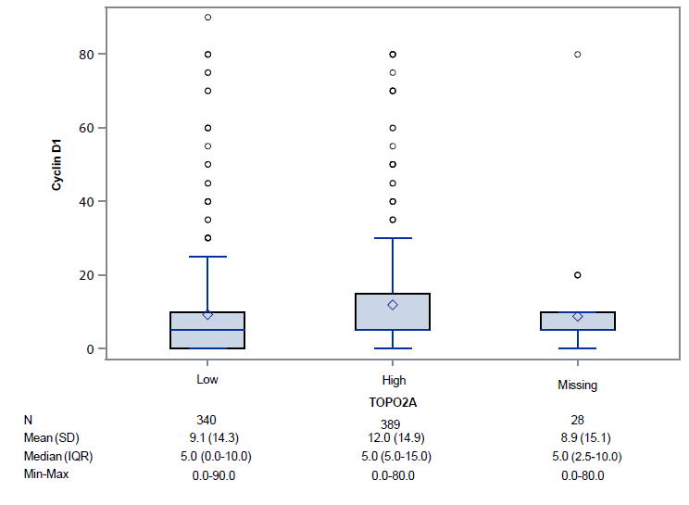
Figure S2.C: p27 distribution by TOPO2A level
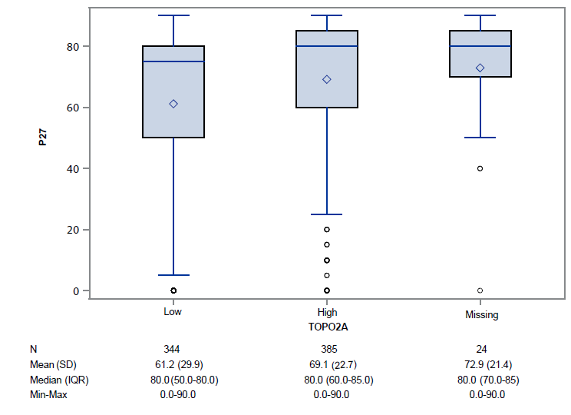

Figure S3.A: Ki67 distribution by Cyclin D1 level
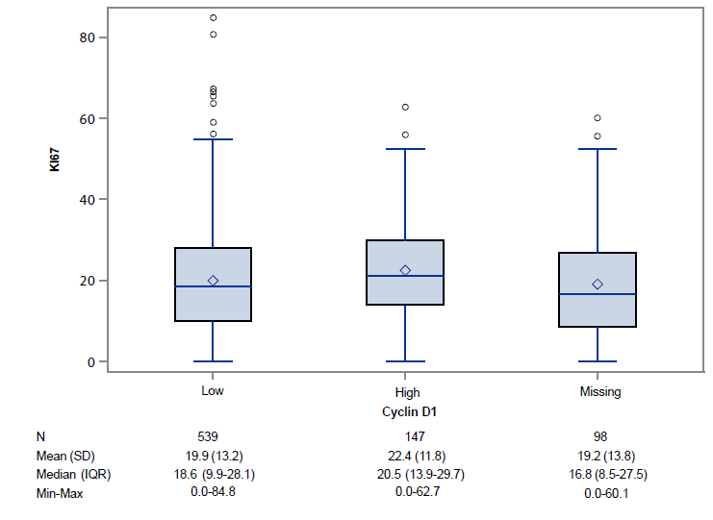

Figure S3.B: p27distribution by Cyclin D1 level
