Supplementary data for:

Investigating novel resistance mechanisms to third-generation EGFR tyrosine kinase inhibitor osimertinib in non-small cell lung cancer patients
Zhe Yang^{1*}, Nong Yang^{2*}, Qiuxiang Ou^{3*}, Yi Xiang⁴, Tao Jiang⁵, Xue Wu³, Hua Bao³, Xiaoling Tong³, Xiaonan Wang⁶, Yang W. Shao^{3,7}, Yunpeng Liu⁸, Yan Wang^{9#}, and Caicun Zhou^{5#}

¹Tumor Research and Therapy Centre, Shandong Provincial Hospital Affiliated to Shandong University, Jinan, Shandong, China; ²Department of Medical Oncology, Lung Cancer and Gastrointestinal Unit, Hunan Cancer Hospital, Affiliated Cancer Hospital of Xiangya School of Medicine, Changsha, China; ³Translational Medicine Research Institute, Geneseeq Technology Inc., Toronto, Canada; ⁴Pulmonary and Critical Care Medicine, Rui Jin Hospital, School of Medicine of Shanghai Jiao Tong University, Shanghai, China; ⁵Shanghai Pulmonary Hospital, Cancer Institute of Tongji University Medical School, Shanghai, China; ⁶Nanjing Geneseeq Technology Inc., Nanjing, China; ⁷School of Public Health, Nanjing Medical University, Nanjing, Jiangsu, China; ⁸Department of Medical Oncology, Key Laboratory of Anticancer Drugs and Biotherapy of Liaoning Province, the First Hospital of China Medical University, Heping District, Shenyang, China; ⁹National Cancer Center/Cancer Hospital, Chinese Academy of Medical Sciences & Peking Union Medical College, Beijing, China; *These authors contributed equally to this work; #Co-corresponding authors.

Supplemental Figure 1. In silico protein structure modeling predicts that G796R/S and G719A substitutions could prevent osimertinib (PDB id: 4ZAU) binding by introducing spatial confliction (hot pink). EGFR are shown in surface.

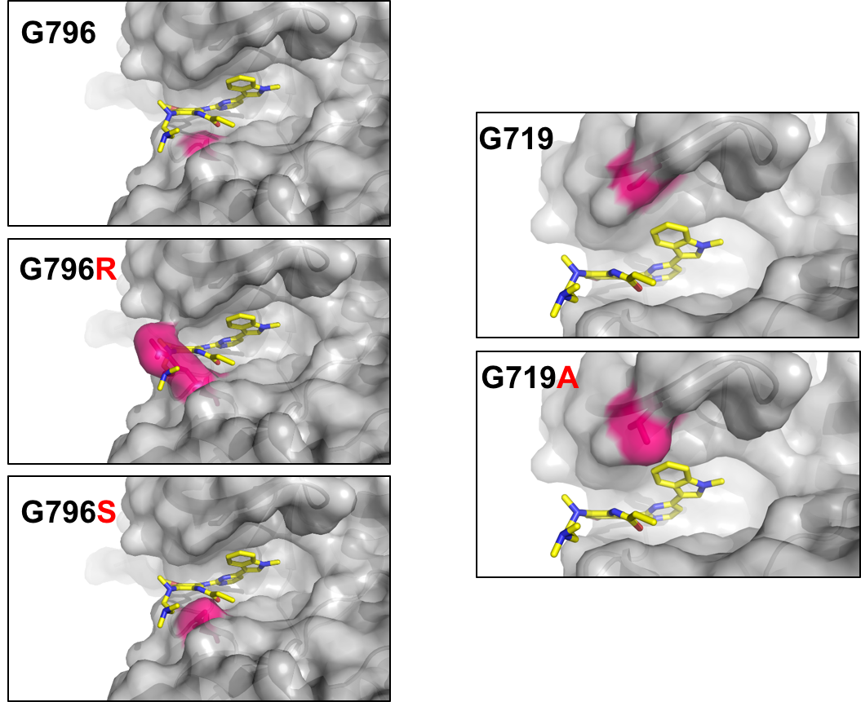
Supplemental Figure 2. Western blots showed that EGFR mutants were expressed at comparable levels in different cell lines. Total cell lysate containing 25 μg of protein were loaded for each sample. Blots were done for total EGFR using ERK2 as the loading control. Ba/F3 cells transfected with the vector pBabe-puro alone were used as the negative control. EGFR wild type was used as the positive control for the comparison of EGFR expression levels in different cell lines. Images were analyzed in LiCOR Image Studio Digits software (version5.2).

Supplemental Figure 3. The growth curves of Ba/F3 cells harboring EGFR activating mutation, with or without T790M, in cis with indicated mutations. 10⁴ cells/well were cultured in the absence of IL-3 during the entire course in 96-well plates. Experiments were repeated twice with mean ± standard deviation plotted at every 24-hour time point after setup. AU, arbitrary units of fluorescence.
Supplemental Figure 4. Ba/F3 cells expressing the EGFR L858R/L718Q mutant variant are resistant to gefitinib while those harboring L792 mutations remain sensitive. Ba/F3 cells harboring exon 19 deletion or L858R plus indicated mutations, either with or without T790M, were treated with gefitinib at the indicated doses, and cell viability was evaluated after 72 hours of treatment and plotted relative to untreated control cells. Experiments were repeated twice with mean ± standard deviation plotted at each concentration. The curves were fitted using a nonlinear regression model with a sigmoidal dose response in the Graphpad Prism 6.
Supplemental Table 1. Information for cfDNA extraction, library preparation input and NGS coverage depth.
Supplemental Table 2. Primers used in site-directed mutagenesis
Point mutation | Primer | Sequence
T790M | Forward | gcaactcatcatgcagctcatgcccttcggc
 | Reverse | gccgaagggcatgagctgcatgatgagttgc
L718Q | Forward | aaagatcaaagtgcagggctccggtgcgttcgg
 | Reverse | ccgaacgcaccggagccctgcactttgatcttt
C797S | Forward | ctcatgcccttcggcagcctcctggactatgtc
 | Reverse | gacatagtccaggaggctgccgaagggcatgag
T790M+L792H | Forward | cgaagggcatgtgctgcatgatgagttgc
 | Reverse | gcaactcatcatgcagcacatgcccttcg
T790M+L792F | Forward | gcaactcatcatgcagttcatgcccttcggctgcc
 | Reverse | ggcagccgaagggcatgaactgcatgatgagttgc
T790M+L792Y | Forward | gcaactcatcatgcagtacatgcccttcggctgcc
 | Reverse | ggcagccgaagggcatgtactgcatgatgagttgc
L792H | Forward | ctcatcacgcagcacatgcccttcggc
 | Reverse | gccgaagggcatgtgctgcgtgatgag
L792F | Forward | gcaactcatcacgcagttcatgcccttcggctgcc
 | Reverse | ggcagccgaagggcatgaactgcgtgatgagttgc
L792Y | Forward | gcaactcatcacgcagtacatgcccttcggctgcc
 | Reverse | ggcagccgaagggcatgtactgcgtgatgagttgc

Supplemental Table 3. Clinical, treatment information and the list of genetic alterations of the 12 patients with matched pre- and post- osimertinib samples.
Supplemental Table 4. Clinical and treatment information for 81 patients with post-osimertinib samples only.
Supplemental Table 5. Genetic alterations identified in the 81 patients with post-osimertinib samples only.
Supplemental Table 6. Experimental IC₅₀ values for different drugs
Cells | IC₅₀ value (n mole/L)
 | Osimertinib |  | Gefitinib
Ex19del | 0.78 |  | 4.13
Ex19del/T790M | 3.48 |  | >1000
Ex19del/T790M/C797S | >1000 |  | >1000
Ex19del/T790M/L718Q | >500 |  | >1000
Ex19del/T790M/L792H | 97.49 |  | >1000
Ex19del/T790M/L792F | 10.04 |  | >1000
Ex19del/T790M/L792Y | 33.04 |  | >1000
Ex19del/C797S | >1000 |  | 3.95
Ex19del/L718Q | NA | NA
Ex19del/L792H | NA | NA
Ex19del/L792F | 4.81 |  | 3.89
Ex19del/L792Y | 36.64 |  | 2.85
L858R | 3.55 |  | 6.65
L858R/T790M | 4.77 |  | >1000
L858R/T790M/C797S | >1000 |  | >1000
L858R/T790M/L718Q | >1000 |  | >1000
L858R/T790M/L792H | 54.75 |  | >1000
L858R/T790M/L792F | 38.65 |  | >1000
L858R/T790M/L792Y | 49.57 |  | >1000
L858R/C797S | >1000 |  | 9.19
L858R/L718Q | >1000 |  | ~500
L858R/L792H | 72.41 |  | 31.25
L858R/L792F | 36.29 |  | 10.2
L858R/L792Y | NA | NA
NA: No proliferation in the absence of IL-3.

