eTable 1. Selected patient characteristics
Patient # | Age | Gender | “T” | “N” | “M” | p16 status | Site
1 | 46 | Female | T4 | N1 | M0 | NA | Buccal/Alveolar
2 | 72 | Male | T2 | N2a | M0 | Positive | Tonsil
3 | 59 | Male | T2 | N3 | M0 | Positive | Tonsil
4 | 46 | Female | T4 | N2c | M0 | NA | Buccal/Alveolar
5 | 52 | Male | T4 | N2b | M0 | NA | Tongue
6 | 46 | Female | T4 | N2c | M0 | NA | Tongue
7 | 64 | Female | T3 | N2b | M0 | Positive | Base of Tongue
8 | 76 | Female | T4 | N2c | M0 | NA | Tongue
9 | 53 | Male | T4 | N2b | M0 | NA | Buccal/Alveolar
10 | 61 | Male | T4 | N1 | M0 | Negative | Retromolar Trigone/Tonsil
11 | 52 | Male | T4 | N2a | M0 | Positive | Tonsil
12 | 45 | Male | T4 | N2b | M0 | NA | Buccal/Hard Palate
NA: not applicable
“T”; “N”, “M” based on to 7th edition AJCC staging

eTable 2. Dosing schedules and duration of treatment
PATIENT # | Dose | # Cycles | Days on TX | Total doses AZD1775 | Total doses of Cisplatin | Total doses of docetaxel
1* | 125mg | 1 | 7 | 8 | 1 | 1
2 | 125mg | 1 | 24 | 18 | 3 | 3
3 | 125mg | 1 | 22 | 18 | 3 | 3
4 | 125mg | 2 | 64 | 32 | 6 | 6
5** | 175mg | 1 | 8 | 8 | 1 | 1
6 | 175mg | 1 | 30 | 18 | 3 | 3
7 | 175mg | 1 | 22 | 18 | 3 | 3
8 | 175mg | 2 | 51 | 27 | 5 | 5
9 | 150mg | 1 | 23 | 18 | 3 | 3
10 | 150mg | 1 | 30 | 18 | 3 | 3
11 | 150mg | 2 | 50 | 32 | 6 | 6
12 | 150mg | 2 | 53 | 34 | 6 | 6
* docetaxel stopped due to infusion reaction
** withdrawn due to non-compliance with oral regimen

eTable 3. Pharmacokinetic parameters of AZD1775 in patients following twice a day doses for 2.5 days in combination with cisplatin and docetaxel
Cycle 1, Day 2 Cycle 1, Day 4
Dose  (mg) | Cmax  (nM) | AUC  (nM/hr) | Tmax  (hr) | Cmax  (nM) | AUC  (nM/hr) |  | Tmax  (hr)
125 mg (n=3) | 317 (192%) | 2151 (183%) | 4  (2-4) | 715 (90%) | 4887  (121%) | 2  (1-4)
150 mg (n=4) | 472 (25%) | 3011  (11%) | 2  (2-6) | 1027 (35%) | 7541  (30%) | 2  (2-4)
175 mg (n=3) | 549 (18%) | 3368 (33%) | 2  (2-6) | 939 (55%) | 7840  (33%) | 4  (4-4)

eTable 4. Selected somatic mutations and copy number aberrations
PATIENT # | Selected Somatic Mutations |  |  | CNAs | p16/HPV* Status
1 | TP53 V272Sfs*73, V272M |  |  | EGFR Amplification | NA
2 | TP53 E258K  EGFR V769dupV  ARAF H121Y  HIF1A Q730E, Q43X  FBXW7 S92X | VHL E42Q  MAPK1 H125R  MDM2 R187T  PDGFRB E471K  TSC2 E1413K, S1730C | DPYD Q860H  DOCK7 E367X  KMT2A D184N  NOTCH1 I133M | PIK3CA Amplification | Positive (HPV 16)
3 | MAPK1 R135K  NOTCH1 A1850T | RAF1 E278K  RUNX1 M418L |  | PIK3CA Amplification | Positive (HPV 16)
4 | TP53 V197M  FGFR3-TACC3 Fusion  CDKN2A W110X | EPHA3 R684X, N493S  MPL P106L |  | - | NA
5 | TP53 R280S  PBRM1 Y600X  EZH2 E341G | GRM3 E78K  H3F3A P67T  GRIN2A K1078M |  | - | NA
6 | TP53 Y220C  PIK3CA E545K | CDKN2A R58X |  | - | NA
7 | IKZF1 E345K  NOTCH1 W1474C | KIT N945T |  | CCND1 Amplification  EGFR Amplification  PIK3CA Copy gain | Positive (HPV 16)
8 | CDKN2A R80X  ATM Splice site | TP53 Splice site |  | - | NA
9 | TP53 R248W LOH  HRAS G12S | CALR D390Y  GRM3 A320T |  | HRAS Copy gain | NA
10 | TP53 R213*, Q317*  CDKN2A A20Gfs*19 | BCORL1 L1114Afs*14 LOH |  | Chr 7 Amplification | Negative
11 | ARID1A N1849Tfs*69  AKT3 D219H | PIK3CA E726K, R88Q, D891H |  | Chr 9 Amplification  PIK3CA Copy gain | Positive (HPV 16)
12 | TP53 Exon3 – Intron3 del |  |  | EGFR Amplification  CCND1 Copy gain | NA
LOH: loss of heterozygosity
NA: not applicable
del: deletion
CNV: copy number aberrations
*HPV type was determine using the UWOncoPlex test as described in Materials and Methods

eFigure 1.
Title: Clinical trial overview and schematic.
Legend: Treatment was administered in 28 days cycles, with AZD1775 given orally twice a day on the first week for 5 doses, followed by AZD1775 at the same dose and frequency but in combination with cisplatin (25mg/m²) and docetaxel (35 mg/m²) every 7 days for three additional weeks. Patients were re-assessed for response and either received a second cycle of AZD1775/chemotherapy for three weeks or definitive therapy.
eFigure 2.
Title: Biomarker response and clinical correlation after neoadjuvant therapy with AZD1775.
Legend: Scatterplot correlation of clinical response with quantified IHC biomarkers of response for (A) percent pCDC2 loss and (B) percent CC3 gain. Biomarker response as demonstrated by IF (left panels) and quantified IHC data as % cells stained (right panels) for (C) γH2AX and (D) pHH3 in biopsies pre-treatment (sample “A”), post-AZD alone (sample “B”), and post-AZD plus cisplatin plus docetaxel (sample “C”).

eFigure1 (see powerpoint for true figure)
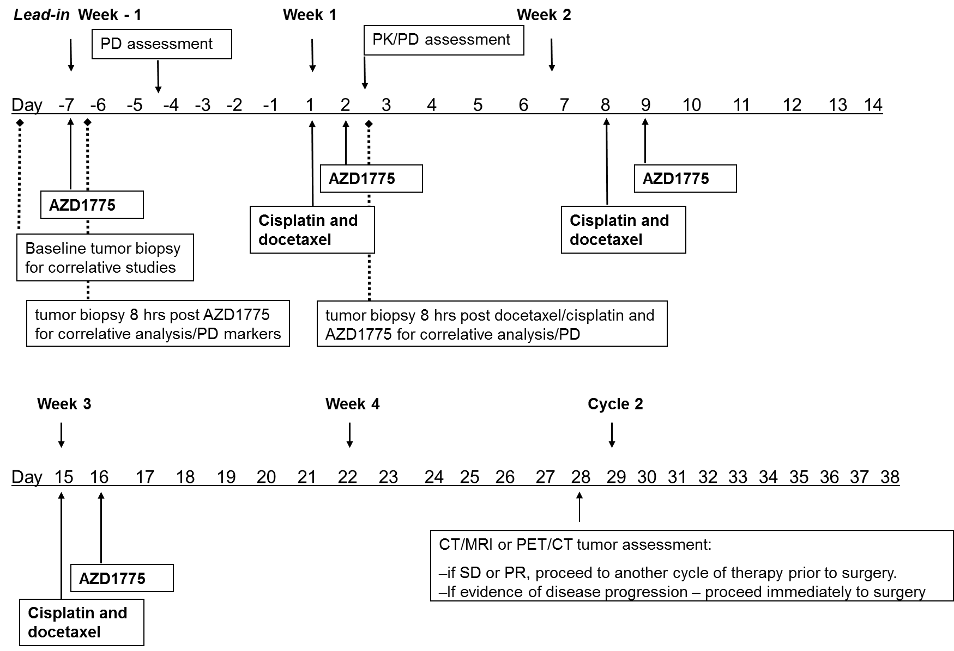

eFigure2 (see powerpoint for true figure)
