Supplemental Figure 1. Patient inclusion and exclusion criteria. TNBC: triple negative breast cancer; ALC: absolute lymphocyte count; nSES: neighborhood socioeconomic status.

All TNBC patients in Oncoshare
N=1498
Only stages I-III
N=1480
Patients not classified as ‘other’ race
N=1463
With available ALC data
N=759
With non-missing nSES
N=747

Supplemental Figure 2a and 2b. Association between minimum lymphocyte count (as percentage of total white blood cell count and absolute value) and stromal tumor infiltrating lymphocytes (sTILs), N=77. Figure 2a. sTILs were correlated with minimum % lymphocyte (p=0.02). Figure 2b. sTILs did not have a significant correlation with minimum absolute (abs) lymphocytes (p=0.36)

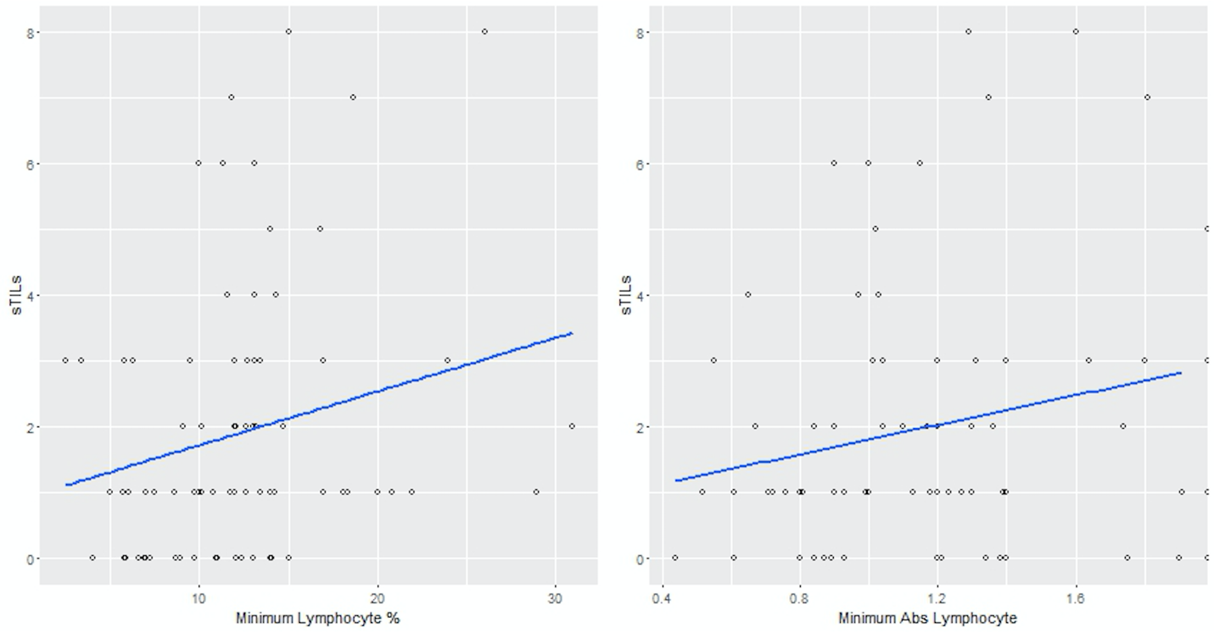

Supplemental Figure 3. Comparison between Absolute Lymphocyte Count (ALC) and percent peripheral lymphocytes

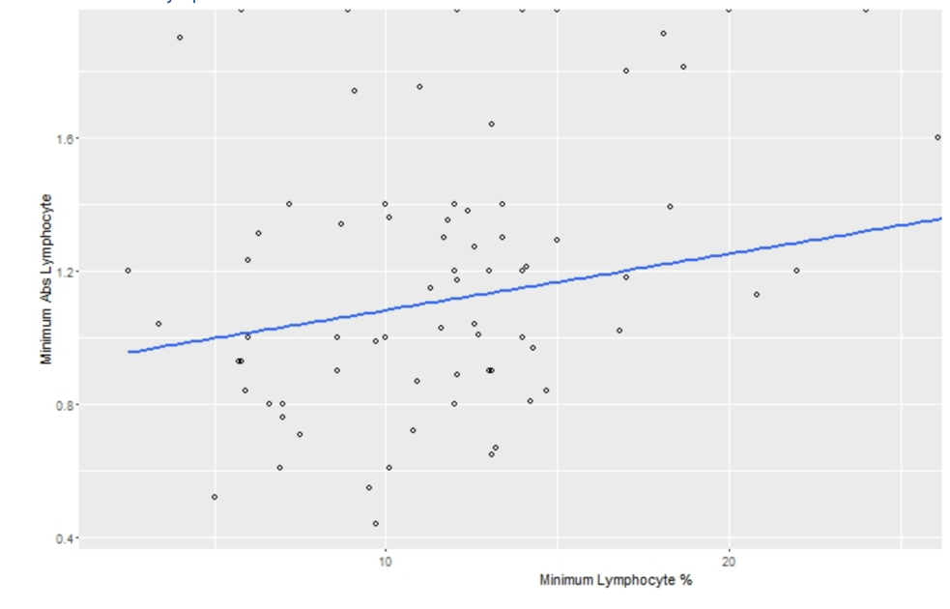

Supplemental Figure 4. Distribution of Absolute Lymphocyte Count (ALC) measures at baseline, defined as ALC value measured within the first three months of breast cancer diagnosis.

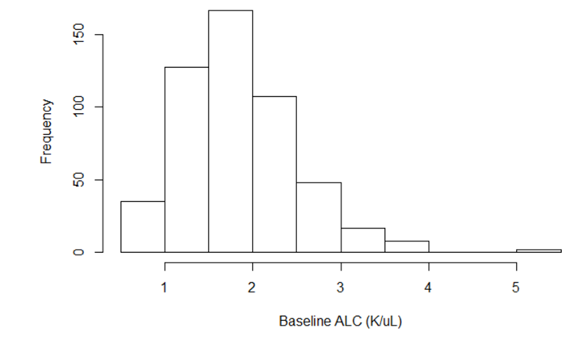

Supplemental Figure 5. Distribution of minimum Absolute Lymphocyte Count (ALC) values at any time point

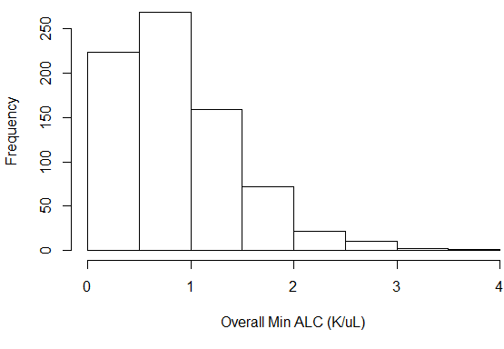

Supplemental Figure 6. Distribution of overall minimum Absolute Lymphocyte Count (ALC) over time

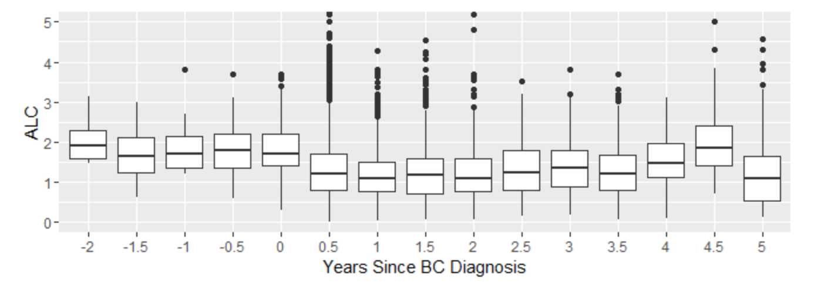

Supplemental Table 1. Multivariable analysis of predictors of lymphopenia (absolute lymphocyte count [ALC] <1K/μL; n=747); statistically significant variables are in bold font.
Odds ratio
(95% confidence interval)
Neoadjuvant/adjuvant chemotherapy use (versus [vs.] none) | 2.66 (1.72, 4.15)
Radiotherapy use (vs. none) | 0.98 (0.71, 1.37)
Neighborhood socioeoconomic status (vs. 1=lowest) | 1.18 (1.03, 1.36)
Non-Hispanic (NH) Black (vs. NH White) | 0.95 (0.44, 2.10)
NH Asian (vs. NH White) | 1.10 (0.69, 1.79)
Hispanic (vs. NH White) | 1.13 (0.62, 2.10)
Positive for deleterious mutation in BRCA1/2† (vs. negative/VUS††) | 1.20 (0.60, 2.45)
Age at diagnosis (per year) | 1.00 (0.99, 1.01)
Ever neutropenic (ANC < 1 K/μL) ††† (vs. never neutropenic) | 6.05 (3.46,11.35)
Stage II (vs. Stage I) | 0.85 (0.59, 1.22)
Stage III (vs. Stage I) | 1.73 (1.02, 3.01)
Grade 2 (vs. Grade 1) | 1.37 (0.52, 3.73)
Grade 3 (vs. Grade 1) | 1.74 (0.69, 4.56)
Unknown grade (vs. Grade 1) | 1.34 (0.42, 4.39)
† BRCA1/2 contains an additional ‘Untested’ category.
†† VUS: Variant of uncertain significance.
††† ANC: absolute neutrophil count.
Supplemental Table 2. Multivariable analysis of the association between minimum absolute lymphocyte count (ALC) and breast cancer-specific mortality using complete case analysis (n=747) †
Hazard ratio
(95% confidence interval)
Minimum ALC | 0.02 (0.00, 0.22)
Neoadjuvant/Adjuvant Chemotherapy use (versus [vs.] none) | 0.83 (0.70, 0.99)
Radiotherapy use (vs. none) | 1.61 (0.70, 3.71)
Neighborhood socioeconomic status (vs. 1=lowest) | 0.79 (0.43, 1.45)
Non-Hispanic (NH) Black (vs. NH White) | 1.39 (0.73, 2.65)
NH Asian (vs. NH White) | 0.99 (0.97, 1.01)
Hispanic (vs. NH White) | 1.02 (0.63, 1.64)
Positive for a deleterious BRCA1/2 mutation†† (vs. negative/VUS†††) | 1.38 (0.26, 7.32)
Untested for a deleterious BRCA1/2 mutation†† (vs. negative/VUS†††) | 0.59 (0.20, 1.76)
Minimum ALC x carriage of BRCA1/2 mutation | 0.58 (0.30, 1.09)
Minimum ALC x untested BRCA1/2 mutation | 0.67 (0.44, 1.03)
Age at diagnosis (per year) | 2.67 (1.40, 5.09)
Ever neutropenic (vs. never neutropenic) | 7.64 (3.86, 15.14)
Stage II (vs. Stage I) | 2.21 (0.28, 17.17)
Stage III (vs. Stage I) | 2.99 (0.40, 22.17)
Grade 2 (vs. Grade 1) | 1.00 (0.10, 9.88)
Grade 3 (vs. Grade 1) | 0.26 (0.00, 18.67)
Unknown grade (vs. Grade 1) | 10.85 (1.18,100.02)
† Controlled for an interaction between minimum ALC and carriage of a deleterious BRCA1/2 mutation.
†† BRCA1/2 contains an additional ‘Untested’ category.
††† VUS: Variant of uncertain significance

Supplemental Table 3. Multivariable analysis of the association between minimum absolute lymphocyte count (ALC) and breast cancer-specific mortality using multiple imputation methods
 | Imputed ALC  (n=759) | Imputed ALC and BRCA1/2 (n=1463)
 | Hazard ratio  (95% confidence interval) | Hazard ratio  (95% confidence interval)
Minimum ALC | 0.17 (0.08, 0.36) | 0.17 (0.08, 0.36)
Neoadjuvant/Adjuvant Chemotherapy use (versus [vs.] none) | 0.52 (0.27, 0.97) | 0.53 (0.35, 0.82)
Radiotherapy use (vs. none) | 0.68 (0.45, 1.04) | 0.86 (0.65, 1.15)
Neighborhood socioeconomic status  (vs. 1=lowest) | 0.82 (0.69, 0.98) | 0.88 (0.78, 1.00)
Non-hispanic (NH) Black (vs. NH White) | 1.46 (0.62, 3.43) | 2.02 (1.17, 3.47)
NH Asian (vs. NH White) | 0.85 (0.46, 1.57) | 0.94 (0.60, 1.48)
Hispanic (vs. NH White) | 1.49 (0.77, 2.90) | 2.36 (1.53, 3.64)
Positive for a deleterious BRCA1/2 mutation† (vs. negative/VUS††) | 0.86 (0.26, 2.86) | 0.90 (0.41, 2.01)
Minimum ALC by carriage of BRCA1/2 mutation††† | 1.19 (0.22, 6.34) | 0.67 (0.18, 2.50)
Age at diagnosis (in years) | 1.00 (0.98, 1.02) | 1.00 (0.98, 1.01)
Ever neutropenic (vs. never neutropenic) | 0.99 (0.61, 1.61) | 1.05 (0.71, 1.56)
Stage II (vs. Stage I) | 2.75 (1.44, 5.26) | 2.34 (1.49, 3.65)
Stage III (vs. Stage I) | 8.24 (4.12,16.45) | 6.40 (3.97,10.30)
Grade 2 (vs. Grade 1) | 2.22 (0.28,17.30) | 3.71 (0.50,27.62)
Grade 3 (vs. Grade 1) | 2.95 (0.39,21.98) | 5.10 (0.70,37.12)
Unknown grade (vs. Grade 1) | 1.02 (0.10,10.10) | 5.02 (0.64,39.12)
† BRCA1/2 contains an additional ‘Untested’ category.
†† VUS: Variant of uncertain significance.
††† Controlled for an interaction between minimum ALC and carriage of a deleterious BRCA1/2 mutation.

Supplemental Table 4. Multivariable analysis of the association between minimum ALC and OM with RT temporal consideration (n=747)
Hazard ratio
(95% confidence interval)
Minimum (min) ALC | 0.24 (0.13, 0.42)
Carriage of a positive BRCA1/2 mutation | 0.83 (0.38, 1.82)
BRCA1/2 untested | 1.36 (0.85, 2.17)
Neoadjuvant/adjuvant chemotherapy use | 0.63 (0.40, 1.00)
Neighborhood socioeconomic status | 0.88 (0.77, 1.00)
Non-hispanic (NH) Black | 1.68 (0.89, 3.15)
NH Asian | 0.99 (0.63, 1.56)
Hispanic | 1.19 (0.69, 2.05)
Age | 1.01 (1.00, 1.03)
Ever neutropenic | 0.99 (0.68, 1.46)
Stage II | 1.48 (0.98, 2.24)
Stage III | 4.17 (2.62, 6.65)
Grade 2 | 2.93 (0.68,12.58)
Grade 3 | 4.28 (1.04,17.68)
Unknown Grade | 2.58 (0.54,12.35)
Min ALC < radiotherapy (RT) | 0.12 (0.05, 0.30)
Min ALC > RT | 1.45 (0.82, 2.57)
Min ALC x (Min ALC < RT) | 4.58 (1.90,11.01)
Min ALC x (Min ALC > RT) | 0.49 (0.20, 1.15)

Supplemental Table 5. Multivariable analysis of the association between minimum ALC and BCM with RT temporal consideration (n=747)
Hazard ratio
(95% confidence interval)
Minimum (min) ALC | 0.21 (0.10, 0.45)
Carriage of a positive BRCA1/2 mutation | 0.95 (0.35, 2.58)
BRCA1/2 untested | 1.83 (0.97, 3.45)
Neoadjuvant/adjuvant chemotherapy use | 0.61 (0.32, 1.14)
Neighborhood socio-economic status | 0.87 (0.73, 1.03)
Non-hispanic (NH) Black | 1.48 (0.65, 3.40)
NH Asian | 0.79 (0.43, 1.46)
Hispanic | 1.29 (0.68, 2.46)
Age | 1.00 (0.98, 1.01)
Ever neutropenic | 0.99 (0.61, 1.59)
Stage II | 2.58 (1.35, 4.92)
Stage III | 7.37 (3.70,14.68)
Grade 2 | 2.56 (0.33,19.96)
Grade 3 | 3.48 (0.47,25.93)
Unknown grade | 1.22 (0.12,12.05)
Min ALC < radiotherapy (RT) | 0.18 (0.06, 0.56)
Min ALC > RT | 1.25 (0.59, 2.66)
Min ALC x (min ALC < RT) | 3.17 (0.85,11.87)
Min ALC x (min ALC > RT) | 0.52 (0.16, 1.71)

Supplemental Table 6. Multivariable analysis of the association between minimum ALC and OM with neutropenia temporal consideration (n=747)
Hazard ratio
(95% confidence interval)
Minimum (min) ALC | 0.24 (0.16, 0.36)
Carriage of a positive BRCA1/2 mutation | 0.89 (0.41, 1.95)
BRCA1/2 untested | 1.45 (0.91, 2.30)
Neoadjuvant/adjuvant chemotherapy use | 0.53 (0.34, 0.83)
Radiotherapy (RT) use | 0.74 (0.54, 1.02)
Neighborhood socio-economic status | 0.85 (0.74, 0.97)
Non-hispanic (NH) Black | 1.69 (0.89, 3.18)
NH Asian | 0.98 (0.62, 1.54)
Hispanic | 1.28 (0.74, 2.22)
Age | 1.01 (1.00, 1.03)
Stage II | 1.46 (0.97, 2.22)
Stage III | 4.34 (2.74, 6.88)
Grade 2 | 2.56 (0.60,10.95)
Grade 3 | 3.85 (0.94,15.83)
Unknown grade | 2.18 (0.46,10.34)
Min ALC < neutropenia | 2.43 (0.61, 9.79)
Min ALC x (min ALC < neutropenia) | 0.25 (0.01, 4.48)

Supplemental Table 7. Multivariable analysis of the association between minimum ALC and BCM with neutropenia temporal consideration (n=747)
Hazard ratio
(95% confidence interval)
Minimum (min) ALC | 0.20 (0.12, 0.36)
Carriage of a positive BRCA1/2 mutation | 0.99 (0.37, 2.69)
BRCA1/2 untested | 1.88 (1.00, 3.54)
Neoadjuvant/adjuvant chemotherapy use | 0.53 (0.29, 0.99)
Radiotherapy use | 0.69 (0.46, 1.05)
Neighborhood socio-economic status | 0.84 (0.71, 1.00)
Nonhispanic (NH) Black | 1.52 (0.66, 3.49)
NH Asian | 0.79 (0.43, 1.45)
Hispanic | 1.33 (0.69, 2.56)
Age | 0.99 (0.98, 1.01)
Stage II | 2.59 (1.36, 4.93)
Stage III | 7.76 (3.92,15.37)
Grade 2 | 2.21 (0.28,17.19)
Grade 3 | 3.10 (0.42,22.97)
Unknown grade | 1.10 (0.11,10.79)
Min ALC < neutropenia | 3.29 (0.72,15.13)
min ALC x (min ALC < neutropenia) | 0.12 (0.00, 3.42)

Supplemental Table 8. Multivariable analysis of the association between minimum percent lymphocyte count and overall mortality using complete case analysis (n=532).
Hazard ratio
(95% confidence interval)
Minimum percent lymphocyte count | 0.92 (0.89, 0.94)
Neoadjuvant/Adjuvant Chemotherapy use (versus [vs.] none) | 0.49 (0.29, 0.82)
Radiotherapy use (vs. none) | 0.84 (0.59, 1.19)
Neighborhood socioeconomic status  (vs. 1=lowest) | 0.86 (0.74, 0.99)
Non-Hispanic (NH) Black (vs. NH White) | 1.32 (0.64, 2.71)
NH Asian (vs. NH White) | 0.93 (0.56, 1.54)
Hispanic (vs. NH White) | 1.12 (0.64, 1.96)
Positive for a deleterious BRCA1/2 mutation† (vs. negative/VUS††) | 0.99 (0.45, 2.16)
Minimum ALC by carriage of BRCA1/2 mutation††† | 1.74 (1.07, 2.82)
Age at diagnosis (in years) | 1.00 (0.99, 1.02)
Ever neutropenic (vs. never neutropenic) | 1.26 (0.84, 1.88)
Stage II (vs. Stage I) | 1.62 (1.00, 2.61)
Stage III (vs. Stage I) | 4.33 (2.56, 7.32)
Grade 2 (vs. Grade 1) | 2.17 (0.49, 9.64)
Grade 3 (vs. Grade 1) | 3.29 (0.79, 13.70)
Unknown grade (vs. Grade 1) | 1.89 (0.37, 9.57)
†BRCA1/2 contains an additional ‘Untested’ category.
†† VUS: Variant of uncertain significance.
††† Controlled for an interaction between minimum percent lymphocyte count and carriage of a deleterious BRCA1/2 mutation.

Supplemental Table 9. Multivariable analysis of the association between minimum percent lymphocyte count and breast-cancer specific mortality using complete case analysis (n=532)
Hazard ratio
(95% confidence interval)
Minimum percent lymphocyte count | 0.91 (0.88, 0.95)
Neoadjuvant/Adjuvant Chemotherapy use (versus [vs.] none) | 0.52 (0.26, 1.05)
Radiotherapy use (vs. none) | 0.73 (0.47, 1.14)
Neighborhood socioeconomic status  (vs. 1=lowest) | 0.84 (0.70, 1.00)
Non-hispanic (NH) Black (vs. NH White) | 1.02 (0.39, 2.69)
NH Asian (vs. NH White) | 0.74 (0.38, 1.45)
Hispanic (vs. NH White) | 1.17 (0.61, 2.24)
Positive for a deleterious BRCA1/2 mutation† (vs. negative/VUS††) | 1.24 (0.45, 3.40)
Minimum ALC by carriage of BRCA1/2 mutation††† | 2.41 (1.23, 4.70)
Age at diagnosis (in years) | 0.99 (0.97, 1.01)
Ever neutropenic (vs. never neutropenic) | 1.27 (0.77, 2.09)
Stage II (vs. Stage I) | 2.88 (1.38, 6.03)
Stage III (vs. Stage I) | 7.98 (3.65,17.43)
Grade 2 (vs. Grade 1) | 2.13 (0.26,17.22)
Grade 3 (vs. Grade 1) | 2.79 (0.37,21.07)
Unknown grade (vs. Grade 1) | 0.87 (0.08,10.06)
†BRCA1/2 contains an additional ‘Untested’ category.
†† VUS: Variant of uncertain significance.
††† Controlled for an interaction between minimum percent lymphocyte count and carriage of a deleterious BRCA1/2 mutation.

