Supplementary Data

Figure S4. Correlation of immunohistochemical expression of the glucocorticoid receptor (GR) after enza or enza/dut/LHRHa with residual cancer burden (RCB). A tissue microarray comprising cores of cancer tissue from each patient was analyzed for RCB and nuclear expression of GR expressed as total proportion of GR-positive tumor nuclei in (A) enza-treated and (B) enza/dut/LHRHa-treated patients. P values were calculated using the nonparametric Mann-Whitney test.
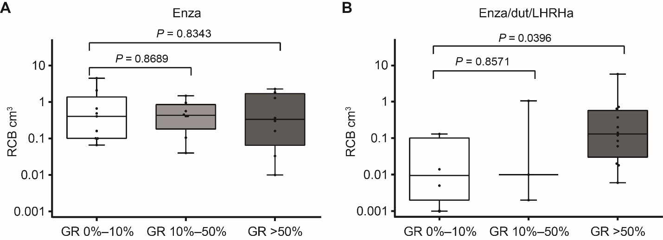
Dut, dutasteride; enza, enzalutamide; LHRHa, luteinizing hormone-releasing hormone analog (leuprolide).

