Supplementary Data

Figure S3. Change in serum androgen levels after enza or enza/dut/LHRHa. Box plots of serum androgens for each cohort at initiation of therapy (day 0) and at prostatectomy (day 180) are depicted for each treatment arm. Levels of (A) pregnenolone, (B) progesterone, (C) DHEA, (D) AED, (E) testosterone, and (F) DHT were measured by mass spectroscopy. P values were calculated using the nonparametric Mann-Whitney test. Limits of quantification were 0.005 ng/mL for AED, progesterone and testosterone, 0.001 ng/mL for DHT and pregnenolone, and 0.15 ng/mL for DHEA.
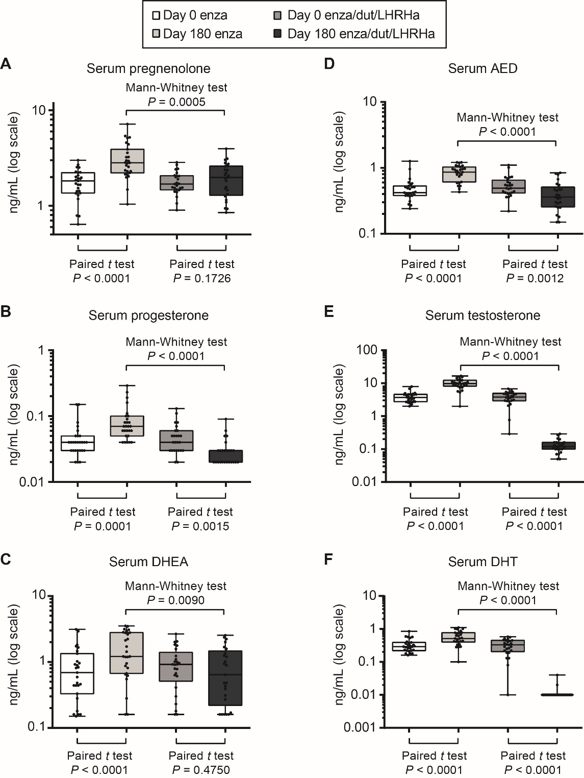
AED, androstenedione; DHEA, dehydroepiandrosterone; DHT, dihydrotestosterone; dut, dutasteride; enza, enzalutamide; LHRHa, luteinizing hormone-releasing hormone analog (leuprolide).

