Supplementary data

Multiplex genome editing to generate universal CAR T cells resistant to PD1 inhibition

Jiangtao Ren¹, Xiaojun Liu¹, Chongyun Fang¹, Shuguang Jiang¹, Carl H. June^{1,2,3*}, Yangbing Zhao^{1,2,3*}

Affiliations:
¹Abramson Cancer Center, University of Pennsylvania, Philadelphia, PA
²Department of Pathology and Laboratory Medicine, Perelman School of Medicine, University of Pennsylvania, Philadelphia, PA
³Abramson Family Cancer Research Institute, Perelman School of Medicine, University of Pennsylvania, Philadelphia, PA

To whom correspondence should be addressed:
yangbing@exchange.upenn.edu
Or
cjune@exchange.upenn.edu

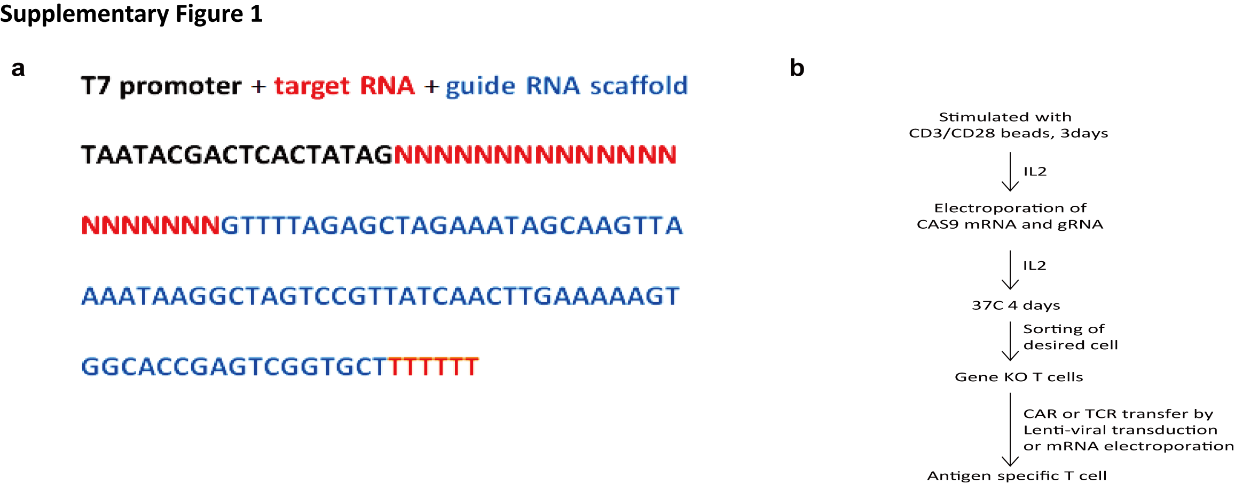

Supplementary Figure 1. Strategy of introducing CRISPR/Cas9 into T cells. (a) Schematic representation of gRNAs driven by the T7 promoter. (b) Schematic representation of the generation of gene-edited antigen-specific T cells using the CRISPR system. T cells were stimulated by CD3/CD28 Dynabeads for three days prior to RNA electroporation. Then T cells were washed three times with OPTI-MEM and re-suspended in OPTI-MEM (Invitrogen) at a final concentration of 1-3x10⁸ cells/ml. Subsequently, 0.1 ml of the cells was mixed with IVT RNA and electroporated in a 2 mm cuvette. 20 µg of Cas9 mRNA and 10 µg of gRNA were electroporated into the cells using a BTX830 (Harvard Apparatus BTX) at 360 V and 1 ms; this process was followed by a second electrotransfer of 5 µg of gRNA 12 to 24 hours later. Following electroporation, the cells were immediately placed in 2 ml of pre-warmed culture media and cultured in the presence of IL-2 (100 IU/ml) at 37°C and 5% CO₂. Specific gene-disrupted T cells were sorted on day 8 and redirected with CAR or TCR by lentiviral transduction or mRNA electroporation gene transfer.

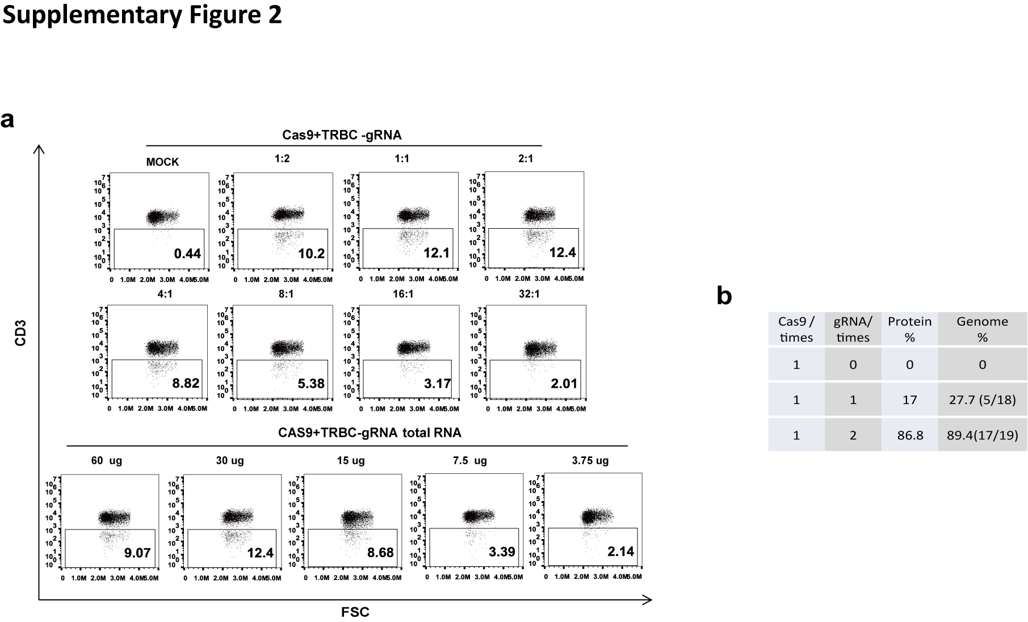

Supplementary Figure 2. Multiple deliveries of gRNAs disrupts genes in human primary T cells with high efficiency without impairing effector function.
(a) CD3 disruption under different Cas9 mRNA and gRNA amount and ratios. (b) Targeting events validated by cloning PCR. PCR products flanking TRBC-gRNA targeting sites were cloned into TOPO vector and performed Sanger sequencing.

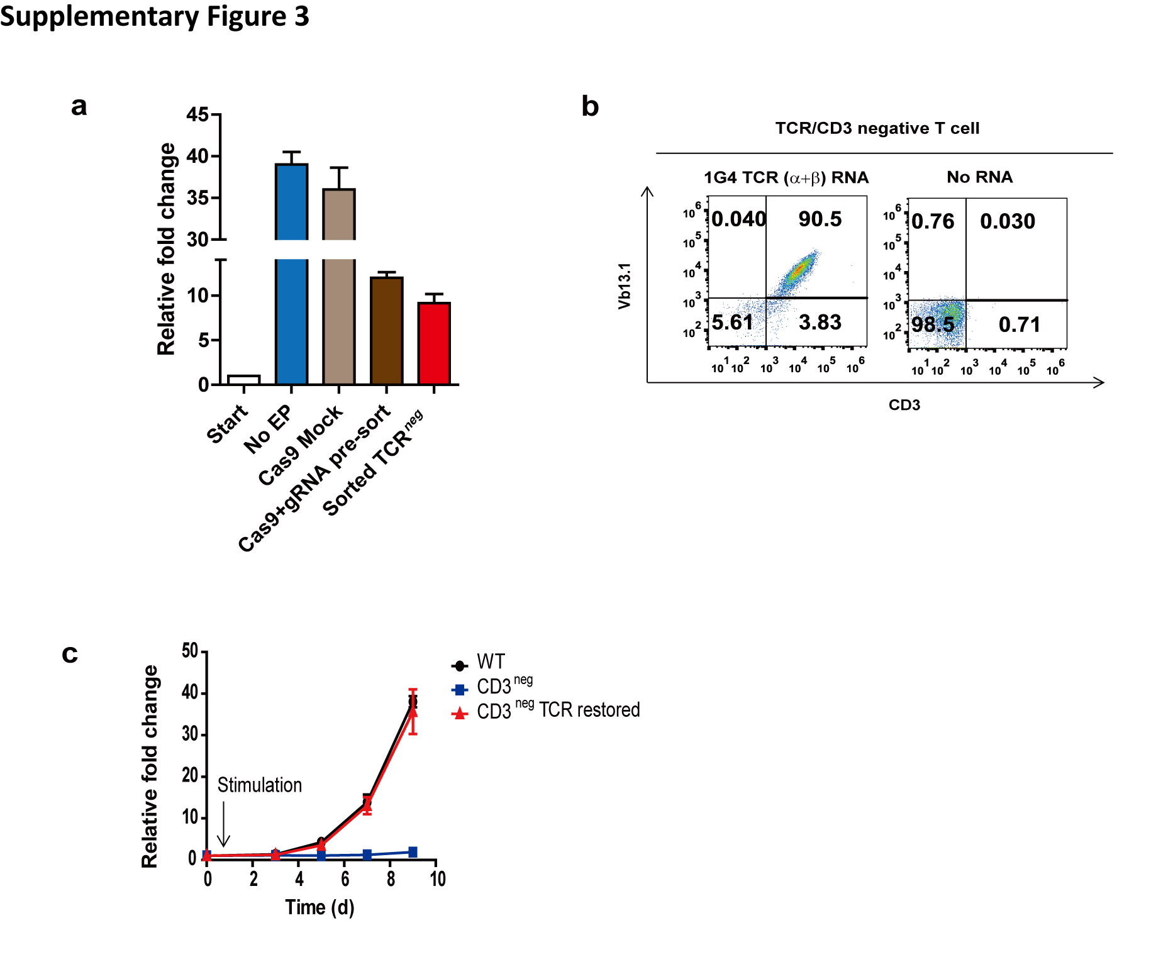

Supplementary Figure 3. Proliferation test of CD3^{neg} T cells.
(a) Relative fold expansion of T cells with or without CRISPR editing. EP, electroporation. (b)CD3 expression measured by flow cytometry. (c) Proliferation of TCR restored CD3^{neg} T cells.

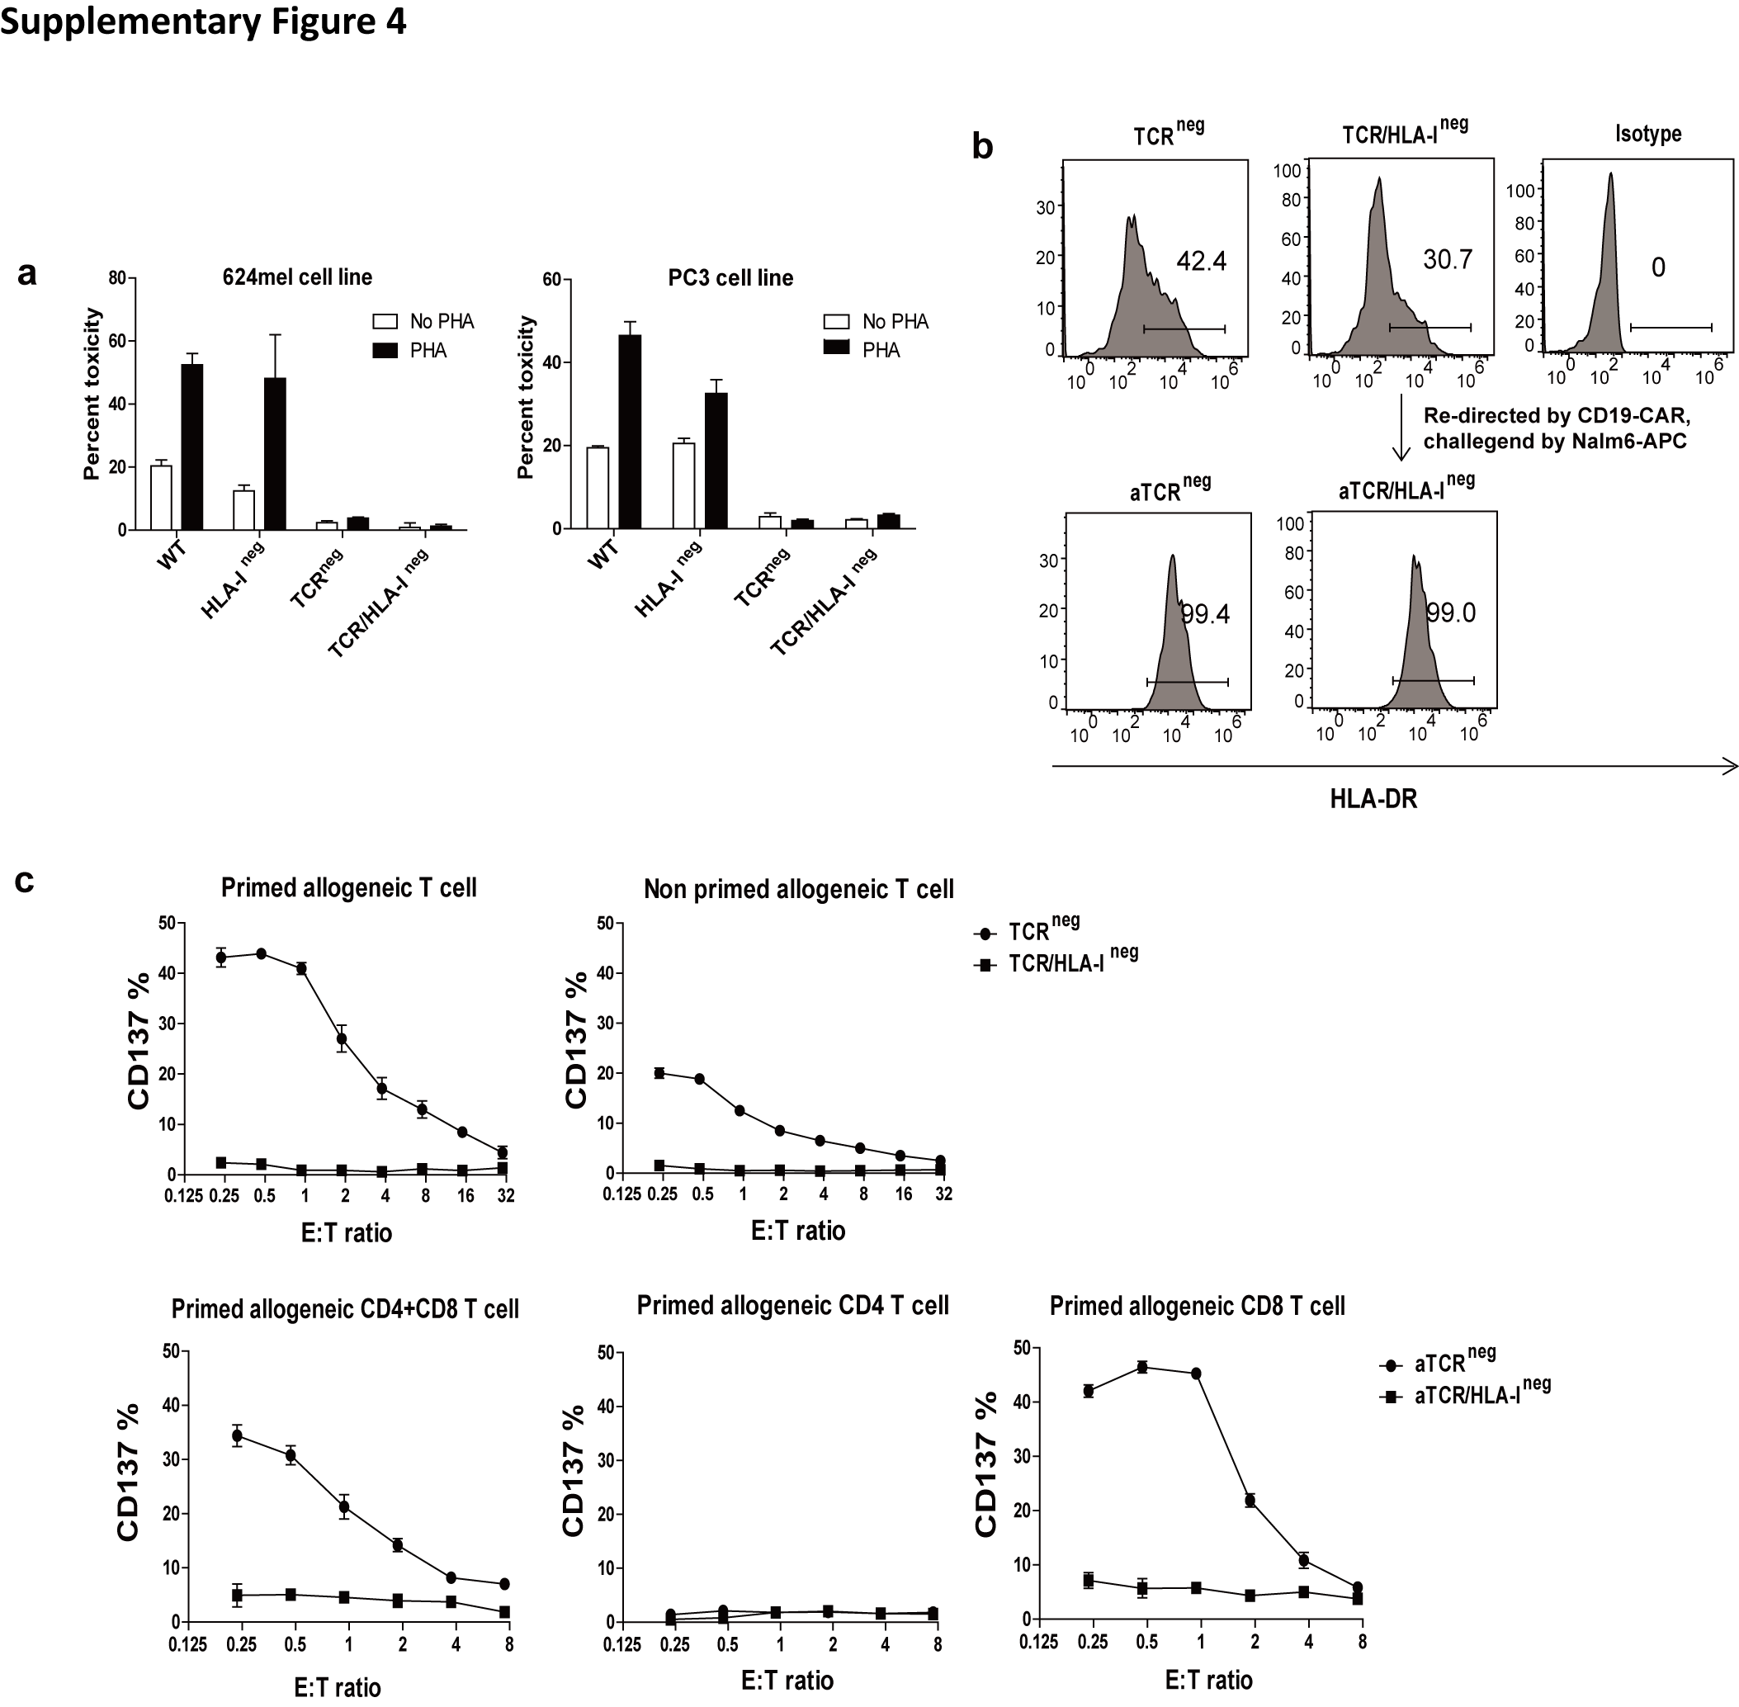

Supplementary Figure 4. Reduced alloreactivity of TCR and B2M double-disrupted T cells.

(a) TCR and B2M double-knockout T cells abrogated the allogeneic killing of HLA unmatched tumor cell lines. Gene-edited T cells were overnight co-cultured with A624-CBG and PC3-CBG tumor, toxicity was calculated by measuring luciferase activity of live cells, Bars, SE, n=3. (b) Gene-edited T cells were re-directed with CD19-CAR mRNA by electroporation, and then incubated with Nalm6 target cells at an E:T ratio of 1:1. HLA-DR expression was measured by flow cytometry. a, activated. (c)Abolishment of target recognition of HLA-I disrupted T cells by allogeneic effector T cells. To generate dendritic cells to prime allogeneic T cells, donor PMBCs were incubate at 37°C, 5% CO2 for 2~3 hours, discarded non-adherent cells, then cultured in10 mL culture medium with Recombinant GM-CSF and IL-4 at a final concentration of 20 ng/mL at 37°C, 5% CO2. Recombinant TNF was added to a final concentration of 20 ng/mL on the fifth day of incubation. The mature dendritic cells were harvested and co-cultured with allogeneic T cells (50% each of CD4 and CD8) at a ratio of 1:10. The primed T cells were harvested at day 9 and CD4 and CD8 were separated for alloreactivity test against HLA-I^{neg} T cells generated from different donors. The alloreactivity of allogeneic T cells was determined by limited dilution assay performed in round-bottomed microplates seeded with different numbers of primed allogeneic CD4 or CD8 T cells and 2X10⁴ irradiated TCR^{neg} or TCR/ HLA-I^{neg} T cells. Cultures were incubated for 2 days and the activation of CD3 positive cells was measured by CD137 staining by flow cytometry. Allogeneic effector CD4 and CD8 T cells were challenged by resting or activated gene-edited T cells at different ratios. Activation of allogeneic T cells by gene-edited T cells was measured by detecting the upregulation of CD137 with flow cytometry (n=3).

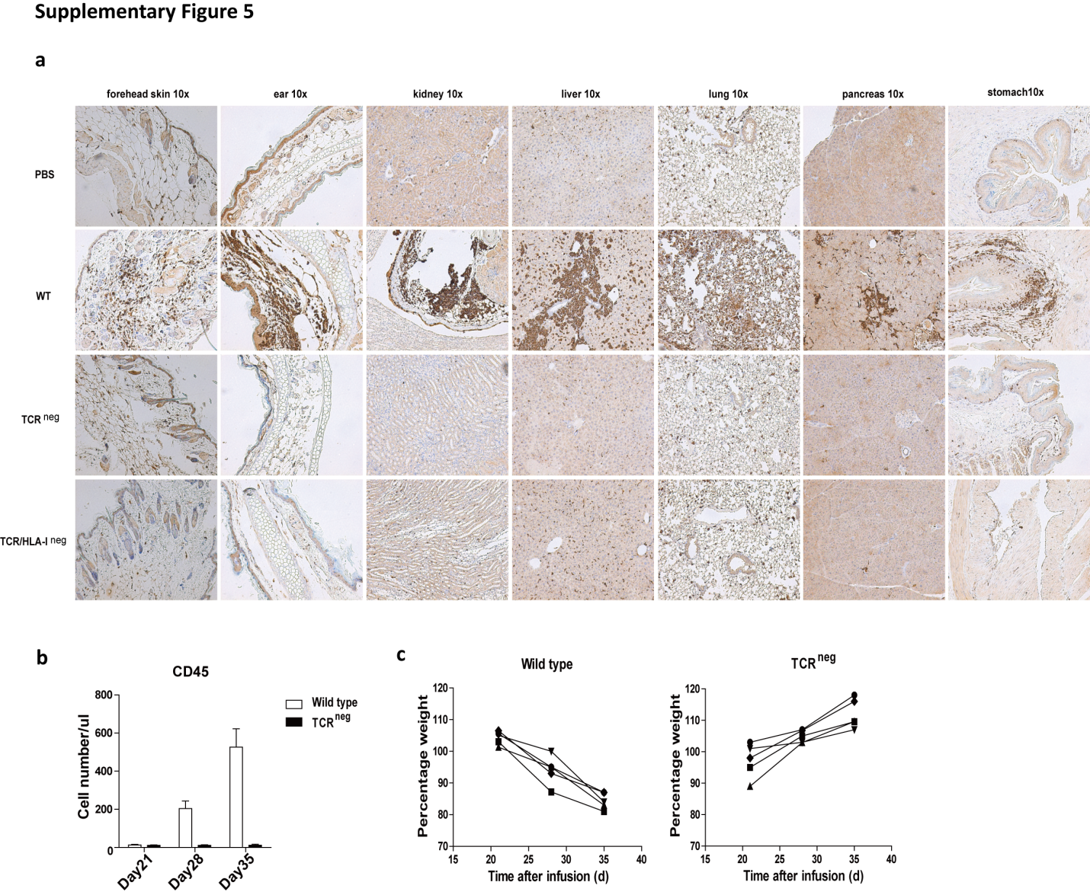

Supplementary Figure 5. GVHD effect of gene-modified CAR T cells (a) Organs of mice from different treatment groups were collected and used for CD8 immunohistochemistry staining. PBS, or 10x10⁶ non-manipulated, TCR ablated, TCR/HLA-I double ablated T cells were injected into 8- to 10-week-old NSG mice that had been conditioned with 175 cGy irradiation. After T cell infusion (Day0), mice were monitored 3 times per week for GvHD study. Mice with weight loss of ~20% were sacrificed for ethical reasons, other mice were sacrificed at day 62. Wild type and TCR^{neg} T cells were infused into sub-lethal irradiated mice, (b) presence of CD45 T cells by a FACS Trucount assay, and (c) weight loss in mice were recorded. Results are expressed as the mean absolute count per µl of peripheral blood±SD with n=5 for all groups. ns, ****P<0.001 by Mann-Whitney test.

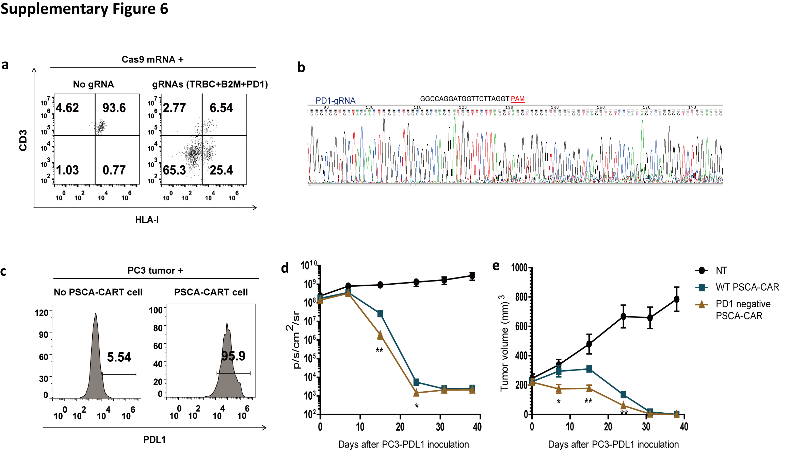

Supplementary Figure 5. Generation of universal CART cells deficient of PD1.
(a) Expression of CD3 and HLA-I expression was measured by flow cytometry on CD19 CART cells treated with Cas9 mRNA alone or treated with Cas9 mRNA and gRNAs targeting TRBC, B2M and PD1. CD3 and HLA-I double negative cells were sorted by negative selection. (b) Sanger sequencing of PCR products flanking PD1-gRNA targeting site. (c) Expression of PDL1 on PC3 tumors. PC3 tumors were co-cultured with PSCA-CART cells at a ratio of 1:1 for 18 hours and PDL1 was measured by flow cytometry. (d) Bioluminescence and tumor burden of mice receiving different treatment, n=6. Imaging commenced 1 day before the start of T cell treatment. *P<0.05, *P<0.01, by Mann-Whitney test. (e) Tumor volume of mice. Results are expressed as the mean tumor volume (mm³±SE) with n=6 for all groups. *P<0.05, *P<0.01, by Mann-Whitney test.

Supplementary table 1
TRAC-OT1-Chr5-f1 | CTTGGCTGGAAAGGGTACTTAGGAA
TRAC-OT1-Chr5-r1 | CCCACCTCCAACACTAGAGACCACA
TRAC-OT2-Chr22-f1 | TTTGAGAGGTACAGCTCCCTTTTGC
TRAC-OT2-Chr22-r1 | AGACCACAGCTCTTCAACAGCCAAA
TRAC-OT3-Chr13-f1 | TATGTCAACCCAGAACCAGAGCAGC
TRAC-OT3-Chr13-r1 | TGTGCCTTTAATTCCCACAACTGGA
TRAC-OT4-Chr2-f1 | TGGATGCATTACACATCAGCATACC
TRAC-OT4-Chr2-r1 | GGCAGCAAAATGAAGCTTTGCTTAA
TRAC-OT5-Chr18-f1 | CTCAGATAAATGGAGCGCAGCCTT
TRAC-OT5-Chr18-r1 | GATCATGCCATCCAACTTTCTTCAG
TRAC-OT6-Chr5-f1 | TCCCATCTTCTTCCAAGAGCTGCTA
TRAC-OT6-Chr5-r1 | AAGTAAAATCACCCAAACACAAAAGGAT
TRAC-OT7-Chr10-f1 | TTGATGAGGGCTAGCAATTTCTTCA
TRAC-OT7-Chr10-r1 | GAAATCCTAACACCCAAGGTGATGG
TRAC-OT8-Chr4-f1 | AGAGACGCGGTTTCACTGTGTTAGC
TRAC-OT8-Chr4-r1 | TTCTTGGCTCGGTGTTCAATCTTTT
TRAC-OT9-Chr22-f1 | TCATGGCTCACTGCAACCTTAAATT
TRAC-OT9-Chr22-r1 | ATGAAGCACAGCCTGTGCTTACAAG
TRAC-OT10-Chr6-f1 | GGAGGTGGTCTGTTTTGCATATGGA
TRAC-OT10-Chr6-r1 | TTTCACCTGCTATAACCAAGCTCCA
TRBC-OT1-Chr8-f1 | ACAGGACATGGTCTATCCTTGCAGG
TRBC-OT1-Chr8-r1 | CTGGCTACAGAGCGAGAGCTCAGAG
TRBC-OT2-Chr1-f1 | CCTTCCTGTCAGAAGATTTATCGGG
TRBC-OT2-Chr1-r1 | GTGAAACCCCGTCTCTACCAAAAAT
TRBC-OT3-Chr9-f1 | TCGCCTCCTCATTCCAGAGTACTCA
TRBC-OT3-Chr9-r1 | AAAACACTAGGTGGCTTCTGGTCAA
TRBC-OT4-Chr16-f1 | TGCATCAGGTATTTAGAACAGTGCCTG
TRBC-OT4-Chr16-r1 | TTTACTGATAATGGGTGGCCAGGAG
TRBC-OT5-Chr3-f1 | TCAAATCTAGTCATCCGTGCATCTAAGTA
TRBC-OT5-Chr3-r1 | CAAAAATGTCTTCTCCACATAGGCCA
TRBC-OT6-Chr20-f1 | GTTAACTTCTTCCTCCTCCCAGCCC
TRBC-OT6-Chr20-r1 | GCAACAGAGCAAGACCCTGTCTCTT
TRBC-OT7-Chr21-f1 | CCTCGATAAGACTGTGTGCCTGAGA
TRBC-OT7-Chr21-r1 | AGAGAATGGACCAACAGGCATACAA
TRBC-OT8-Chr4-f1 | TCCTTGAAGGTAAATTTGCCCAACA
TRBC-OT8-Chr4-r1 | TTGTTTAATCGTCACAGGACATCCC
TRBC-OT9-Chr2-f1 | GAGAGTCTGAGTAAGAAGCAGGGCC
TRBC-OT9-Chr2-r1 | AAATCCAGAGTCAAAATCCCTGAGC
TRBC-OT10-ChrX-f1 | GCAACAAACATGGGAGTGCAGATAT
TRBC-OT10-ChrX-r1 | TGTGTGCAGCTTGTTAACTGCACAG

