Supplementary information for the manuscript:

Co-clinical assessment of tumor cellularity in pancreatic cancer
Irina Heid^{1, 11}, Katja Steiger^{2, 11}, Marija Trajkovic-Arsic^{3, 11}, Marcus Settles¹, Manuela R. Eßwein¹, Mert Erkan⁷, Jörg Kleeff⁴, Carsten Jäger⁴, Helmut Friess⁴, Bernhard Haller⁵, Andreas Steingötter⁸, Roland M. Schmid^{3,10}, Markus Schwaiger^{6,10}, Ernst J. Rummeny¹, Irene Esposito⁹*, Jens T. Siveke^{3,10}*, Rickmer F. Braren¹*

Supplementary Figure 1.
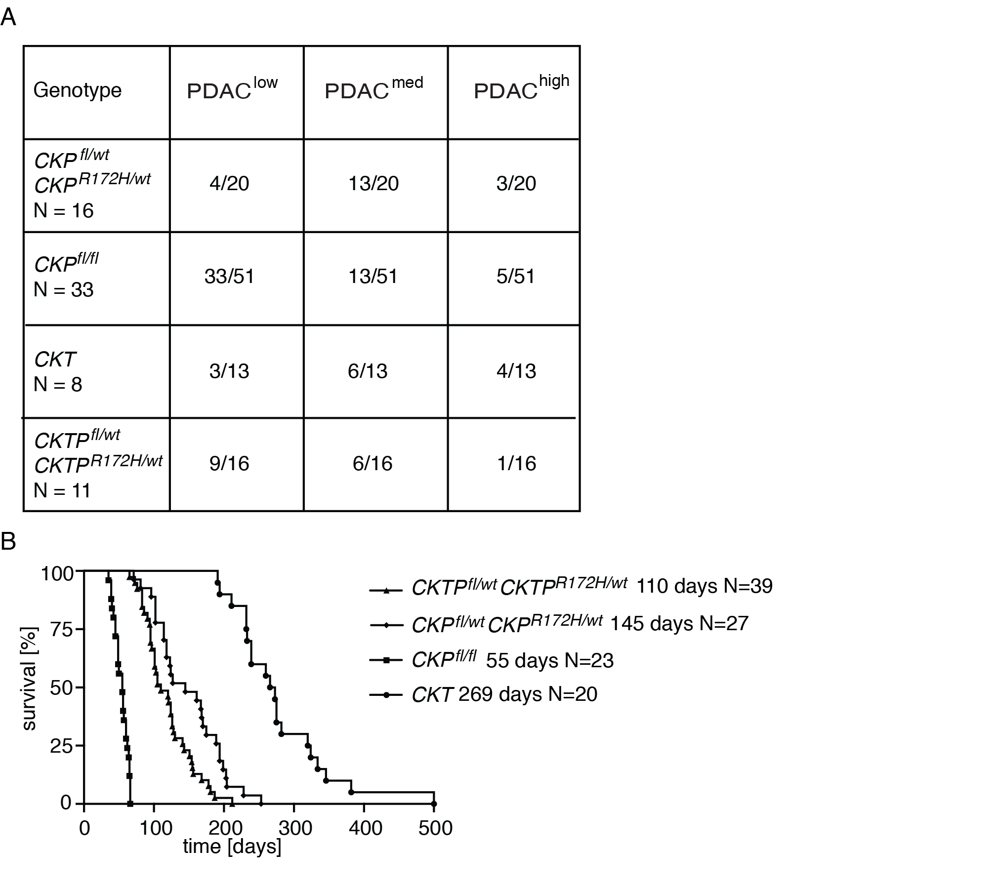 Summary and survival of murine cohort used in the study. (A) Distribution of the PDAC groups according to cellular content among the used genotypes. Only animals that received DW-MRI and were included into the study are described. n = number of animals per genotype, all other numbers represent the amount of analyzed lesions. Up to three lesions per animal (i.e. head, neck and/or tail region) were included. (B) Kaplan Mayer survival analysis of the genotypes used in the study.

Supplementary Figure 2

Consort diagram of the patient distribution of surgical subcohort 1.

Supplementary Figure 3.
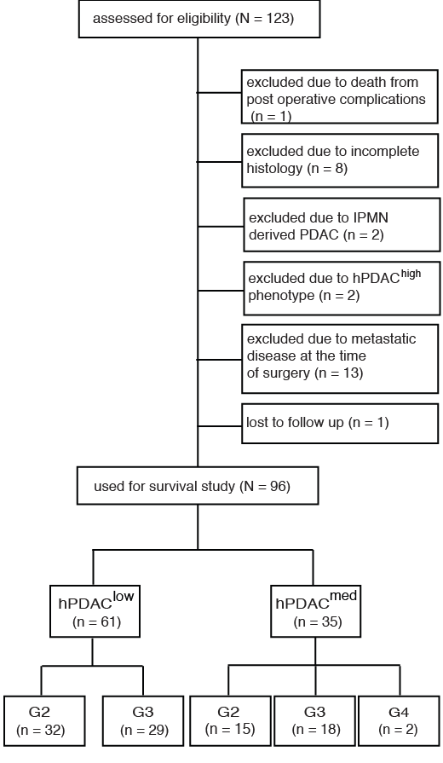
Consort diagram of the patient distribution of surgical subcohort 2.

Supplementary Figure 4.
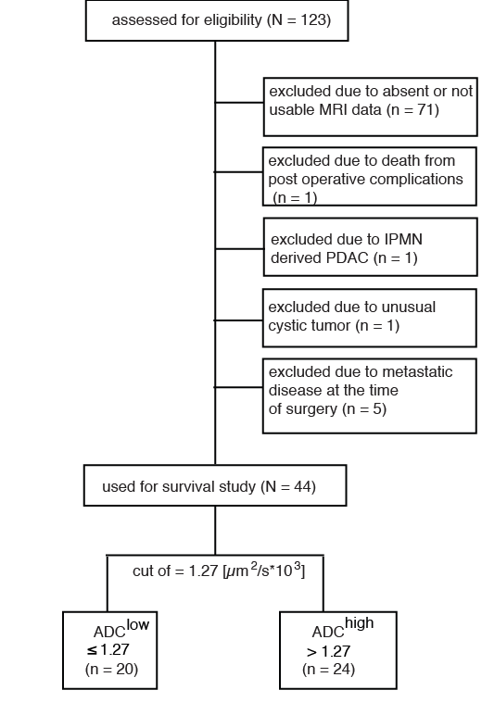

Consort diagram of the patient distribution of surgical subcohort 3.

Supplementary Figure 5. 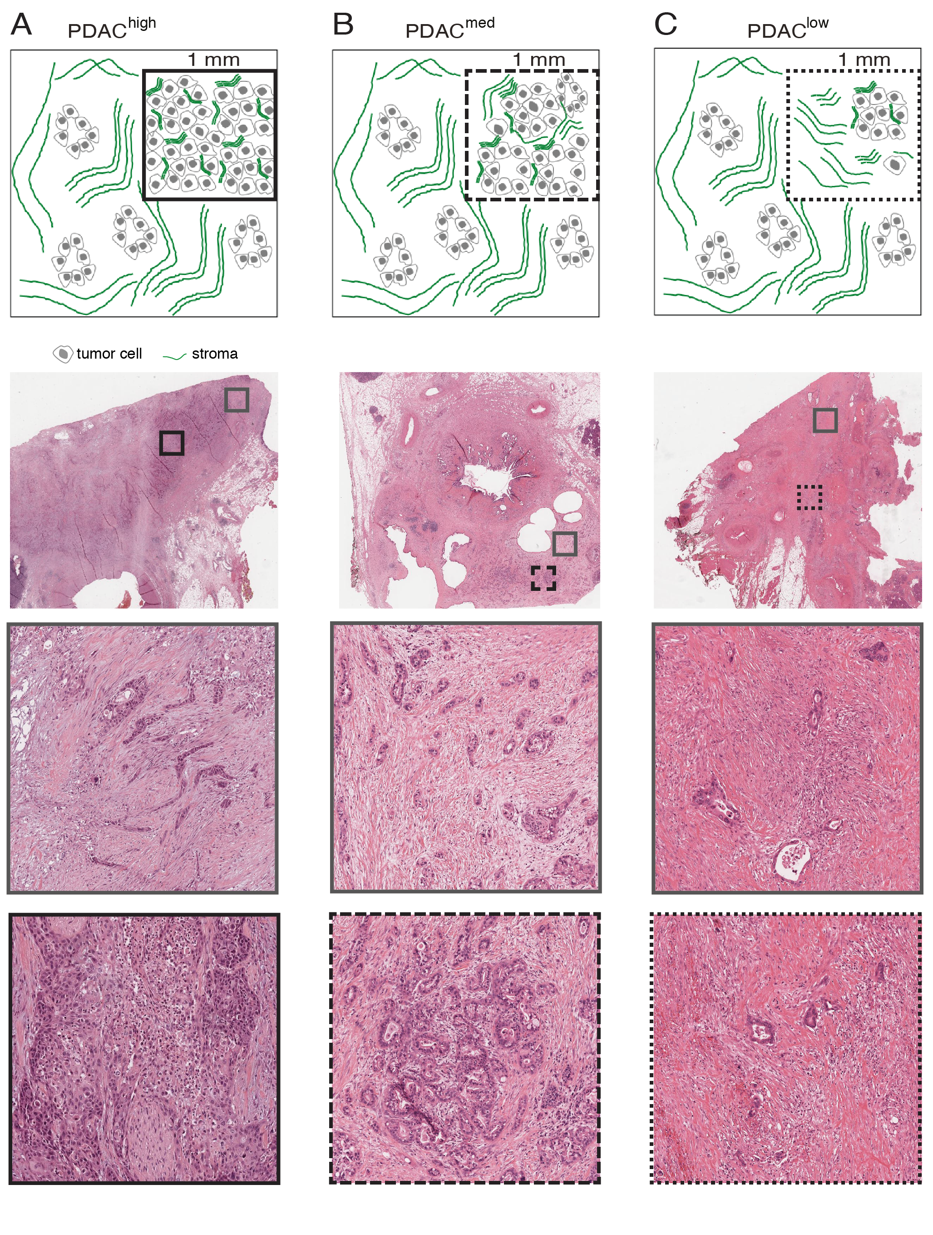

Schematic of relative tumor cell and stroma contribution in PDAC^{high} (A), PDAC^{med} (B) and PDAC^{low} (C) groups and corresponding H&E stained examples (upper row: overview, areas of 1mm² marked with rectangles, middle and lower row: close-up images of the areas marked in the overview). All tumors contain areas with only few tumor cells (grey rectangles). PDAC^{high} tumors display tumor cell clusters with >70% of tumor cells within an area of 1mm² (solid line). Tumor cell cluster in PDAC^{med} tumors contain between 30 and 70% of tumor cells (rough dotted line). In PDAC^{low} tumors no tumor cell cluster area with more than 30% tumor cells within an area greater equal 1 mm² are observed (fine dotted line).

Supplementary Table 1.
Subcohort 1 | PDAC^{low} (N=10) | PDAC^{med} (N=7) | PDAC^{low} and PDAC^{med} (N=4) | P-value  (X²- test)
Sex |  |  |  | 0.82
male | 6 | 5 | 3
female | 4 | 2 | 1
Age mean, (std. dev.) | 65.6 (36-75) | 70.2 (44-78) | 46.9 (43-58) | 0.09 (Mann-Whitney-U-Test)
T |  |  |  | 0.24
1 | 0 | 0 | 1
3 | 10 | 6 | 1
4 | 0 | 1 | 2
N |  |  |  | 0.28
0 | 5 | 1 | 1
1 | 5 | 6 | 3
G |  |  |  | 0.03
2 | 7 | 3 | 0
3 | 3 | 2 | 4
4 | 0 | 2 | 0
R |  |  |  | 0.42
0 | 6 | 5 | 1
1 | 3 | 2 | 3
X | 1 | 0 | 0
Neoadjuvant CTx | 1 | 0 | 0 | 0.56
Adjuvant CTx | 9 | 7 | 2 | 0.06

Statistics of the patients used in surgical subcohort 1.
HR = Hazard Ratio
CI = Confidence Interval
T= T-status
N = Lymph Node Infiltration
G = Grading
R = Resection Margin
R0 = microscopically free of tumor
R1 = microscopically not free of tumor
Rx = unknown
CTx = Chemotherapy

Supplementary Table 2.

Subcohort 2 | PDAC^{low} (N=61) | PDA^{med} (N=35) | P-value  (X²- test)
Sex
male | 32 | 22 | 0.32
female | 29 | 13
Age (mean, std. dev.) | 65.6 (11.4) | 64.1 (10.0) | 0.29 (Mann-Whitney-U-test)
T |  |  | 0.26
1 | 0 | 1
2 | 3 | 3
3 | 51 | 24
4 | 7 | 7
N |  |  | 0.02
0 | 20 | 4
1 | 41 | 31
G |  |  | 0.14
2 | 32 | 15
3 | 29 | 18
4 | 0 | 2
R |  |  | 0.89
0 | 34 | 20
1 | 24 | 14
2 | 1 | 0
X | 2 | 1
Neoadjuvant CTx | 3 | 0 | 0.41
Adjuvant CTx | 52 | 29 | 0.09

Statistics of the patients used in surgical subcohort 2.
HR = Hazard Ratio
CI = Confidence Interval
T= T-status
N = Lymph Node Infiltration
G = Grading
R = Resection Margin
R0 = microscopically free of tumor
R1 = microscopically not free of tumor
Rx = unknown
CTx = Chemotherapy

Supplementary Table 3.

Subcohort 3 | ADC^{high} (N=24) | ADC^{low} (N=20) | P-value  (X²- test)
Sex
male | 14 | 13 | 0.65
female | 10 | 7
Age (mean, std. dev.) | 65.2 (9.3) | 64.9 (13.7) | 0.55 (Mann-Whitney-U-test)
T |  |  | 0.55
1 | 1 | 2
3 | 20 | 14
4 | 3 | 4
N |  |  | 0.06
0 | 8 | 2
1 | 16 | 18
G |  |  | 0.18
1 | 0 | 1
2 | 15 | 7
3 | 9 | 11
4 | 0 | 2
R |  |  | 0.50
0 | 14 | 10
1 | 9 | 10
X | 1 | 0
Neoadjuvant CTx | 3 | 0 | 0.26
Adjuvant CTx | 20 | 16 | 0.77

Statistics of the patients used in surgical subcohort 3.

HR = Hazard Ratio
CI = Confidence Interval
T= T-status
N = Lymph Node Infiltration
G = Grading
R = Resection Margin
R0 = microscopically free of tumor
R1 = microscopically not free of tumor
Rx = unknown
CTx = Chemotherapy

Supplementary Table 4.
 | P-value | HR | 95.0% CI
 |  |  | lower | upper
PDAC^{low} versus PDAC^{med} | 0.034 | 1.730 | 1.043 | 2.868
Age | 0.253 | 1.014 | 0.990 | 1.039
Sex | 0.991 | 1.003 | 0.637 | 1.577
T1 + T2 + T3 +T4 | 0.367
T1 + T2 | 0.970 | 0.983 | 0.406 | 2.382
T3 + T4 | 0.365 | 1.683 | 0.563 | 4.770
N | 0.276 | 1.376 | 0.775 | 2.443
G all | 0.000 | 2.744 | 1.599 | 4.709
R all | 0.587
R0 | 0.802 | 0.933 | 0.541 | 1.608
R1 + R2 | 0.335 | 1.812 | 0.541 | 6.067
CTx | 0.037 | 0.515 | 0.276 | 0.961

HR = Hazard Ratio
CI = Confidence Interval
T= T-status
N = Lymph Node Infiltration
G = Grading
R = Resection Margin
R0 = microscopically free of tumor
R1 = microscopically not free of tumor
R2 = macroscopically not free of tumor
CTx = Chemotherapy

Results of a multivariable Cox regression model fit to the data of subcohort 2 that assess whether PDAC is associated with overall survival after adjustment for common predictors.

Supplementary Table 5.
 | P-value | estimated cut off
Lowest ADC | 0.055 | 1.08
T | 0.113 | 1.08
N | 0.076 | 1.08
G1 + G2 vs. G3 + G4 | 0.068 | 1.08
R | 0.068 | 1.08
CTx | 0.024 | 1.08

T= T-status
N = Lymph Node Infiltration
G = Grading
R = Resection Status
CTx = Chemotherapy

The permutation test analysis revealing association between overall survival and lowest ADC stratified by each of the relevant categorical variables. Data used for analysis are derived from surgical subcohort 3.

