Supplementary Data
1. Supplemental Table 1: Optimal conditions for PDX model luciferization
2. Supplemental Table 2: Array CGH characterization of PDX models
2. Supplemental Table 3: BROCA characterization of PDX models
3. Supplemental Table 4: Somatic Sequence Alterations in parental tumor and xenograft DF101
4. Supplemental Table 5: Somatic Sequence Alterations in parental tumor and xenograft DF149
5. Supplemental Table 6: PIK3CA FISH in PDX models
6. Supplemental Figure 1: Schema for PDX model generation and luciferization
7. Supplemental Figure 2: IHC characterization through multiple passages of DF68 PDX
8. Supplemental Figure 3: Array CGH comparison between parental, initial PDX, and luciferized PDX cells in DF86
9. Supplemental Figure 4: PI3K pathway activation analysis from PDX RPPA samples
10. Supplemental Figure 5: Correlation between BLI and plasma CA125 biomarker levels in DF14-Luc
Supplemental Table 1: Luciferization conditions for DF PDX models

DF ID | Infection method | Puromycin concentration (ug) | Days in puromycin | Day / Luc counts | % viable cells / ATP assay | Medium | Days between collection and re-implantation
DF09 | Poly / 2x accutase | 2.5 | 5 | 7 / 1949 | 9.20% | RPMI | 8
DF14 | Poly / 2x spinfect 600g x 30’ | 2.5 | 5 | 7 / 19,837 | 9-12% | WIT-P | 8
DF20 | Poly / 2x mix shake & direct, accutase | 4 | 5 | 8 / 8290 | 12.2-13% | R+P | 8
DF59 | Poly / 2x direct, accutase | 2 | 8 | 12 / 3146 | 25.8-64.3% | RPMI | 12
DF68 | Poly / 2x direct, accutase | 2.5 | 4 | 7 / 1087 | 3.7-10% | R+P | 8
DF83 | Poly / 2x direct, accutase | 5 | 4 | 7 / 34,481 | 14-45% | WIT-P | 7
DF86 | Poly / 2x shake 30’, accutase | 2.5 | 5 | 7 / 32,897 | 5.6-23.3% | R+P | 8
DF101 | Poly / 1x direct, accutase | 2.5 | 4 | 7 / 2356 | 1.3-8.4% | RPMI | 9
DF106 | Poly / 1x shake, accutase | 5 | 4 | 6 / 399 | 4.1-61% | WIT-P | 7
DF118 | Poly / 2x direct | 2 | 8 | 10/ 22,600 | 3.65-5.92% | WIT-T | 11
DF149 | Poly / 2x direct | 5 | 10 | 9 / 3145 | N/A | WIT-P | 12
DF172 | Poly / 2x direct, accutase | 3 | 4 | 5 / 115,807 | 3.4-55% | RPMI | 8
DF181 | Poly / 2x mix | 3 | 6 | N/A | N/A | WIT-P1 | 10
DF216 | Poly / 2x direct | 2 | 3 | N/A | N/A | RPMI | 7

Supplemental Table 3: BROCA characterization of PDX models

DF ID | Patient Tumor | Variant Allelic Fraction (Tumor) | Luciferized PDX | Variant Allelic Fraction  (PDX)
DF20 | TP53 | 0.15 | TP53 | 0.99
 |  |  | PTEN | 0.13, 0.05, 0.05, 0.04  (multiple variants)
 |  |  | PPM1D | Unknown
DF68 | TP53 | 0.44 | TP53 | 1
 | BRCA1 | 0.80 | BRCA1 | 1
 | PTEN copy loss | -- | PTEN copy loss | --
DF83 | TP53 | 0.9 | TP53 | 0.96
 | CDKN2A copy loss |  | CDKN2A copy loss
 |  |  | SDHC | 0.03
DF86 | TP53 | 0.92 | TP53 | 1
 | BRCA1 copy loss of last 5 exons | -- | BRCA1 copy loss of last 5 exons | --
 |  |  | APC (mutation conserves amino acid sequence) | 0.29
DF101 | TP53 | 0.99 | TP53 | 0.99
 | BRCA1 | 0.97 | BRCA1 | 0.97
 | NBN | Unknown | NBN | Unknown
 | PTEN copy loss |  | PTEN copy loss
DF106 | TP53 | 0.76 | TP53 | 0.99
 | CDKN2A copy loss |  | CDKN2A copy loss
DF118 | TP53 | 0.78 | TP53 | 0.99
DF149 | TP53 | 0.68 | TP53 | 0.98
DF172 | TP53 | 0.83 | TP53 | 0.98
 |  |  | RET | 0.1
 |  |  | RAD51C | Unknown
DF181 | TP53 | 0.27 | TP53 | 0.94
 | BRIP1 | 0.62 | BRIP1 | 0.94
DF216 | TP53 | ~0.75 (manual estimate) | TP53 | ~1 (manual estimate)

Supplemental Table 6: PIK3CA FISH of PDX models

DF ID | PIK3CA:CEP3 ratio | Status
DF09 | 1.05 | No gain
DF14 | 1.04 | No gain
DF20 | 2.5 | Amplification
DF59 | 1.76 | Gain
DF68 | 1.5 | Gain
DF83 | 0.96 | No gain
DF86 | 2 | Amplification
DF101 | 1.28 | No gain
DF106 | 2 | Amplification
DF118 | 1.14 | No gain
DF149 | 1.2 | No gain
DF172 | 1.68 | Gain
DF181 | 1.54 | Gain
DF216 | 1.6 | Gain

Supplemental Figure 1. Schema for PDX model generation and luciferization
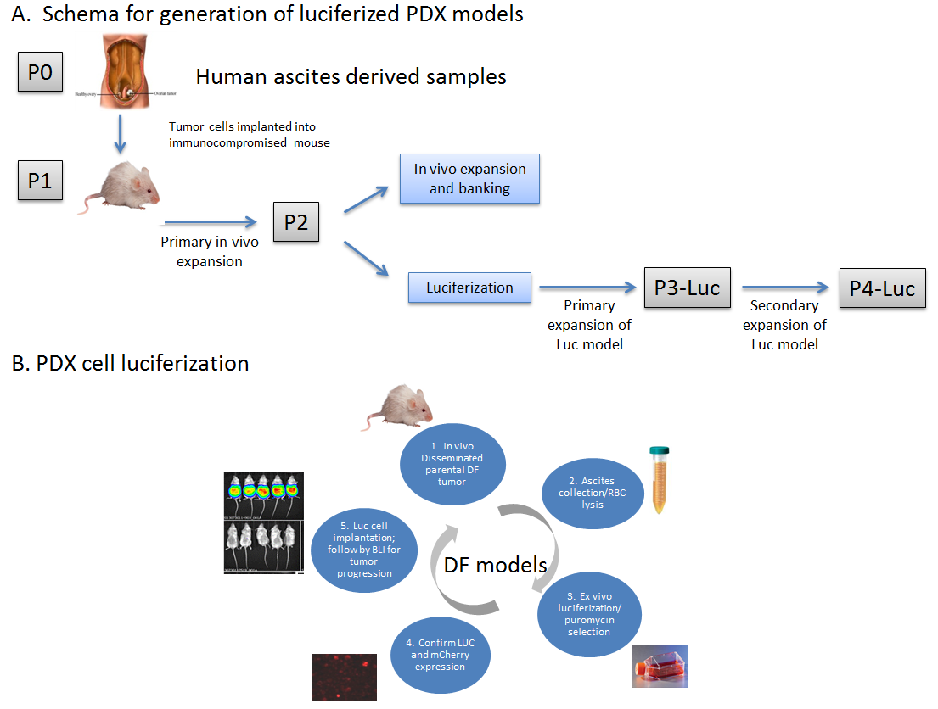
Supplemental Figure 2. IHC characterization through multiple passages of DF68 PDX

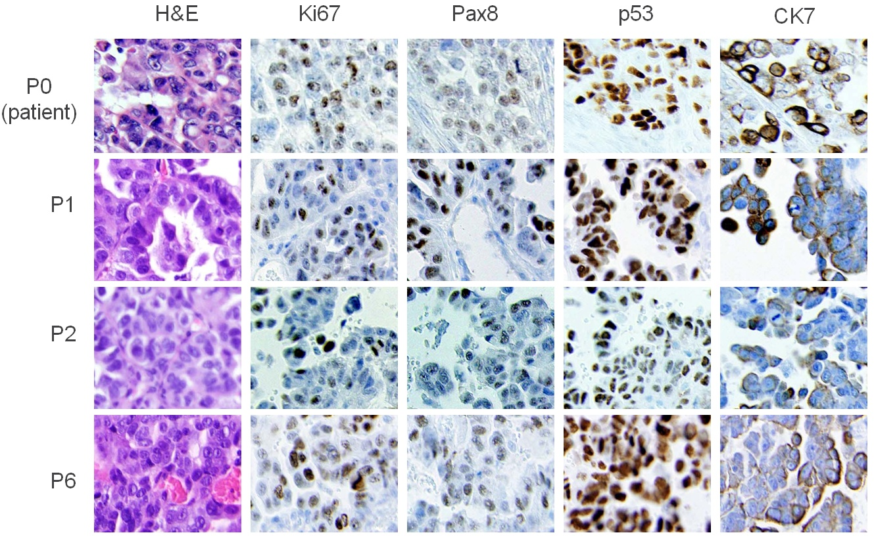

Supplemental Figure 3. Array CGH comparison between patient tumor, pre-luciferized PDX, and luciferized PDX cells in DF86

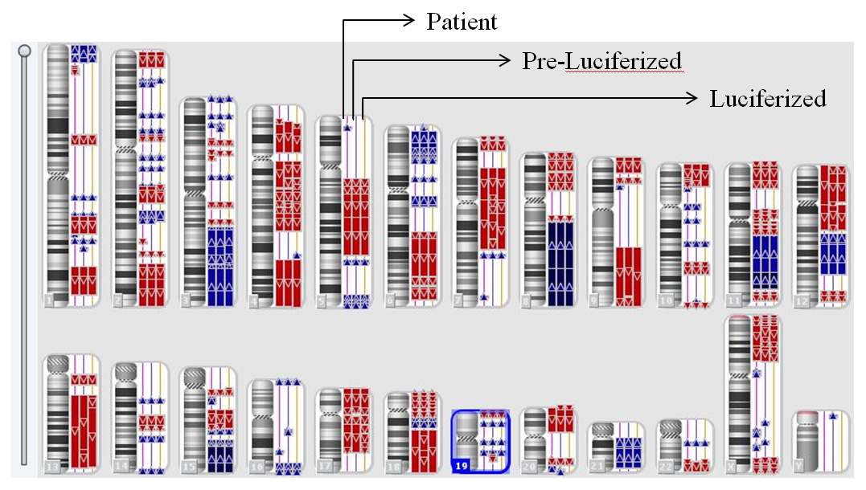

Copy number variation (CNV) analysis was performed on DNA extracted from the original patient tumor, the pre-luciferized PDX tumor cells, and the luciferized PDX tumors. A chromosome view map indicates overall high preservation of copy number alterations between the pre-luciferized and luciferized PDX models and the original patient tumor.
Supplemental Figure 4. PI3K pathway activation clustering analysis from PDX RPPA samples

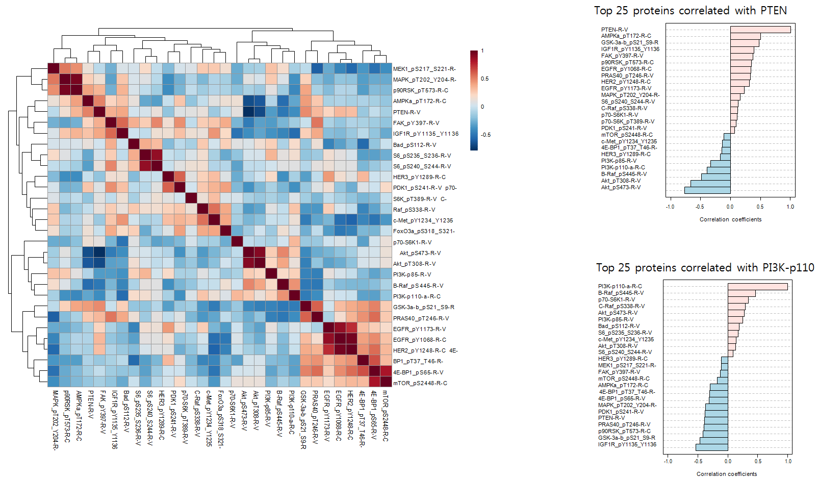
A.
B.
C.

Clustering analysis shows a strong correlation between phosphoproteins that are adjacent in known canonical pathways, supporting that the RPPA analysis is of high quality. A. Phosphorylation readouts cluster as canonical signaling modules in a correlation heat map. B, C. Spearman correlations for the top 25 correlated proteins to PTEN and to PI3K-p110.
Supplemental Figure 5. Correlation between CA125 concentration and BLI signal in DF14-Luc mice

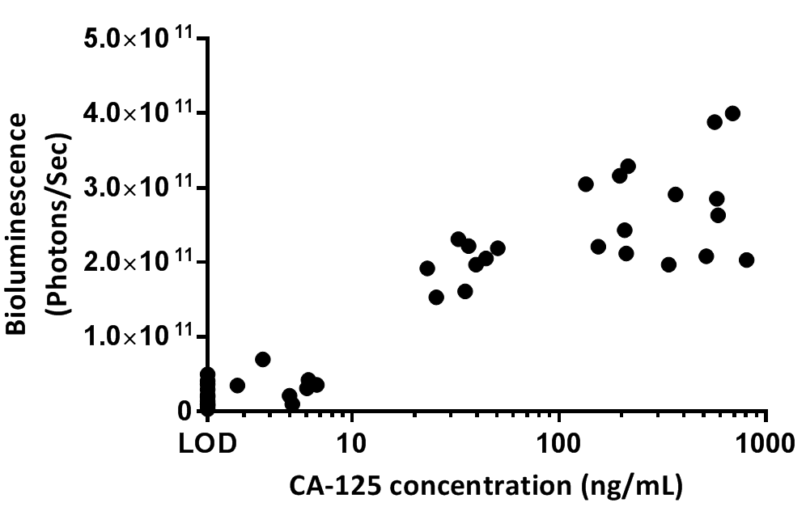
Spearman r = 0.73, p <0.0001

Mouse plasma CA125 levels are correlated with BLI signals in DF14-Luc mice.

