Supplementary Figures

Supplementary Fig S1 Guardant360 ctDNA Sequencing Gene Panel
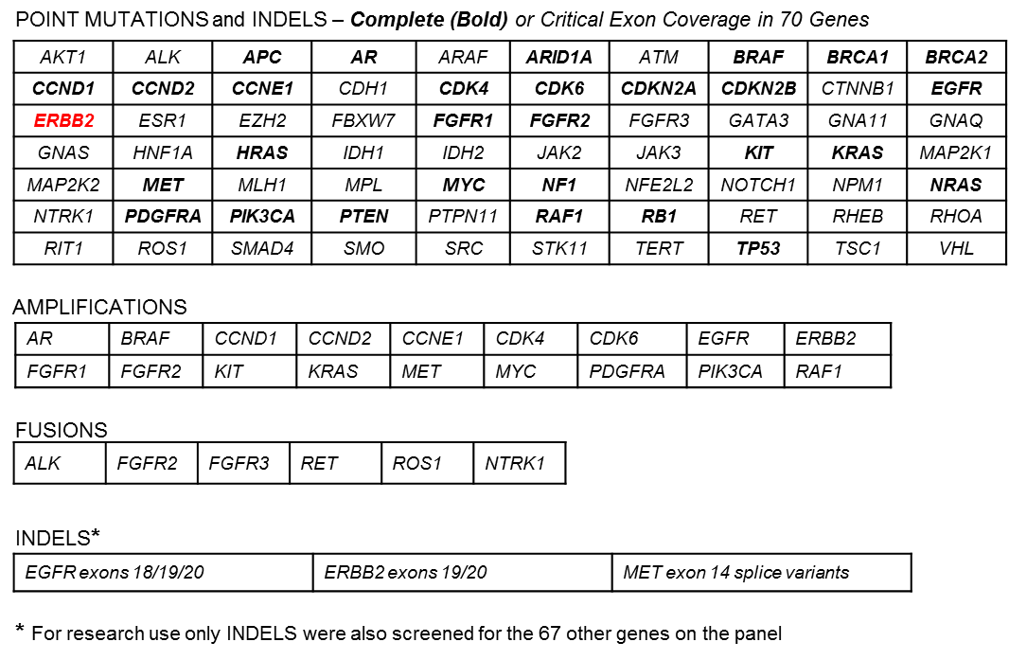
The Guardant360 panel version GH2.9 reports single nucleotide variants (SNVs) in 70 genes, gene copy number amplifications in 18 genes, fusions/rearrangements in 6 genes as well as indels in 3 genes. Complete exons are sequenced for all exons in 30 genes, including ERBB2, and the critical exons in 40 genes (597 exons total). Thus, a 146,000 base pair targeted region is sequenced for each patient sample. 2,720 probes. Average GC 47%.

Supplementary Fig S2 Consort Diagram

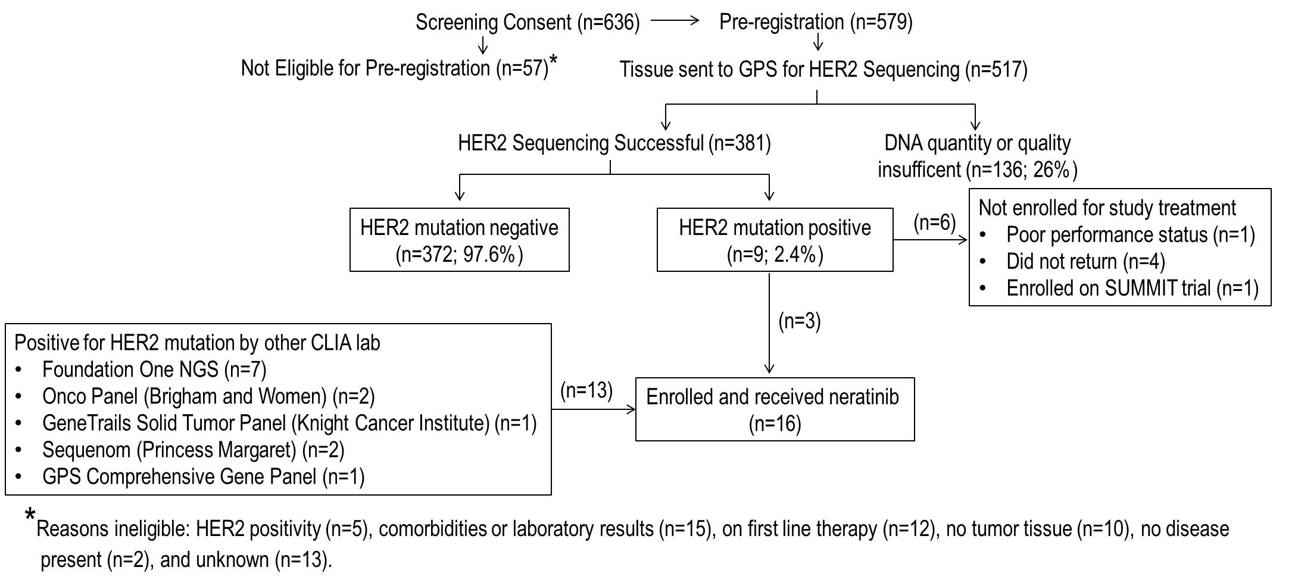

Supplementary Fig S3. Distribution of HER2 activating mutations identified by plasma ctDNA sequencing in 1,584 breast cancer patients

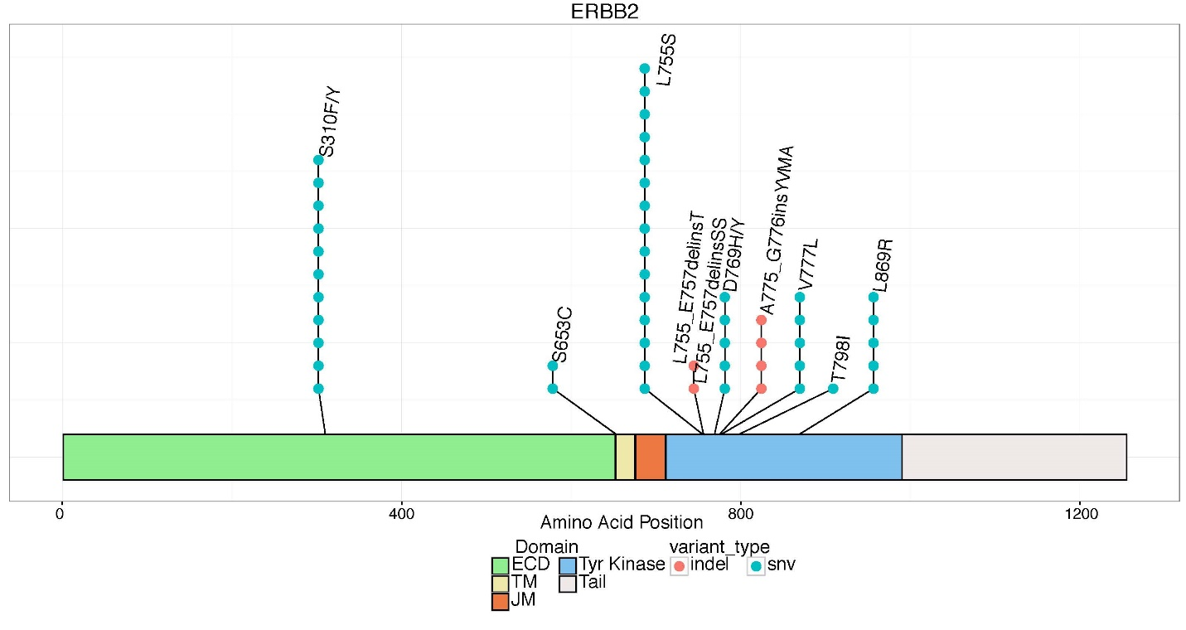
Each circle represents a single patient.

SUPPLEMENTARY TABLES

Supplementary Table S1 HER2 Activating Mutations Detection by Tumor DNA
versus Plasma Cell-free DNA Sequencing
 | HER2 mutation by tumor DNA sequencing*
HER2 mutation by ctDNA sequencing* | Pos | Neg
Pos (concordant with tumor sequencing) | 11 | 0
Pos (discordant with tumor sequencing) | 1 | NA
Neg | 2 | 32
No detectable ctDNA mutation | 0 | 8
Total | 14 | 40
Comparing the tumor DNA sequencing, the sensitivity and specificity of ctDNA for the detection of HER2 activating mutation was 11/14 (79%, 90% CI: 53-94%) and 32/32 (100%, 90% CI: 91-100%), respectively. The overall concordance rate was 43/46 (93.5%, 90% CI 87-100%). * Mutation data is detailed in Supplementary Table S2. NA, not applicable

Supplementary Table S2 HER2 Mutation by Tumor or ctDNA sequencing, ctDNA HER2 mutation Variant Allele Frequency, and Tumor Response in Individual Patient with Activating HER2 Mutations (n=14)
Pt  ID | HER2 Mutation  by tumor sequencing | ctDNA HER2 Mutation Variant Allele Frequency |  |  |  | Best Response  % change in tumor size |  | PFS  (Weeks)
 |  | Baseline ctDNA  HER2 Mutation | Baseline | 4-week | Progression
13 | P780_Y781insGSP | Not detected (Neg) | 0% | 0% | NA | SD | NM | 75
16 | L869R | L869R | 15.44% | 0.27% | 1.6% | SD | -12% | 37
14 | S310F,V842I | Not detected | 0%, 0% | 0%, 0% | 0.34%, 0% | SD | NM | 32
 | Not detected | D769Y | 0.94% | 0% | 0.2%
 | Not detected | I767M | 0% | 0% | 0.25%
 | Not detected | T862A | 0% | 0% | 17.79%
 | Not detected | T798I | 0% | 0% | 0.39%
 | Not detected | L869R | 7.47% | 0.55% | 22.86%
15 | V777_G778insGSP | V777_G778insGSP | 0.19% | 0% | 0.82% | CR | -100% | 32
9 | L755S | L755S | 0.96% | 0.15% | 14.82% | PR | -35% | 31
8 | L755S | L755S | 45.98% | 1.11% | NA | SD | NM | 22
2 | A775_G776insYVMA | A775_G776insYVMA | 10.28% | 0.11% | 15.65% | SD | 5% | 20
6 | D769H | D769H | 2.85% | 0.25% | 3.76% | SD | -23% | 12
3 | S310F | Not detected (Neg) | 0% | 0% | 0% | PD | 11% | 9
1 | P780_Y781insGSP | P780_Y781insGSP | 14.27% | 2.01% | 8.84% | PD | 17% | 8
12 | L755S | L755S | 4.22% | 1.71% | 5.04% | PD | 33% | 8
11 | L755S | L755S | 32.41% | 43% | NA | PD | 0% | 8
7 | L755S | L755S | 4.63% | 16.41% | NA | PD | 41% | 4
10 | L755S | L755S | 15.20% | NA | NA | PD | 17% | 3
NA, Sample Not available; NM, no measurable disease by RECIST; SD, Stable Disease; CR, Complete Response; PR, Partial Response; PD, Progressive Disease; PFS, Progression free survival; Shaded VAFs data were used for the plot in Figure 2d.

