Supplemental figures and tables:
Table 1. Clinico-pathologic features of the Non-small cell lung cancer cohorts (Cohort A, B and C)
Table 2. Cox regression model with clinicopathologic features, tumor B7-H3, B7-H4 and PD-L1 protein expression risk ratios for 3 cohorts.
Figure 1. B7-H3 antibody validation
Figure 2. B7-H4 antibody validation
Figure 3. B7-H3 tumor and stromal protein expression regression, staining examples
Figure 4. Co-expression co-localization of B7-H3 and PD-L1
Figure 5. Additional images for Co-expression co-localization of B7-H3 and B7-H4

Table 1. Clinico-pathologic features of the Non-Small Cell Lung Cancer cohorts (Cohort A, B and C)
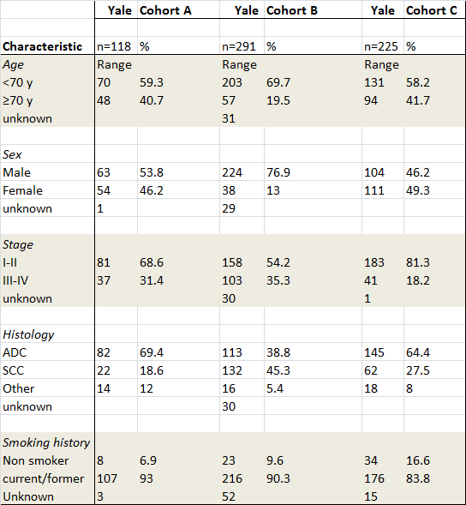
Table 2. Cox regression model with clinicopathologic features, tumor B7-H3, B7-H4 and PD-L1 protein expression risk ratios for 3 cohorts. B7-H3 tumor QIF score risk ratios are highlighted in the redbox

Figure 1. B7-H3 antibody validation, Representative fluorescence images showing the B7-H3 plasmid transfected SK-BR-3 cell lines A)negative control, B) positive control; below QIF score distribution of highest 5 Field of view for the negative controls and plasmid transfected cell lines. lines are highlighting the mean with standard deviation.
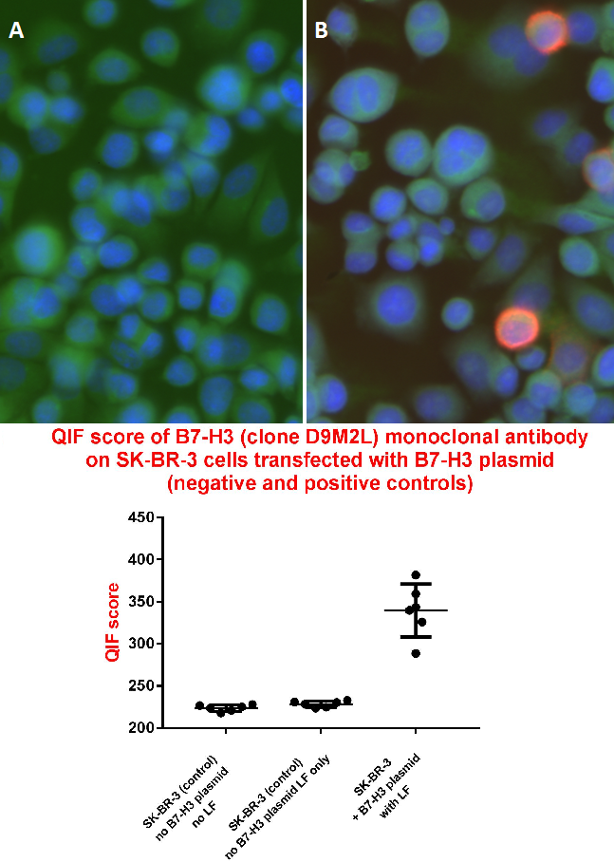

Figure 2. B7-H4 antibody validation, Representative fluorescence images showing the B7-H4 plasmid transfected cell lines A)negative control, B) positive control; below QIF score distribution of highest 5 Field of view for the negative controls and plasmid transfected cell lines, lines are highlighting the mean with standard deviation.
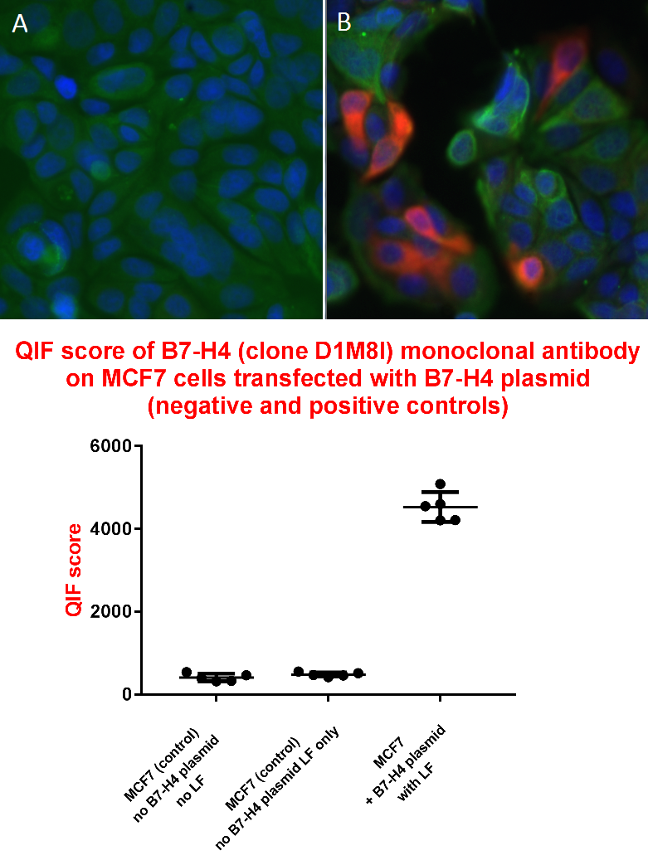

Figure 3. Representative fluorescence images showing the stromal dominant (A), and tumor dominant (B) B7-H3 protein expression on a TMA spot, Cytokeratin as tumor mask in green channel and B7-H3m target protein in red channel, C tumor and tumor stroma QIF scores in a combined analysis of Cohort A, B and C.
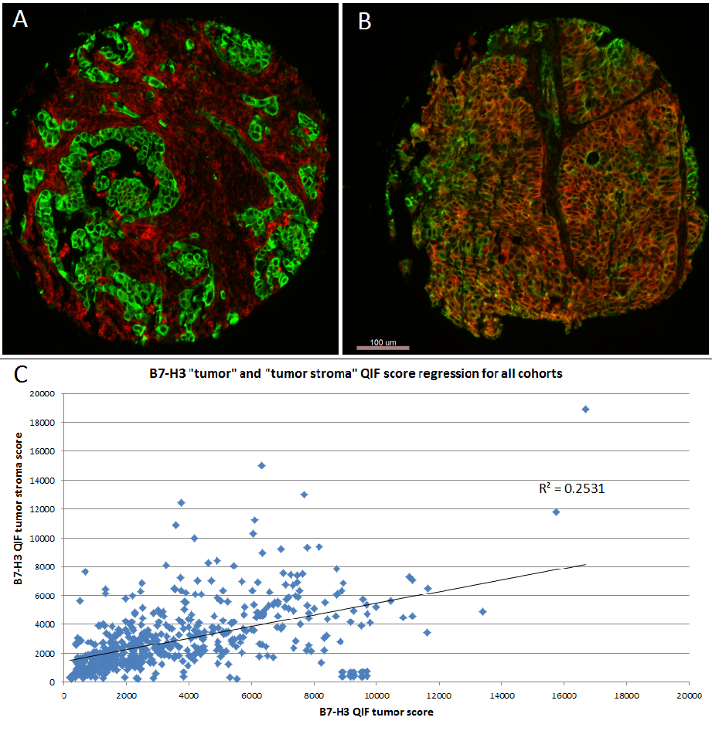

Figure 4. Detection of B7-H3 and PD-L1 protein expression by confocal microscopy to assess co-localization in lung cancer. Representative fluorescence images showing the simultaneous detection of B7-H3 (red channel), PD-L1 (yellow channel), cytokeratin (green channel) and DAPI (blue channel)

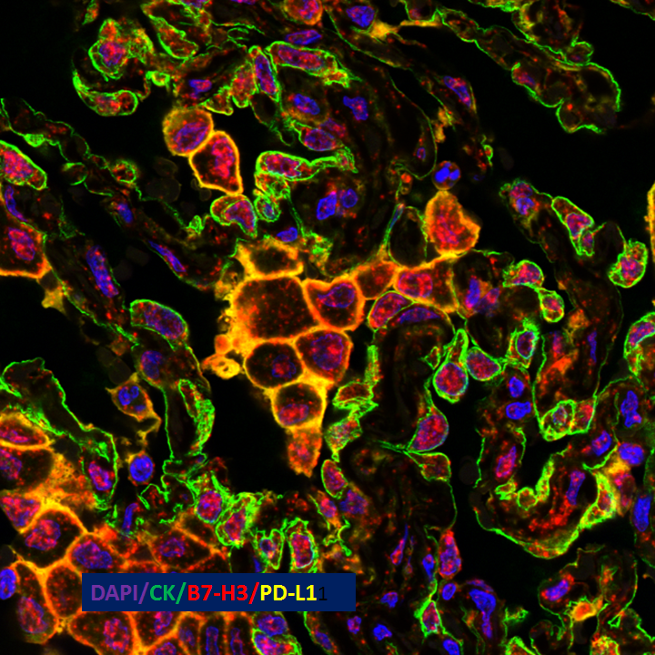

Figure 5. Detection of B7-H3 and B7-H4 protein expression to assess co-localization using immunofluorescence (QIF) in lung cancer. A) Representative fluorescence images showing the simultaneous detection of B7-H3 (red channel), B7-H4 (blue channel) and cytokeratin (green channel, inserted box is highlighting the area that has been magnified in figure B-D. B) B7-H3 (red channel), Cytokeratin (tumor mask in green channel). C) B7-H3 (red channel), B7-H4 (blue channel) and cytokeratin (green channel), D) B7-H4 (blue channel), Cytokeratin (green channel) Bar=100 μm.

