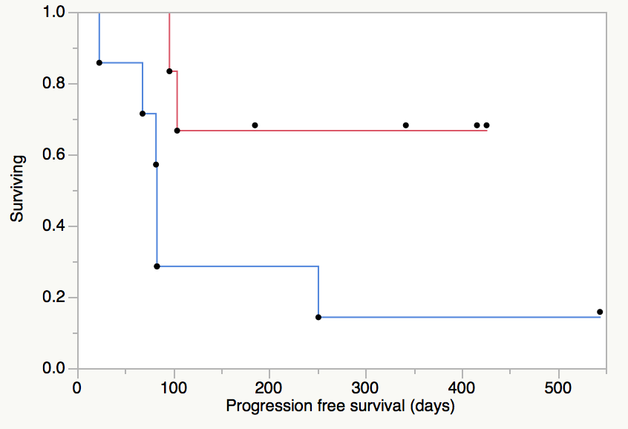
Log-rank test p=0.03
Gain in intra-tumoral CD8 count and Progression free survival
A

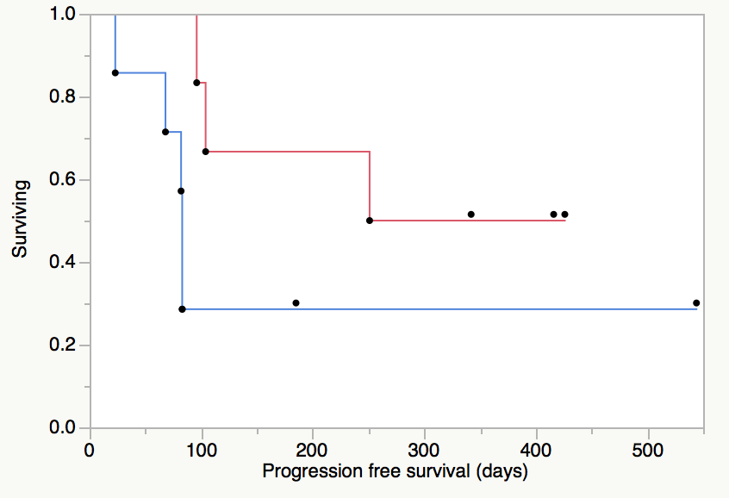
Log-rank test p=0.13
Gain in intra-tumoral CD68 count and Progression free survival
B

Supplementary Figure 3. Gain in immune cell counts and Kaplan-Meier progression free survival curves. (A) Progression free survival stratified according to median intra-tumoural CD8+ counts per 4 high power fields (median: 375 cells) (B) Progression free survival stratified according to median peri-tumoural CD68+ counts per mm² (median: 212 cells).

