**Clinical Cancer Research**

**Supplementary data**

**Title : Circulating DNA demonstrates convergent evolution and common resistance mechanisms during treatment of colorectal cancer**

**Supplemental Table S1:**

**A**



**B**



**Legend Supplemental Table S1 : Point mutations tested by plasma analysis in the KPLEX R study, (A)**. **Comparison of point mutations tested by tumor tissue and plasma analysis, (B)**. *KRAS exon 12/13* and *BRAFV600E* point mutations were tested in each patients before and during treatments (n=42). * Despite of low volume of plasma samples, extended *KRAS* point mutations were tested only on wild type *KRAS exon 2* and *BRAFV600E* patients in either baseline or during treatment (n=6). *\*\* NRAS* *12/13* point mutations were tested only in patients #23 and #25 and only for the last cycle of FOLFOX/Dasatinib plus Cetuximab treatment (C4) because we had no more plasma volume at baseline.\*\*\**NRAS* 61 point mutations were tested in a post-blind manner in *KRAS/BRA*F wild type patients in either baseline and during treatments and also in *NRAS 61* mutant patients as determined by tumor tissue analysis (n=4). *# EGFR S492R* was tested only in patients in rechallenge for Cetuximab targeted therapy (n=13).

**Supplemental Table S2:**

**A**



**B**



**C**



**D**



**E**



**F**



**Legend Supplemental Table S2: Concordance between tumor-tissue analysis and cfDNA analysis before treatments.** Concordance of *KRAS/BRAF* mutant status between tumor-tissue analysis and cfDNA analysis before treatments when considering both cohorts, A. Concordance of *KRAS* mutant status between tumor-tissue analysis and cfDNA analysis before treatments when considering cohort 1, B. Concordance of *KRAS/BRAF* mutant status between tumor-tissue analysis and cfDNA analysis before treatments when considering cohort 2, C. Concordance of *KRAS* codon *61* mutant status between tumor-tissue analysis and cfDNA analysis before treatments when considering cohort 2, D. Concordance of *KRAS* codon *146* mutant status between tumor-tissue analysis and cfDNA analysis before treatments when considering cohort 2, E. Concordance of *NRAS* codon *61* mutant status between tumor-tissue analysis and cfDNA analysis before treatments when considering cohort 2, F. WT, wild type.

**Supplemental Table S3:**

**A**



**B**

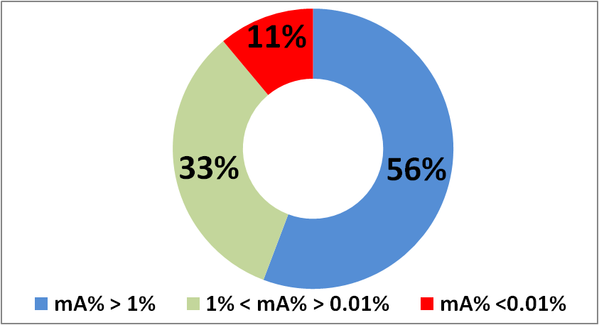

**Legend Supplemental Table S3:** Mutation load at baseline in mutant patients with the equivalent type of mutation as determined by tumor tissue and plasma analysis are heterogneous from 31.83% to 0.009%, (A). Percentage of mutation load found at baseline in mutant patients with the equivalent type of mutation as determined by tumor tissue and plasma analysis according range, (B). NQ, scored positive but non quantifiable.

**Supplemental Table S4:**

**A**



**B**

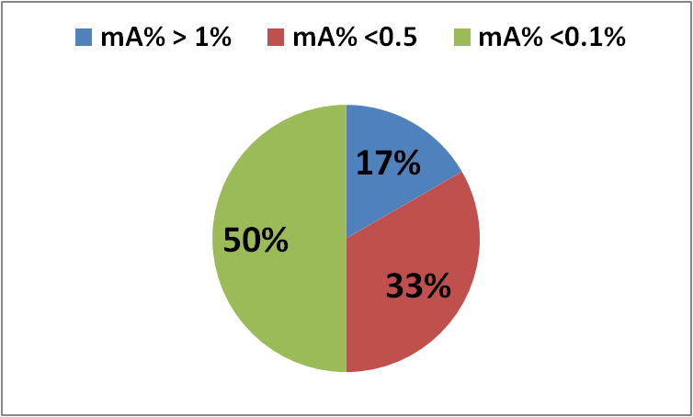

**Legend Supplemental Table S4:** Mutation load values of emerging mutant subclones during treatments for both cohorts are reported in (A). Most emerging mutant subclones appears with a mutation load below 0.5% including down to 0.1%, (B). Sensitive methods is needed to track emergence of mutant subclones during targeted therapies. ND, non detected; NQ, scored positive but non quantified.

**Supplemental Table S5 :**



**Legend Supplemental table S5 : Compilation of cfDNA data, CEA level and imaging for both cohorts before and during treatments.** SD, Stable Disease; PD, Progressive Disease; PR, Partial Response; TE, Treatment Effects; AE, Adverse Events, W/D consent, Without Doctor consent; CEA, carcinoembryonic antigen (ng/mL); CV, control value; RefA, concentration of total cfDNA (ng/mL of plasma); total mA, addition of the concentration of all point mutations found in an same sample (ng/mL of plasma); mA%; total mA%, total mutation load calculated as ((total mA/RefA)x100).

**Supplemental table S6:**

**A**



**B**



**Legend Supplemental Table S6: Concordance between tumor-tissue analysis and cfDNA analysis before treatments when considering if patients having primary tumor in place or not in place when entering in the study.**

**Supplemental Table S7:**

**A**



**B**



**Legend Supplemental Table S7: Mutant patients and point mutations determined at baseline with different mA% thresholds.** At baseline, patients with at least one point mutation with a mutation load below 1%, 0.5% and 0.1% were represented in (A). In red patients with all mutations found at baseline with a mutation load below thresholds and no determined as mutant. In blue point mutations with mutation load below thresholds and no determined. The proportions point mutations no detected and patients no determined as mutants with mA% thresholds at 1%, 0.5% and 0.1% were reported in B. Non quantifiable (NQ) mutation load were considered as mA% below 0.1%. NQ, scored positive but non quantifiable.

**Supplementary Table S8**



**Legend supplemental table S8: Description of all point mutations found from plasma analysis at baseline according to increasing allelic frequencies and the mutational status as determined with tumor tissue analysis.** Note, several patients may appear more than once because of multiple point mutations. WT: Wild Type; *: *KRAS 12/13* mutant patient but the specific point mutation is non-determined**.**

**Supplementary Table S9**

**A**

**B**

**Legend Supplementary Table S9: Evolution of increasing mA% from baseline to end of treatment, A.** Evolution of mA from baseline to the end of treatment, B. ND: No mutation detected; WT: Wild type for the mutations tested; PR: Partial Response; SD: Stable Disease; PD; Progressive Disease; CV; Control Value; TE: Treatment Effects; AE: Adverse Events; Total mA%: total mutation load; Total mA: total of mutant ctDNA; W/D: Without clinician consent; WD: With clinician consent; N/A: Data missing

**Supplemental Figure S1: Patient's Flow chart**

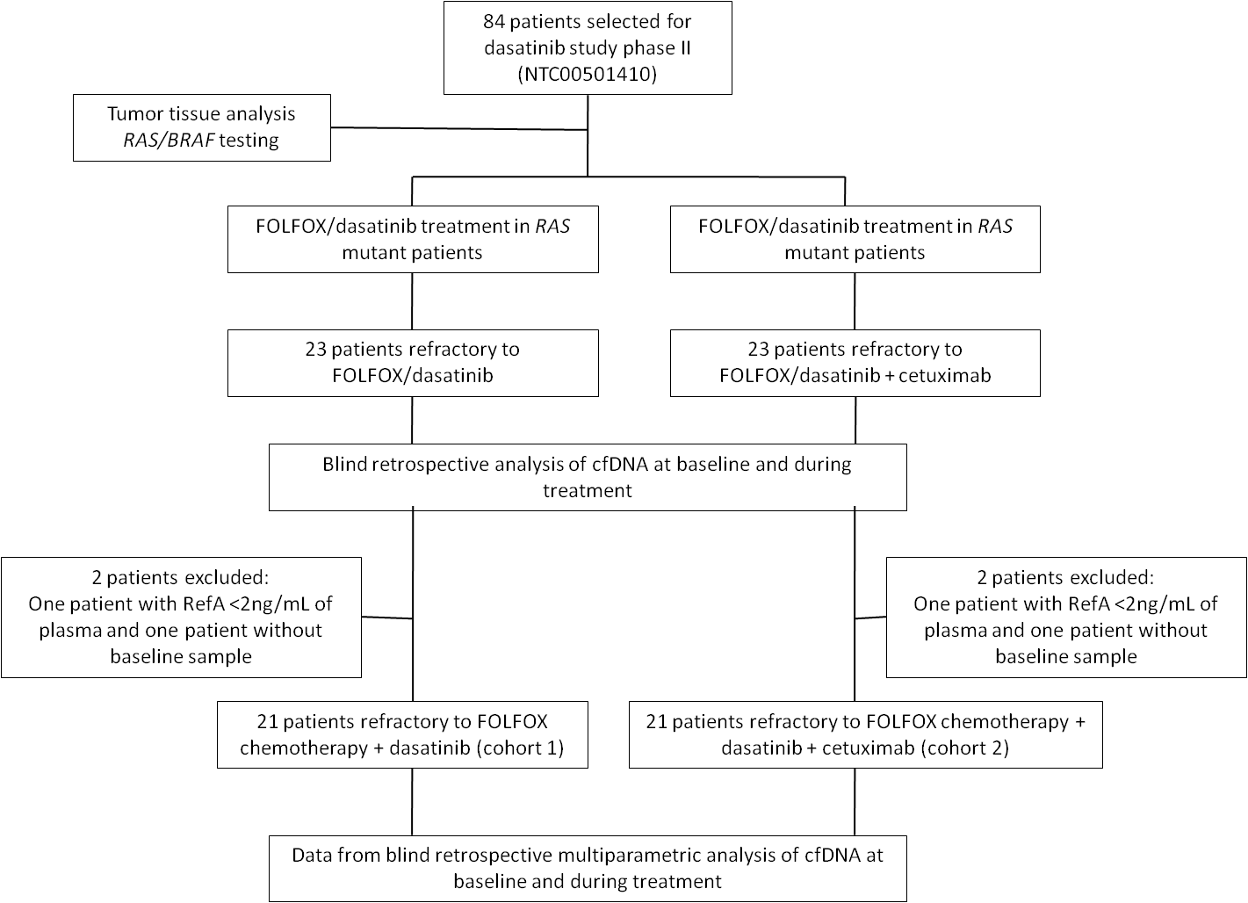

**Supplemental Figure S2 :**

**A**

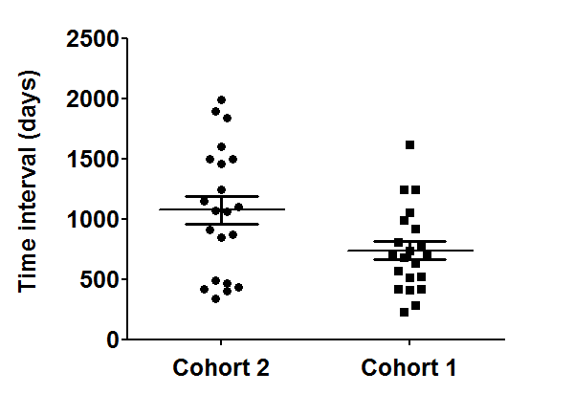

*

**B**

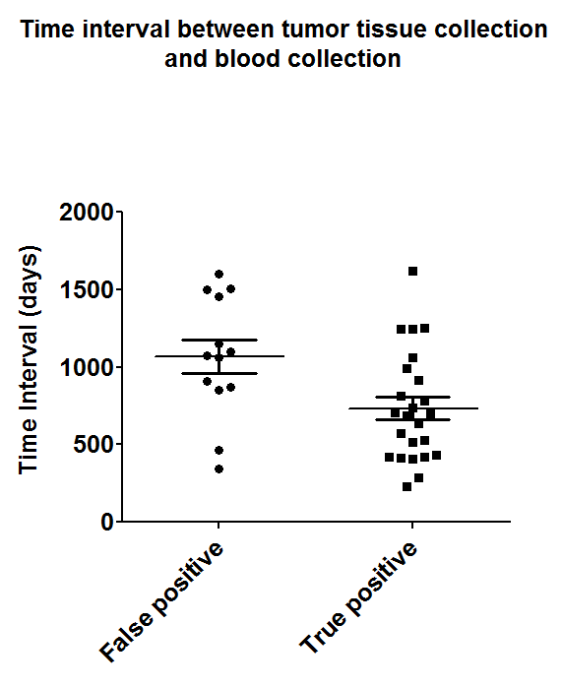

*

**Legend Supplemental Figure S2 : Time lag between tumor tissue collection and blood drawing.** Time lag between tumor tissue collection and blood drawing is significant between cohorts 1 and 2 (p.value 0.0380) (A), and also between true and false positive patients (p.value: 0.0163), (B).

**Supplemental** **Figure S3:**

**A**

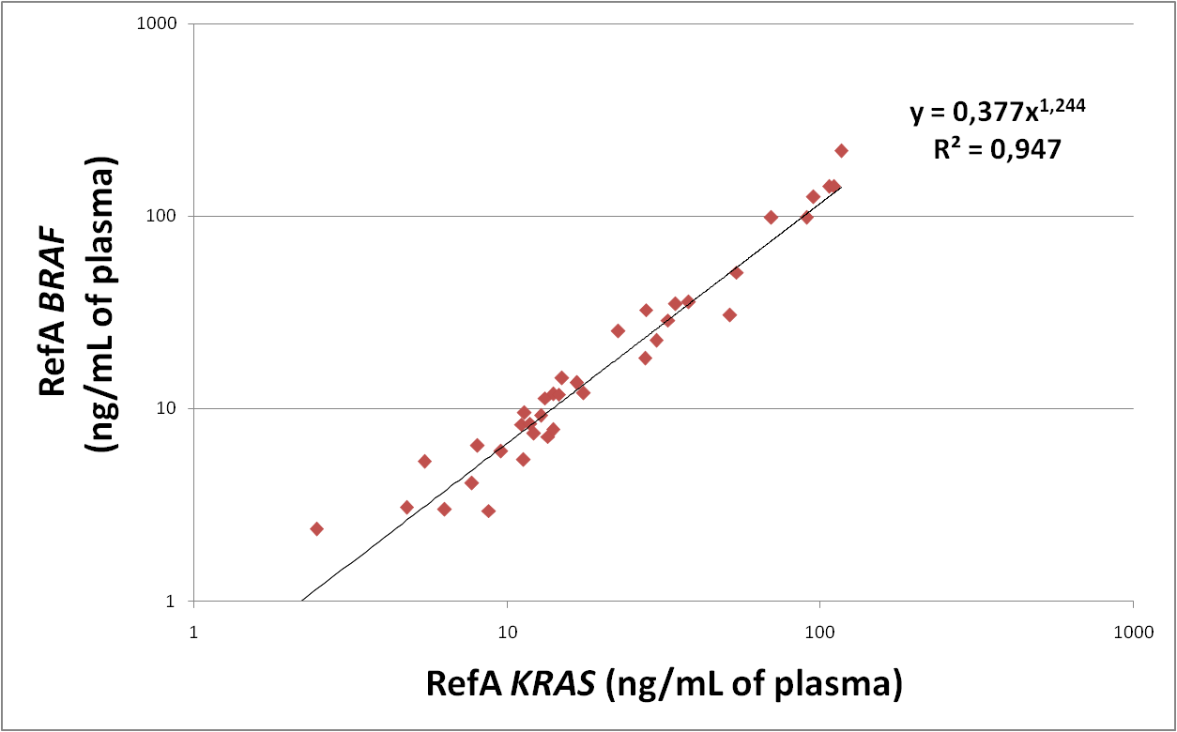

**Legend Supplemental Figure S3A: Total concentration of cfDNA (RefA) at baseline as determined by targeting *BRAF* and *KRAS* wild type sequence.** Before treatments and for both cohorts, total concentration of circulating DNA when targeting short wild type sequence of *KRAS* and *BRAF* genes seems similar. Data are expressed in logarithm and show the robustness of the method.

**B**

**Legend Supplemental Figure S3B: *KRAS/BRAF* ratio before treatment as determined by targeting *BRAF* and *KRAS* wild type sequence.** *KRAS/BRAF* ratio before initiation of treatments (n=41). At baseline *KRAS/BRAF* ratio when targeting short wild type sequences are near 1. Data show the reliability of the method for follow-up of patients during treatments.

**Supplemental Figure S4: RefA values do not differ at baseline between cohorts 1 and 2**



|  |  |
| --- | --- |
| Table Analyzed | RefA values at baseline |
| Column A | Cohorte 2 |
| vs | vs |
| Column B | Cohort 1 |
|  |  |
| Mann Whitney test |  |
| P value | 0,3585 |
| Exact or approximate P value? | Gaussian Approximation |
| P value summary | ns |
| Are medians signif. different? (P < 0.05) | No |
| One- or two-tailed P value? | Two-tailed |
| Sum of ranks in column A,B | 414.5 , 488.5 |
| Mann-Whitney U | 183,5 |

**Supplemental Figure S5: RefA values do not differ at baseline between patients stopped treatment before C4 and others**



|  |  |
| --- | --- |
| Table Analyzed | RefA values |
| Column A | Stopped treatment before C4 |
| vs | vs |
| Column B | Treated at least until C4 |
|  |  |
| Mann Whitney test |  |
| P value | 0,7559 |
| Exact or approximate P value? | Gaussian Approximation |
| P value summary | ns |
| Are medians signif. different? (P < 0.05) | No |
| One- or two-tailed P value? | Two-tailed |
| Sum of ranks in column A,B | 356.5 , 546.5 |
| Mann-Whitney U | 195,5 |

**Supplemental Figure S6: Concentrations of mutant cfDNA do not differ at baseline between cohorts 1 and 2**



|  |  |
| --- | --- |
| Table Analyzed | Concentration of mutant allele (mA) (ng/mL of plasma) |
| Column A | Cohort 2 |
| vs | vs |
| Column B | Cohort 1 |
|  |  |
| Mann Whitney test |  |
| P value | 0,6485 |
| Exact or approximate P value? | Gaussian Approximation |
| P value summary | ns |
| Are medians signif. different? (P < 0.05) | No |
| One- or two-tailed P value? | Two-tailed |
| Sum of ranks in column A,B | 420 , 661 |
| Mann-Whitney U | 226,0 |

**Supplemental Figure S7: Concentration of mutant cfDNA do not differ at baseline between patients stopped treatment before C4 and others**



|  |  |
| --- | --- |
| Table Analyzed | Concentration of mutant allele (mA) (ng/mL of plasma) |
| Column A | Sopped before C4 |
| vs | vs |
| Column B | Treated at least until C4 |
|  |  |
| Mann Whitney test |  |
| P value | 0,1828 |
| Exact or approximate P value? | Gaussian Approximation |
| P value summary | ns |
| Are medians signif. different? (P < 0.05) | No |
| One- or two-tailed P value? | Two-tailed |
| Sum of ranks in column A,B | 456 , 625 |
| Mann-Whitney U | 203,0 |

**Supplemental Figure S8: Mutation load do not differ at baseline between cohorts 1 and 2**



|  |  |
| --- | --- |
| Table Analyzed | Mutation load values (mA%) |
| Column A | Cohort 2 |
| vs | vs |
| Column B | Cohort 1 |
|  |  |
| Mann Whitney test |  |
| P value | 0,7698 |
| Exact or approximate P value? | Gaussian Approximation |
| P value summary | ns |
| Are medians signif. different? (P < 0.05) | No |
| One- or two-tailed P value? | Two-tailed |
| Sum of ranks in column A,B | 404 , 631 |
| Mann-Whitney U | 225,0 |

**Supplementary Figure S9:**

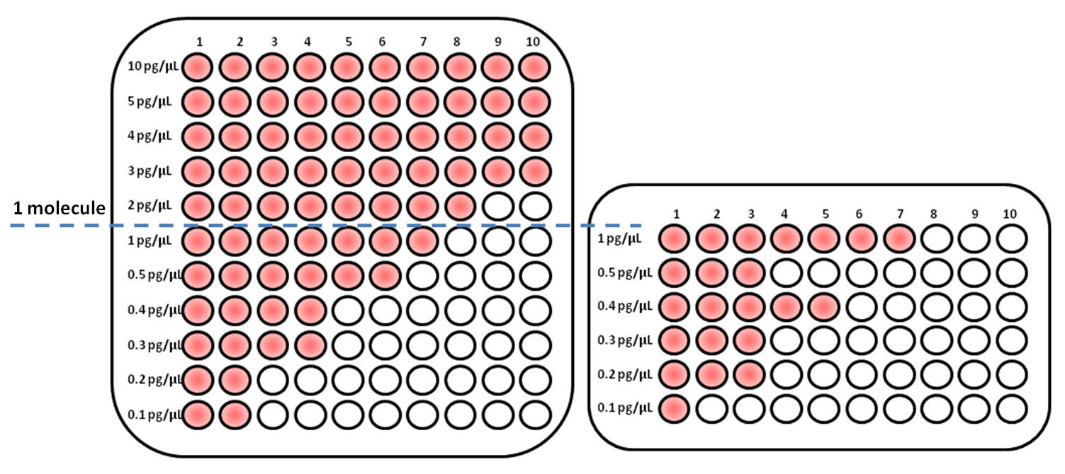

**Legend supplementary Figure S9**: **Validation of point mutation detection/quantification under the Poisson law.** To confirm the validity of our assay in these samples with a mutation found at low concentration we designed a set of experiments to determine whether these findings were due to non-specificity of primers set or if point mutation detection was occurring by a Poisson law distribution due to the low concentration. After extraction of cfDNA from a patient with a *KRAS G12V* mutation, we created samples with serial dilutions from 10 pg/µL to 0.1pg/µL. For each dilution we created samples with a total volume of 50µL. These serial dilutions were placed in 10 wells, 5µL of sample in each well. We performed the Q-PCR with two thermocyclers, LC480 (Roche) (A) and CFX96 (Bio-Rad) (B). Our findings show that IntPlex can detect *KRAS G12V* mutant fragments in 100% of cases (10/10) in dilutions 10pg/µl to 3 pg/µL. Theoretically, presence of one targeted sequence copy in all wells would correspond to 1.5 pg/mL DNA, and consequently concentrations below this concentration obey to Poisson law distribution. At concentrations below 1 pg/ µL, 70% (7/10) of mutations could be detected and at concentrations of 0.1pg/µL, 10% (1/10) of mutations could be detected. Our results suggest that IntPlex follows a Poisson distribution for detection of low frequency mutations and that our findings are not due to primer non-specificity.

**Supplemental Figure S10: Illustration of point mutation detection at very low frequency with IntPlex ASB QPCR method in mCRC patients in the study.**

**Melt curves analysis**

Legend:

Blue peaks: Short *KRAS* amplification (quantification of total concentration of cirDNA)

Green peaks: No template control (DNase free water) for the point mutation tested in sample

Red peak: Positive control amplification (cell lines or synthetic DNA) for the point mutation tested in sample

Black peaks: Point mutation amplification in sample

**1/ Case of a discordant patient with lowest mA% calculated (0.03%):**

Patient #34 at baseline: *KRAS G13D* detection by IntPlex method

This patient was scored mutant at baseline in plasma analysis with an allele frequency at **0.03%**

This patient was scored wild type in tumor tissue analysis

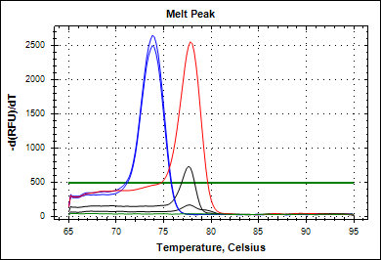

Blue peaks: Short *KRAS* amplification (quantification of total concentration of cirDNA)

Green peaks: No template control (DNase free water) for the point mutation tested in sample

Red peak: Positive control amplification (H3E5 cell line) for the point mutation tested in sample

Black peaks: *KRAS G13D* amplification in patient #34 at baseline

Melt curve analysis:

Tm (°C) of positive control H3E5 cell line: 77.8°C

Tm (°C) of *KRAS G13D* amplification in patient #34 at baseline: 77.6°C

Patient #34 at baseline: *BRAFV600E* detection by IntPlex method

This patient was scored mutant at baseline in plasma analysis with an allele frequency at **0.16%**

This patient was scored wild type in tumor tissue analysis

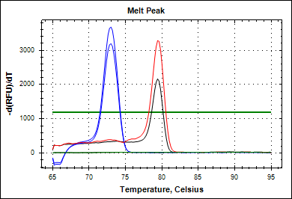

Blue peaks: Short *BRAF* amplification

Green peaks: No template control (DNase free water) for the point mutation tested in sample

Red peak: Positive control amplification (HT 29 cell line) for the point mutation tested in sample

Black peaks: *BRAFV600E* amplification in patient #34 at baseline

Melt curve analysis:

Tm (°C) of positive control HT 29 cell line: 79.4°C

Tm (°C) of *BRAFV600*E amplification in patient #34 at baseline: 79.4°C

**2/ Case of concordant patients with lowest allelic frequency (0.009% and 0.08%):**

**A/** Patient #10 at baseline: *KRAS G13D* detection by IntPlex method

This patient was scored mutant at baseline in plasma analysis with an allele frequency at **0.009%**

This patient was scored mutant *KRAS G13D* in tumor tissue analysis

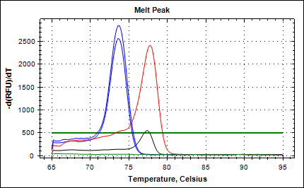

Blue peaks: Short *KRAS* amplification (quantification of total concentration of cirDNA)

Green peaks: No template control (DNase free water) for the point mutation tested in sample

Red peak: Positive control amplification (H3E5 cell line) for the point mutation tested in sample

Black peaks: *KRAS G13D* amplification in patient #10 at baseline

Melt curve analysis:

Tm (°C) of positive control H3E5 cell line: 77.8°C

Tm (°C) of *KRAS G13D* amplification in patient #10 at baseline: 77.4°C

**B/** Patient #21 at baseline: *KRAS G13D* detection by IntPlex method

This patient was scored mutant at baseline in plasma analysis with an allele frequency at **0.08%**

This patient was scored mutant *KRAS G13D* in tumor tissue analysis

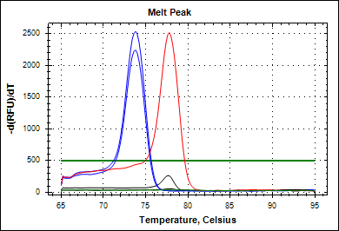

Blue peaks: Short *KRAS* amplification (quantification of total concentration of cirDNA)

Green peaks: No template control (DNase free water) for the point mutation tested in sample

Red peak: Positive control amplification (H3E5 cell line) for the point mutation tested in sample

Black peaks: *KRAS G13D* amplification in patient #21 at baseline

Melt curve analysis:

Tm (°C) of positive control HT 29 cell line: 77.8°C

Tm (°C) of *KRAS G13D* amplification in patient #21 at baseline: 77.6°C