|  |  |  |  |  |
| --- | --- | --- | --- | --- |
| Supplementary Table S1. Baseline Patient Demographic and Clinical Characteristics | | | | |
| Characteristic | LHRHa Plus 12-Week AA  (n = 28) | | LHRHa Plus 24-Week AA  (n = 30 | |
|  | No. | % | No. | % |
| Age, years |  |  |  |  |
| Median | 55.0 | | 60.0 | |
| Range | 50-70 | | 50-74 | |
| High risk (Gleason score ≥ 8 or PSA ≥ 20 ng/mL) | 21 | 75 | 22 | 73 |
| Intermediate risk (Gleason score < 8 or PSA < 20 ng/mL) | 7 | 25 | 8 | 27 |
| Gleason score at baseline |  |  |  |  |
| 7 | 8 | 29 | 10 | 33 |
| 8 | 10 | 36 | 6 | 20 |
| 9 | 10 | 36 | 11 | 37 |
| 10 | 0 | 0 | 3 | 10 |
| PSA at baseline, ng/mL |  |  |  |  |
| Median | 12.1 | | 6.4 | |
| Range | 2.7-316.6 | | 2.0-128.8 | |
| < 10 | 12 | 43 | 20 | 67 |
| 10 to < 20 | 9 | 32 | 6 | 20 |
| ≥ 20 | 7 | 25 | 4 | 13 |
| Elevated PSA velocity[*](javascript:popRef('TF1-1')) | 7 | 30 | 4 | 17 |
| Stage T3 at initial diagnosis | 8 | 29 | 6 | 20 |
| Time from initial diagnosis to first dose, days |  |  |  |  |
| Median | 59 | | 60 | |
| Rang | 20-383 | | 23-113 | |

*Rise in PSA of > 2 ng/mL between any two time points within 12 months preceding diagnostic prostate biopsy.

**Supplementary Figure S1**

A

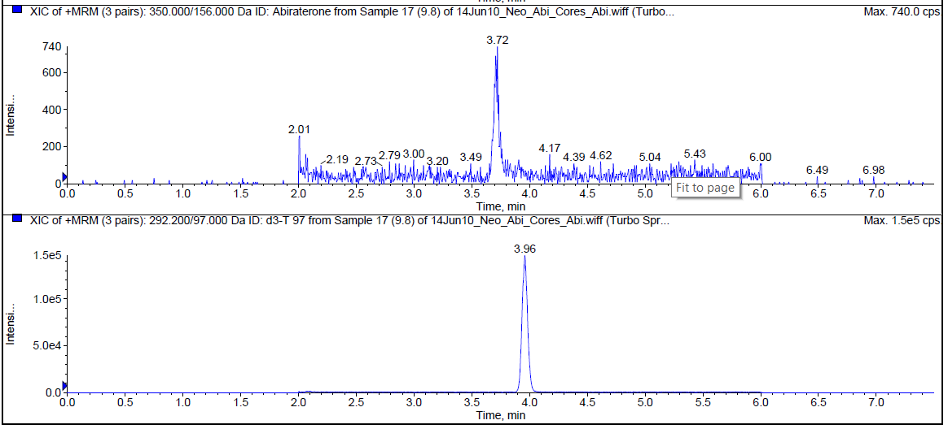

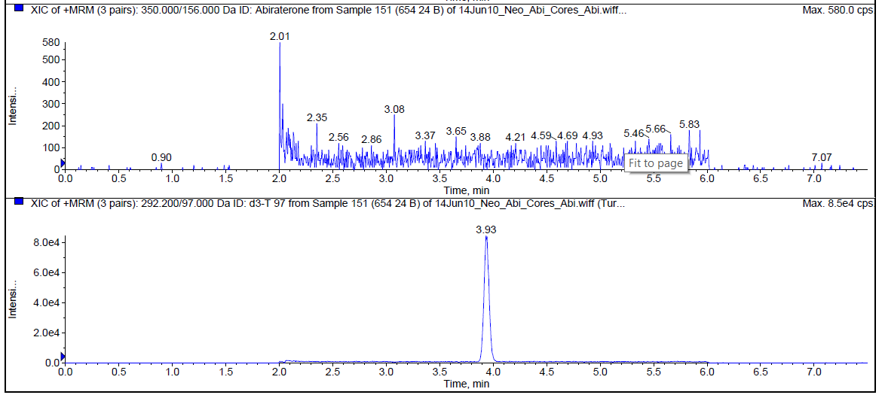

B

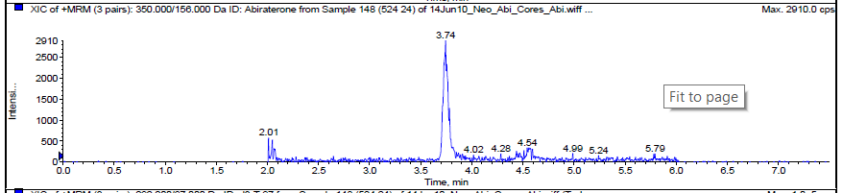

C

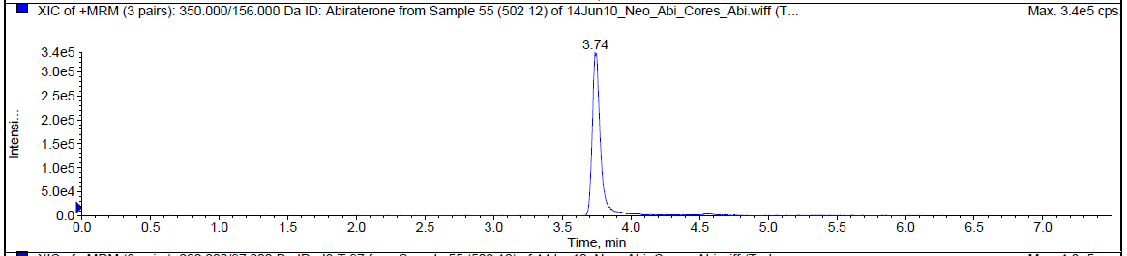

D

**Supplementary Figure S1. Representative chromatograms showing retention time for abiraterone standard and tissue samples.** Analytes were detected using multiple reaction monitoring (MRM), at a characteristic ion dissociation transition of m/z  350.00 → 155.90. The peak and retention time for abiraterone is shown in A) the 9.8pg/sample dilution of the abiraterone standard, and in examples of tissue with B) undetectable, C) intermediate (50 ng/mg), and D) high (1899 ng/mg) abiraterone levels

|  |  |  |  |  |  |  |  |  |
| --- | --- | --- | --- | --- | --- | --- | --- | --- |
| **Supplementary Table S2. Observed and Expected Hardy Weinberg (HW) Frequency of SLCO Genotypes** | | | | | | | | |
| Gene | SNP | Life Tech Primer | Mean Allele Frequency | Allele | n | Frequency | | p value |
| Observed | HW |
| SLCO1B1 | rs4149056 | C__30633906_10 | 0.123 | CC | 3 | 6% | 5% |  |
| CT | 16 | 31% | 33% |  |
| TT | 33 | 63% | 62% | ns |
| SLCO1B1 | rs2306283 | C__901697_20 | 0.405 | GG | 14 | 26% | 22% |  |
| AG | 23 | 43% | 50% |  |
| AA | 17 | 31% | 28% | ns |
| SLCO1B3 | rs60140950 | C__25765255_20 | 0.0781 | CC | 0 | 0% | 1% |  |
| CG | 10 | 19% | 17% |  |
| GG | 44 | 81% | 82% | ns |
| SLCO1B3 | rs4149177 | C__25639181_40 | 0.291 | TT | 3 | 6% | 3% |  |
| GT | 13 | 25% | 30% |  |
| GG | 37 | 70% | 67% | ns |
| SLCO2B1 | rs1077858 | C__27163766_10 | 0.4197 | GG | 8 | 15% | 10% |  |
| AG | 18 | 33% | 43% |  |
| AA | 28 | 52% | 47% | 0.095 |
| SLCO2B1 | rs12422149 | C__3101331_10 | 0.2016 | AA | 1 | 2% | 1% |  |
| AG | 7 | 13% | 15% |  |
| GG | 46 | 85% | 84% | ns |
| SLCO2B1 | rs949069 | C__8750254_10 | 0.3682 | AA | 4 | 8% | 4% |  |
| AG | 12 | 23% | 31% |  |
| GG | 37 | 70% | 65% | 0.058 |
| SLCO2B1 | rs1789693 | C__8750240_20 | 0.4848 | TT | 7 | 13% | 14% |  |
| AT | 26 | 48% | 46% |  |
| AA | 21 | 39% | 40% | ns |
| SLCO2A1 | rs34550074 | C__25747054_10 | 0.2773 | TT | 1 | 2% | 4% |  |
| CT | 19 | 35% | 31% |  |
| CC | 34 | 63% | 65% | ns |
| SLCO3A1 | rs1517618 | C__8719325_10 | 0.1102 | GG | 0 | 0% | 2% |  |
| CG | 16 | 30% | 25% |  |
| CC | 38 | 70% | 73% | ns |
| SLCO4A1 | rs1047099 | C__25650049_10 | 0.1814 | AA | 2 | 4% | 6% |  |
| AG | 21 | 40% | 36% |  |
| GG | 29 | 56% | 58% | ns |
| SLCO5A1 | rs3750266 | C__25805811_10 | 0.4444 | AA | 12 | 22% | 16% |  |
| AG | 19 | 35% | 48% |  |
| GG | 23 | 43% | 36% | 0.0579 |
| SLCO6A1 | rs10055840 | C__30106264_10 | 0.2227 | CC | 2 | 4% | 7% |  |
| CG | 24 | 44% | 38% |  |
| GG | 28 | 52% | 55% | ns |

|  |  |  |
| --- | --- | --- |
| **Supplementary Table S3. Distribution of Men with Undetectable Tissue ABI Levels** | | |
| ABI Status | Lupron 24/ ABI 24 | Lupron 24/ ABI 12 |
| Tissue ND, Serum ND | n=3* | n=3* |
| Tissue ND, Serum detectable | n=1** |  |
| Tissue ND, Serum NA | n=1** |  |
| *Discontinued ABI >1 month prior to surgery (liver abnormalities, n=2; non-compliance, n=2; delay in surgery, n=2)  **Verified to be taking ABI until day of surgery.  ND – not detectable, NA – not available | | |

**Supplementary Figure S2.**

Steroids

Androgens

upstream of CYP17A

Androgens

downstream of CYP17A

A

B



**Supplementary Figure S2. Serum steroid levels in samples with undetectable vs detectable prostate abiraterone levels.** A) Levels of steroids upstream of CYP17A. B) Levels of steroids downstream of CYP17A. Steroid levels measured by mass spectrometry and compared to steroid levels in serum obtained at 12 weeks from patients treated with LHRHa therapy who had not yet started abiraterone treatment (No ABI Rx). Lines represent the median with interquartile range. P values from non-parametric Mann-Whitey t tests.

**Supplementary Figure S3.**



**Supplementary Figure S3. Association of SLCO single nucleotide polymorphisms with serum or tissue steroid levels.** Lines represent the median with interquartile range. P values from non-parametric Mann-Whitey t tests.

**Supplementary Figure S4.**



**Supplementary Figure S4. Absolute abiraterone levels measured in LNCaP cells overexpressing SLCO2B1 or SLCO1B3.** Abiraterone levels (mean and standard deviation) measured in LNCaP cells stably expressing vector control (VC) or the indicated SLCO construct after incubation with abiraterone at 0.5um or 5uM for 4 hours (cell lines denoted 2B (1) and 2B (2) indicate two independently cloned cell lines). Abiraterone levels adjusted to the protein concentration of the cell lysate. P values from un-paired two sample tests between each SLCO expressing cell line and the vector control (VC).

|  |  |  |  |  |  |  |  |  |
| --- | --- | --- | --- | --- | --- | --- | --- | --- |
| **Supplementary Table S4. Characteristics of SLCO Genotypes and Potential Prostate Cancer Associations** | | | | | | | | |
| Gene | SNP | Mean Allele Frequency | Location | Base  Change | Amino Acid Change | Polyphen Score* | Potential Prostate Cancer (PCa)  Related Associations | Reference |
| SLCO1B1 | rs4149056 | 0.123 | Exon | 521T>C | Val174Ala | 1.000 | T>C decreased protein expression | 1 |
| SLCO1B1 | rs2306283 | 0.405 | Exon | 388A>G | Asp130Asn | 0.000 |  |  |
| SLCO1B3 | rs60140950 | 0.078 | Exon | 767G>C | Gly256Ala | 0.998 |  |  |
| SLCO1B3 | rs4149177 | 0.291 | Exon | 334T>G | Ser112Ala | 0.000 | T>G impaired testosterone uptake, longer time to progression on ADT; decreased PCa specific mortality | 2-4 |
| SLCO2B1 | rs1077858 | 0.419 | Intron | A/G | na | na | A>G higher protein expression, shorter TTP on ADT in patients without prior hormone treatment and decreased OS | 5-7 |
| SLCO2B1 | rs12422149 | 0.202 | Exon | 935G>A | Arg312Glu | 0.147 | A>G increased DHEAS uptake in PCa cells, shorter TTP on ADT | 5-7 |
| SLCO2B1 | rs949069 | 0.368 | Intron | A/G | na | na |  |  |
| SLCO2B1 | rs1789693 | 0.485 | Intron | A/T | na | na | Patients with the minor allele (AT or TT) had longer OS from ADT initiation | 5-7 |
| SLCO2A1 | rs34550074 | 0.277 | Exon | 1186C>T | Ala396Thr | 0.001 |  |  |
| SLCO3A1 | rs1517618 | 0.110 | Exon | 882G>C | Asp294Glu | 0.000 |  |  |
| SLCO4A1 | rs1047099 | 0.181 | Exon | 232G>A | Val78Ile | 0.051 |  |  |
| SLCO5A1 | rs3750266 | 0.444 | Exon | 97G>A | Leu33Phe | 0.000 |  |  |
| SLCO6A1 | rs10055840 | 0.223 | Exon | 1961C>G | Thr654Arg | 0.001 |  |  |
| *1 – probably damaging; 0 – probably benign.  na – not applicable.; TTP – time to progression; ADT – androgen deprivation therapy, OS – overall survival | | | | | | | | |

|  |  |  |  |  |  |  |  |  |  |  |  |  |  |  |  |
| --- | --- | --- | --- | --- | --- | --- | --- | --- | --- | --- | --- | --- | --- | --- | --- |
| **Supplementary Table S5. Association of SLCO Genotype with Tissue Abiraterone, Estimated Tumor Volume and Minimal Residual Disease (MRD)** | | | | | | | | | | | | | | | |
| Gene | SNP | Genotype* | | Prostate Tissue Abiraterone Level (pg/mg) | | | | Estimated Tumor  Volume (cm3) | | | | | MRD  (tumor volume <0.5cc) | | |
|  |  |  | N | mean | median | stdev | p | mean | median | stdev | p | N | | % | p |
| SLCO1B3 | rs4149117 | TT / GT | 17 | 45 | 43 | 34 | 0.17 | 2.3 | 1.2 | 2.6 | 0.04 | 4 | | 0.24 | 0.07 |
|  |  | GG | 28 | 123 | 48 | 170 |  | 1.9 | 0.6 | 3.2 |  | 14 | | 0.50 |  |
| SLCO2B1 | rs1789693 | TT | 6 | 34 | 33 | 16 | 0.004 | 0.6 | 0.6 | 0.6 | 0.07 | 3 | | 0.50 | 0.015 |
|  |  | AT | 24 | 65 | 39 | 93 |  | 2.7 | 1.1 | 3.3 |  | 5 | | 0.21 |  |
|  |  | AA | 15 | 172 | 107 | 202 |  | 1.5 | 0.4 | 2.8 |  | 10 | | 0.67 |  |
|  | rs1789693 | TT/ AT | 30 | 59 | 36 | 84 | 0.0008 | 2.3 | 1.0 | 3.1 | 0.11 | 8 | | 0.27 | 0.009 |
|  |  | AA | 15 | 172 | 107 | 202 |  | 1.5 | 0.4 | 2.8 |  | 10 | | 0.67 |  |
| SLCO2B1 | rs12422149 | AA / AG | 7 | 258 | 158 | 269 | 0.03 | 1.4 | 0.7 | 1.5 |  | 3 | | 0.43 |  |
|  |  | GG | 38 | 99 | 44 | 229 |  | 2.1 | 0.9 | 3.2 |  | 15 | | 0.39 |  |
| SLCO2B1 | rs1077858 | GG | 6 | 156 | 42 | 287 |  | 3.9 | 2.6 | 4.3 | 0.06 | 0 | | 0.00 | 0.09 |
|  |  | AG | 16 | 66 | 50 | 62 |  | 2.1 | 0.8 | 3.5 |  | 7 | | 0.44 |  |
|  |  | AA | 23 | 98 | 42 | 128 |  | 1.5 | 0.7 | 1.9 |  | 11 | | 0.48 |  |
|  | rs1077858 | GG | 6 | 156 | 42 | 287 |  | 3.9 | 2.6 | 4.3 | 0.01 | 0 | | 0.00 | 0.03 |
|  |  | AG / AA | 39 | 85 | 48 | 107 |  | 1.7 | 0.7 | 2.7 |  | 18 | | 0.46 |  |
| SLCO2B1 | rs949069 | AA / AG | 14 | 178 | 60 | 224 | 0.12 | 2.2 | 1.7 | 2.0 | 0.12 | 4 | | 0.29 |  |
|  |  | GG | 30 | 57 | 46 | 50 |  | 1.8 | 0.8 | 3.3 |  | 14 | | 0.47 |  |
| SLCO2A1 | rs34550074 | TT / CT | 16 | 102 | 58 | 144 |  | 2.6 | 1.7 | 2.8 | 0.03 | 3 | | 0.19 | 0.03 |
|  |  | CC | 29 | 91 | 40 | 143 |  | 1.7 | 0.4 | 3.0 |  | 15 | | 0.52 |  |
| *In cases where the frequency of the rare homozygote was below 10% it was combined with the heterozygote and only the dichotomized genotype is presented. | | | | | | | | | | | | | | | |

**References**

1. Nozawa T, Suzuki M, Yabuuchi H, et al: Suppression of cell proliferation by inhibition of estrone-3-sulfate transporter in estrogen-dependent breast cancer cells. Pharm Res 22:1634-41, 2005

2. Sharifi N, Hamada A, Sissung T, et al: A polymorphism in a transporter of testosterone is a determinant of androgen independence in prostate cancer. BJU Int 102:617-21, 2008

3. Hamada A, Sissung T, Price DK, et al: Effect of SLCO1B3 haplotype on testosterone transport and clinical outcome in caucasian patients with androgen-independent prostatic cancer. Clin Cancer Res 14:3312-8, 2008

4. Wright JL, Kwon EM, Ostrander EA, et al: Expression of SLCO transport genes in castration resistant prostate cancer and impact of genetic variation in SCLO1B3 and SLCO2B1 on prostate cancer outcomes. Cancer Epidemiol Biomarkers Prev, 2011

5. Yang M, Xie W, Mostaghel E, et al: SLCO2B1 and SLCO1B3 may determine time to progression for patients receiving androgen deprivation therapy for prostate cancer. J Clin Oncol 29:2565-73, 2011

6. Wang X, Harshman LC, Xie W, et al: Association of SLCO2B1 Genotypes With Time to Progression and Overall Survival in Patients Receiving Androgen-Deprivation Therapy for Prostate Cancer. J Clin Oncol 34:352-9, 2016

7. Harshman LC, Wang X, Nakabayashi M, et al: Statin Use at the Time of Initiation of Androgen Deprivation Therapy and Time to Progression in Patients With Hormone-Sensitive Prostate Cancer. JAMA Oncol 1:495-504, 2015