Supplementary Materials

Increasing HER2 Receptors

Fig. S1. MM-302 tumor deposition in preclinical xenografts as a function of HER2 expression. Cancer cells with HER2 receptors level ranging from 0 to 3+ were inoculated in nu/nu or SCID mice at various densities without matrigel. When tumors have reached average volumes of approximately 250 mm³, mice were administered intravenously with 3 mg/kg of MM-302 via tail vein injection. At 24 h post-injection, mice were perfused with 10 mL of phosphate buffered saline to remove vascular MM-302; tumors were collected and snap frozen for high performance liquid chromatography (HPLC) analysis following methods previously described elsewhere (1,2). HER2 receptor number of each cancer cell line was measured by quantitative fluorescence activated cell sorting using an anti-HER2 antibody and Quantum Simply Cellular microspheres as reported elsewhere (3). There was no correlation trend between MM-302 gross tumor deposition and HER2 receptor levels.

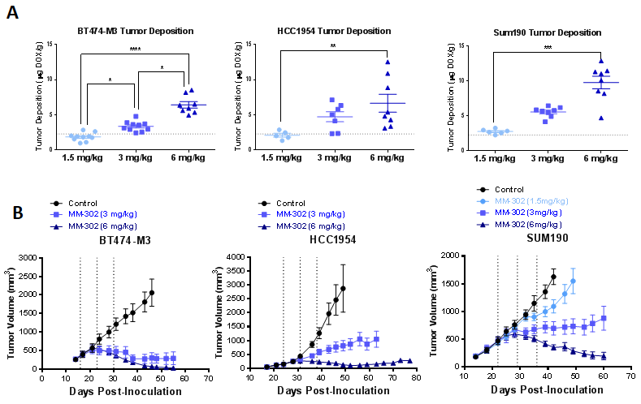

Fig. S2. Preclinical assessment of minimum ⁶⁴Cu-MM-302 tumor delivery for anti-tumor activity. Mice bearing HER2-positive breast xenograft tumors were treated with 1.5 mg/kg, 3 mg/kg, or 6 mg/kg of MM-302. (A) Tumor deposition of MM-302 at 24 h post-injection was quantified via gamma-counting and HPLC analysis, respectively, as previously reported (4) at all 3 dose levels. The local drug concentrations were found to increase proportionally as the doses administered increases. (B) Dose-response relationship is illustrated by evaluating tumor growth inhibition for 3 treatment cycles (q1w, represented by vertical dashed lines) and beyond over 20 days post third dose. Tumor volumes were measured twice weekly for approximately 60 days thereafter. Animal studies were carried out following the NIH Guide for the Care and Use of Laboratory Animals, as well as guidelines approved by the Institutional Animal Care and Use Committee (IACUC). * p ≤ 0.05; ** p ≤ 0.01; *** p ≤ 0.001, **** p ≤ 0.0001 (Kruskal-Wallis rank test)

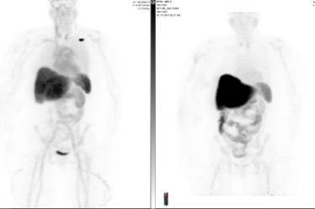
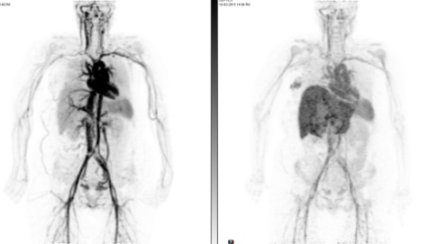
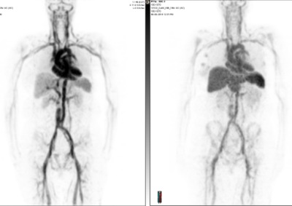
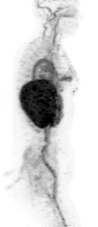
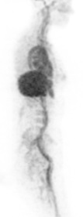
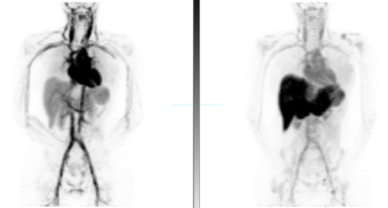
Patient 13 (+ cyclo)
Rapid clearance
Patient 07 (no cyclo)
Average clearance
0 % i.d./kg
14 % i.d./kg
Patient 17 (+ cyclo)
Average clearance
Scan 1 on Day 1
Scan 2 on Day 2
Patient 15 (no cyclo)
Rapid clearance
Scan 1 on Day 1
Scan 2 on Day 2
Arm 4 (+ Cyclophosphamide)
Arm 3 (no Cyclophosphamide)
Average Clearance
Rapid Clearance

Fig. S3. Maximum intensity projection images of selected patients with average and rapid clearance of ⁶⁴Cu-MM-302. Patients with rapid clearance of ⁶⁴Cu-MM-302 have significantly higher sequestration of ⁶⁴Cu-MM-302 in the liver compared to those who have average clearance, and does not seem to be attributed to the cyclophosphamide treatment.

B.
A.

Fig. S4. Stability of ⁶⁴Cu-MM-302 in patients. Stability of ⁶⁴Cu labeling of MM-302 was assessed in 3 patients. Blood samples were collected at various time points on Day 1, 2, and 3 after ⁶⁴Cu-MM-302 administration. (A) ⁶⁴Cu radioactivity was quantified in whole blood, serum, lymphocytes, macrophages, and red blood cells. (B) Serum and size exclusion chromatography was used to determine the amount of liposome-associated ⁶⁴Cu vs. released ⁶⁴Cu using methods previously reported (4). ⁶⁴Cu radioactivity was primarily found in the serum with minimal activity detected in the blood cells. A representative example of the elution profile of a serum sample collected at 44 h post-⁶⁴Cu-MM-302 administration is shown, in which the majority of the ⁶⁴Cu radioactivity was recovered in the liposomal fractions.

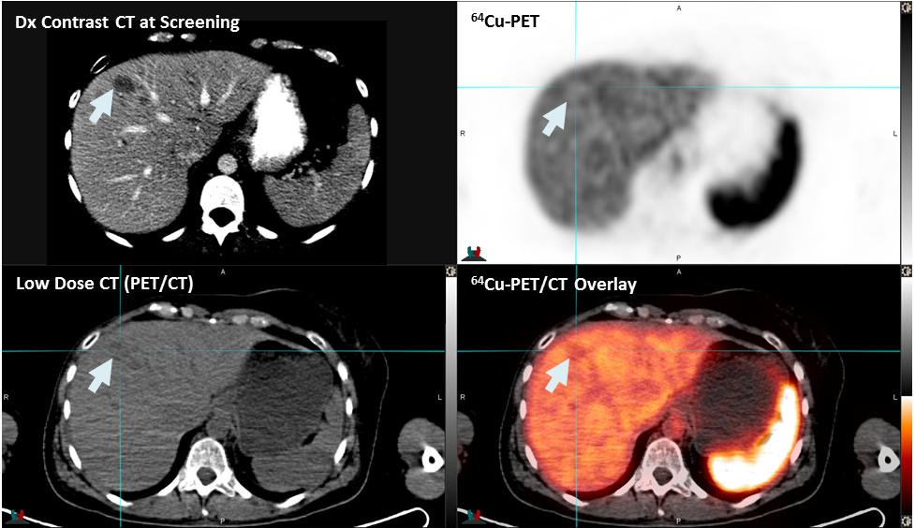

Fig. S5. Hepatic tumor lesion with similar uptake as normal liver tissue. An example of a hepatic lesion with uptake similar to that of normal liver tissue. Diagnostic contrast CT image (top left) was utilized to aid identification of lesion boundary for ROI selection. PET signal scale bars represent ⁶⁴Cu activity ranging from 0 to 20 %ID/kg (decay-corrected).

Fig. S6. Estimated parameter values (k₁, k₋₁, VVF) for lesions from 3 patients who underwent 3 scans. The rates of washout were not identifiable (effectively zero) for 3 lesions (not plotted on log-scale figure).

Parameter | Description | Value | Units | Reference
V_{c} | Blood volume | Fit to data | L
k_{el} | Rate constant for elimination of liposome from blood | Fit to data | 1/min
V_{t} | Tumor volume | Measured from images | L
VVF | Vascular volume fraction |  | Dimensionless
Q | Blood flow rate into tumor per unit tissue | 0.0282 | L/min/kg | (5)
r | Tissue density | 1 | kg/L
k₁ | Permeability surface area product per unit tissue for transport from tumor capillary into tumor tissue | Fit to data | L/min/kg
k₋₁ | Permeability surface area product per unit tissue for transport out of tumor tissue into tumor capillary | Fit to data | L/min/kg

Table S1. Model parameters for tracer kinetic modeling of ⁶⁴Cu-MM-302 liposome transport into and out of tumors.

 |  |  | Total (N = 19)
Age | Median, years (range) |  | 54.9 (41-71)
Gender | Male, n (%) |  | 0 (0)
 | Female, n (%) |  | 19 (100)
Race | American Indian or Alaska Native, n (%) |  | 0 (0)
 | Asian, n (%) |  | 0 (0)
 | Black or African American, n (%) |  | 2 (10.5)
 | Caucasian, n (%) |  | 17 (89.5)
 | Native Hawaiian or other Pacific Islander, n (%) |  | 0 (0)
 | Other, n (%) |  | 0 (0)
Ethnicity | Hispanic or Latino, n (%) |  | 0(0)
 |  | Non-Hispanic or Non-Latino, n (%) | 19 (100)

Table S2. Patient Demographic (n=19).

Target Organ | mGy/MBq | CV*
Heart Wall | 0.280 | 42.6%
Spleen | 0.149 | 52.4%
Liver | 0.116 | 50.6%
Urinary Bladder Wall | 0.096 | 48.6%
Gallbladder Wall | 0.037 | 28.2%
Osteogenic Cells | 0.032 | 15.7%
Pancreas | 0.024 | 15.0%
Adrenals | 0.023 | 17.1%
Kidneys | 0.020 | 16.3%
Stomach Wall | 0.020 | 13.6%
Uterus | 0.020 | 10.7%
ULI Wall | 0.019 | 15.7%
Lungs | 0.019 | 14.4%
Thymus | 0.019 | 13.0%
Small Intestine | 0.019 | 14.9%
Ovaries | 0.018 | 13.3%
LLI Wall | 0.018 | 13.2%
Muscle | 0.017 | 14.4%
Breasts | 0.016 | 14.1%
Thyroid | 0.016 | 15.8%
Testes | 0.016 | 14.1%
Red Marrow | 0.015 | 14.4%
Brain | 0.014 | 16.3%
Skin | 0.014 | 15.4%
Total Body | 0.021 | 15.3%
Effective Dose (mSv/MBq) | 0.028 | 10.9%

*Coefficient of variation

Table S3. Radiation Dosimetry of ⁶⁴Cu-MM-302 (n=11).

References for Supplementary Materials
1. Geretti E, Leonard SC, Dumont N, Lee H, Zheng J, De Souza R, et al. Cyclophosphamide-Mediated Tumor Priming for Enhanced Delivery and Antitumor Activity of HER2-Targeted Liposomal Doxorubicin (MM-302). Mol Cancer Ther. 2015;14:2060–71.
2. Reynolds JG, Geretti E, Hendriks BS, Lee H, Leonard SC, Klinz SG, et al. HER2-targeted liposomal doxorubicin displays enhanced anti-tumorigenic effects without associated cardiotoxicity. Toxicol Appl Pharmacol. 2012;262:1–10.
3. Hendriks BS, Klinz SG, Reynolds JG, Espelin CW, Gaddy DF, Wickham TJ. Impact of tumor HER2/ERBB2 expression level on HER2-targeted liposomal doxorubicin-mediated drug delivery: multiple low-affinity interactions lead to a threshold effect. Mol Cancer Ther. 2013;12:1816–28.
4. Lee H, Zheng J, Gaddy D, Orcutt KD, Leonard S, Geretti E, et al. A gradient-loadable (64)Cu-chelator for quantifying tumor deposition kinetics of nanoliposomal therapeutics by positron emission tomography. Nanomedicine. 2014;1–11.
5. Baxter LT, Zhu H, Mackensen DG, Butler WF, Jain RK. Biodistribution of monoclonal antibodies: scale-up from mouse to human using a physiologically based pharmacokinetic model. Cancer Res. 1995;55:4611–22.

