Supplemental Table 1. Patient characteristics of all six individuals with MDM2/4 amplifications who received immunotherapy.

Case # | Cancer diagnosis | Age/Sex | Genomic alterations | PD-L1 status (IHC) | Immunotherapy | Time-to-treatment failure | Response by imaging
1 | Bladder cancer | 73/ Men | MDM2 amplification  AKT2 amplification  BRIP1 truncation exon 19  PIK3CA H450_V461 > GS  RAF1 amplification ocal)  MYC amplification (equivocal)  RNF43 S262*  ARID2 S889*  FRS2 amplification | Negative  (22C3 antibody) | Atezolizumab  (anti-PD-L1) | 1.9 months. | 258% increase from pre-immunotherapy imaging.  7.2-fold increase in progression pace compared to 2 months before therapy.
2 | Breast cancer (triple negative) | 44/ Women | MDM2 amplification  PTCH1 T416S  TP53 S127Y | Negative  (SP142 antibody) | Pembrolizumab  (anti-PD-1) | 1.5 months. | 55% increase from pre-immunotherapy imaging.  42.3-fold change in pace of progression compared to the 2 months before immunotherapy
3 | Endometrial stromal sarcoma | 65/ Women | Profiling from initial surgical sample:  CDKN2A R58* p14ARF P72L  ZC3H7B-BCOR Fusion  Profiling from liver mass biopsy 2 weeks after nivolumab:  MDM2 amplification  CDKN2A R58* p14ARF P72L  FRS2 amplification  Profiling from new abdominal mass biopsy 2 months after nivolumab:  MDM2 amplification  CDKN2A R58* p14ARF P72L  ZC3H7B-BCOR fusion  FRS2 amplification | Negative  (SP142 antibody) | Nivolumab  (anti-PD-1) | 1.5 months. | 242% increase from pre-immunotherapy imaging.  ~2.3 fold increase in rate of progression compared to the 2 months before immunotherapy
4 | Adenocarcinoma of lung | 50/ Women | MDM2 amplification  KIF5B-RET fusion | Not tested. | Pembrolizumab  (anti-PD-1) | 0.3 months. | 135% increase from pre-immunotherapy imaging.  7.1-fold increase in progression pace compared to 2 months before therapy
5 | Adenocarcinoma of lung | 61/ Men | MDM2 amplification  CDK4 amplification | Not tested. | Pembrolizumab  (anti-PD-1) | 1.2 months. | Target lesions were stable. However, new brain metastases were found.
6 | Squamous cell carcinoma of hypopharynx | 62/ Men | MDM4 amplification  EGFR amplification  FGFR1 amplification  KRAS amplification  PIK3CA amplification  CDKN2A/B loss  IKBKE amplification (equivocal)  MYC amplification  NTRK1 M375I  SOX2 amplification  TP53 D259fs*2, Y220C  BCL2L2 amplification  CUL3 splice site 379-1G>T  NFKBIA amplification  NKX2-1 amplification  PIK3C2B amplification  ZNF703 amplification | Not tested. | Investigational immunotherapeutic agent (OX40 agonist) | 1.4 months. | Stable disease on scan.  However had rapid clinical progression.

Abbreviations: IHC = immunohistochemistry

Supplemental Table 2. Patient characteristics among patients who received anti-PD-1/PD-L1 (N = 102) ¹.
Variables | All  (N=102) | TTF  <2 months (N=39) | TTF  ≥2 months (N=63) | Odds- ratio *  (95% CI)  (Univariate) | p-value *  (Univariate) | Odds- ratio #  (95% CI)  (Multivariate) | p-value #  (Multivariate) | p-value §  (Bootstrap)
Age ≤ 65 years | 64 (62.7%) | 24 (61.5%) | 40 (63.5%) | 0.92 (0.42-2.10) | >0.9999
Age > 65 years | 38 (37.3%) | 15 (38.5%) | 23 (36.5%)
Cancer diagnosis
Non-small cell lung cancer | 38 (37.3%) | 18 (46.2%) | 20 (31.7%) | 1.84 (0.83-4.13) | 0.21
Squamous cell carcinoma of head and Neck | 9 (8.8%) | 2 (5.1%) | 7 (11.1%) | 0.43 (0.09-2.20) | 0.48
Cutaneous squamous cell carcinoma | 9 (8.8%) | 0 (0) | 9 (14.3%) | <0.18 (0.02-1.31) ¶ | 0.012 | 0.74 (0-6.31) | 0.83 | 0.001
Melanoma | 6 (5.9%) | 1 (2.6%) | 5 (7.9%) | 0.31 (0.03-2.40) | 0.40
Renal cell carcinoma | 5 (4.9%) | 2 (5.1%) | 3 (4.8%) | 1.08 (0.19-5.49) | >0.9999
Genomic alterations
TP53 | 50 (49.0%) | 20 (51.3%) | 30 (47.6%) | 1.16 (0.50-2.47) | 0.84
CDKN2A/B | 25 (24.5%) | 9 (23.1%) | 16 (25.4%) | 0.88 (0.37-2.10) | >0.9999
TERT | 17 (16.7%) | 5 (12.8%) | 12 (19.0%) | 0.63 (0.23-1.80) | 0.59
LRP1B | 13 (12.7%) | 2 (5.1%) | 11 (17.5%) | 0.26 (0.06-1.20) | 0.12
KRAS | 10 (9.8%) | 2 (5.1%) | 8 (12.7%) | 0.37 (0.08-1.70) | 0.31
NOTCH1 | 10 (9.8%) | 0 (0) | 10 (15.9%) | <0.16 (0.01-1.07) ¶ | 0.012 | 0.47 (0-3.16) | 0.54 | 0.001
PIK3CA | 10 (9.8%) | 4 (10.3%) | 6 (9.5%) | 1.09 (0.33-3.90) | >0.9999
MLL2 | 9 (8.8%) | 1 (2.6%) | 8 (12.7%) | 0.18 (0.02-1.30) | 0.15
EGFR | 8 (7.8%) | 7 (17.9%) | 1 (1.6%) | 13.6 (2.20-154.8) | 0.005 | 11.8 (1.40-560.5) | 0.02 | 0.014
MYC | 8 (7.8%) | 4 (10.3%) | 4 (6.3%) | 1.69 (0.46-6.06) | 0.48
PTEN | 8 (7.8%) | 2 (5.1%) | 6 (9.5%) | 0.51 (0.10-2.20) | 0.71
BRAF | 7 (6.9%) | 4 (10.3%) | 3 (4.8%) | 2.29 (0.58-9.41) | 0.42
PTCH1 | 7 (6.9%) | 1 (2.6%) | 6 (9.5%) | 0.25 (0.02-1.67) | 0.25
Variables | All  (N=102) | TTF  <2 months (N=39) | TTF  ≥2 months (N=63) | Odds- ratio *  (95% CI)  (Univariate) | p-value *  (Univariate) | Odds- ratio #  (95% CI)  (Multivariate) | p-value #  (Multivariate) | p-value §  (Bootstrap)
ASXL1 | 6 (5.9%) | 0 (0) | 6 (9.5%) | <0.3 (0.03-2.43) ¶ | 0.08 | 0.47 (0-3.16) | 0.54 | 0.34
ATM | 6 (5.9%) | 2 (5.1%) | 4 (6.3%) | 0.8 (0.15-3.57) | >0.9999
CTNNB1 | 6 (5.9%) | 2 (5.1%) | 4 (6.3%) | 0.8 (0.15-3.57) | >0.9999
GNAS | 6 (5.9%) | 1 (2.6%) | 5 (7.9%) | 0.31 (0.03-2.43) | 0.4
NF1 | 6 (5.9%) | 1 (2.6%) | 5 (7.9%) | 0.31 (0.03-2.43) | 0.4
NOTCH2 | 6 (5.9%) | 2 (5.1%) | 4 (6.3%) | 0.8 (0.15-3.57) | >0.9999
RB1 | 6 (5.9%) | 3 (7.7%) | 3 (4.8%) | 1.67 (0.37-7.40) | 0.67
RET | 6 (5.9%) | 3 (7.7%) | 3 (4.8%) | 1.67 (0.37-7.40) | 0.67
SETD2 | 6 (5.9%) | 2 (5.1%) | 4 (6.3%) | 0.8 (0.15-3.57) | >0.9999
SMAD4 | 6 (5.9%) | 2 (5.1%) | 4 (6.3%) | 0.8 (0.15-3.57) | >0.9999
APC | 5 (4.9%) | 2 (5.1%) | 3 (4.8%) | 1.08 (0.19-5.49) | >0.9999
ARID1A | 5 (4.9%) | 1 (2.6%) | 4 (6.3%) | 0.39 (0.03-2.52) | 0.65
ARID2 | 5 (4.9%) | 1 (2.6%) | 4 (6.3%) | 0.39 (0.03-2.52) | 0.65
BRCA2 | 5 (4.9%) | 2 (5.1%) | 3 (4.8%) | 1.08 (0.19-5.49) | >0.9999
CREBBP | 5 (4.9%) | 0 (0) | 5 (7.9%) | <0.39 (0.03-2.52) ¶ | 0.15
FGFR1 | 5 (4.9%) | 2 (5.1%) | 3 (4.8%) | 1.08 (0.19-5.49) | >0.9999
MCL1 | 5 (4.9%) | 1 (2.6%) | 4 (6.3%) | 0.39 (0.03-2.52) | 0.65
MDM2 | 5 (4.9%) | 5 (12.8%) | 0 (0) | >7.09 (1.08-87.8) ¶ | 0.007 | 11.1 (1.95-infinity) | 0.02 | 0.001
STK11 | 5 (4.9%) | 1 (2.6%) | 4 (6.3%) | 0.39 (0.03-2.52) | 0.65
ZNF217 | 5 (4.9%) | 0 (0) | 5 (7.9%) | <0.39 (0.03-2.52) ¶ | 0.15
DNMT3A | 4 (3.9%) | 3 (7.7%) | 1 (1.6%) | 5.17 (0.74-68.0) | 0.15

* Odds-ratio and p-value by Fisher's exact test.
# Odds-ratio and p-value by exact conditional logistic regression (multivariate) analysis. Included characteristics with p-value ≤ 0.1 from univariate analysis.
§ Bootstrapping with multiple logistic regression analysis was conducted on characteristics with p-value ≤ 0.1 from univariate analysis. p-value based on 989 bootstrap samples.
¶ If a variable dichotomized as N versus zero, and the odds ratio is thus zero or infinity, we adjusted the events to be 1 (instead of zero) versus N-1. This produces a numerical odds ratio, which is less than the actual infinite odds ratio. For example, for MDM2, where there were N = 5 versus zero patients with TTF<2 versus ≥2 months, the actual odds ration is infinity. Using the adjustment above, the numeric odds ratio for N=4 versus one patient is 7.09 and we list it as “>7.09.” The p-value shown is the actual p-value for the unadjusted numbers.

¹ Included variables with N ≥ 5, except for DNMT3A (N=4).
Abbreviations: CI = confidence interval; TTF = time-to-treatment failure.

Supplemental Table 3. Patients with EGFR alterations and TTF less than 2 months on immunotherapy (N=8 of a total of 10 patients with EGFR alterations).

Case # | Cancer diagnosis | Age/Sex | Genomic alterations | PD-L1 status (IHC) | Immunotherapy | Time-to-treatment failure | Response by imaging
7 | Squamous cell carcinoma of unknown primary | 56/Men | EGFR amplification  BRCA2 W1692fs*3  BRIP1 T733fs*4  MLH1 loss exons 12-19  PTEN R173C, S229*, splice site 1027-  2A>G  ARID1A Q1334_R1335insQ  CDKN2A/B loss  MEN1 R521fs*15  MSH6 F1088fs*5  PIK3CB E1051K  BAP1 Q441*  CHD2 V175fs*1  CIC P786fs*138  CTCF E363fs*5  CTNNA1 A784T  EP300 Q128*  HNF1A G292fs*25  JAK1 K860fs*16, P430fs*2  MLL2 P647fs*283, R2105H  MLL3 K2797fs*26  TP53 R282W | Negative  (SP142 antibody) | Pembrolizumab  (anti-PD-1) | 0.7 months. | 3% decrease from pre-immunotherapy imaging.
8 | Glioblastoma | 62/Men | EGFR amplification, EGFR vIVa  CDKN2A loss p16INK4a and p14ARF exons 2-3  PIK3R1 N453del  QKI E135fs*5  SETD2 splice site 5016-2_5018delAGAAA  TERT promoter -124C>T | Negative  (22C3 antibody) | Nivolumab  (anti-PD-1) | 0.8 months. | 2.4 % increase from baseline imaging.
9 | Squamous cell carcinoma of lung | 64/Men | EGFR amplification  PIK3CA amplification  CCND1 amplification  MCL1 amplification  TP53 splice site 560-7_561del9  FGF19 amplification  FGF3 amplification  FGF4 amplification  SOX2 amplification | Not tested. | Nivolumab  (anti-PD-1) | 0.8 months. | 30% increase from pre-immunotherapy imaging.
10 | Squamous cell cancer of hypopharynx | 62/Men | EGFR amplification  FGFR1 amplification  KRAS amplification  PIK3CA amplification  CDKN2A/B loss  IKBKE amplification (equivocal)  MDM4 amplification  MYC amplification  NTRK1 M375I  SOX2 amplification  TP53 D259fs*2, Y220C  BCL2L2 amplification  CUL3 splice site 379-1G>T  NFKBIA amplification  NKX2-1 amplification  PIK3C2B amplification  ZNF703 amplification | Not tested. | Investigational immunotherapeutic agent (OX40 agonist) | 1.4 months. | Stable disease (0%) from pre-immunotherapy imaging.
11 | Adenocarcinoma of lung | 54/Men | EGFR E746_A750del, T790M  AKT1 amplification  CDKN2A/B loss  TP53 R248W  NFKBIA amplification  NKX2-1 amplification | Not tested. | Nivolumab  (anti-PD-1) | 1.1 months. | 125% increase from pre-immunotherapy imaging.  (3% increase from baseline to pre-immunotherpay). 41.7 fold increase in progression pace.
12 | Adenocarcinoma of lung | 44/Men | EGFR E746_A750del  MET amplification  CDK6 amplification  MYC amplification  RICTOR amplification  TP53 R248W  FGF10 amplification | Not tested. | Clinical trial with anti-PD-1 antibody | 1.6 months. | 18% increase from pre-immunotherapy imaging.
13 | Adenocarcinoma of lung | 73/Man | EGFR amplification, L858R, T790M  MITF amplification  TP53 C238_N239>*VGSDCTTIHYNYMC  FOXP1 amplification  NFKBIA amplification  NKX2-1 amplification  NOTCH2 P6fs*27 | Negative  (22C3 antibody) | Nivolumab  (anti-PD-1) | 1.7 months. | 53.6% increase from pre-immunotherapy imaging.  (Only 1.5% increase from 2 month pre-therapy baseline scan to pre-immunotherapy scan).  35.7-fold increase in the pace of progression.
14 | Renal cell carcinoma | 44/Man | EGFR I1060fs*18  VHL R120G  PIK3CA E545A  ERRFI1 loss  CDKN2A/B loss  BAP1 M231fs*11  TNFRSF14 loss | Not tested. | Nivolumab  (anti-PD-1) | 0.6 months. | Clinical progression with respiratory failure from known lung metastases. No imaging available to evaluate the response.

Abbreviations: IHC = immunohistochemistry

Supplemental Table 4. Patients with DNM3TA alterations and TTF less than 2 months on immunotherapy (N=4 of a total of 5 patients with DNM3TA alterations).

Case # | Cancer diagnosis | Age/Sex | Genomic alterations | PD-L1 status (IHC) | Immunotherapy | Time-to-treatment failure | Response by imaging
15 | Cutaneous melanoma | 70/Man | DNMT3A P718L  KDR R1032Q  NRAS Q61H  PDGFRA E459K  CDKN2A R80*  MCL1 amplification  TP53 S241F  ARID1A Y1377*  EPHA3 G766E  FGFR2 W156*  RAD50 Q689* | Not tested. | Ipilimumab (anti-CTLA-4) | 1.4 months. | 182% increase from 2 months prior to immunotherapy. No imaging just prior to the initiation of immunotherapy was available.
16 | Cutaneous melanoma | 59/Man | DNMT3A R882H  BRAF V600K  MYD88 L265P  TERT promoter -124C>T | Not tested. | Pembrolizumab  (anti-PD-1) | 7 days. | Clinical progression (Overall stable brain metastases per imaging).
17 | Adenocarcinoma of lung | 57/Woman | BRAF V600E  DNMT3A R882H  TP53 D281Y, Q331* | Positive (Percent staining: 80%)  (22C3 antibody) | Nivolumab  (anti-PD-1) | 4 days. | No serial imaging available. Four days after nivolumab, patient was admitted for hydropneumothorax, and subsequently died 9 days after the therapy.
18 | Adenocarcinoma of lung | 72/ Woman | RET CCDC6-RET fusion  TP53 H193R  DNMT3A splice site 2478+1G>A  LRP1B D2600Y  NFE2L2 R18Q | Not tested. | Nivolumab  (anti-PD-1) | 7 days. | No serial imaging available. Seven days after the initiation of nivolumab, patient was admitted for respiratory and kidney failure. Subsequently deceased 17 days after the therapy.

Supplemental Figure legend.

Supplemental Figure 1. Evaluation of tumor biopsy at the time of progression (Case #4).
Two months after the initiation of nivolumab, tumor biopsy was obtained from the rapidly emerging abdominal mass which revealed high-grade endometrial stromal sarcoma (red arrow) with scattered apoptotic bodies (black arrow). However there was no finding suggestive of pseudoprogression including lymphocyte infiltration or tumor necrosis (Hematoxylin and eosin, 200x magnification).

Supplemental Figure 2.

Supplemental Figure 2.A.
Case #11:
54 year old man with metastatic adenocarcinoma of lung. Genomic profiling revealed aberrations including EGFR E746_A750del and T790M. After progressing on standard chemotherapy and anti-EGFR therapies (3% increase in last two months before immunotherapy), patient was started on nivolumab. However, 1.1 months after starting on nivolumab, patient was found to have worsening shortness of breath. Imaging revealed progression of thoracic lymphadenopathy as well as new liver metastases (125% increase; 41.7-fold increase in progression pace.) and taken off from therapy.

Supplemental Figure 2.B.
Case #13:
73 year old man with adenocarcinoma of lung. Molecular profiling showed EGFR amplification, L858R and T790M. After progressing on chemotherapy and anti-EGFR therapies, patient was started on nivolumab (1.5% increase in tumor size in the two months before immunotherapy). Restaging scan 1.7 months after the initiation of nivolumab showed disease stability of lung mass but progression of target liver mass as well as new liver metastases (53.6% increase; 35.7-fold increase in the pace of progression.). Nivolumab was therefore stopped.

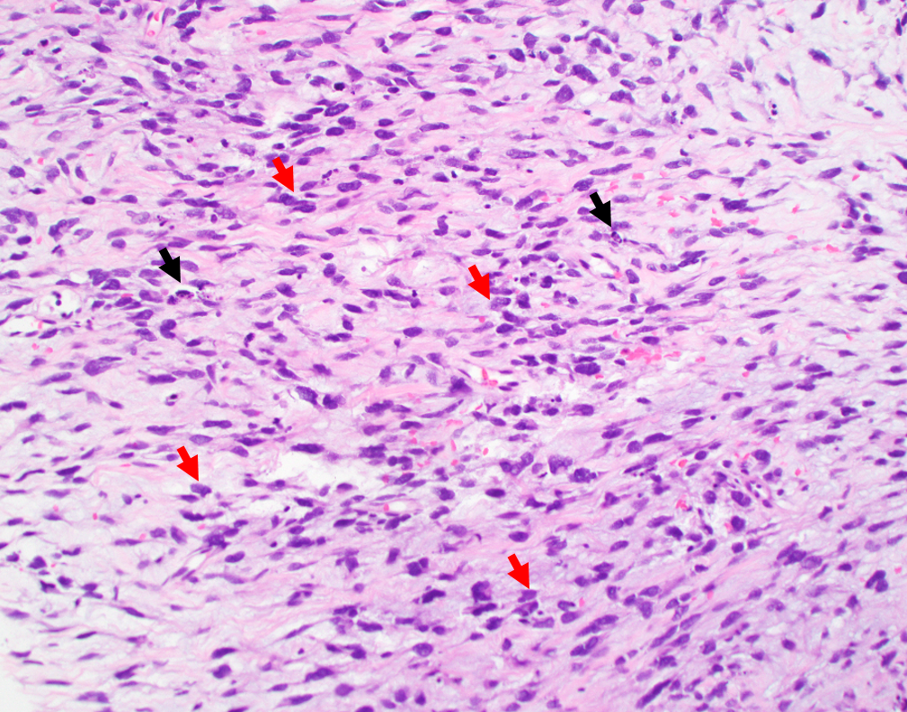
Supplemental Figure 1. Evaluation of tumor biopsy at the time of progression (Case #4).

Supplemental Figure 2.
Supplemental Figure 2.A. Case #11
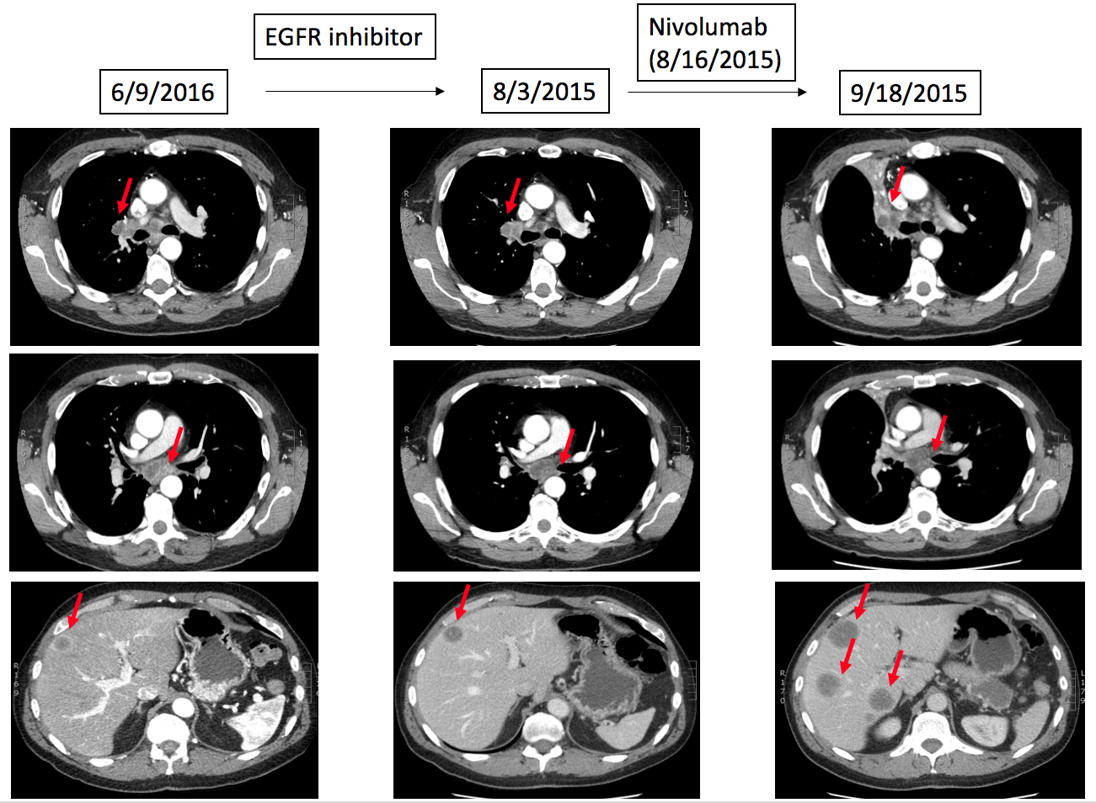

Supplemental Figure 2.B. Case #13
