# Supplementary Appendix

## **Figure S1.**

Rucaparib plasma concentration-time profiles following once daily oral administration. Error bars represent standard deviation (SD).

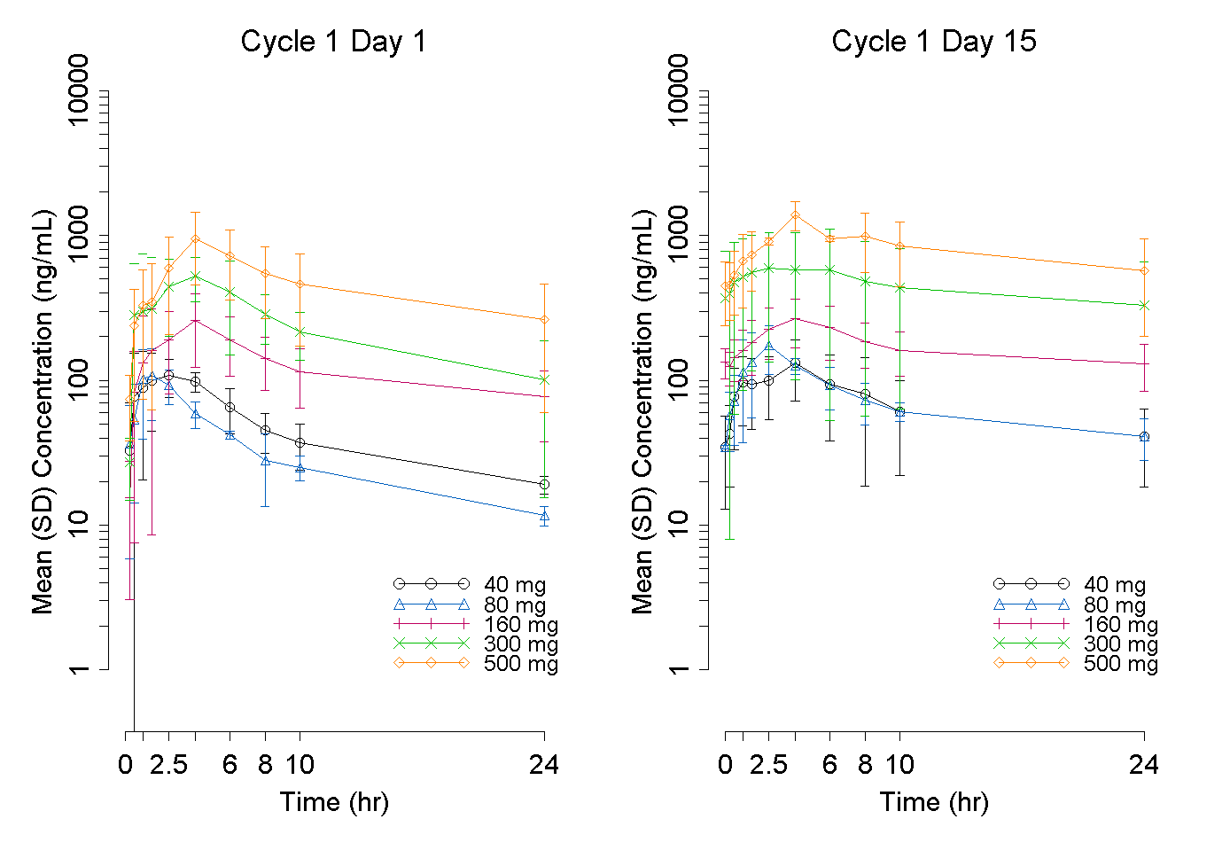

## **Figure S2.**

Rucaparib plasma concentration-time profiles following twice daily oral administration. Error bars represent standard deviation (SD).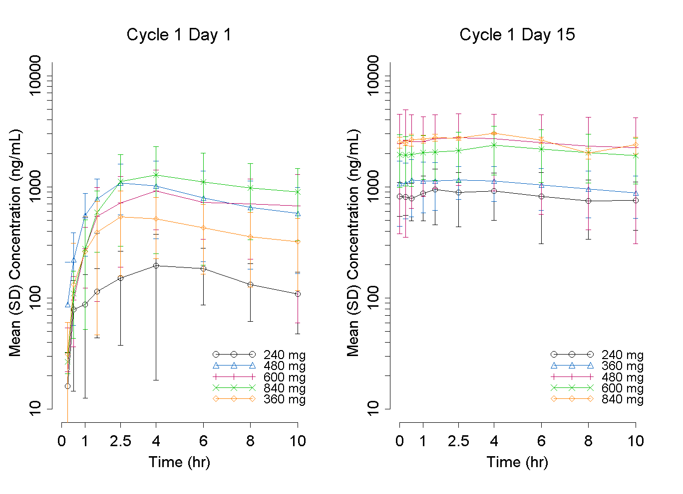

## **Figure S3.**

Observed and predicted relationship between rucaparib dose and exposure at steady state on once-daily (QD) and twice-daily (BID) dosing schedules. Upper panel: QD dosing; lower panel: BID dosing. Open circles: observed individual steady-state Cmax or AUC0-τ; solid line: model prediction, shaded area: 90% confidence intervals.

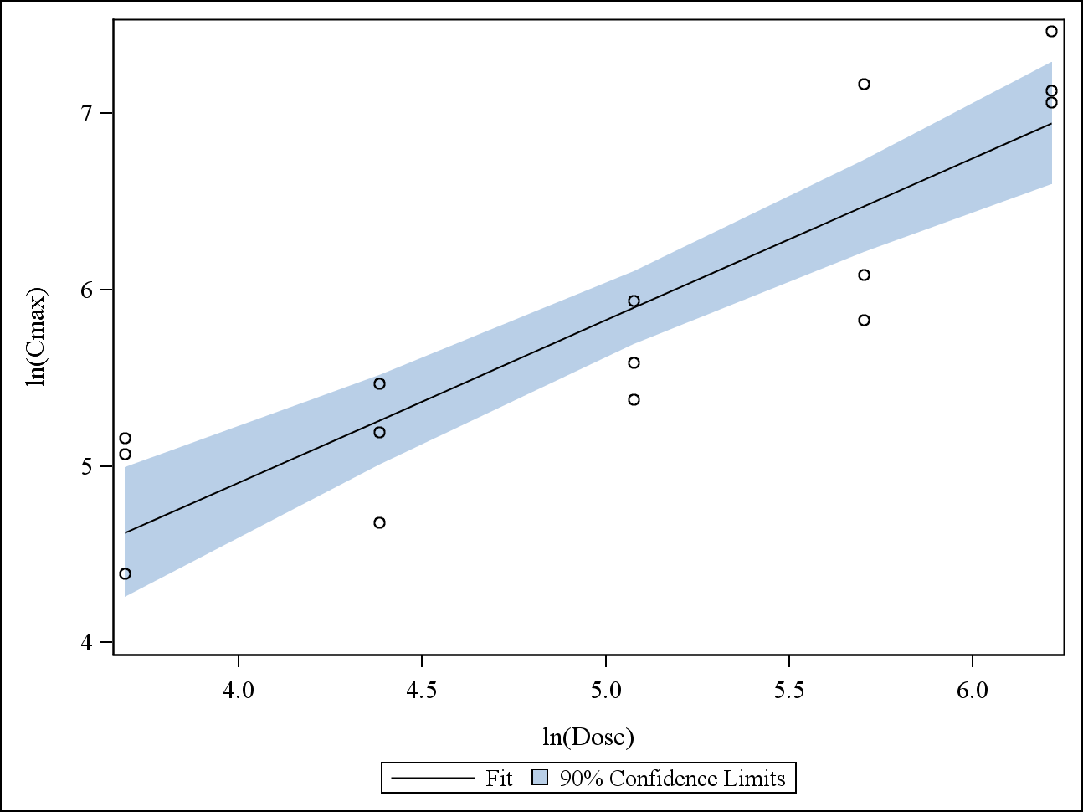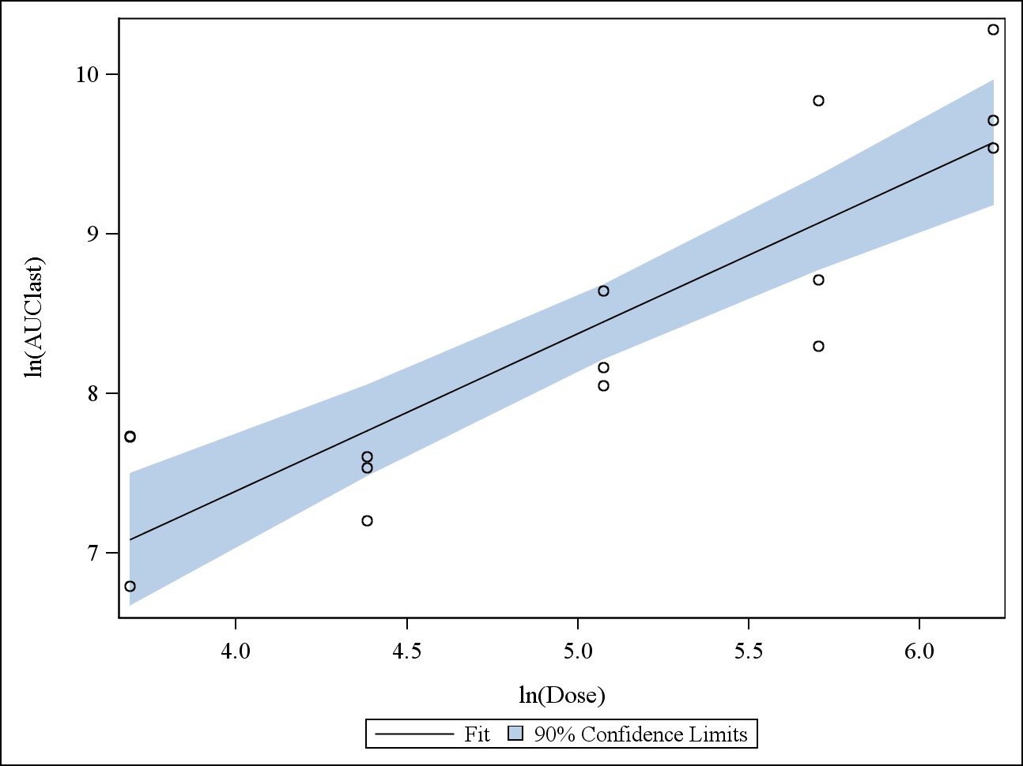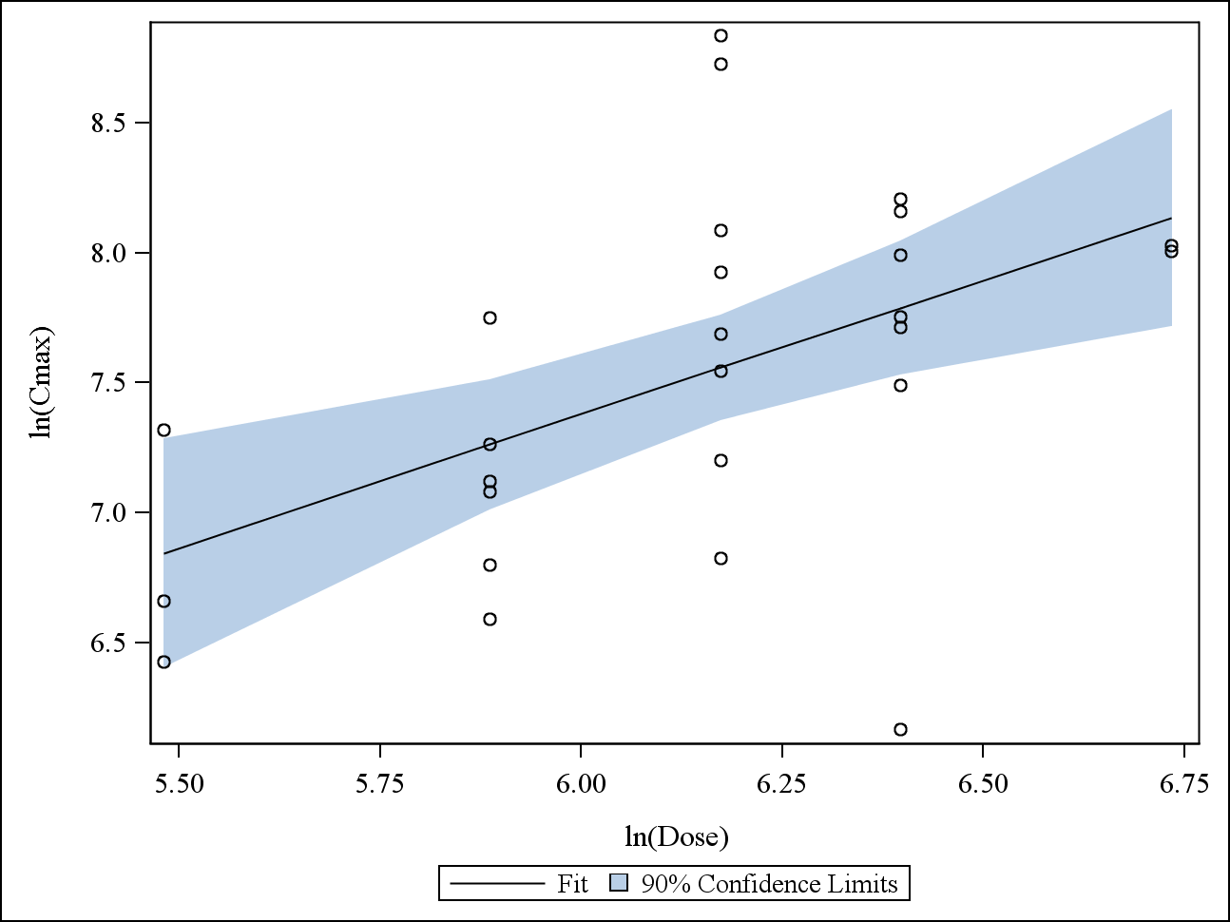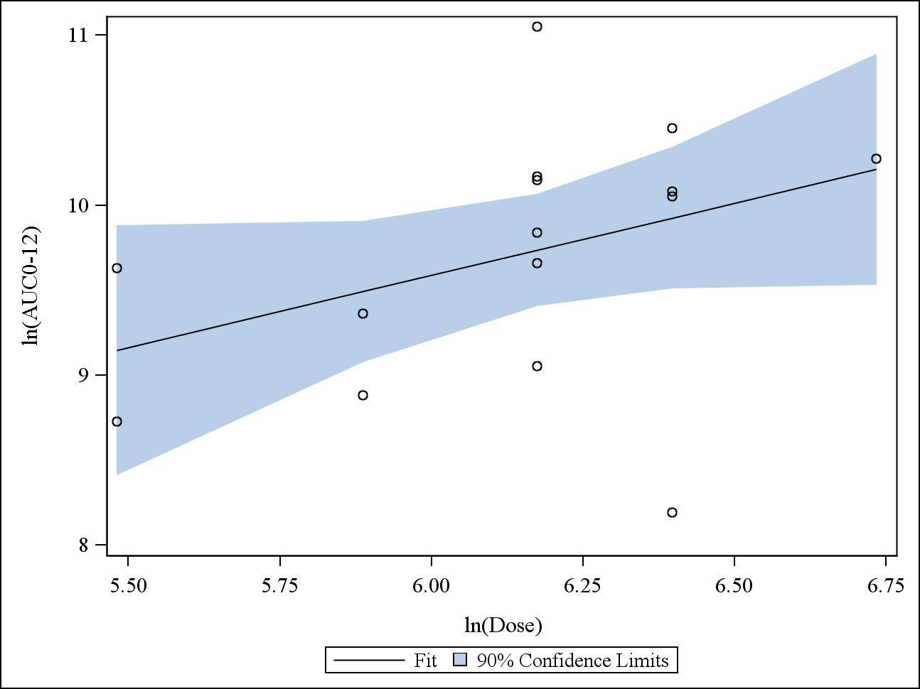

AUC0-τ, area under the concentration time curve from time 0 to last measurable concentration; Cmax, maximum concentration.

## Figure S4.

Radiological response to rucaparib 600 mg twice daily in a patient with ovarian cancer who had a germline *BRCA2* mutation and visceral disease at baseline.



## Table S1. Summary of pharmacokinetics parameters of rucaparib administered under fasting and fed conditions

|  |  |  |  |  |  |  |
| --- | --- | --- | --- | --- | --- | --- |
| **Dose** | **Visit** | **Statistics** | **T1/2, h** | **Tmax, h** | **Cmax, ng/mL** | **AUClast,  ng×h/mL** |
| 40 mg QD | Cycle 1, day -7 fasted | *n* | 3 | 3 | 3 | 3 |
| Geometric mean | 9.78 | - | 69.9 | 611 |
| Geometric mean CV% | 49.2 | - | 60.4 | 85 |
| Median | 8.16 | 4 | 57.6 | 468 |
| Min, max | 6.9, 16.6 | 2.5, 4.05 | 45.2, 131 | 347, 1410 |
| Cycle 1, day 1 fed | *n* | 3 | 3 | 3 | 2 |
| Geometric mean | 11.8 | - | 53.7 | 698 |
| Geometric mean CV% | 48.2 | - | 98 | - |
| Median | 12.7 | 2.55 | 71.1 | 794 |
| Min, max | 7.21, 17.8 | 1, 4.08 | 21.3, 102 | 415, 1170 |
| 300 mg QD | Cycle 1, day -7 fasted | *n* | 4 | 6 | 6 | 6 |
| Geometric mean | 21.4 | - | 374 | 4780 |
| Geometric mean CV% | 54.1 | - | 56.1 | 56.3 |
| Median | 24.1 | 4.09 | 424 | 5410 |
| Min, max | 11.9, 33.8 | 2.5, 24.22 | 182, 638 | 2390, 8680 |
| Cycle 1, day 1 fed | *n* | 3 | 6 | 6 | 5 |
| Geometric mean | 16.6 | - | 410 | 6040 |
| Geometric mean CV% | 40.2 | - | 76.8 | 64.5 |
| Median | 20.5 | 5.95 | 393 | 6000 |
| Min, max | 10.6, 21.1 | 2.53, 10 | 177, 1210 | 2670, 12100 |
| AUClast area under the plasma concentration-time curve from time 0 to last measurable concentration; Cmax, maximum plasma concentration;CV, coefficient of variation; QD, once daily; T1/2, half-life; Tmax, time of occurrence of Cmax. | | | | | | |