Supplementary informations:

Supplementary materials and methods:
Sample preparation and ELISA. Frozen omenta were cryo-sectioned (7 sections of 100µm thickness) and lysed in a buffer containing 150mM NaCl, 20mM Tris (pH 7.5), 1mM EDTA, 1% Triton and 2X protease inhibitor cocktail (Roche) and further processed by sonication. 1 additional section (taken after the 4th section) was stained with H&E to assess disease content. Protein concentration was determined by Bicinchoninic acid assay according to the manufacturer’s protocol.
Plasma from HGSOC patients and healthy controls were isolated as described above. Disease status and chemotherapy response of the patients was established according to the CRS system (1).
Plasma samples and omental protein extracts were tested for their content in human IgG1, IgG2, IgG3 and IgG4 by ELISA with the “IgG subclass human ELISA kit” following manufacturers’ recommendation (Life Technologies).

RNA isolation and transcriptomic analyses. Total RNA from frozen omentum was isolated using the RNeasy kit (Qiagen) following manufacturers instructions. Briefly, tissue was homogenized in RLT buffer, passed through QIAshredder (Qiagen) and purified using mini spin columns. DNAse digestion step was performed and RNA quality was evaluated with the Bioanalyzer 2100 expert (Agilent) as per manufacturers instructions. Sequenced RNA samples exhibited RIN numbers between 8 and 10.
RNA Sequencing was performed by Oxford Gene Technology (Begbroke UK) on the Illumina HiSeq2500 platform which generated ~42 million 101 Base-pair paired end reads per sample. Sequenced reads were mapped to Human RefSeq genes archived in the Illumina iGenomes resource (2) using RSEM (3)(version 1.2.4) in dUTP strand-specific mode. The mapping stage was performed with bowtie (version 0.12.7), part of the RSEM pipeline (4). RSEM was used for subsequent mapped read counting. Differentially expressed genes were identified with the EdgeR package (5) using Bioconductor (version 2.7; www.bioconductor.org), running on R (version 2.12.1;R-REF). We compared stage 1/2 non-involved omentum vs stage 3/4 diseased omentum (pre and post NACT) and stage 1/2 non-involved omentum vs stage 3/4 post-chemotherapy omentum with low residual disease (good responders). Common differentially expressed genes in both those comparisons and representative of the B cell signature in HGSOC omentum were selected. RNA-seq data have been deposited in Gene Expression Omnibus (GEO) under the accession number GSE71340.

BCR sequencing and analysis. B cells were isolated from HGSOC omentum and healthy peripheral blood following the protocol described above, centrifuged and subjected to RNA extraction using the RNeasy micro kit (Qiagen). Total RNA was used as template in IgH RT/PCR amplification reactions to generate Illumina MiSeq compatible sequencing libraries. For reverse transcription, the primers used included gene-specific region for the IgH variable region families and a conserved joining region primer (6,7). RT/PCR primers also included random nucleotides upstream of the gene specific regions, which allowed for control for amplification bias in subsequent reaction steps (8), as well as sequencing adapter sequences. Following reverse transcription and complementary strand synthesis, secondary PCR reactions were done to ligate Illumina sequencing barcodes and the remainder of the adapter sequence. Primers were generated by Ultramer synthesis and ordered from Integrated DNA Technologies. Sequences of primers used in these experiments are shown in Supplementary Table S6.
IgH amplicon libraries were pooled and sequenced on the Illumina MiSeq platform using 2x250 paired-end sequencing chemistry. Bases and QC assessment of sequencing were generated by CASAVA 1.8 (Illumina). QC-passed sequence reads were joined in silico using Pandaseq (9) to infer a contig that represents the original amplicon sequence. Variable region (IgHV), Joining region (IgHJ), and Complementary-determining region 3 (CDR3) identifications were done using IMGT-HighVQuest (10,11). Sequence data were passed through a series of informatics filters to ensure only high-quality reads would be considered for repertoire analysis. Reads that passed filtering were compiled by clonotype, with a given clonotype defined as IgHV gene, IgHJ gene, and unique CDR3 nucleotide sequence usage. After normalization based on molecular tag resolution, clonotype distributions were inferred to compare population diversities (12).

B cell purification, re-stimulation and cytokine production. B cells were isolated from the omental stroma vascular fraction (SVF) using the MACS bead cell separation system (Miltenyi). Briefly, the isolated SVF was additionally filtered through a 40µm strainer and centrifuged with Ficoll-PaqueTM Plus (GE Healthcare). The interphase ring was collected for B cell purification with human CD19 Microbeads according to manufacturer’s recommendations. Cells labeled with the CD19⁺ targeting beads were passed through two LS columns to obtain purities between 91 and 99%.
B cells were stimulated in 96-well plates at a density of 100 000/well in 200µl of RPMI 10% FBS, 0.05mM β-Mercapto-Ethanol, 5ng/ml Phorbol 12-myristate 13-acetate (PMA) and 1µg/ml Ionomycin for 48h at 37˚C and 5% CO₂, after which media was analyzed by electrochemiluminescence multiplex assay using the V-Plex Human Cytokine 30Plex kit (Mesoscale).

Omental IgG purification. 500mg of frozen omental tissue were dissociated using a MACS Dissociator (Miltenyi) in a buffer containing 100mM NaCl, 20mM Tris (pH 7.5), 1mM EDTA, 0.3% CHAPS and 2X protease inhibitor cocktail (Roche). For immunocytofluorescence on HGSOC cells lines, IgGs from HGSOC omentum and plasma from healthy controls were purified using the NabTM protein A/G Spin kit (Pierce). IgG solutions were then concentrated and dialyzed in PBS using the Vivaspin 2 centrifugal concentrator columns (10kDa MWCO, GE Healthcare) according to manufacturer’s protocol.
For mass spectrometry analysis of the targets of tumor IgGs, purification was performed as follow. Briefly, a pre-clearing step of protein lysates from HGSOC omenta was carried out by incubation with unbound agarose (Pierce) for 20min at 4˚C under rotation. Samples were then centrifuged and supernatants incubated without beads for 4 hours at 4˚C under rotation to favor the binding of endogenous IgGs to their targets in the lysates. 20µL of the lysate was then frozen for later analysis as total fraction. The remaining extract was split in two: half was incubated with control agarose while the other half was incubated with agarose coupled to protein A/G for 4 additional hours at 4˚C on rotation. Samples were then centrifuged, the supernatant was discarded and the beads extensively washed with PBS. Proteins bound to the beads were eluted in SDS Page (2X) buffer at 100˚C for 5min and frozen at -80˚C for later separation on SDS Page gel and proteomics analysis.
For the in vitro activation of DCs, protein extracts from two HGSOC omental metastases or plasma from three healthy volunteers were incubated for 2 hours at 4°C under rotation with Agarose beads bound to protein A/G. After centrifugation the beads were extensively washed with PBS before elution of the IgGs in 3 times 400μl of a buffer containing 0.1% Glycine pH 3.5. Once eluted, 40μl of 1mM Tris buffer pH9 were added to the antibody mix before concentration and dialysis of the samples with PBS using the Vivaspin 2 centrifugal concentrator columns (10kDa MWCO, GE Healthcare). IgGs from both tumor extracts (and IgGs from the three healthy plasma) were then combined for the in vitro treatment of DCs.

Mass spectrometry. Proteins immunoprecipitated with agarose beads conjugated to protein A and G, control beads eluate and total extract were separated on SDS page gel and revealed with EZ BlueTM gel staining reagent (Sigma). Bands within each sample were cut and frozen at -80˚C for later analysis. Those corresponding to IgG proteins at 25 and 50 kDa in the sample immunoprecipitated with protein A/G agarose beads were excluded. Gel pieces were processed as in Shevchenko et al. (2006) (13), with some modifications. Briefly, gel pieces were de-stained with 50 mM ammonium bicarbonate (50% acetonitrile [ACN]), reduced with 10 mM dithiothreitol (100 mM ammonium bicarbonate), amidated with 55 mM iodoacetamide (100 mM ammonium bicarbonate), and digested overnight with trypsin (Sigma) in 10 mM ammonium bicarbonate (10% ACN). Peptides were extracted from the gel pieces using 5% formic acid (10% ACN) solution, desalted using C₁₈/graphitic carbon micro-centrifuge columns (Glygen), and dried down for further analysis. The dried peptide extracts were re-suspended in 100 µL of 0.1% TFA (3% ACN). Each sample was then injected onto nanoACQUITY UPLC system (Waters) and separated over a 120 min linear gradient (5-35% ACN). The top 5 most intense multiply charged ions in each orbitrap MS¹ scan were selected for collision-induced fragmentation (CID), and the subsequent fragment ions were analyzed in the ion trap. The resolution of the MS¹ scan was set to 30,000 FWHM. Antigens found enriched in the IP fraction compared to total fraction but not enriched in the control fraction were considered as potential targets of IgGs. Peptide assignments were considered true positives if their respective Mascot scores were ≥ 75.

Targeting of HGSOC tumor cell lines by omental IgGs. The ability of tumor IgGs to bind tumor cells was assessed by flow cytometry and immunofluorescence.
Flow cytometry: 100 000 AOCS1 and G33 cells were incubated with 0.25mg/ml antibody solution purified from 3 HGSOC omental tumors in PBS 2.5% BSA, 2mM EDTA for 30min at 4˚C. Cells were then washed and sequentially incubated with a rabbit anti-human IgG (Dako) and an anti-rabbit IgG Alexa fluor 488 (Invitrogen). Fixable viability dye Alexa fluor 506 (ebioscience) was added during the last antibody incubation. Cells were then fixed in 2% formal saline solution and analyzed using a LSRFortessa cell analyzer (BD Biosciences).
Immunofluorescence: AOCS1 and G33 cells were cultured on round cover slips (13mm). At 60% confluence cells we fixed with 4% formal saline solution (Sigma) and permeabilized with PBS 0.1% Triton X100 (Sigma). Cells were then incubated with 0.25mg/ml tumor IgGs overnight at 4˚C and sequentially stained with a Rabbit anti-human IgG (Dako) and an anti-Rabbit IgG AlexaFluor 488 (Invitrogen) for 40min at room temperature. Coverslips were mounted on glass slides with Prolong Gold antifade reagent with Dapi (Life Technology) and staining was analyzed with an LSM510 confocal microscope (Zeiss).

In vivo experiment: 10x10⁶ ID8 cells stably expressing the luciferase protein were intraperitoneally injected in C57Bl6 mice (Jackson Laboratories). One day prior to ID8 cell injection and every 2 weeks mice were injected with 250µg of anti-CD20 or control IgG (3 first injections IV + 2 Injections IP) (Genentech). Disease progression was monitored with the IVIS imaging system 100 (Xenogen) after administration of Luciferin.
Depletion of B cells and activation of T cell in the ascitic fluid was analyzed by Flow cytometry. Antibodies see supplementary table S2.
Analysis was performed using an LSRFortessa cell analyzer (BD Biosciences).
Animal experiments were conducted with the approval of the ethic comity of the Biological service unit Queen Mary University London (UK) and following the UKCCCR guidelines.

Supplementary Tables and Figures legend:

Supplementary Table S1. Total patient cohort. Characteristics of the patients selected in this study.

Supplementary Table S2: List of antibodies used for flow cytometry analyses.

Supplementary Table S3: Patient cohort for CD20 staining. Characteristics of the patients who received neoadjuvant chemotherapy or not and were included in the CD20 IHC cohort.

Supplementary Table S4. Patient cohort selected for IgG dosage in HGSOC omental tumors. Baseline characteristics of the patients and histology of the tumor analyzed.

Supplementary Table S5. Patient cohort selected for IgG dosage in the plasma of HGSOC patients and healthy controls. Baseline characteristics and classification of the patients following to the Chemotherapy Response Score (CRS) system (1). This allowed classification of patients according to their response to NACT treatment.

Supplementary Table S6. Primer sequences used for IgH amplification.

Supplementary Figure S1. B cell subpopulations in the omentum and blood of HGSOC patients. (A) Plot showing the proportion of IgM⁺ memory (CD27⁺IgM⁺), class switched memory (CD27⁺IgM⁻), CD27⁻ atypical memory (CD27⁻IgM⁻) and naïve (CD27⁻IgM⁺) in unmatched pre and post chemotherapy HGSOC omentum. (**p≤0.01, Mann Whitney) (B) Quantification of the IgM⁺ memory (CD27⁺IgM⁺), class switched memory (CD27⁺IgM⁻), CD27⁻ atypical memory (CD27⁻IgM⁻) and naïve (CD27⁻IgM⁺) B cells subpopulations in the blood of stage 3/4 HGSOC patients (n=5). (C and D) Proportion of CD86⁺PD1⁻ (C), PD1⁺CD86⁻ (D) cells in naïve and memory B cell subpopulations from pre and post chemotherapy omentum of HGSOC patients. (E and F) Proportion of CD86⁺PD1⁺ cells in naïve and memory B cell subpopulations from total (E) and pre and post chemotherapy omentum (F) of HGSOC patients. (*p≤0.05; **p≤0.01, Mann Whitney).

Supplementary Figure S2. Immunoglobulin production in HGSOC omentum and plasma. (A) Immunofluorescent staining on FFPE sections from one representative omental metastasis showing the presence of IgM⁺ (green) CD20⁺ (red) B cells and IgM deposits in the stroma of tumor nodules. (B) Proportion of the different immunoglobulin subpopulations in two post-chemotherapy (G146 and G175) and one pre-chemotherapy (G168) omental biopsies analyzed by mass spectrometry. MUCB stands for Ig Mu heavy chain (C and D) Proportions of IgG1, IgG2, IgG3 and IgG4 among total IgGs in the omentum (C) and plasma (D) of HGSOC patients and healthy controls. (E) Concentration of IgG1, IgG2, IgG3 and IgG4 in plasma from HGSOC patients and healthy controls.

Supplementary Figure S3. Omental IgGs can target tumor antigens. (A-C) Tumor cell-targeting IgGs were extracted from 3 HGSOC omental metastases. (A and B) Binding of intracellular antigens by omental IgGs was analyzed by immunofluorescent staining of G33 and AOCS1 HGSOC cell lines. Scale bar: 20µm. (C) Targeting of surface antigens by omental IgGs was analyzed by flow cytometry. Arrows highlight the subpopulations of AOCS1 cells targeted by G175 and G146 IgGs (D) Immunohistochemistry staining showing the presence of GNA13, DPYSL3 and HSPB1 proteins in the samples analyzed by mass spectrometry.
Supplementary figures
Supplementary Figure S1
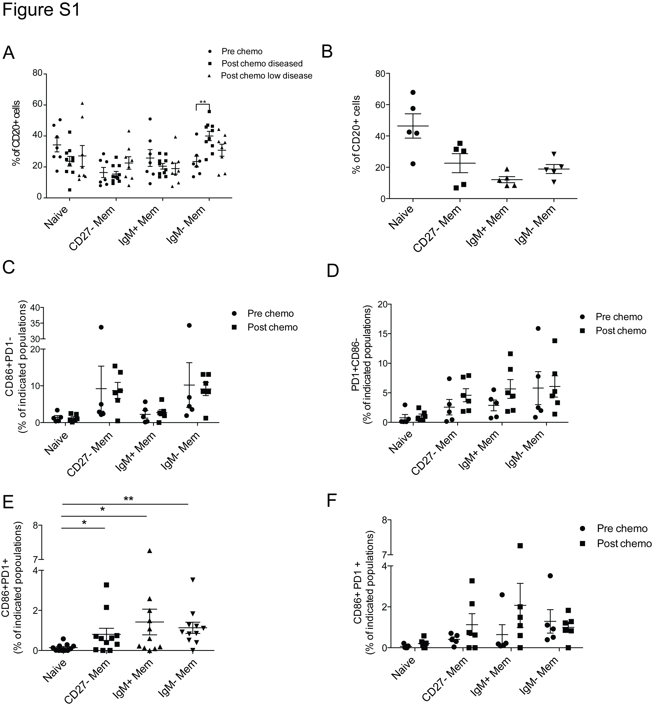

Supplementary Figure S2
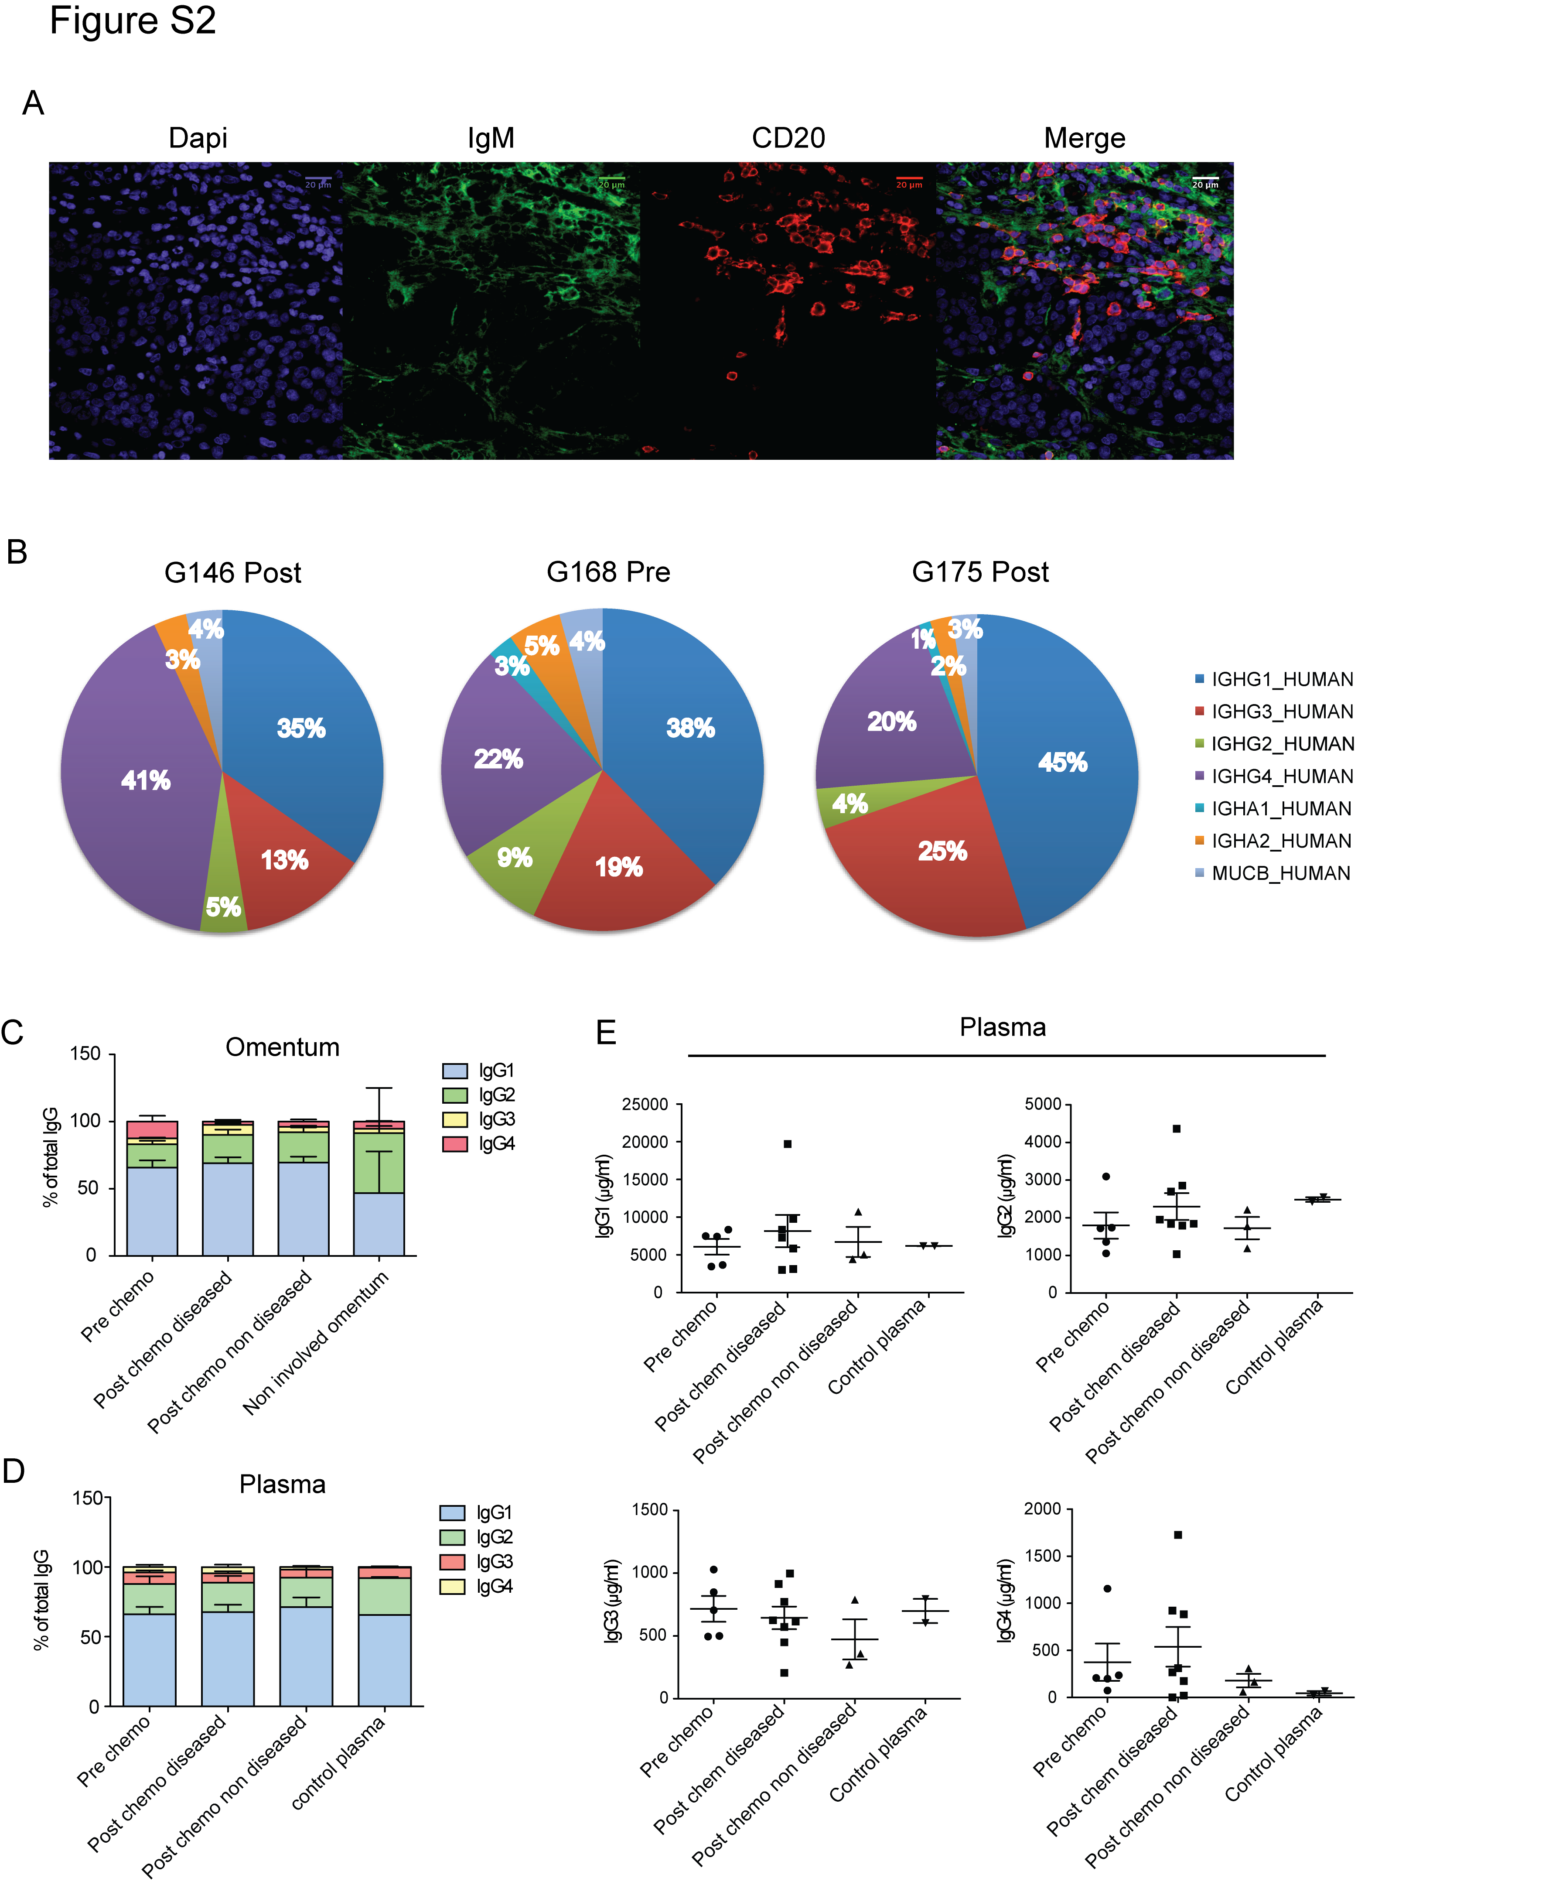

Supplementary Figure S3
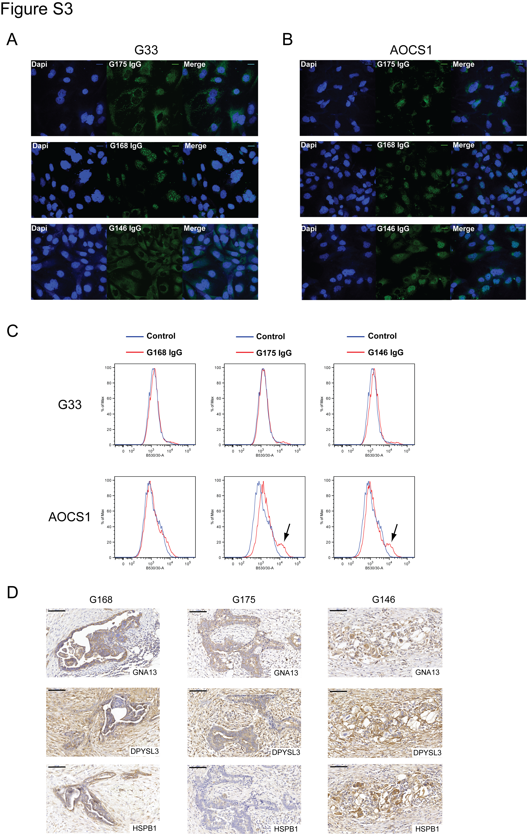

Bibliography:

1. Bohm S, Faruqi A, Said I, Lockley M, Brockbank E, Jeyarajah A, et al. Chemotherapy Response Score: Development and Validation of a System to Quantify Histopathologic Response to Neoadjuvant Chemotherapy in Tubo-Ovarian High-Grade Serous Carcinoma. J Clin Oncol 2015;33:2457-63.
2. Illumina I. 2016 January. iGenomes. In Reference sequences and annotation database. Build(s) <http://support.illumina.com/sequencing/sequencing_software/igenome.html>. Accessed 2015 January.
3. Akasaki Y, Kikuchi T, Irie M, Yamamoto Y, Arai T, Tanaka T, et al. Cotransfection of Poly(I: C) and siRNA of IL-10 into fusions of dendritic and glioma cells enhances antitumor T helper type 1 induction in patients with glioma. J Immunother 2011;34:121-8.
4. Langmead B, Trapnell C, Pop M, Salzberg SL. Ultrafast and memory-efficient alignment of short DNA sequences to the human genome. Genome Biol 2009;10:R25.
5. Robinson MD, McCarthy DJ, Smyth GK. edgeR: a Bioconductor package for differential expression analysis of digital gene expression data. Bioinformatics 2010;26:139-40.
6. van Dongen JJ, Langerak AW, Bruggemann M, Evans PA, Hummel M, Lavender FL, et al. Design and standardization of PCR primers and protocols for detection of clonal immunoglobulin and T-cell receptor gene recombinations in suspect lymphoproliferations: report of the BIOMED-2 Concerted Action BMH4-CT98-3936. Leukemia 2003;17:2257-317.
7. Boyd SD, Marshall EL, Merker JD, Maniar JM, Zhang LN, Sahaf B, et al. Measurement and clinical monitoring of human lymphocyte clonality by massively parallel VDJ pyrosequencing. Sci Transl Med 2009;1:12ra23.
8. Yourstone SM, Lundberg DS, Dangl JL, Jones CD. MT-Toolbox: improved amplicon sequencing using molecule tags. BMC Bioinformatics 2014;15:284.
9. Masella AP, Bartram AK, Truszkowski JM, Brown DG, Neufeld JD. PANDAseq: paired-end assembler for illumina sequences. BMC Bioinformatics 2012;13:31.
10. Brochet X, Lefranc MP, Giudicelli V. IMGT/V-QUEST: the highly customized and integrated system for IG and TR standardized V-J and V-D-J sequence analysis. Nucleic Acids Res 2008;36:W503-8.
11. Alamyar E GV, Duroux P, Lefranc MP. A High-Throughput System and Web Portal for the Analysis of Rearranged Nucleotide Sequences of Antigen Receptors. JOBIM 2010 2010;Paper 63 (2010).
12. Magurran AE, Khachonpisitsak S, Ahmad AB. Biological diversity of fish communities: pattern and process. J Fish Biol 2011;79:1393-412.
13. Shevchenko A, Tomas H, Havlis J, Olsen JV, Mann M. In-gel digestion for mass spectrometric characterization of proteins and proteomes. Nat Protoc 2006;1:2856-60.

