Supplementary information
Figure 1 Mean (±SD) serum lumretuzumab profiles following multiple ascending doses from 100 mg up to 2000 mg
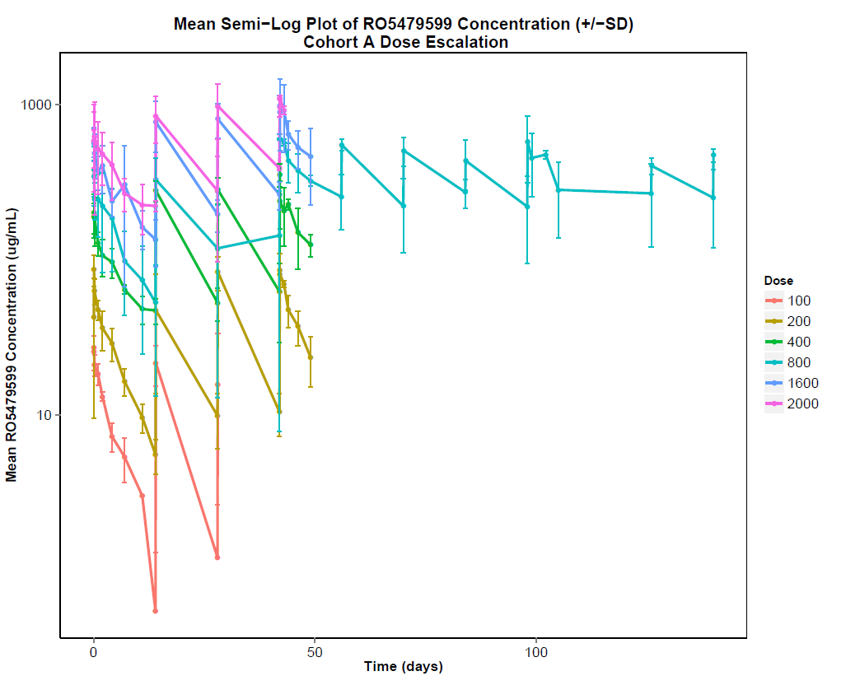
Figure 2 Percentage change in standardized uptake value maximum from baseline as assessed by FDG-PET at (a) Cycle 1 Day 14 and (b) Cycle 4 Day 14
(a)
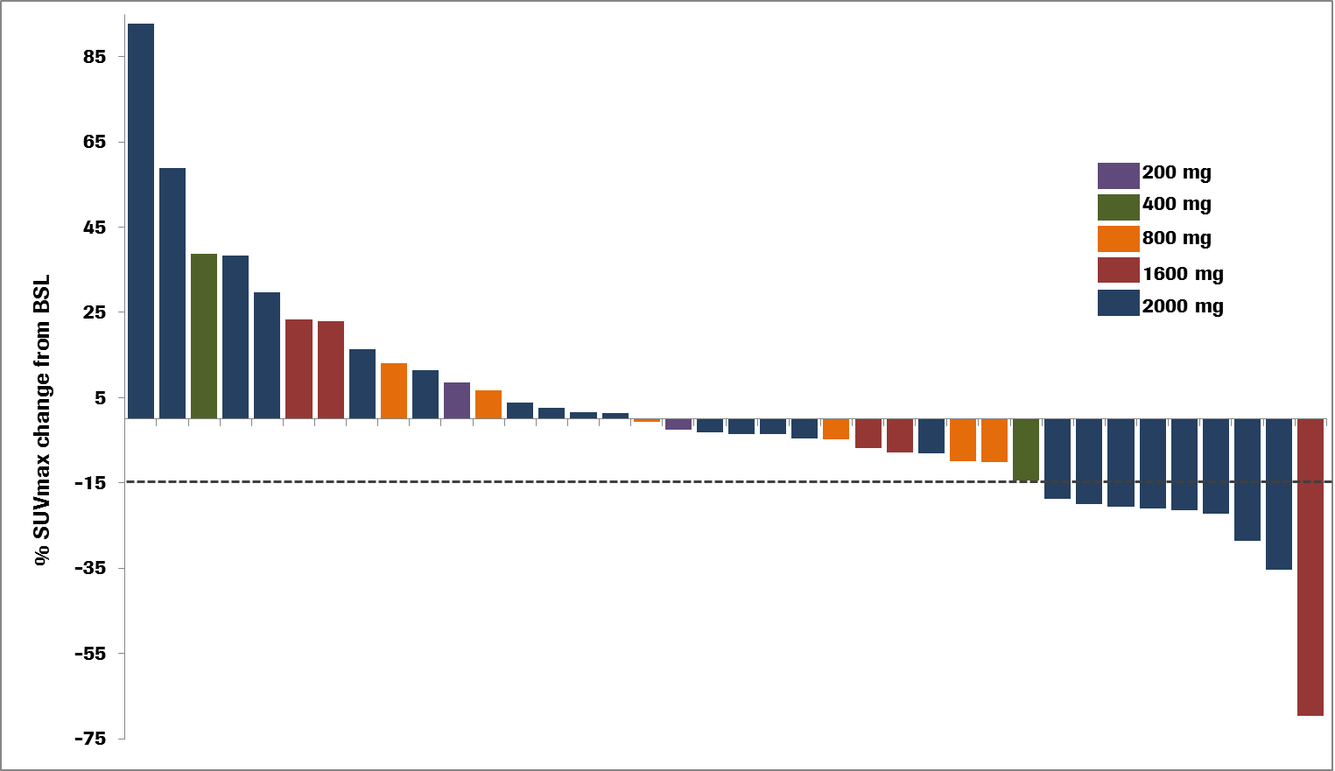
(b)
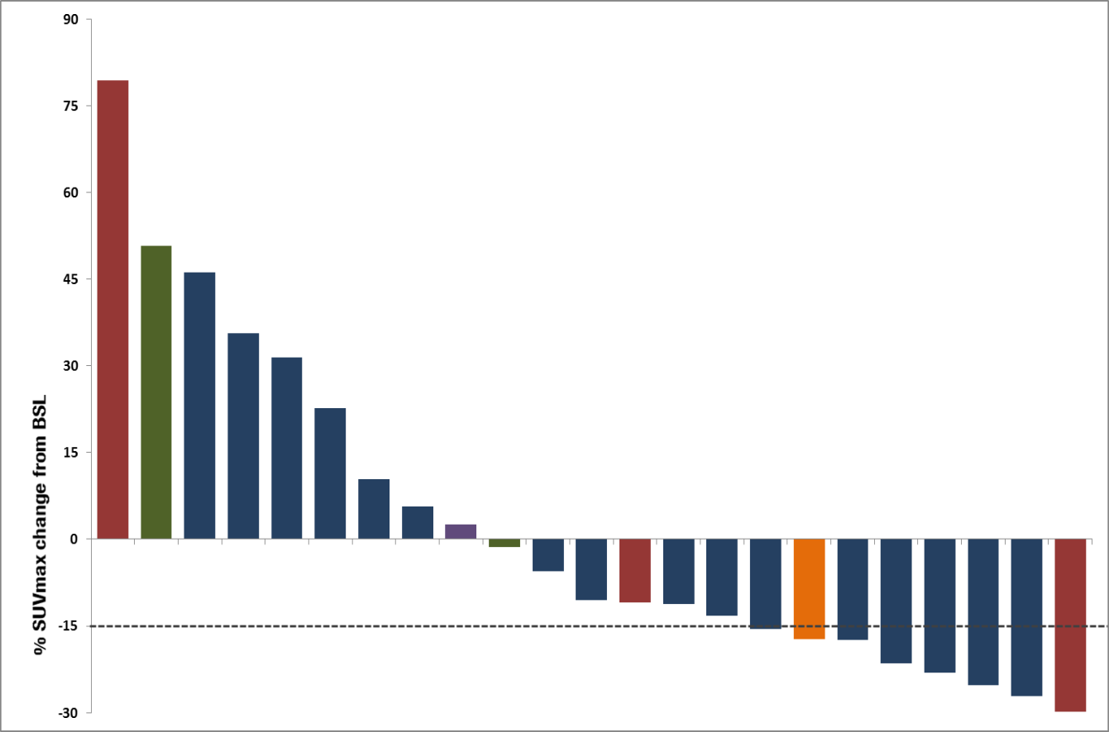
Table 1 Summary of baseline and change in HER3 expression measured by IHC in skin and tumor biopsy samples pre and post treatment with lumretuzumab
Lumretuzumab (mg) | Membrane HER3 Expression (IRS_{median})
 | Skin Biopsies |  |  | Tumor Biopsies
 | Predose (n) | ΔIRS (n)  (Day 14, Cycle 1 – Predose) | P-valueª | Predose (n) | ΔIRS (n)  (Day 14, Cycle 1 – Predose) | P-valueª
100 | 1.35 (3) | -0.67 (3) | NA | 0.66 (3) | NA | NA
200 | 0.81 (3) | -0.81 (3) | NA | 2.4 (3) | -2.05 (2) | NA
400 | 1.08 (3) | -1.08 (3) | NA | 2.6 (3) | -2.6 (3) | NA
800 | 0.99 (7) | -0.92 (6) | NA | 1.26 (7) | -0.65 (5) | NA
1600 | 0.49 (5) | -0.49 (5) | NA | 1.2 (5) | -1.2 (5) | NA
2000 | 1.2 (25) | -1.12 (24) | <0.0001 | 1.74 (25) | -1.24 (23) | <0.0001
ª P-value has been calculated using Wilcoxon signed-rank test if 10 or more paired samples were available.

Table 2 Summary of change in expression of HER3, HER2, EGFR and cMET in fresh tumor biopsies compared to primary archival samples
Marker | Paired cases | Median change in IRS from archival tissue | Patients (%) with increased IRS compared to archival tissue
HER3 | 34 | 1.06 ª | 88.2
EGFR | 34 | 0.48 ª | 76.5
HER2 | 34 | 0 | 85.7
cMET | 34 | 0.86 ª | 91.2
ª P<0.001 Wilcoxon signed rank test.

Table 3 Peripheral blood immunophenotyping (T, B and NK cells and NK subsets) from patients dosed with 2000 mg lumretuzumab
 | Median Baseline Value |  | Cycle 2 – pre-infusion |  | Cycle 3 – pre-infusion
Population | Cells/µL (N) |  | % change Cycle 1* | N Changing † | % change Cycle 1* | N Changing †
Lymphocytes | 1109 (24) | 6.2 (-40, 61)% |  | 9/11 | 4.4 (-25, 133)% | 6/13
B (CD3–CD19⁺) | 97 (25) | -11.3 (-38, 95)% |  | 13/10 | 3.3 (-38, 127)% | 9/11
CD3 (mature T) | 674 (25) | 4.9 (-44, 99)% |  | 10/13 | 3,9 (-33, 239)% | 9/11
CD4 (helper T) | 428 (25) | 1.3 (-62, 120)% |  | 10/13 | 1.2 (-44, 171)% | 9/11
CD8 (cytotoxic T) | 233 (25) | -5.8 (-41, 87)% |  | 13/10 | 3.6 (-20, 271)% | 9/11
CD8NK (CD3⁺CD8⁺CD16⁺CD56⁺) | 38 (24) | -6.9(-64, 301)% |  | 12/10 | 44** (-53, 370)% | 5/13
CD56T (CD3⁺CD56⁺) | 43 (24) | 2 (-66, 61)% |  | 10/12 | 4.2 (-70, 265)% | 9/9
NK (CD3⁻CD16/CD56⁺) | 173 (25) | 9.8 (-64, 152)% |  | 11/12 | 27,3 (-60, 384)% | 7/13
CD16NK (CD3/CD19⁻CD16/CD56⁺) | 164 (24) | 11.1 (-65, 148)% |  | 10/12 | 30.8 (-61, 400)% | 6/13
CD16NK MESF¹ | 402135 (24) | 16.6 (-22, 126)% |  | 8/14 | 26.7 (-36, 219)% | 6/13
CD56^{bright} NK (CD3/CD19⁻CD16/CD56⁺) | 9 (23) | -7.8 (-56, 394)% |  | 11/10 | -4.5 (-40, 497)% | 9/9
CD16⁺CD56⁻NK (CD3/CD19/CD56⁻CD16⁺) | 10 (23) | 10.7 (-63, 192)% |  | 8/13 | -0.8 (-57, 190)% | 9/9
CD56^{dim} NK (CD3/CD19/CD16⁻CD56⁺) | 8 (23) | -22.3 (-53, 110)% |  | 12/9 | -8.5 (-66, 249)% | 11/17
CD56 NKp46 NK (CD3/CD19⁻CD56/CD335⁺) | 145 (24) | 14.3** (-57, 442)% |  | 8/14 | 32.1 (-56, 385)% | 5/14
CD56 NKp46 NK MESF¹ | 4230 (24) | 16*** (-26, 213)% |  | 6/16 | -3.8 (-31, 75)% | 11/8
CD56^{dim}CD16^{bright}NK(CD3/CD19⁻CD16/CD56⁺) | 145 (24) | 9.1 (-67, 133)% |  | 10/12 | 34.9 (-63, 457)% | 6/13
*Median percentage change in cells/μL from pre-infusion Cycle 1 (Day 1) (range: min, max). P>0.05**, < 0.005***.
† Number of patients showing change consistent with the median change from baseline on Day 1 of Cycle 1 or Cycle 2 (for example, a negative change).
¹ Mean Equivalent Soluble Fluorescence (MESF) intensity of CD16 of the CD3–/CD19-/CD56+/CD16+ and CD56/NKp46 populations.

Table 4 Ex-vivo activation potential of peripheral NK lymphocytes for all patients at baseline and following exposure to lumretuzumab in the 2000 mg dose cohort
 | All Patients | 2000mg Lumretuzumab Dose Cohort
Condition | Cycle 1 (pre-infusion) | Cycle 1 (pre-infusion) | Cycle 2 (pre-infusion) | Cycle 3 (pre-infusion)
ADCC-independent control (K562 cells) * | 13.8 (2.1 to 29)% (28) | 12.5 (5.4 to 29)% (14) | 12.3 (5 to 26)% (14) | 11.8 (4 to 27)% (15)
+ HER3 WT | 13.5 (3.9 to 36)% (37) | 10.9 (3.9 to 36)% (20) | 10.5 (0.7 to 27)% (19) | 15.2 (3 to 25)% (19)
+ lumretuzumab | 27.2(7.5 to 53)% (41) | 26.5 (7.5 to 53)% (23) | 25.7 (3.2 to 49)% (22) | 29.3 (11 to 47)% (21)
Values are median % (range: min-max) CD3-/CD56+/CD107+ cells and number of patients (n).
* NK lymphocyte activation stimulated directly by the ADCC-independent control cell line K562 (and independent of either HER3 on the target cell, or CD16 on the NK cell).
ADCC = antibody-dependent cellular cytotoxicity

Table 5 Summary of tumor immune effector cell infiltration
Immune effector cell population | All patients |  | 2000 mg lumretuzumab dose cohort
 | Number of patients | Median (range) pretreatment  (cells/mm²)ª | Number of patients | Median % change (range)  (Day 14 Cycle 1 – Day 1 Cycle 1) | Number of patients with a change^{b}  (decrease/increase)
CD3+ (mature T) | 44 | 97 (1 to 360) | 23 | -17.4 (-74 to 967) | 12/11
CD68 (macrophage) | 47 | 90 (12 to 275) | 23 | 7.0 (-92 to 181) | 8/15
CD16+ (NK,FCγRIII) | 45 | 140 (23 to 600) | 23 | 8.3 (-68 to 525) | 8/15
ª Values express “number of positive staining cells/mm²” for all evaluable samples.
^{b} Number of patients treated with 2000 mg of lumretuzumab showing a change on Day 14 of Cycle 1 from baseline (n: negative/positive) (no missing values).

Table 6 Tumor response to treatment (RECIST)
No. of patients (%)
N = 47
Complete response | 0
Partial response | 0
Stable disease | 10 (21.3)
Progressive disease | 29 (61.7)
Clinical progression ª | 5 (10.6)
Lost to follow up | 3 (6.4)
ª If the overall response was based solely on symptomatic deterioration, i.e. without confirmation by an imaging method.

