**Supplementary Figure S1.** Distribution of BRAF V600E cfDNA mutation fraction across study samples

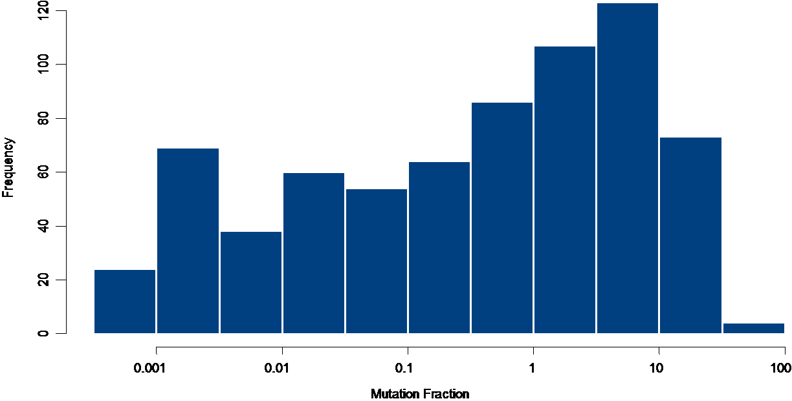

**Supplementary Figure S2.** cfDNA-ND patients exhibited higher response rates to dabrafenib and trametinib compared with cfDNA V600E/K patients.



**Supplementary Table S1.** Baseline clinical characteristics

|  |  |
| --- | --- |
| **Variable** | **Value** |
| Age (years) |  |
| Median (range) | 54 (19–93) |
| Gender |  |
| Male (%) | 430 (60) |
| Female (%) | 290 (40) |
| Tumor V600 status; n (%) |  |
| V600E | 641 (89) |
| V600K | 79 (11) |
| Visceral disease; n (%) |  |
| Non-visceral | 139 (19) |
| Visceral | 138 (19) |
| Visceral and non-visceral | 439 (61) |
| ECOG PS; n (%) |  |
| 0 | 440 (61) |
| 1 | 268 (37) |
| 2 | 1 (< 1) |
| Missing | 11 (2) |
| LDH; n (%) |  |
| Normal | 427 (59) |
| Elevated | 287 (40) |
| Missing | 6 (1) |
| M Stage; n (%) |  |
| M0 | 17 (2) |
| M1 | 1 (< 1) |
| M1a | 79 (11) |
| M1b | 106 (15) |
| M1c | 513 (72) |
| Missing | 4 (1) |
| Number of disease sitesa; n (%) |  |
| <3 | 133 (45) |
| ≥3 | 169 (55) |

a Data available for METRIC only (N = 293).

ECOG: Eastern Cooperative Oncology Group performance status.

**Supplementary Table S2.** Correlation between cfDNA mutation fraction, baseline tumor burden (SLD), and LDH

|  |  |  |  |  |  |  |  |  |  |
| --- | --- | --- | --- | --- | --- | --- | --- | --- | --- |
|  | | **BREAK-2** | | **BREAK-3** | | **BREAK-MB** | | **METRIC** | |
| R | n | R | n | R | n | R | n |
| **SLD** | **V600E** | 0.72 | 60 | 0.58 | 218 | 0.62 | 103 | 0.45 | 248 |
| **LDH** | **V600E** | 0.64 | 58 | 0.69 | 219 | 0.65 | 104 | 0.65 | 254 |
| **SLD** | **V600K** | 0.46 | 15 | NA | NA | 0.73 | 24 | 0.71 | 36 |
| **LDH** | **V600K** | 0.52 | 15 | NA | NA | 0.75 | 26 | 0.64 | 37 |

cfDNA correlation performed in patient populations determined to be V600E/K in tumor (by PCR test).

LDH: lactate dehydrogenase; n: number of patients with data for both LDH and SLDNA: not applicable; R: Spearman’s correlation coefficient; SLD: sum of longest diameter.

**Supplementary Table S3.** Association between cfDNA mutation fraction, with baseline covariates

|  |  |  |  |  |  |
| --- | --- | --- | --- | --- | --- |
| **Covariate** | **Baseline tissue** | **Level** | **N** | **cfDNA median mutation fraction (min, max)** | ***P*-value** |
| ECOG | V600E | 0 | 396 | 0.35 (0, 41) | < 0.0001a |
| 1 | 234 | 2.17 (0, 38) |
| 2 | 1 | 3.07 (-) |
| Missing | 10 |  |
| V600K | 0 | 44 | 0.18 (0, 27) | 0.0015 |
| 1 | 34 | 6.84 (0, 57) |
| 2 | 0 | - |
| Missing | - | 1 |
| Visceral disease | V600E | Non-visceral | 128 | 0.21 (0, 35) | < 0.0001 |
| Visceral | 116 | 0.20 (0, 26) |
| Visceral + non-visceral | 394 | 1.25 (0, 41) |
| Missing | 3 | - |
| V600K | Non-visceral | 11 | 0.27 (0, 1.6) | 0.0080 |
| Visceral | 22 | 0.14 (0, 43) |
| Visceral + non-visceral | 45 | 4.68 (0, 57) |
| Missing | 1 | - |
| M stage | V600E | Others | 563 | 0.91 (0, 41) | 0.0009 |
| M1A | 75 | 0.27 (0, 29) |
| Missing | 3 | - |
|  | V600K | Others | 74 | 1.99 (0, 57) | 0.3134 |
| M1A | 4 | 0.33 (0, 1.6) |
| Missing | 1 | - |
| Number of disease sitesb | V600E | ≥3 | 137 | 1.31 (0, 38) | < 0.0001 |
| <3 | 119 | 0.10 (0, 41) |
| Missing | 0 | - |
| V600K | ≥3 | 23 | 4.75 (0, 27) | 0.0074 |
| <3 | 14 | 0.02 (0, 21) |
|  | Missing | 0 | - |
| LDH | V600E | Normal | 385 | 0.08 (0, 22) | < 0.0001 |
| ULN-2 x ULN | 151 | 3.29 (0, 41) |
| 2–4 x ULN | 61 | 6.66 (0, 35) |
| >4 x ULN | 38 | 11.03 (0, 19) |
| Missing | 6 | - |  |
| V600K | Normal | 42 | 0.14 (0, 19) | < 0.0001 |
| ULN-2 x ULN | 20 | 3.5 (0, 43) |
| 2–4 x ULN | 12 | 19.45 (1, 57) |
| >4 x ULN | 5 | 19.49 (10, 33) |
| Missing | 0 | - |  |

a ECOG = 1 and 2 combined.

b Data available for METRIC only.

ULN: Upper Limit of Normal; 2 x ULN: two times ULN.

**Supplementary Table S4.** Association between cfDNA mutation status, with baseline covariates

|  |  |  |  |  |
| --- | --- | --- | --- | --- |
| Covariate | **Level** | **cfDNA V600E or K**  **n (%)** | **cfDNA V600-ND**  **n (%)** | **Total** |
| ECOG | 0 | 309 (57) | 131 (80) | 440 |
| 1, 2 | 237 (43) | 32 (20) | 269 |
| Missing |  |  | 11 |
| Visceral disease | Non-visceral | 91 (17) | 48 (29) | 139 |
| Visceral | 92 (17) | 46 (27) | 138 |
| Visceral + non-visceral | 366 (67) | 73 (44) | 439 |
| Missing |  |  | 4 |
| M stage | Others | 497 (90) | 140 (85) | 638 |
| M1A | 54 (10) | 25 (15) | 79 |
| Missing |  |  | 4 |
| Number of disease sitesa | ≥3 | 135 (63) | 25 (32) | 160 |
| <3 | 81 (37) | 52 (67) | 133 |
| Missing |  |  | 0 |
|  | Normal | 273 (64) | 154 (36) | 427 |
| LDH | ULN-2 x ULN | 163 (30) | 8 (5) | 171 |
| 2–4 x ULN | 71 (13) | 2 (1) | 73 |
| >4 x ULN | 42 (8) | 1 (<1) | 43 |
| Missing |  |  | 6 |

a Data available for METRIC only.

ULN: Upper Limit of Normal; 2 x ULN: two times ULN.

**Supplementary Table S5.** cfDNA-ND patients exhibited higher response rates to dabrafenib and trametinib compared with cfDNA V600E/K patients

|  |  |  |  |  |  |
| --- | --- | --- | --- | --- | --- |
|  | | **(CR + PR)/N (%)** | | |  |
| **Study** | **Arm/Cohort** | **cfDNA V600E** | **cfDNA V600K** | **cfDNA-ND** | **p-value b** |
| BREAK-2 | Dabrafenib | 25/46 (54) | 3/13 (23) | 11/16 (69) | 0.0399 |
| BREAK-3 | Dabrafenib | 71/137 (52) | NA | 22/33 (67) | 0.1723 |
| DTIC | 7/32 (22) | NA | 3/18 (17) | 0.7301 |
| BREAK-MB | Dabrafenib  Cohort A | 19/43 (44) | 0/11 (0) | 3/7 (43) | 0.0093 |
| Dabrafenib  Cohort B | 14/40 (35) | 4/13 (31) | 9/16 (56) | 0.2855 |
| METRIC | Trametinib | 27/125 (22) | 2/21 (10) | 14/52 (27) | 0.2595 |
| Chemotherapya | 3/65 (5) | 0/5 (0) | 6/25 (24) | 0.0264 |

cfDNA: circulating-free DNA; CR: complete response; DTIC: dacarbazine; NA: not applicable; PR: partial response.

a chemotherapy = dacarbazine or paclitaxel.

b Fisher’s Exact test comparing cfDNA V600E, V600K (where available), and ND response rates.

**Supplementary Table S6.** cfDNA mutation fraction independently predicts PFS and OS in patients with baseline tumor V600E mutations

|  |  |  |  |  |  |  |
| --- | --- | --- | --- | --- | --- | --- |
| **Study** | **Treatment** | **Covariate** | **HR** | **(95% CI)** | | **p-value** |
| **PFS IN PATIENTS WITH BASELINE TUMOR V600E MUTATIONS** | | | | | | |
| **BREAK-2**  **BREAK-3** | **Dabrafenib (n=53)**  **Dabrafenib (n=169)** | **Mutation Fraction** | 1.12 | 1.05 | 1.20 | 0.0006 |
|  |  | **LDH (High vs Normal)** | 1.89 | 1.18 | 3.04 | 0.0070 |
|  |  | **ECOG (1/2 vs 0)** | 1.68 | 1.13 | 2.50 | 0.0103 |
|  |  | **Visceral vs non-visceral** | 1.80 | 1.08 | 3.00 | 0.0236 |
|  |  |  |  |  |  |  |
| **BREAK-3** | **DTIC (n=49)** | **Mutation Fraction** | 1.14 | 1.06 | 1.23 | 0.0008 |
|  |  |  |  |  |  |  |
| **Break-MB** | **Cohort A (n=50)** | **LDH (High vs Normal)** | 1.97 | 1.05 | 3.70 | 0.0353 |
|  |  |  |  |  |  |  |
| **Break-MB** | **Cohort B (n=54)** | **LDH (High vs Normal)** | 2.65 | 1.40 | 5.00 | 0.0026 |
|  |  | **ECOG (1/2 vs 0)** | 2.02 | 1.01 | 4.07 | 0.0479 |
|  |  |  |  |  |  |  |
| **METRIC** | **GSK1120212 (n=160)** | **Mutation Fraction** | 1.09 | 1.02 | 1.17 | 0.0125 |
|  |  | **LDH (High vs Normal)** | 1.70 | 1.00 | 2.89 | 0.0500 |
|  |  |  |  |  |  |  |
| **METRIC** | **Chemotherapy (n=84)** | **Number of Disease Sites (>=3 vs <3)** | 2.07 | 1.25 | 3.43 | 0.0049 |
|  |  |  |  |  |  |  |
| **OS IN PATIENTS WITH BASELINE TUMOR V600E MUTATIONS** | | | | | | |
| **BREAK-2** | **Dabrafenib (n=53)** | **LDH (High vs Normal)** | 6.72 | 3.15 | 14.36 | <0.0001 |
|  |  | **ECOG (1/2 vs 0)** | 5.37 | 2.44 | 11.81 | <0.0001 |
|  |  |  |  |  |  |  |
| **BREAK-3** | **Dabrafenib (n=169)** | **Mutation Fraction** | 1.09 | 1.03 | 1.16 | 0.0057 |
|  |  | **LDH (High vs Normal)** | 2.07 | 1.27 | 3.38 | 0.0036 |
|  |  | **Visceral Disease (Y vs N)** | 2.68 | 1.62 | 4.43 | 0.0001 |
|  |  |  |  |  |  |  |
| **BREAK-3** | **DTIC (n=49)** | **Mutation Fraction** | 1.25 | 1.13 | 1.36 | <0.0001 |
|  |  | **M Stage (M1A vs Others)** | 0.23 | 0.07 | 0.79 | 0.0196 |
|  |  |  |  |  |  |  |
| **Break-MB** | **Cohort A (n=50)** | **LDH (High vs Normal)** | 2.05 | 1.05 | 3.97 | 0.0343 |
|  |  |  |  |  |  |  |
| **Break-MB** | **Cohort B (n=54)** | **LDH (High vs Normal)** | 3.27 | 1.69 | 6.33 | 0.0004 |
|  |  |  |  |  |  |  |
| **METRIC** | **GSK1120212 (n=160)** | **LDH (High vs Normal)** | 2.13 | 1.41 | 3.22 | 0.0003 |
|  |  | **ECOG (1/2 vs 0)** | 1.63 | 1.09 | 2.43 | 0.0185 |
|  |  | **M Stage (M1A vs Others)** | 0.46 | 0.21 | 0.97 | 0.0421 |
|  |  |  |  |  |  |  |
| **METRIC** | **Chemotherapy (n=84)** | **LDH (High vs Normal)** | 3.39 | 2.00 | 5.74 | <0.0001 |

a Chemotherapy = dacarbazine or paclitaxel.

Mutation fraction, fraction of mutant DNA alleles to wild-type DNA alleles for patients with tissue V600E mutation