Supplementary Figures
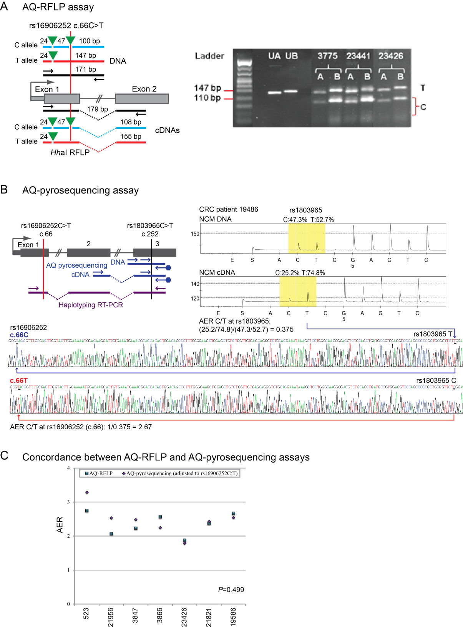
Supplementary Figure 1. Allele quantification assays used to measure relative levels of mRNA expression at exonic SNPs within MGMT.
A: Allele quantification restriction fragment length polymorphism (AQ-RFLP) assay at the SNP rs16906252C>T site at c.66 to determine normalized levels of allelic expression of MGMT mRNAs. Left: Map of the HhaI (green triangle) AQ-RFLP assay used to measure the levels of transcripts derived from the T allele (undigested) and C allele (digested) of the expressed rs16906252 SNP (vertical red line) in the normal colorectal mucosa of subjects heterozygous for the rs16906252C>T SNP. PCR amplification fragments are shown as black bars and digested PCR products as blue (C allele) and red (T allele) bars. The assay used to detect alleles in genomic DNA (above) was designed to produce fragments of comparable size to those generated from cDNAs (below), for normalization of band intensities. A second, non-polymorphic HhaI site within the amplified fragments, which was digested irrespective of the rs16906252 genotype to produce a constant 24 bp fragment, served as an internal digestion control. For genomic DNAs, the C allele produced a HhaI fragmentation pattern of 47 bp and 100 bp, plus the 24 bp non-polymorphic digestion control band. The T allele produced fragments of 147 bp (undigested) and 24 bp. For cDNAs, the C allele resulted in the differential digestion to fragments sized 47 and 108 bp, plus the constant 24 bp band. The T allele generated fragments of 155 bp and 24 bp. Right: Representative agarose gel following electrophoresis of amplification products before and after digestion with HhaI in genomic DNA (A) and corresponding cDNA (B) from the normal colonic mucosa of three cases heterozygous for the rs16906252 SNP. Patient identification numbers are indicated above the relevant lanes. UA and UB lanes: undigested genomic DNA and undigested cDNA, respectively. For the rs16906252 C allele (labeled C), the intensities of the 100 bp and 108 bp bands, in genomic DNA and cDNA, respectively, were measured by densitometry, and the 108 bp band in cDNAs normalized against the 100 bp band in the genomic DNA of the same sample. For the T allele, the undigested 147 bp band in genomic DNA and the 155 bp band in cDNA were measured by densitometry, and the intensity of the 155 bp band in cDNA normalized against the 147 bp band in genomic DNA. Ladder: pUC19 DNA/MspI (HpaII) size marker, 23, ready-to-use (Fermentas).
B: Allele quantification pyrosequencing (AQ-pyrosequencing) assay used to determine allelic expression ratios (AERs) at the expressed rs1803965C>T SNP site located at c.252 within exon 3 in heterozygotes from the Sydney CRC series and the RT-PCR and clonal sequencing assay used to derive the rs16906252;rs1803965 haplotypes among double-heterozygotes. Left: AQ-pyrosequencing assay map. Right: Representative AQ pyrograms at the rs1803965C>T SNP site in genomic DNA and cDNAs from the NCM of one representative CRC case. Beneath, sequence electropherograms from cloned RT-PCR products encompassing both SNPs within exons 1 and 3 in the same case to establish the rs16906252;rs1803965 haplotypes at these two linked SNPs. The top trace shows the rs1803965T allele assayed is linked to the rs16906252C allele, and the bottom trace shows the rs1803965C allele assayed is linked to the rs16906252T allele of functional interest. The T allele of the assayed is exon 3 SNP is clearly expressed at a higher level than the C allele. When inverted to correlate with rs16906252C:T, this produces an AER of 2.7. SNPs are located with reference to MGMT consensus sequence NM_002412.3.
C: Close concordance in results between the AQ-RFLP and AQ-pyrosequencing assays in samples studied by both assays. Seven NCM samples from CRC cases were analyzed by both AQ assays. The rs16906252C:T AER values are plotted according to assay. The P value shows no significant difference in the distribution of AER values was observed between the two methods using a related samples Mann Whitney U test.

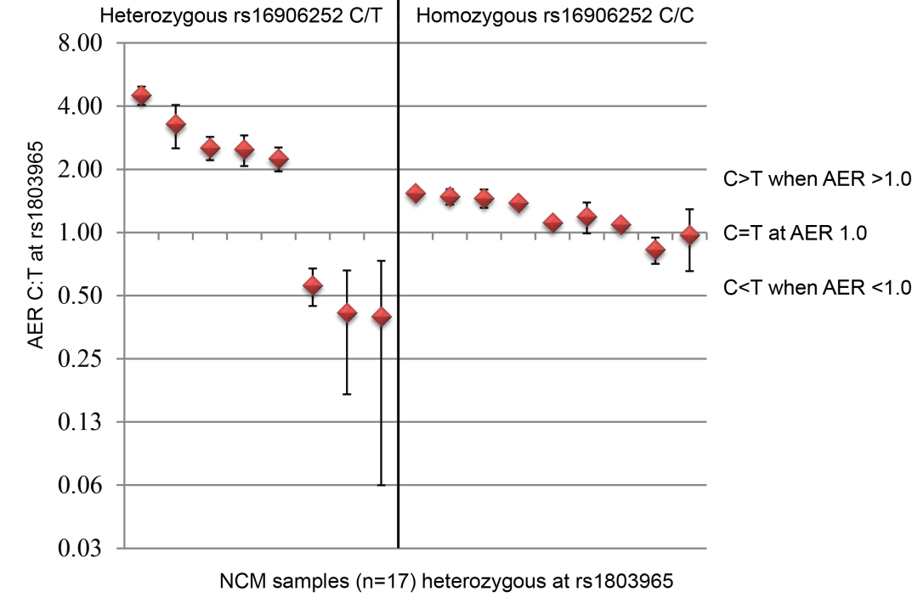
Supplementary Figure 2. Allelic expression ratios of MGMT transcripts in the normal colorectal mucosa (NCM) of colorectal cancer (CRC) patients as measured by allele quantification (AQ) pyrosequencing at exon 3 SNP rs1803965.
All 17 CRC cases were heterozygous for the rs1803965 exon 3 SNP within MGMT at which allelic expression levels were determined by AQ-pyrosequencing (Supplementary Figure 1B). Cases were then segregated by rs16906252 genotype into the heterozygous C/T group (n=8, left) or the homozygous C/C group (n=9, right). AERs are plotted on a log² scale as the normalized ratio of transcript levels derived from the rs1803965 C allele relative to the T allele, and are shown as the mean ± standard deviation from three replicates. Significant variance in the AER was observed in the NCM among cases who were also heterozygous for the rs16906252C>T SNP within exon 1.

