SUPPLEMENTARY FIGURES

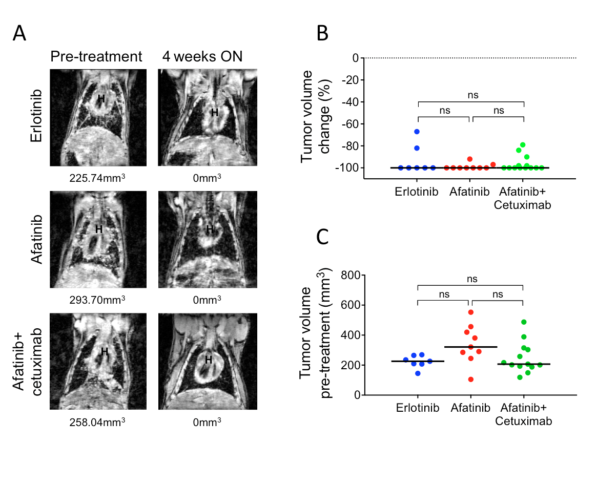

Supplementary Figure S1

A. Coronal MR images of CCSP-rtTA; TetO-EGFR^{L858R} mice pre-treatment and after 4 weeks of treatment with erlotinib, afatinib or afatinib plus cetuximab. Tumor volumes are shown at the bottom of the images. H= heart. B. Scatter plot showing the percent tumor shrinkage after 4 weeks of treatment on erlotinib, afatinib or afatinib plus cetuximab. One-way ANOVA Bonferroni multiple comparison test shows no statistical difference among the groups (p=ns). C. Scatter plot showing the initial tumor volumes in CCSP-rtTA; TetO-EGFR^{L858R} mice used to study tumor recurrence after erlotinib, afatinib or afatinib plus cetuximab treatment. One-way ANOVA Bonferroni multiple comparison test shows no statistical difference among the groups (p=ns).

Supplementary Figure S2

A. Change in body weight during intermittent dosing. Values are plotted as the percentage of the pre-treatment mouse weight.

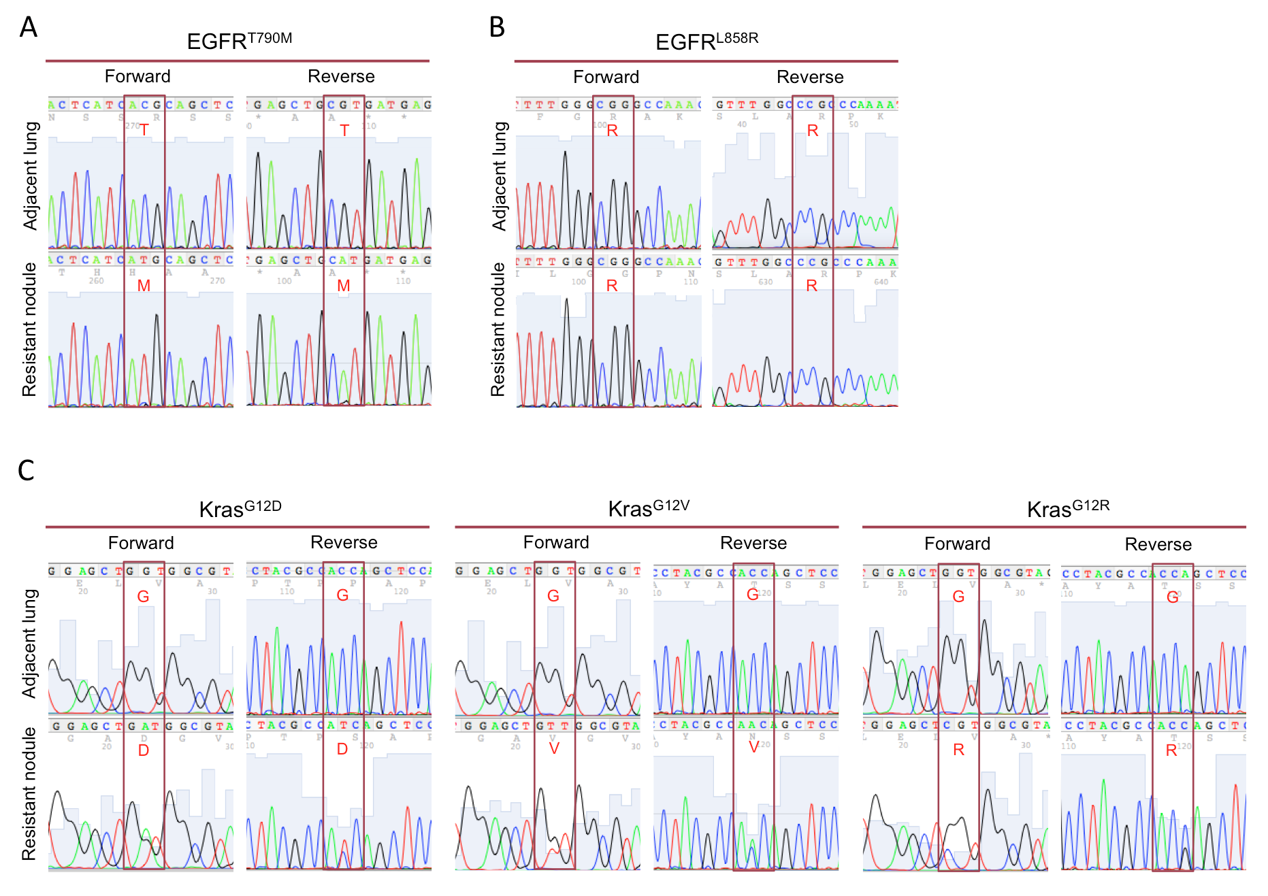

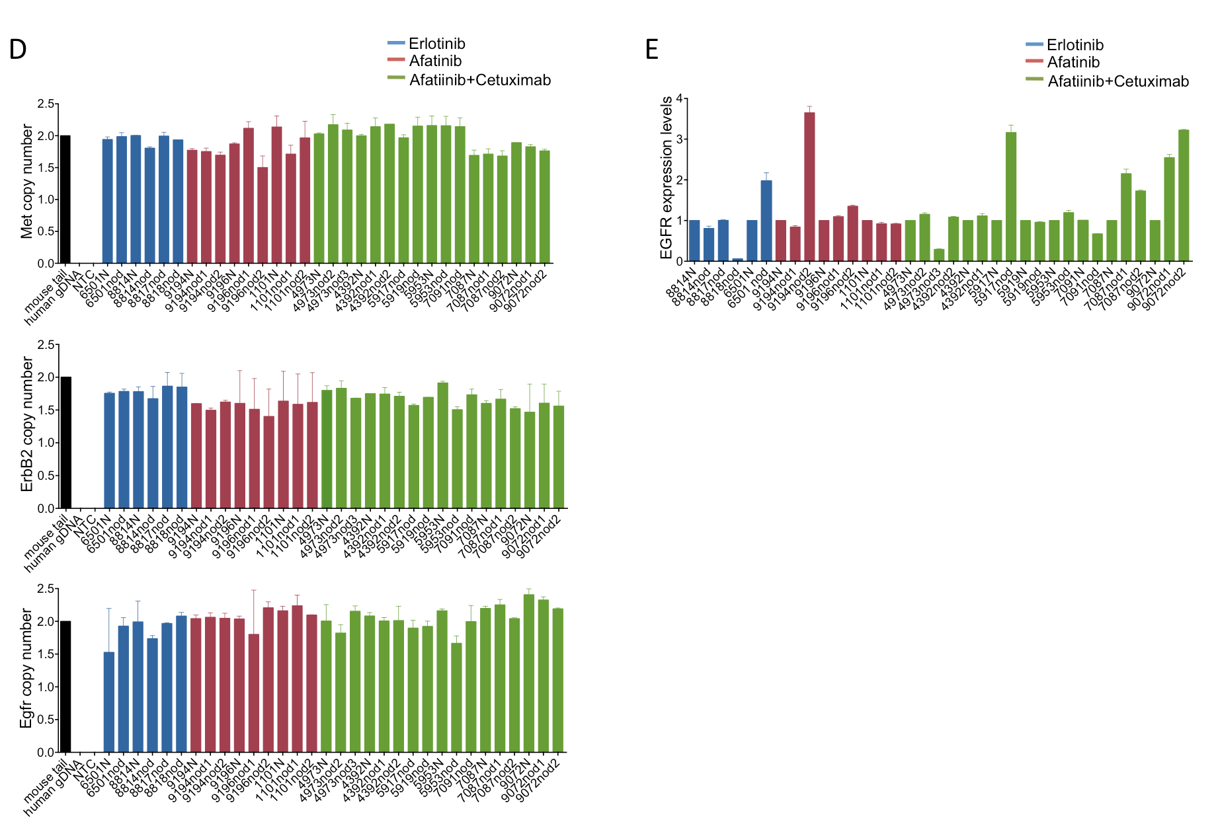

Supplementary Figure S3

Secondary mutations in EGFR in drug-resistant tumors. A. DNA sequencing chromatograms showing the presence of the T790M mutation in a drug resistant nodule from a mouse treated with afatinib plus cetuximab. The mutation is not present in the normal adjacent lung. B. Representative DNA sequencing chromatograms showing the presence of L858R in afatinib plus cetuximab resistant nodules. C. DNA sequencing chromatograms showing 3 Kras mutations found in the afatinib plus cetuximab-resistant nodules 5953, 7091 and 7087nod1 (G12D), 5917 (G12V) and 4392nod1 (G12R). The mutations are not present in the normal adjacent lung. D. Copy number assay for Egfr, Her2 and Met in lung adenocarcinomas from CCSP-rtTA; TetO-EGFR^{L858R} mice. Erlotinib resistant tumors are shown in blue, afatinib-resistant tumors are shown in red and afatibib+cetuximab-resistant tumors are shown in green. In black, genomic DNA from the tail of a C57BL/6J mouse used as “calibrator”. Two assays have been run for ErbB2 and Egfr. The mean and standard error are shown for each sample. N= normal, nod= nodule, NTC= no template control. E. Expression levels of the EGFR transgene in the erlotinib-resistant (blue), afatinib-resistant (red) and afatinib plus cetuximab-resistant (green) tumors. Data are normalized to normal adjacent lung or tail of the same mouse. N= normal, nod= nodule.

