SUPPLEMENTAL MATERIAL

Supplemental Figure 3.

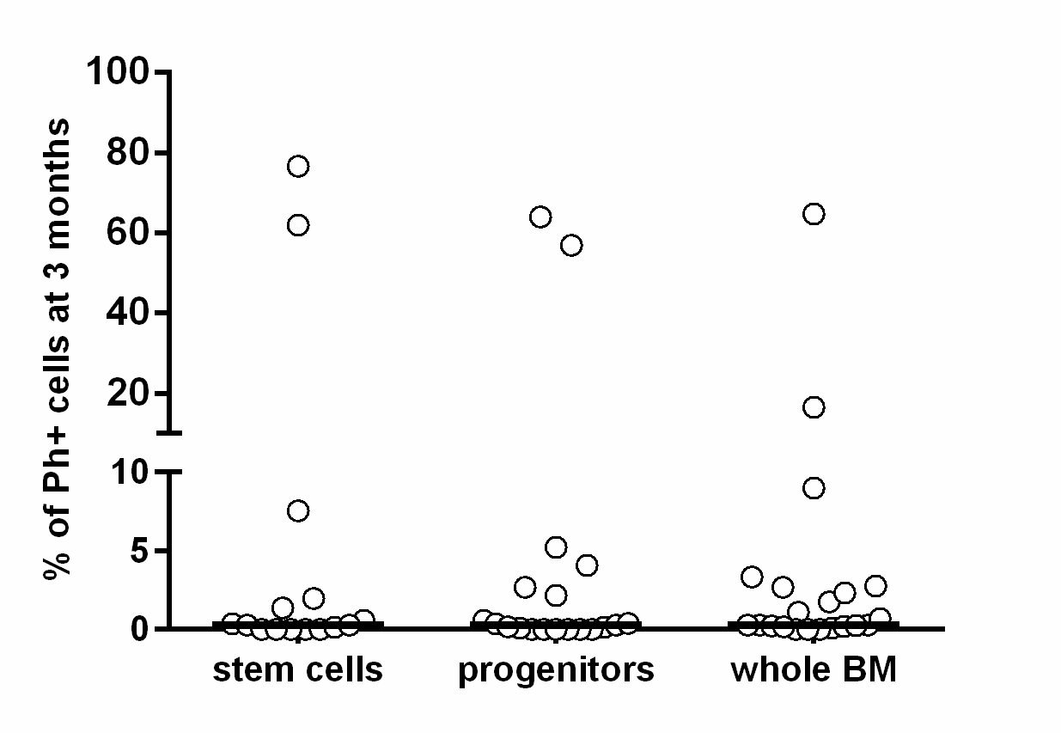
Supplemental Figure 3: The proportion of Ph+ cells at 3 months in the stem and progenitor cell compartment and whole BM as measured by sorting plus FISH. The mean and median percentages of Ph+ cells were 10% and 0.3% in the LSC fractions, 7.2% and 0.3% in the LPC fractions and 5.1% and 0.3% in the whole BM fractions. Black lines represent mean values.

