**Supplementary Figures and Table**

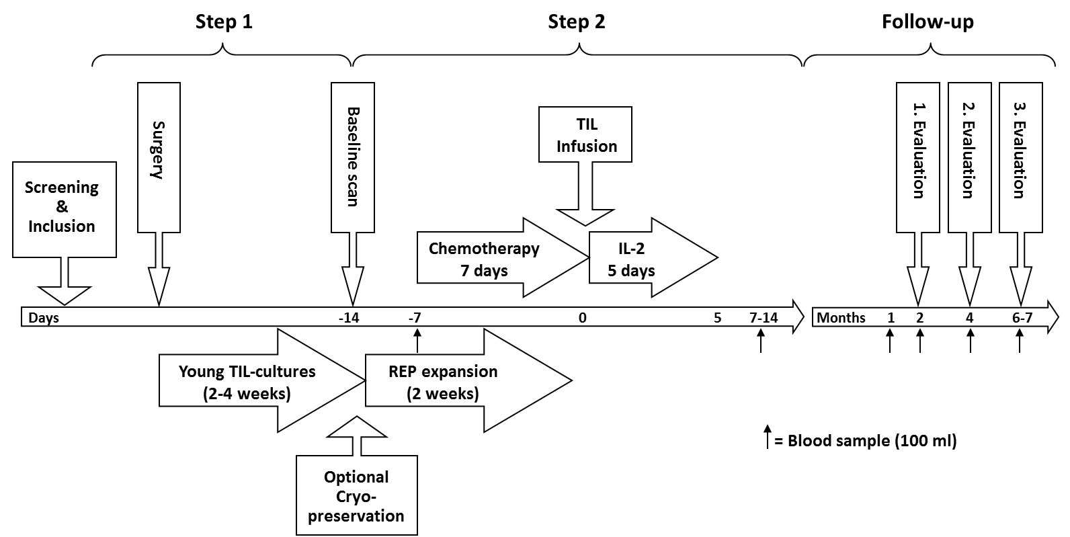

**Supplementary Figure S1. Treatment and monitoring schedule**

Step 1: Suitable tumor lesions are resected and transferred to the laboratory under sterile conditions.

In a tissue culture hood, tumors are cut into small 1-3 mm3 fragments and placed in culture plates with growth medium and IL-2. TILs are initially expanded for 2 to 4 weeks during the Pre-REP phase until at least 50x106 cells are reached. At this stage, the cells can be cryopreserved for future use or entered directly into the two-week Rapid Expansion Protocol (REP).

Step 2: The cells are expanded in the REP with anti-CD3 antibodies, allogeneic irradiated feeder PBMCs and IL-2. Before TIL infusion the patients are treated in-hospital with a 7-days preparative regimen using cyclophosphamide and fludarabine that transiently depletes host lymphocytes, ”making room” for the infused TILs and removing cytokine sinks and regulatory T cells to facilitate TIL persistence. TIL infusion is followed by administration of IL-2 according to the decrescendo-regimen.

Patients are hospitalized for approximately 3 weeks. Imaging evaluations with PET/CT scans are performed shortly before treatment (baseline) and at regular intervals after treatment. Blood samples to investigate blood lymphocytes are drawn before treatment, 1, 4 and 8 weeks after treatment and thereafter whenever the patients are evaluated for clinical response.

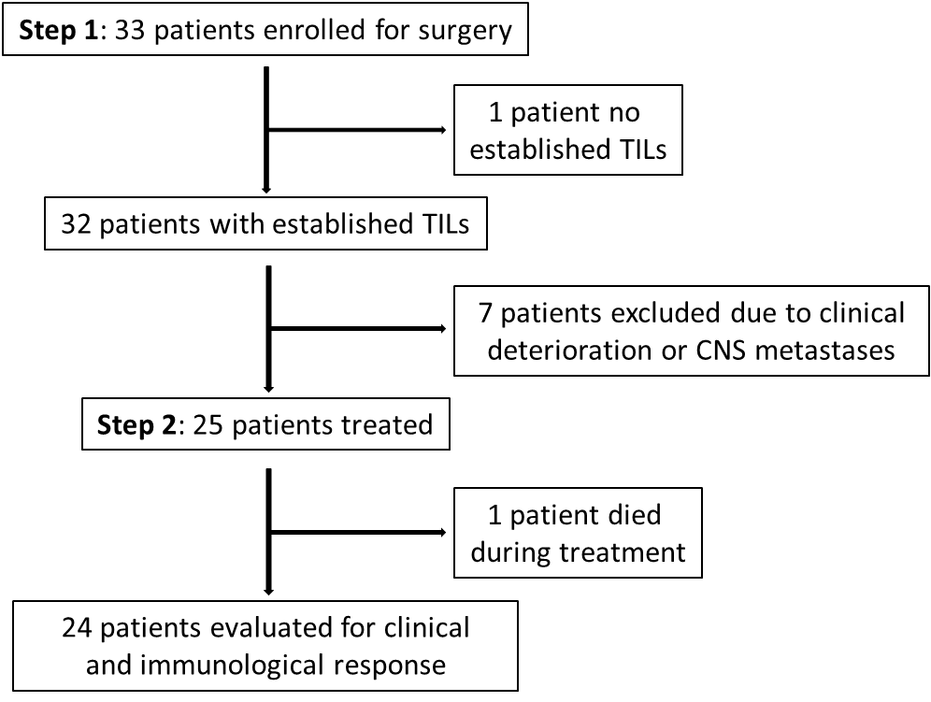

**Supplementary Figure S2. Enrolled patients and number of dropouts.**

Abbreviations: tumor infiltrating lymphocytes, TIL; CNS, central nervous system.

The patients were enrolled in the protocol in a two-step enrolment process. Step 1 includes surgery and initial TIL expansion and possible cryopreservation of the cells and step 2 is enrolment for treatment.

33 patients with metastatic melanoma were enrolled in the study in step 1. One patient was excluded due to unsuccessful TIL culture generation and seven patients were excluded during TIL establishment due to clinical deterioration (n=4) or development of CNS metastases (n=3). 25 patients were included for treatment (step 2). In 11 of the 25 treated patients (44%) the TILs were cryopreserved prior to final expansion in the REP and time from surgery to TIL transfer ranged from 26-251 days. The two-step enrolment process allowed enrolment in step 1 with initial manufacturing and cryopreservation of the TILs for patients not yet eligible for TIL transfer (e.g. patients that was not in RECIST progression after previous therapy). When these patients became eligible they were enrolled in step 2 and the TILs were thawed and expanded in the REP. The two-step enrolment process with optional TIL cryopreservation makes the treatment more flexible and may decrease patient drop-out due to deterioration of clinical performance, but increases the number of patients who will never be eligible for TIL transfer therapy.

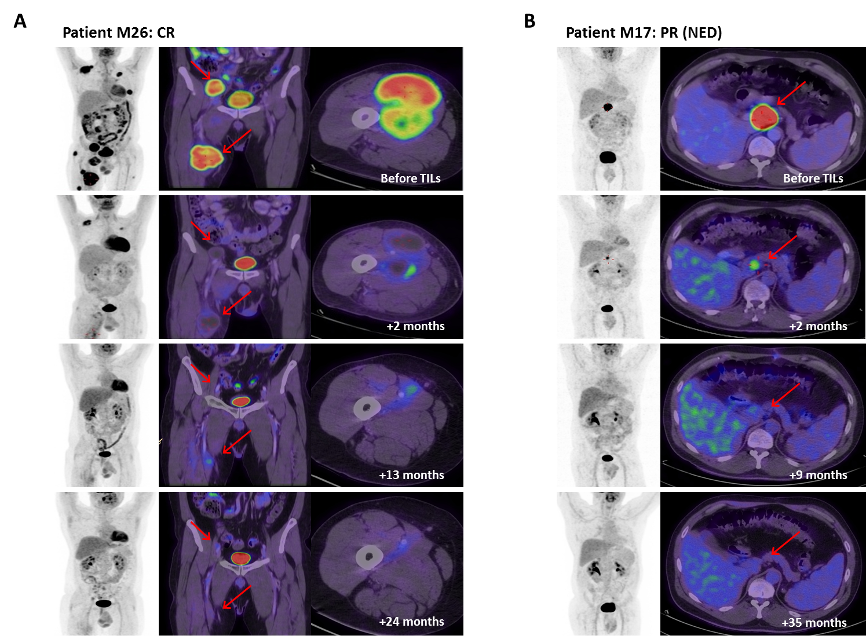

**Supplementary Figure S3**

The figure shows FDG-PET/CT scans of two responding patients.

(A) FDG-PET/CT scans from patient M26 showing an initial considerable partial response (PR) 2 month after treatment followed by slowly regression of remaining tumor lesions. The patient achieved a complete response (CR) according to RECIST 13 months after treatment. The patient has an ongoing CR 32 months after TIL-ACT.

(B) Patient M17 had disease localized to an unresectable lymph node in the liver hilum. After treatment the lymph node metastasis were significantly reduced in size and metabolic activity and the patient obtained a partial response (PR). 7 Months after treatment the lymph node metastasis was surgically resected and histological examination confirmed malignant melanoma cells. The patient is without evidence of disease (NED; no evidence of disease) more than 45 months after TIL-ACT.

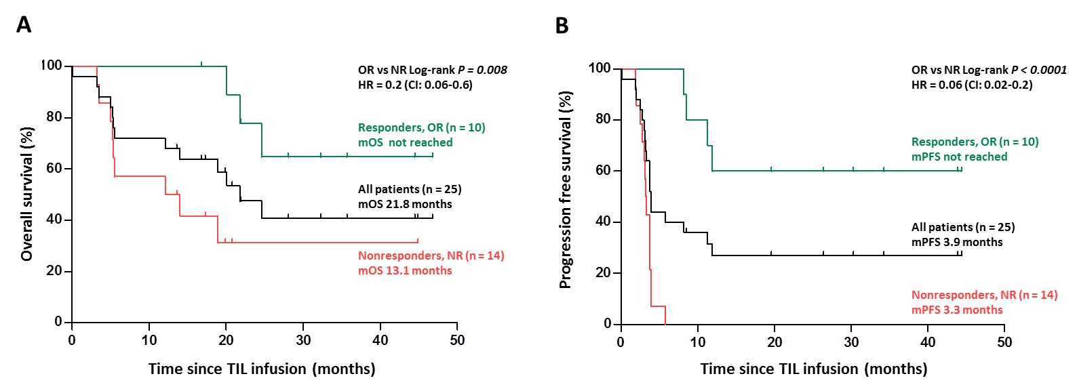

**Supplementary Figure S4.** Kaplan-Meier curves of (A) overall survival and (B) progression free survival in all 25 treated patients. Separate survival curves are shown for responders (OR) in green (n = 10) and for non-responders (NR) in red (n = 14) and curves are compared by the log-rank test.

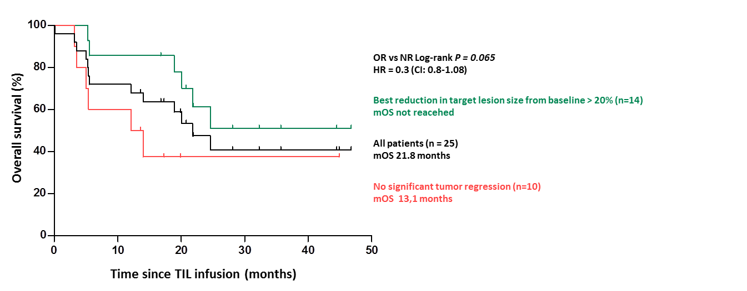

**Supplementary Figure S5.** Kaplan-Meier curves of overall survival in all 25 treated patients including separate survival curves for patients with best reduction in target lesion size from baseline >20% (n=14) in green and patients with no significant tumor regression (n=10) in red. Curves are compared by log-rank test.

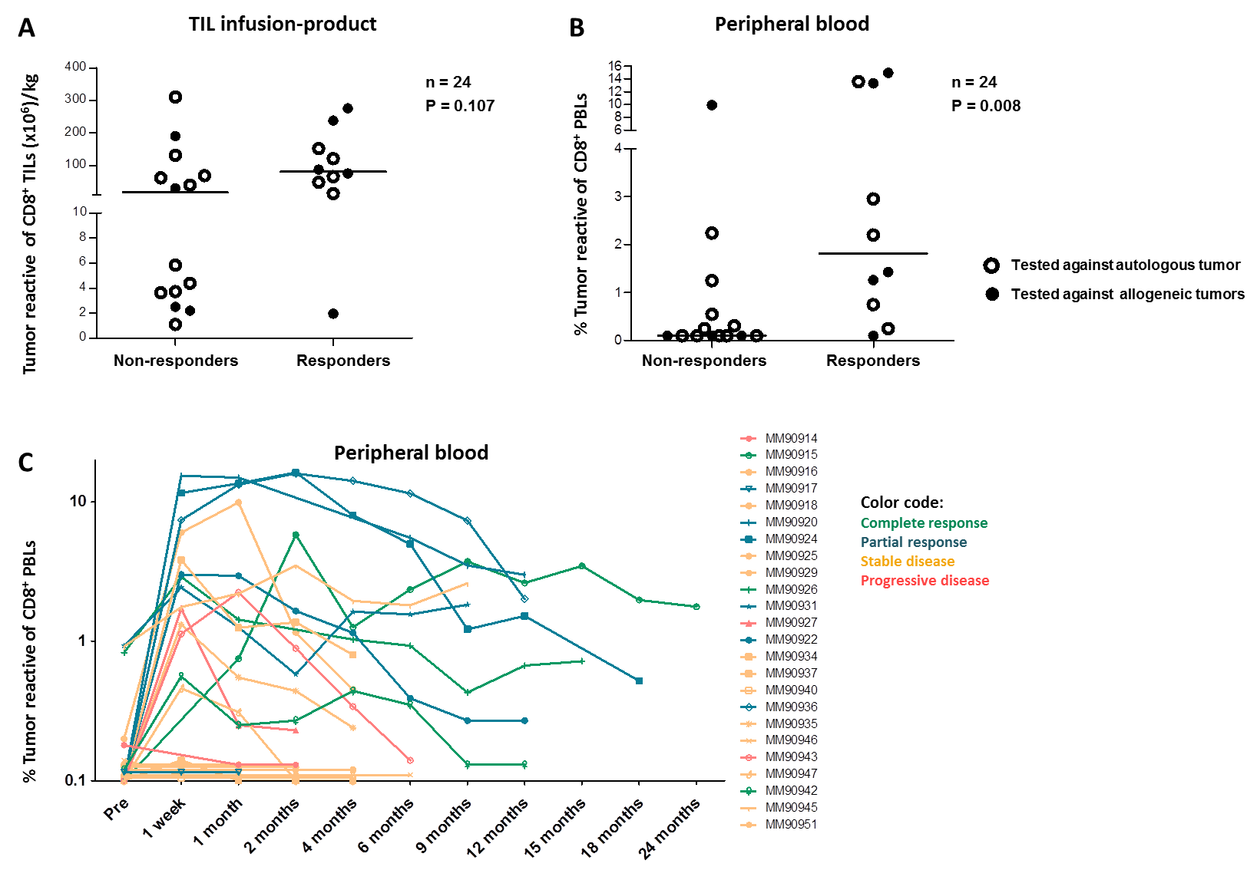

**Supplementary Figure S6. Antitumor responses of infusion products and peripheral blood.** TILs or peripheral blood lymphocytes (PBLs) were co-cultured with autologous short-term cultured melanoma cell lines or HLA-semimatched allogeneic melanoma cell lines, and tumor reactivity was evaluated by assessing the amount of CD8+ T cells staining double positive for any combination of IFN-, TNF, or CD107a.

(A) The figure shows the absolute number per kg of bodyweight of *in vitro* tumor-reactive TILs contained in the infusion products, and its association with tumor regression in 24 patients. Patients are stratified in responders (n=10) and non-responders (n=14) according to RECIST 1.0.

(B) The figure shows the percentage tumor-reactive of CD8+ (CD3+) PBLs one month after treatment and its association with tumor regression in 24 patients. Patients are stratified in responders (n=10) and non-responders (n=14) according to RECIST 1.0.

(C) The figure shows induction and persistence of antitumor responses in the blood of the treated patients (n=24). Patients are stratified into “complete responders (CR)” in green (n=3), “partial responders” in blue (n=7), stable disease in yellow (n=11) and progressive disease in red (n=3).



**Supplementary Table S1**

Objective responses of individual patients in relation to prior immunotherapies, including IL-2/IFN-, ipilimumab and TIL-ACT.