Kroeger et al. Supplementary Materials:
Detailed Materials and Methods:
Biospecimens and patient characteristics
Biological specimens and associated clinical data were obtained with either informed written consent or a formal waiver of consent under protocols approved by the Research Ethics Board of the BC Cancer Agency (BCCA) and the University of British Columbia (Vancouver BC). Survival analyses were performed using a previously described 172-case tissue microarray (TMA; 0.6 mm duplicate cores) containing primary tumor samples from HGSC patients seen at the BC Cancer Agency from 1984 to 2000 (Table S5)(1,2). Patients in this cohort had not received chemotherapy prior to surgery and were deemed optimally de-bulked, meaning they had no macroscopic residual disease following surgery. Other analyses used primary tumor specimens from a prospective HGSC cohort (2007-present), which were obtained through the BCCA’s Tumour Tissue Repository, a member of the Canadian Tissue Repository Network. Gene-expression analysis and survival was based on 578 ovarian serous cystadenocarcinoma cases from The Cancer Genome Atlas(3). Clinical characteristics are available for download (tcga-data.nci.nih.gov/tcga/).

Flow cytometry and cell sorting
After thawing at 37⁰C, disaggregated tumor cell suspensions were washed and labeled with a viability dye (eFluor 780; eBiosciences, San Diego CA) followed by fluorophore-conjugated monoclonal antibodies to cell surface proteins (Table S6). Flow cytometry was performed using a BD Influx instrument (Mississauga ON). For B cell sorting experiments, cells were labeled with FITC-anti-IgD, PE-anti-CD19, and PerCP-Cy5.5-anti-CD38. Memory B cells (CD19+IgD-CD38-) and plasma cells (CD19+, IgD-, CD38hi) were sorted into separate collection tubes and immediately resuspended in buffer RLTplus supplemented with 2-mercaptoethanol (QIAGEN, Venlo, Netherlands) for IgG sequencing (below). Data were analyzed with FlowJo software v10.0.7 (TreeStar Inc., Ashland OR).

IgG sequence analysis
RNA was extracted from FACS-purified memory B cells and plasma cells (1-5 x10³ of each) and bulk tumor cells (2.5 x 10⁶) using the RNeasy mini spin kit (QIAGEN, Venlo, Netherlands) and stored at -80C. RNA was converted to cDNA using the qScript cDNA synthesis kit (Quanta Biosciences, Gaithersburg MD), and PCR reactions were performed using primers designed to amplify all known immunoglobulin variable regions from IGHG-containing transcripts as per Tiller et al.(4). Resulting PCR products were molecularly cloned into a plasmid vector containing the constant portion of human IgG1 (GenBank accession no. DQ407610) and transformed into the DH5α E. coli strain. Up to 192 colonies per sample were picked and subjected to Sanger sequencing (Beckman Coulter Genomics, Danvers, MA). VDJ junctions were determined using IMGT-Vquest(5). Identical sequences were collapsed, and divergent sequences sharing VDJ elements were deemed to be somatically hypermutated derivatives of a common B cell clone.

Immunohistochemistry
Unless otherwise stated, all IHC instruments and reagents were obtained from Biocare Medical (Concord CA). Antibodies and sources are listed in Table S6. For multicolor IHC, 4 μm sections of formalin-fixed paraffin embedded tissue were deparaffinized, subjected to antigen retrieval with Diva decloaker reagent (125⁰C for 30 seconds), and loaded into an Intellipath FLX Autostainer. Slides were blocked with Peroxidased-1 and Background Sniper, and primary antibodies were applied for 30 minutes at room temperature. This was followed with Mach2 Mouse-AP polymer and Rat 1 step-HRP polymer (30 minutes each) and color development with Ferangi Blue and Deep Space Black chromogens. After the first round of staining, slides were denatured by incubating at 50⁰C for 45 minutes in a low pH SDS-glycine solution as our previous publication(6). Second and third rounds of staining involved similar steps but with appropriate diluents (Renaissance background reducing, Da Vinci Green, Van Gogh Yellow), polymers (Mach2 Double Stain #2, Mach2 Mouse-HRP polymer, Mach2 rabbit-HRP polymer), and chromogens (Warp Red, DAB, Bajoran Purple, Vina Green, and Hi Def Green from Enzo Life Sciences, Brockville ON). Stained slides were washed with water, air-dried and coverslipped using Ecomount.

Image analysis and scoring
TIL and TLS were scored on whole tumor sections stained with antibodies to CD3, CD8, CD20, CD21, CD208, and PNAd (Table S2). Stained sections were imaged with an Aperio ScanScope (Leica Biosystems, Wetzlar Germany) and analyzed using ImageScope software v12.1 (Aperio Technologies, Vista CA) with the Stereology Toolkit v4.2.0 (ADCIS, Saint-Contest, France). Ten random 20x fields were selected, and TIL populations were enumerated and normalized to the area of tumor epithelium evaluated. TLS-proximal TIL density was determined by analyzing tumor epithelium within 500 µm of a germinal center, and cell counts were normalized per unit area of a 20x field. PC density was determined using a four-point scale modified from Lohr et al.: (0 = no plasma cells present, 1 = plasma cells represent 1-20% of stroma, 2 = 21-75%, 3 = 76-100%)(7). For the survival analysis, PCs were scored as present or absent. Display images were generated with an Olympus BX53 microscope (Olympus, Waltham MA ) and Nuance multispectral camera (CRi, now part of Perkin-Elmer, Waltham MA), and brightness levels were adjusted using Adobe Photoshop CS6.

NanoString gene expression analysis
Total RNA was prepared from FFPE whole tumor sections using the AllPrep DNA/RNA FFPE kit (Ambion, Life Technologies, Carlsbad CA). Total RNA (200 ng) was analyzed using the Pan Cancer Immune Profiling panel and nCounter platform (NanoString Technologies, Seattle WA). Data was normalized using nSolver software with default settings. Differentially expressed genes were identified by comparing averaged log-scaled read counts between samples.

Bioinformatic analysis of The Cancer Genome Atlas dataset
Gene expression microarray data and associated clinical data were downloaded from bioconductor (bioconductor.org) as an R package (“curatedOvarianData”(8)). Raw expression values were converted to z-scores. Corresponding RNA-seq normalized read count values (fragment per kilobase per million reads; FPKM) and non-synonymous point mutation counts were derived from TCGA RNA seq files(9) and provided by Scott Brown and Dr. Rob Holt (Genome Sciences Center, BCCA, Vancouver, Canada). The number of potential immunogenic point mutations per case was determined by filtering using the Immune Epitope Data Base (iedb.org) netMHCpan algorithm(10) to identify mutant peptides predicted to bind autologous HLA-A alleles with <500 nM affinity(9). BRCA1, BRCA2, and TP53 mutation status were obtained from TGCA through c-Bioportal (cbioportal.org) and appended to gene expression data. BRCA1 promotor methylation calls were kindly provided by Dr. Douglas Levine (Memorial Sloan Kettering Cancer Center, New York, NY). mRNA expression of differentiation and overexpressed antigens (from the Cancer Immunity website at cancerimmuity.org) and cancer-testis (CT) antigens (from the CTdatabase at cta.lncc.br) were determined from the TCGA gene expression dataset using a threshold value of three standard deviations from the mean (z-score=3). Semi-supervised hierarchical clustering of CT antigens based on column means was accomplished by restricting sample order and using Euclidean distance calculations.

Statistical analysis
Statistical analyses were performed using R v3.1.1 and GraphPad Prism v6.0. As indicated, t tests, one-way ANOVA with post hoc Tukey corrections, and Mann-Whitney tests were used to compare means. Chi-squared analysis and Fisher’s exact test were used to test proportional relationships. Linear regression analysis and Spearman’s correlation were used to determine relationships between TIL and plasma cells. Survival analysis was performed using Kaplan-Meier plots and log-rank tests. P-values of less than 0.05 were considered significant unless otherwise stated.
References:

1. Milne K, Kobel M, Kalloger SE, Barnes RO, Gao D, Gilks CB, et al. Systematic analysis of immune infiltrates in high-grade serous ovarian cancer reveals CD20, FoxP3 and TIA-1 as positive prognostic factors. PLoS One. 2009;4(7):e6412.

2. Clarke B, Tinker AV, Lee CH, Subramanian S, van de Rijn M, Turbin D, et al. Intraepithelial T cells and prognosis in ovarian carcinoma: novel associations with stage, tumor type, and BRCA1 loss. Mod Pathol. 2009;22(3):393-402.

3. TCGA. Integrated genomic analyses of ovarian carcinoma. Nature. 2011;474(7353):609-615.

4. Tiller T, Busse CE, Wardemann H. Cloning and expression of murine Ig genes from single B cells. J Immunol Methods. 2009;350(1-2):183-193.

5. Brochet X, Lefranc MP, Giudicelli V. IMGT/V-QUEST: the highly customized and integrated system for IG and TR standardized V-J and V-D-J sequence analysis. Nucleic Acids Res. 2008;36(Web Server issue):W503-508.

6. deLeeuw RJ, Kroeger DR, Kost SE, Chang PP, Webb JR, Nelson BH. CD25 Identifies a Subset of CD4+FoxP3- TIL That Are Exhausted Yet Prognostically Favorable in Human Ovarian Cancer. Cancer Immunol Res. 2015;3(3):245-253.

7. Lohr M, Edlund K, Botling J, Hammad S, Hellwig B, Othman A, et al. The prognostic relevance of tumour-infiltrating plasma cells and immunoglobulin kappa C indicates an important role of the humoral immune response in non-small cell lung cancer. Cancer Lett. 2013;333(2):222-228.

8. Ganzfried BF, Riester M, Haibe-Kains B, Risch T, Tyekucheva S, Jazic I, et al. curatedOvarianData: clinically annotated data for the ovarian cancer transcriptome. Database (Oxford). 2013;2013:bat013.

9. Brown SD, Warren RL, Gibb EA, Martin SD, Spinelli JJ, Nelson BH, et al. Neo-antigens predicted by tumor genome meta-analysis correlate with increased patient survival. Genome Res. 2014;24(5):743-750.

10. Nielsen M, Lundegaard C, Blicher T, Lamberth K, Harndahl M, Justesen S, et al. NetMHCpan, a method for quantitative predictions of peptide binding to any HLA-A and -B locus protein of known sequence. PLoS One. 2007;2(8):e796.

No. distinct seqs. | IGHV-gene and allele | identity % | IGHD-gene and allele | IGHJ-gene and allele | identity % | Amino acid sequence of VDJ junction
15 | 5-10-1*03 F | 95.83 | 6-6*01 F | 4*02 F | 93.75 | CVRHRRTAWYLDYW
5 | 3-11*04 F | 90.62 | unknown | 3*01 F | 85.42 | CGRGPIDFW
4 | 4-34*01 F | 91.93 | 1-26*01 F | 3*02 F | 94.00 | CARRHSGTSSSAFDIW
4 | 4-31*03 F | 85.91 | 5-24*01 | 3*01 F | 88.00 | CARSDGYNIRARAFDVW
3 | 1-2*02 F | 95.14 | D2-15*01 F | 3*02 F | 95.83 | CARLKGVGASRRGYLDYW
5 | 4-59*01 F | 97.89 | D1-26*01 F | 6*02 F | 93.55 | CARVSGHYYYYAMDVW
3 | 1-58*01 F | 91.67 | D3-3*01 F | 6*02 F | 85.48 | CAADGGYDDFRSGYHRNYDFAMDVR
3 | 4-61*02 F | 90.03 | D3-3*01 F | 5*01 F | 94.12 | CARETWSGYYDCFDSW
3 | 4-31*02 F | 97.59 | 2-21*02 F | 3*02 F | 96.00 | CARESLVTAAFDIR
2 | 3-30*03 F | 97.57 | 3-3*01 F | 6*02 F | 82.26 | CAKDHGGRFSFLYGKDVW
2 | 1-46*01 F | 96.18 | 2-21*02 F | 6*02 F | 88.71 | CARMDCGGDCFDTEYHWFYGMDVW
1 | 3-30*03 F | 93.40 | 6-6*01 F | 4*02 F | 89.58 | CAEEGISARRFDYW
1 | 1-3*01 F | 98.26 | 6-19*01 F | 5*02 F | 94.12 | CAKAEGGWYWFDPW
1 | 3-48*01 F | 86.81 | 3-3*01 F | 6*02 F | 91.94 | CAKEDRSLDYYYGMDVW
1 | 1-69*09 F | 96.18 | 3-9*01 F | 6*02 F | 88.71 | CARANVSYDILTGRDFYYAMDVW
1 | 4-31*09 F | 97.93 | 2-21*01 F | 6*02 F | 82.26 | CARDEKRFLYGMDVW
1 | 3-11*06 F | 97.92 | 3-3*01 F | 6*02 F | 75.81 | CARDMESYDFWTGYYIFSEVTGVW
1 | 4-59*01 F | 91.23 | 7-27*01 F | 6*02 F | 90.32 | CARDPGNRDPTYDYYYGMDVW
1 | 3-7*03 F | 88.54 | 1-26*01 F | 6*01 F | 81.36 | CARDRGSDGMDVW
1 | 1-2*02 F | 96.88 | 2-2*01 F | 6*02 F | 83.87 | CARGGEDQLLFFYGMDVW
1 | 4-39*01 F | 88.32 | 3-3*01 F | 4*02 F | 85.42 | CARHGAGYHDFRSGFLPLDYW
1 | 5-10-1*03 F | 96.88 | 3-22*01 F | 6*02 F | 91.94 | CARHHSPPSGYLYPYYYGMDVW
1 | 3-48*02 F | 96.84 | 1-26*01 F | 4*02 F | 87.50 | CARNSGSYWVADYW
1 | 4-38-2*02 F | 89.58 | 3-22*01 F | 4*02 F | 85.42 | CARQGSYNSDNTGYFSDFW
1 | 1-2*02 F | 94.44 | D3-10*01 F | 6*04 F | 88.89 | CARRPGSGRGSGSPRSPYYYYLGMDVW
1 | 3-15*01 F | 97.28 | D1-20*01 F | 6*02 F | 91.94 | CRRDNWNLGTNYYYGMDVW
1 | 5-10-1*03 F | 97.22 | 3-10*01 F | 4*02 F | 93.75 | CVRHRRTAWASDTAMYYCARHRRAGWNFDYW
1 | 1-18*04 F | 93.75 | 1-26*01 F | 6*02 F | 88.71 | RALGGGYYYYALDVW
Table S1. PC-derived immunoglobulin heavy (IGH) V, D, and J region usage and consensus junction amino acid sequences for distinct VDJ families as determined by Sanger sequencing and IMGT V-QUEST alignment (reference 67). Shown are sequences derived from sorted intratumoral PCs from a single patient sample. Data are representative of three out of three independent tumors.
Table S2. Genes with greater than 10-fold differential expression between tumors with high numbers of PC (“PC”, n=4) versus no B-lineage cells (“no PC/B cells” n=3), or high numbers of PC versus tumors with CD20+ TIL but without PCs (“B cells”, n=2) (based on average transcript counts in NanoString analysis of FFPE tumor tissue).

PC vs no PC/B cells |  |  | PC vs no PC/B cells (cont.) |  |  | PC vs no PC/B cells (cont.) |  |  | PC vs B cells
gene | Log10 difference |  | gene | Log10 difference |  | gene | Log10 difference |  | gene | Log10 difference
CXCL11 | 1.001640947 |  | DDX43 | 1.292921578 |  | SLAMF1 | 1.790527677 |  | SMPD3 | 1.018385581
KLRB1 | 1.004321848 |  | LILRA5 | 1.300056135 |  | HAMP | 1.798128501 |  | IL22RA2 | 1.051370816
CTLA4 | 1.006753042 |  | CD274 | 1.300216854 |  | CD3G | 1.817972112 |  | DMBT1 | 1.066439959
CXCR3 | 1.009043315 |  | TNFSF8 | 1.320463148 |  | CCR7 | 1.893791274 |  | POU2AF1 | 1.078016287
SH2D1A | 1.029119398 |  | PDCD1 | 1.347145077 |  | MAGEA3 | 1.981191215 |  | S100A7 | 1.09752199
CD5 | 1.030296902 |  | XCR1 | 1.36459708 |  | CT45A1 | 1.993577059 |  | CXCL5 | 1.118679107
ICOS | 1.04421094 |  | CD38 | 1.365388348 |  | CEACAM6 | 2.001385812 |  | IL5RA | 1.138909679
TNFRSF13B | 1.053988333 |  | MARCO | 1.374080412 |  | MAGEC2 | 2.028084915 |  | HAMP | 1.145753586
S100A12 | 1.063526422 |  | CCR4 | 1.375081875 |  | MAGEC1 | 2.103192994 |  | CEACAM6 | 1.154706384
CCL8 | 1.065892979 |  | SLAMF6 | 1.397385358 |  | POU2AF1 | 2.249916713 |  | LTK | 1.174187463
CD40LG | 1.068836578 |  | SLAMF7 | 1.420868232 |  | CCL18 | 2.260896349 |  | TNFRSF17 | 1.177764181
GZMB | 1.069234388 |  | IRF4 | 1.430060926 |  | CD79A | 2.533551218 |  | CLEC6A | 1.182205435
IL5RA | 1.120317113 |  | CCL21 | 1.44231369 |  | DMBT1 | 2.59760075 |  | CXCL13 | 1.217256307
SMPD3 | 1.126692452 |  | MAGEA4 | 1.469747549 |  | HLA-DRB4 | 2.647605727 |  | CCL25 | 1.25816707
LTF | 1.147988944 |  | CCL19 | 1.505765391 |  |  |  |  | CD207 | 1.306352239
GZMM | 1.157985827 |  | KLRG1 | 1.517409382 |  |  |  |  | DDX43 | 1.311514144
S100A8 | 1.163337108 |  | CCL7 | 1.521629967 |  |  |  |  | CCL7 | 1.314030257
S100A7 | 1.196204119 |  | MS4A1 | 1.530832384 |  |  |  |  | IL6 | 1.376642122
CD2 | 1.202954362 |  | SSX4 | 1.549184056 |  |  |  |  | MAGEA3 | 1.4041579
CD27 | 1.217500289 |  | CXCL13 | 1.63752027 |  |  |  |  | MAGEA4 | 1.488340115
FLT3 | 1.219476255 |  | LILRA4 | 1.653138193 |  |  |  |  | SSX4 | 1.567776622
CXCL10 | 1.229019183 |  | CLEC4C | 1.654370413 |  |  |  |  | TPTE | 1.749992088
CXCL9 | 1.23105401 |  | PPBP | 1.679778304 |  |  |  |  | LILRA4 | 1.800963915
CCR2 | 1.255728643 |  | CCL13 | 1.746501877 |  |  |  |  | C4BPA | 1.808171241
BTLA | 1.281868232 |  | TNFRSF17 | 1.747847454 |  |  |  |  | MAGEC2 | 2.012751361
IL18RAP | 1.284894972 |  | C4BPA | 1.789578675 |  |  |  |  | MAGEC1 | 2.12178556

Table S3. Differentiation, overexpressed, and CT antigen genes analyzed for expression in TCGA microarray data.

differentiation antigens |  | overexpressed antigens |  |  | CT antigens
CEACAM1 |  | AFP | MDM2 |  | ACTL8 | GPATCH2 | NXF2 | SPO11
CEACAM21 |  | AIM2 | MMP2 |  | ADAM2 | IL13RA2 | ODF1 | SSX1
CEACAM3 |  | ALDH1A1 | MMP7 |  | ADAM29 | IMP3 | ODF2 | SSX2B
CEACAM4 |  | BCL2L1 | MUC1 |  | AKAP3 | KIAA0100 | OIP5 | SSX2
CEACAM5 |  | WDR46 | MUC5AC |  | AKAP4 | LDHC | PAGE1 | SSX3
CEACAM6 |  | BIRC5 | PLIN2 |  | ATAD2 | LUZP4 | PAGE4 | SSX4
CEACAM7 |  | CA9 | PTTG1IP |  | BRDT | MAGEA1 | PBK | SSX5
CEACAM8 |  | CALCA | RGS5 |  | CABYR | MAGEA10 | PIWIL2 | SSX6
KLK3 |  | CCND1 | RHOC |  | CASC5 | MAGEA11 | PLAC1 | SSX7
MLANA |  | CES2 | RNF43 |  | CCDC33 | MAGEA12 | PRAME | SYCP1
PMEL |  | CPSF1 | SCRN1 |  | CEP290 | MAGEA2 | PRM1 | TAF7L
RAB38 |  | CSF1 | SMCP |  | CEP55 | MAGEA4 | PRM2 | TDRD1
SCGB2A2 |  | MDK | SOX10 |  | CRISP2 | MAGEA5 | PTPN20B | TEX14
TYRL |  | DKK1 | STEAP1 |  | CSAG3 | MAGEA6 | ROPN1 | TEX15
TYRP1 |  | ENAH | TERT |  | CTAG1A | MAGEA8 | RQCD1 | TFDP3
 |  | EPCAM | TP53 |  | CTAG2 | MAGEA9 | SAGE1 | THEG
 |  | EPHA3 | TPBG |  | CTAGE1 | MAGEB1 | SEMG1 | TMEFF1
 |  | ERBB2 | VEGF |  | CTAGE5 | MAGEB2 | SPA17 | TPTE
 |  | EZH2 | WT1 |  | CTNNA2 | MAGEB3 | SPAG1 | TSGA10
 |  | FGF5 |  |  | DDX43 | MAGEB4 | SPAG4 | TSPY10
 |  | FOLH1 |  |  | DKKL1 | MAGEC1 | SPAG6 | TSPY6P
 |  | GPC3 |  |  | DMRT1 | MAGEC2 | SPAG8 | TTK
 |  | HPN |  |  | DNAJB6 | MAGEC3 | SPAG9 | TULP2
 |  | IL13RA1 |  |  | ELOVL4 | MORC1 | SPANXB2 | VENTXP1
 |  | KIF20A |  |  | GAGE1 | NOL4 | SPANXB2 | XAGE1B
 |  | LGSN |  |  | GAGE12J | NR6A1 | SPANXC | ZNF165

Table S4. List of genes that by hierarchical clustering were differentially expressed in tumors with a PC signature (Fig. S3).

Enriched in “PC”
CRISP2 | MAGEA6
CSAG3 | MAGEA8
CTAG1A | MAGEA9
CTAG2 | NXF2
DDX43 | PAGE1
GAGE1 | PAGE4
IL13RA2 | SSX1
KIAA0100 | SSX2
LDHC | SSX3
MAGEA1 | SSX4
MAGEA10 | SSX5
MAGEA11 | SSX6
MAGEA12 | SSX7
MAGEA2 | TPTE
MAGEA4 | XAGE1B
MAGEA5

Table S5. Clinical characteristics of HGSC patients represented on the 172-case TMA used for survival analysis; P-values refer to results of univariate analyses between the indicated variable and disease-specific survival using one-way ANOVA or chi-squared tests.

Parameter |  | Value | Univariate P-value
Median disease-specific survival |  | 4.8 years
Age  Median (range) |  | 71.3 years (37.6-85.9) | 0.044
FIGO Stage | I | 43 cases (25%) | 0.053
 | II | 71 cases (41%)
 | III | 58 cases (34%)
Grade | 2 | 51 cases (30%) | 0.52
 | 3 | 121 cases (70%)

Table S6. Antibodies used in this study.

Flow Cytometry
Marker | Clone | Supplier | Isotype
CD138 | MI15 | BD bioscience | mIgG1, k
CD19 | HIB19 | BD bioscience | mIgG1, k
CD20 | 2H7 | BD horizon | mIgG2b, k
CD27 | O323 | eBioscience | mIgG1, k
CD38 | HIT2 | Biolegend | mIgG1
CD95 | DX2 | Biolegend | mIgG1, k
CXCR3 | CEW33D | eBioscience | mIgG1, k
CXCR5 | RF8B2 | BD bioscience | rIgG2b, k
IgD | 1A6-2 | BD bioscience | mIgG2a
IgG | G18-145 | BD bioscience | mIgG1, k
Immunohistochemistry
Marker | Clone | Supplier | Isotype
CD3 | SP7 | Spring Biosciences | rbIgG
CD8 | C8/144B | Cell Marque | mIgG1,k
CD20 | L26 | Biocare Medical | mIgG2a,k
CD21 | 2G9 | Biocare Medical | mIgG2a
CD79a | SP18 | Spring Biosciences | rbIgG
CD138 | B-A38 | Biocare Medical | mIgG1
CD38 | SP149 | Spring Biosciences | rbIgG
CD208 | 1010E1.01 | Novus Biologicals | rtIgG2a
AID | Ek2-5G9 | AbD Serotec | rtIgG2b
CD20 | N/A | Spring Bioscience | RbPAb
BCL-6 | LN22 | Biocare Medical | mIgG2b
PNAd | MECA-79 | Biolegend | rtIgM
L26 +CD3 | L26 + CD3 | Biocare Medical | mIgG2a,k + rbIgG

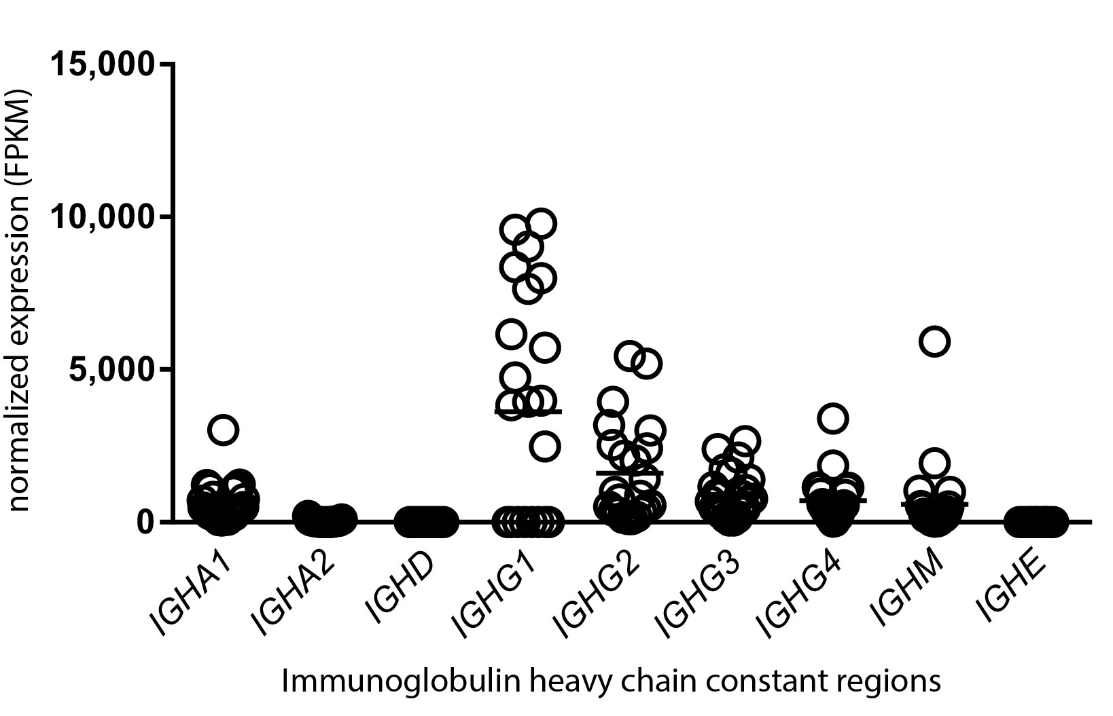

Fig. S1. Immunoglobulin heavy chain expression in HGSC. Standardized read count (FPKM) data for 9 immunoglobulin heavy chain classes were plotted using TCGA HGSC RNA-seq data.

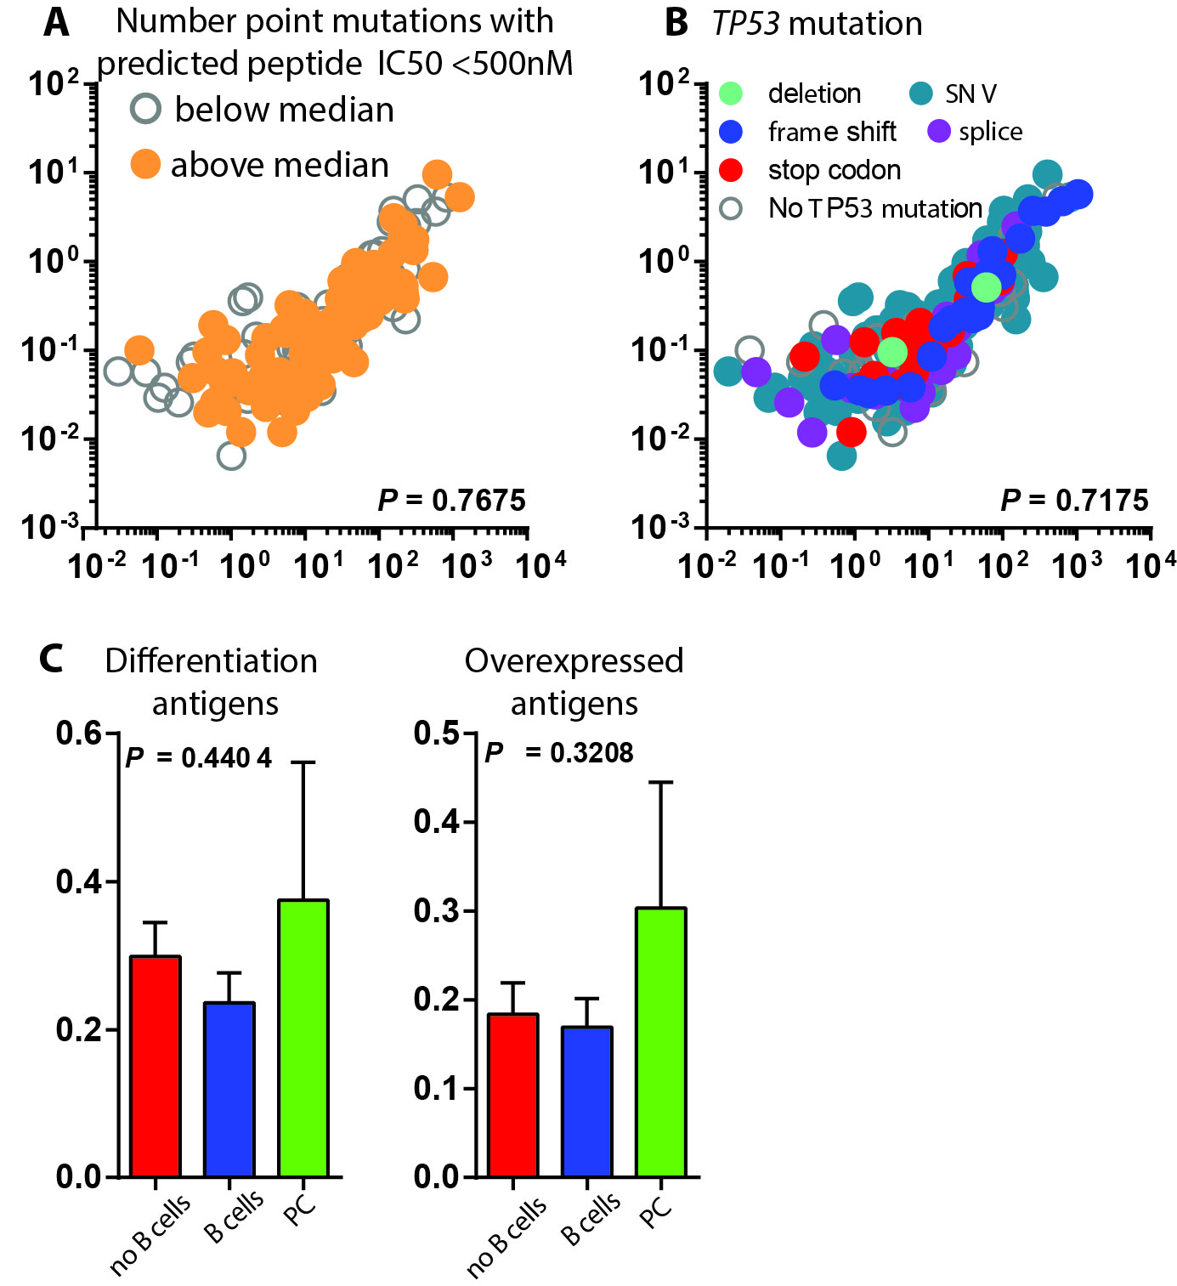

Fig. S2. Lack of association between the PC gene signature and immunogenic mutations, TP53 mutations, and differentiation/overexpressed antigens in HGSC. A, B) IGJ vs TNFRSF17 data was plotted as in Figure 7 with A) overlaid above-median immunogenic point mutation count (defined as point mutations that are predicted to result in a mutant peptide with <500nM affinity for HLA-A in cases positive for expression of HLA-A), or B) overlaid with TP53 mutation type.

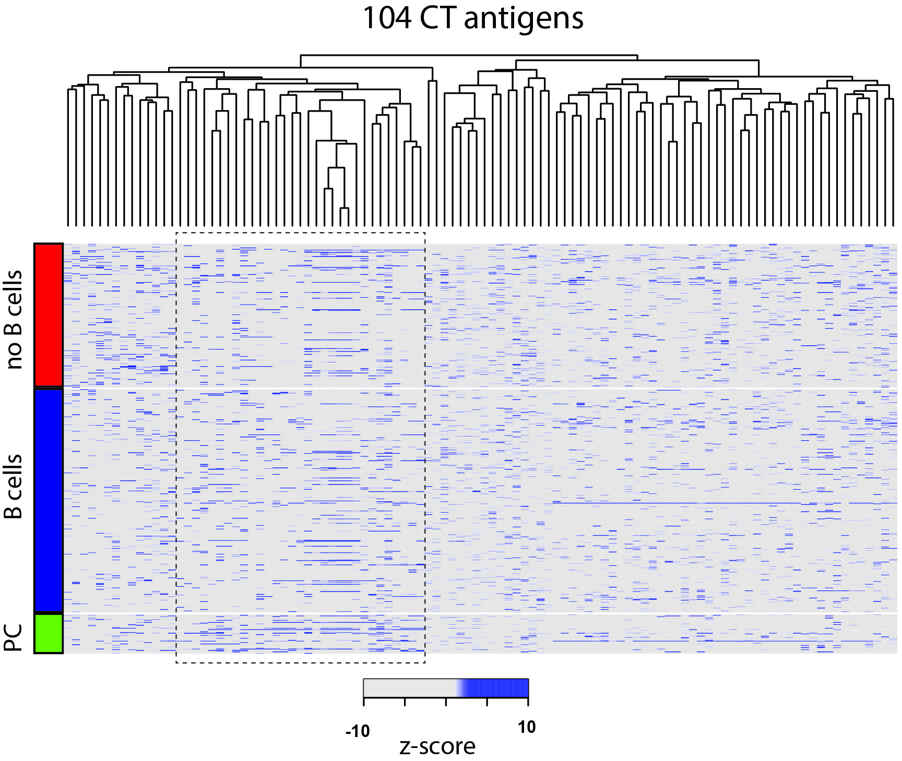

Fig. S3. Heatmap of CT antigen expression. Semisupervised hierarchical clustering of CT antigen expression (z-scores). Dotted line indicates a branch of genes that was overrepresented in PC signature positive tumors.

