**SUPPLEMENTARY FIGURES**

|  |  |  |  |
| --- | --- | --- | --- |
| **OVERALL SURVIVAL** | | | **Overall survival**  **months**  **Probability** |
| Median overall survival =  22 months  (95% CI [16.9-28.1]) | | |
| Time (mo) | Survival rate (%) | 95% CI |
| 6 | 81.4 | [72.2-87.9] |
| 12 | 68.9 | [58.7-77.2] |
| 18 | 57.9 | [47.3-67.1] |
| 24 | 44.9 | [34.5-54.8] |
| 36 | 29.8 | [19.9-40.3] |

**Supplementary figure 1. Overall survival data.** Abbreviations. CI : confidence interval; mo: months.



**Supplementary figure 2A.** Ref A KRAS, RefA BRAF, DII KRAS and DII BRAF in group of patients with the primary tumor in place at time of blood collection (n=54) and without (n=43). mA and mA% in the group of mutant patients with the primary tumor in place at time of blood collection (n=24) and without (n=19).



**Supplementary figure 2B.** Ref A KRAS, RefA BRAF, DII KRAS, DII BRAF in group of patients with one metastatic site at time of blood collection (n=49), two (n=26) and three or more than three (n=17). mA and mA% in group of patients with one metastatic site at time of blood collection (n=21), two (n=8) and three or more than three (n=11).



**Supplementary figure 2C.** Ref A KRAS, RefA BRAF, DII KRAS, DII BRAF in group of patients with right colon cancer (n=22), left colon cancer (n=41) and rectum cancer (n=34). mA and mA% in group of mutant patients with right colon cancer (n=15), left colon cancer (n=17) and rectum cancer (n=11).



**Supplementary figure 2D.** Ref A KRAS, RefA BRAF, DII KRAS, DII BRAF in group of patients with well differenciated tumor G1 (n=13), moderately differenciated tumor G2 (n=45) and poorly differenciated tumor G3 (n=8). mA and mA% in group of mutant patients with well differenciated tumor G1 (n=7), moderately and poorly differenciated tumor G2/G3 (n=23).

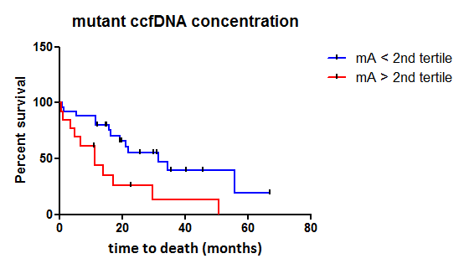

p=0,0067

HR=2,77

**S**

**Supplementary figure 3.** Kaplan Meier survival curve and log-rank test according to mA determined by ccfDNA analysis dichotomized around the 2nd tertile in patients carrying exclusively *KRAS*-point mutations (n=38). Abbreviations : mA, mutant ccfDNA concentration.

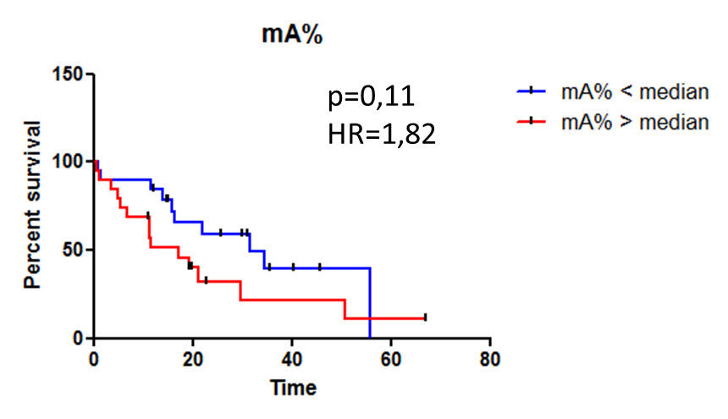

**Supplementary figure 4.** Kaplan Meier survival curve and log-rank test according to mA% determined by ccfDNA analysis in patients carrying exclusively *KRAS*-point mutations. Abbreviation : mA%, mutation load.