Supplemental Figure S3. Gene expression profiling of two DLBCL cell lines (SU-DHL-2 and SU-DHL-6) exposed to DMSO or OTX015 (500 nM) for 1, 2, 4, 8 or 12 hours. (A), Heatmap of average gene set expression of the top 80 most enriched gene sets from combined GSEA and MetaCore analysis. The gene set expression was calculated as the mean expression of all members in the set. Y-axis: cell lines at different time points. The heatmap colors are not scaled and show the consistent increase (or decrease) of gene set expression in time. X-axis: top differentially expressed gene sets as assessed by GSEA and MetaCore. For GSEA, gene sets were filtered for a minimal fold-change of >0.15 and FDR<0.05. For MetaCore, gene sets were considered significant at FDR<0.01 and obtained using the list of differentially expressed genes with a logratio treshold of 0.2 and a p-value of 0.05. (B), Hierarchical clustering of genes in the top enriched gene sets. The heatmap coloring shows the overall importance of a gene and gene set combination in the data set. The normalized value is proportional to the product of the rank of the gene differential expression (top side colors) and rank of the gene sets differential expression (left side colors). A cell value of zero (dark blue color) means the gene is not member of that particular gene set. A value close to one (bright red) means both gene and gene set were highly ranked in the analysis. Differential gene expression was assessed by two-group comparison OTX015 vs. DMSO. Differential expression of the gene set was calculated as the average differential expression of its members.

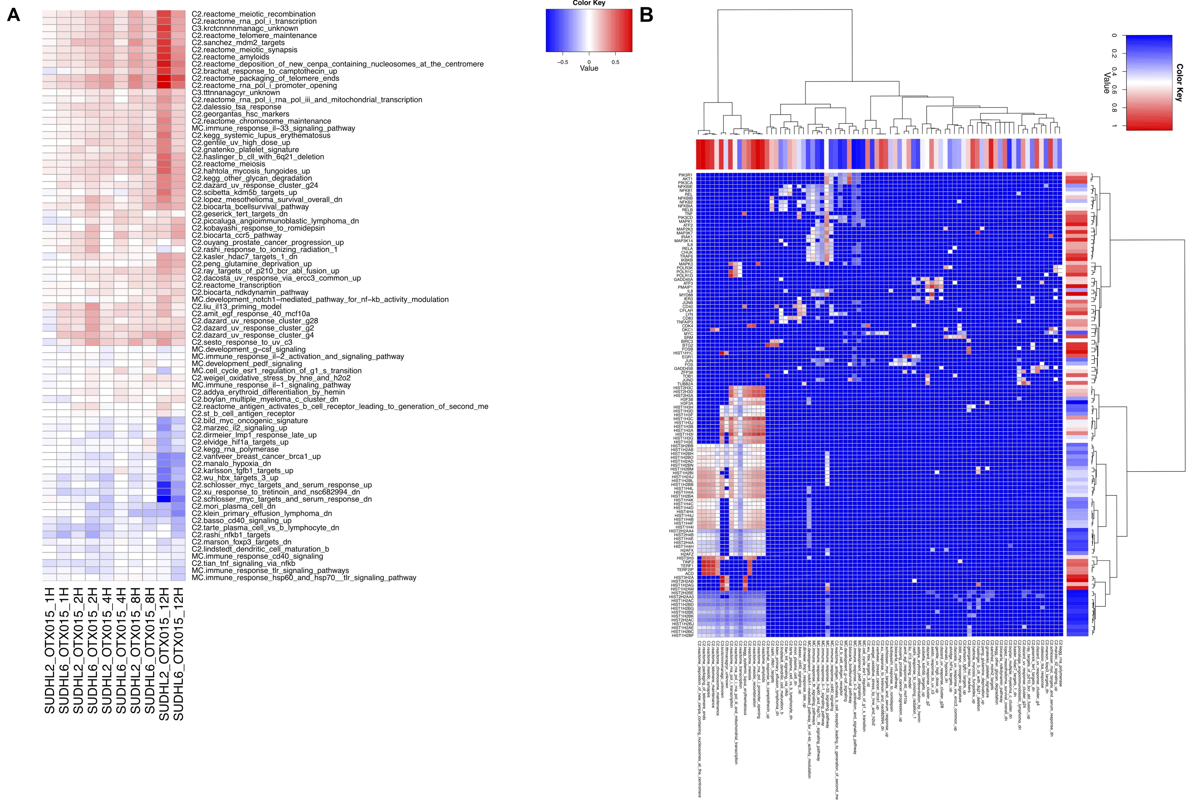

Supplemental Figure S4. Metacore Network of the top regulated genes by OTX015 (500 nM) in SU-DHL-2 and SU-DHL-6 cells, identifying MYC as a hub.
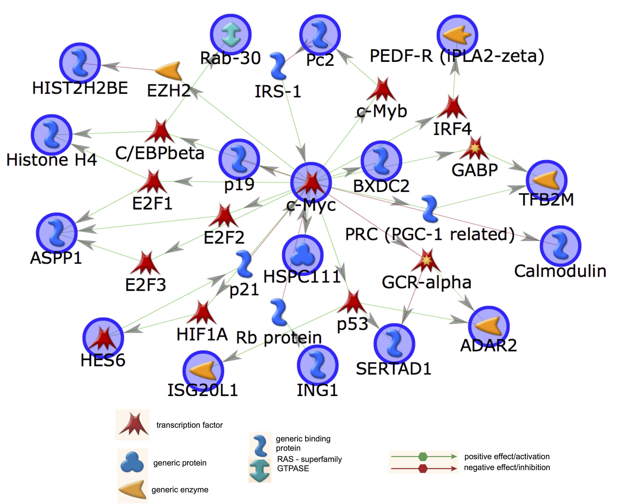

Supplemental Figure S5. OTX015 shows biologic effects similar to JQ1. Enrichment plots of JQ1 expression signatures derived from different pre-clinical cancer models (1-5) in SUDHL2 and SUDHL6 cells treated with OTX015 (500 nM). The plot shows the ordered differential expression of the 8000 most varying genes (i.e. with highest variance) in the experiment. In red are highlighted the genes that belong to the particular gene set. Gene sets with genes concentrated to the left or right of the plot are highly enriched. All JQ1 signatures were highly statistically significant according to a Kolmogorov-Smirnov test (calculation not shown).
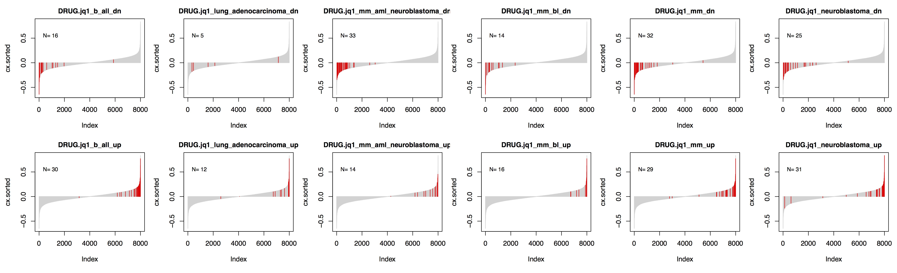
References
1. Mertz JA, Conery AR, Bryant BM, Sandy P, Balasubramanian S, Mele DA, et al. Targeting MYC dependence in cancer by inhibiting BET bromodomains. Proc Natl Acad Sci U S A. 2011;108:16669-74.
2. Delmore JE, Issa GC, Lemieux ME, Rahl PB, Shi J, Jacobs HM, et al. BET bromodomain inhibition as a therapeutic strategy to target c-Myc. Cell. 2011;146:904-17.
3. Lockwood WW, Zejnullahu K, Bradner JE, Varmus H. Sensitivity of human lung adenocarcinoma cell lines to targeted inhibition of BET epigenetic signaling proteins. Proc Natl Acad Sci U S A. 2012;109:19408-13.
4. Ott CJ, Kopp N, Bird L, Paranal RM, Qi J, Bowman T, et al. BET bromodomain inhibition targets both c-Myc and IL7R in high-risk acute lymphoblastic leukemia. Blood. 2012;120:2843-52.
5. Puissant A, Frumm SM, Alexe G, Bassil CF, Qi J, Chanthery YH, et al. Targeting MYCN in neuroblastoma by BET bromodomain inhibition. Cancer Discov. 2013;3:308-23.

