Supplementary Tables:

Gene | Assay ID | Samples With Detectable Expression, N(%)
AREG | Hs00950669_m1 | 103 (100)
β-ACTIN | Hs00357333_g1 | 103 (100)
BTC | Hs01101201_m1 | 103 (100)
CD73 | Hs04234687_m1 | 95 (92)
DUSP4 | Hs01027785_m1 | 102 (99)
EGF | Hs00153181_m1 | 40 (39)
EGFR | Hs00193306_m1 | 103 (100)
EPGN | Hs02385425_m1 | 21 (20)
EREG | Hs00914313_m1 | 98 (95)
HBEGF | Hs00181813_m1 | 102 (99)
HER2 | Hs01001580_m1 | 103 (100)
HER3 | Hs00176538_m1 | 102 (99)
HER4 | Hs00955525_m1 | 32 (31)
PHLDA1 | Hs00378285_g1 | 103 (100)
TGFA | Hs00608187_m1 | 102 (99)

Supplementary Table 1: List of assay primer sets used in this study. All assay sets were purchased from Applied Biosystems-Life Technologies, Foster City, CA, USA

 | AREG | BTC | CD73 | DUSP4 | EGF | EGFR | EPGN | EREG | HBEGF | HER2 | HER3 | HER4 | PHLDA1 | TGFA
AREG | 1 | 0.322 | 0.137 | -0.026 | 0.151 | 0.250 | -0.038 | 0.553 | 0.216 | 0.146 | 0.193 | -0.024 | 0.242 | 0.048
BTC | 0.322 | 1 | 0.159 | 0.128 | 0.164 | 0.265 | 0.057 | 0.209 | 0.171 | 0.365 | 0.369 | 0.113 | 0.245 | 0.045
CD73 | 0.137 | 0.159 | 1 | 0.240 | 0.195 | 0.222 | -0.048 | 0.023 | -0.017 | 0.052 | 0.086 | 0.118 | 0.197 | 0.054
DUSP4 | -0.026 | 0.128 | 0.240 | 1 | -0.108 | 0.066 | -0.152 | -0.181 | 0.245 | 0.163 | -0.021 | 0.308 | 0.394 | 0.148
EGF | 0.151 | 0.164 | 0.195 | -0.108 | 1 | 0.205 | 0.571 | 0.061 | -0.195 | 0.036 | 0.123 | 0.390 | -0.187 | -0.223
EGFR | 0.250 | 0.265 | 0.222 | 0.066 | 0.205 | 1 | 0.200 | 0.128 | 0.005 | 0.215 | 0.260 | 0.149 | 0.057 | 0.120
EPGN | -0.038 | 0.057 | -0.048 | -0.152 | 0.571 | 0.200 | 1 | -0.011 | -0.238 | 0.076 | 0.190 | 0.500 | -0.114 | -0.410
EREG | 0.553 | 0.209 | 0.023 | -0.181 | 0.061 | 0.128 | -0.011 | 1 | 0.152 | 0.097 | 0.154 | -0.041 | 0.127 | 0.025
HBEGF | 0.216 | 0.171 | -0.017 | 0.245 | -0.195 | 0.005 | -0.238 | 0.152 | 1 | 0.117 | 0.088 | 0.213 | 0.302 | 0.223
HER2 | 0.146 | 0.365 | 0.052 | 0.163 | 0.036 | 0.215 | 0.076 | 0.097 | 0.117 | 1 | 0.475 | 0.169 | 0.175 | 0.154
HER3 | 0.193 | 0.369 | 0.086 | -0.021 | 0.123 | 0.260 | 0.190 | 0.154 | 0.088 | 0.475 | 1 | 0.093 | 0.133 | 0.104
HER4 | -0.024 | 0.113 | 0.118 | 0.308 | 0.390 | 0.149 | 0.500 | -0.041 | 0.213 | 0.169 | 0.093 | 1 | 0.040 | -0.101
PHLDA1 | 0.242 | 0.245 | 0.197 | 0.394 | -0.187 | 0.057 | -0.114 | 0.127 | 0.302 | 0.175 | 0.133 | 0.040 | 1 | 0.156
TGFA | 0.048 | 0.045 | 0.054 | 0.148 | -0.223 | 0.120 | -0.410 | 0.025 | 0.223 | 0.154 | 0.104 | -0.101 | 0.156 | 1

Supplementary Table 2. Table of co-regulation among the 14 genes using a Kendall tau analysis. The most highly associated genes are indicated in bold.
Supplementary Figures
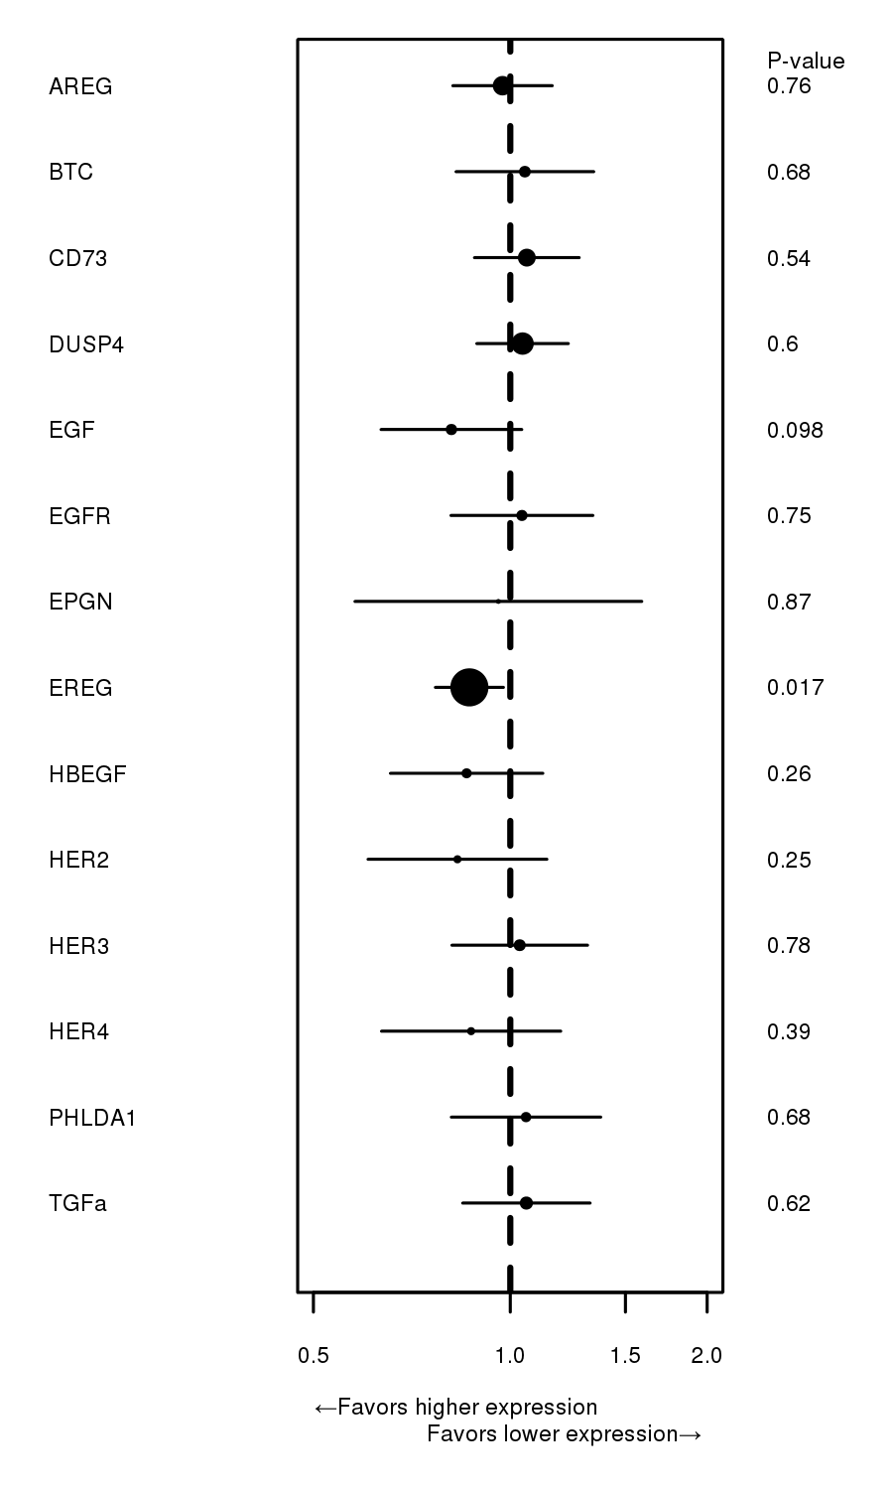
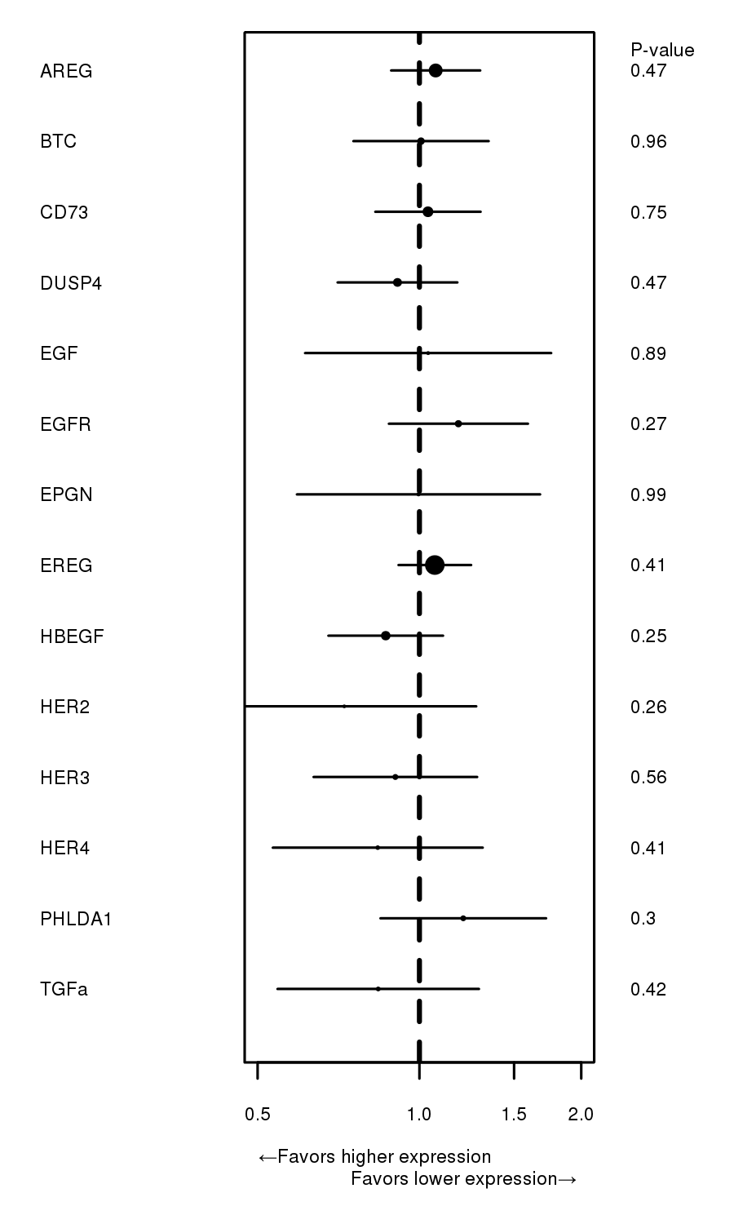
A
B
Supplementary Figure 1: Forest plots showing associations of gene expression levels with OS in KRAS WT (A) and KRAS Mut (B) pts. All assayed genes are shown. The length of the line indicates the 95% confidence interval and the diameter of the median dot is inversely proportional to the standard deviation.

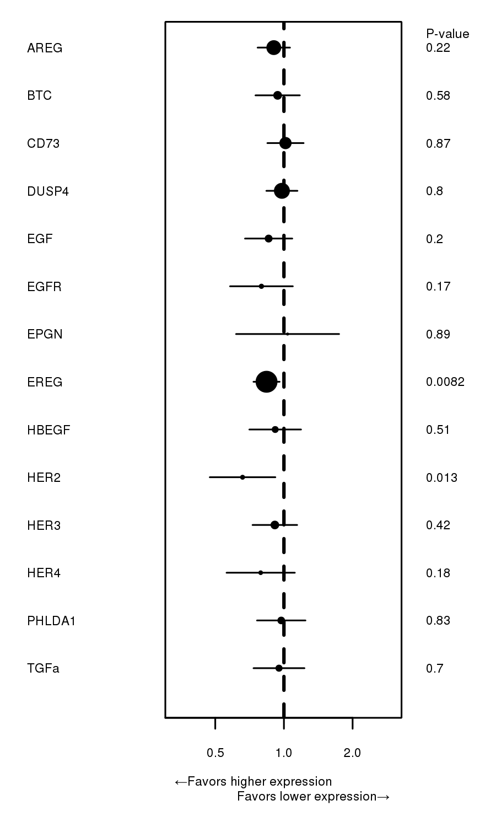
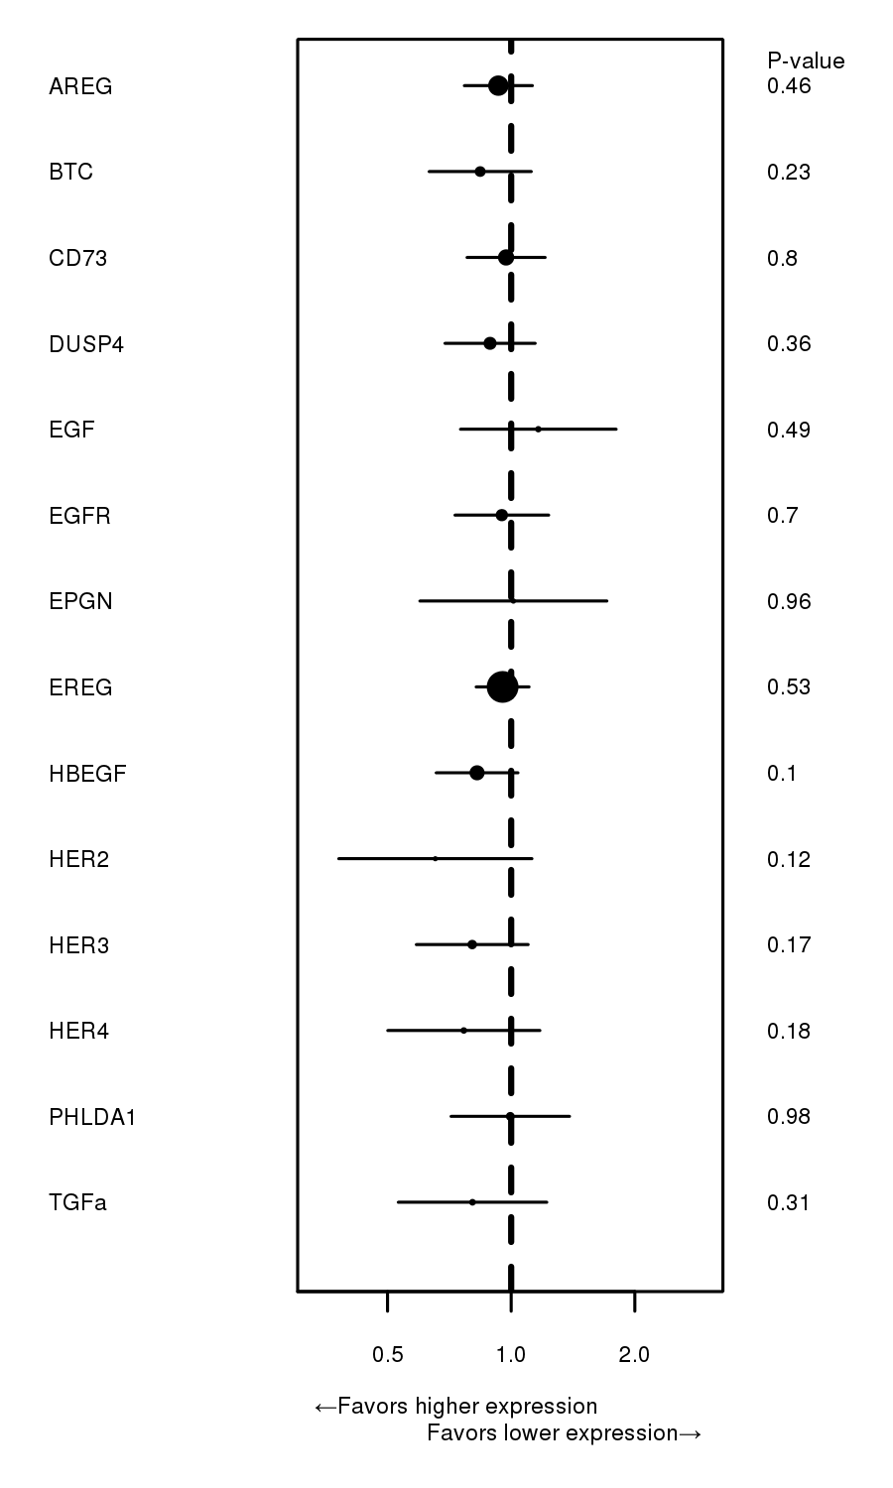
Supplementary Figure 2: Forest plots showing associations of gene expression levels with PFS in KRAS WT (A) and KRAS Mut (B) pts. All assayed genes are shown. The length of the line indicates the 95% confidence interval and the diameter of the median dot is inversely proportional to the standard deviation.
A
B

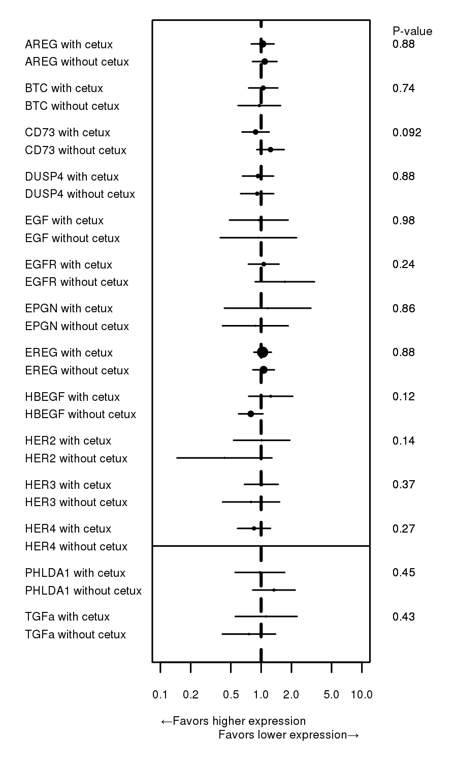
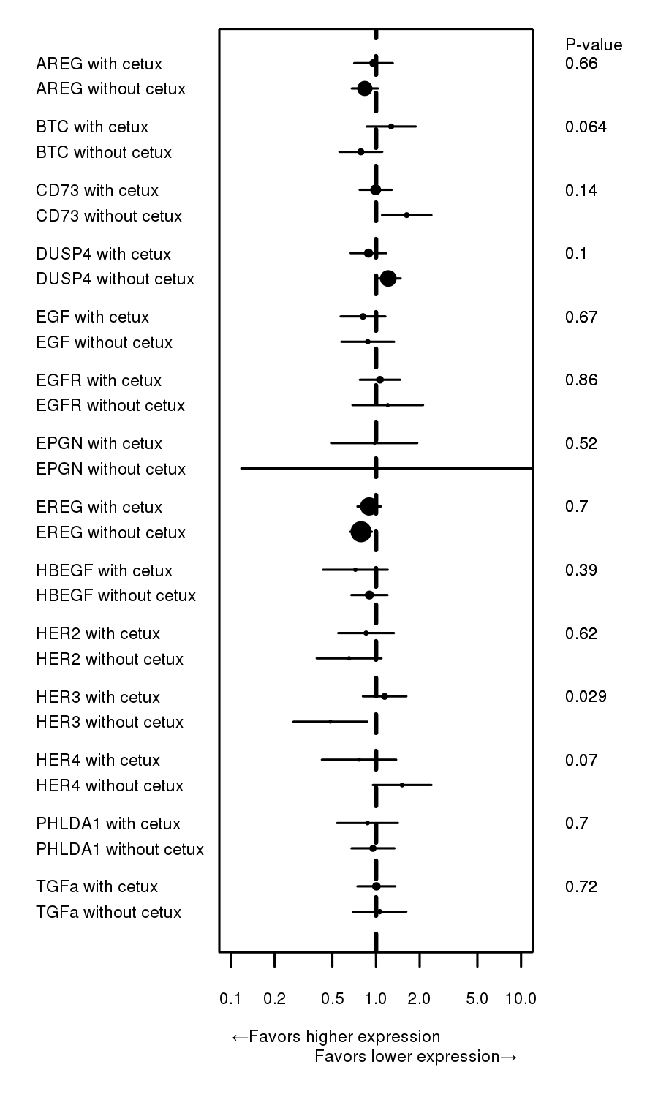
Supplementary Figure 3: Forest plots showing associations of gene expression levels and treatment group with OS in KRAS WT (A) and KRAS Mut (B) pts. All assayed genes are shown. The length of the line indicates the 95% confidence interval and the diameter of the median dot is inversely proportional to the standard deviation.
A
B

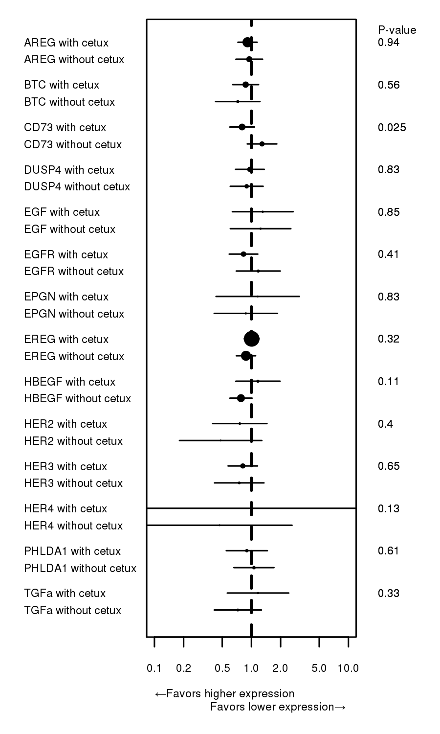
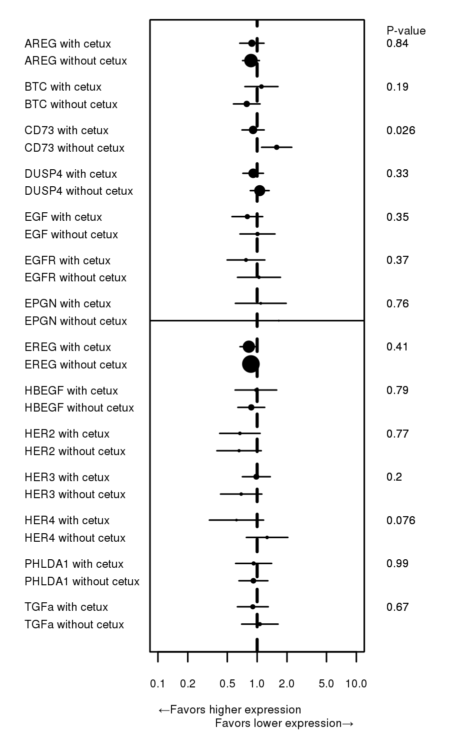
Supplementary Figure 4: Forest plots showing associations of gene expression levels and treatment group with PFS in KRAS WT (A) and KRAS Mut (B) pts. All assayed genes are shown. The length of the line indicates the 95% confidence interval and the diameter of the median dot is inversely proportional to the standard deviation.
A
B

