SUPPLEMENTARY FIGURES

Supplementary Figure 1. Principal component analysis for patients in ECOG-5103. Analysis was performed using Eigenstrat and reference data from 11 HapMap phase III populations to identify clusters using the first two eigenvectors computed using all SNPs. Blue diamond: Utah residents with Northern and Western European ancestry from the CEPH collection (CEU); Red square: Han Chinese in Beijing, China (CHB), Chinese in Metropolitan Denver, Colorado (CHD) and Japanese in Tokyo, Japan; Blue cross: Yoruba in Ibadan, Nigeria; Green triangle, African American samples in ECOG-5103; Purple bar: European American samples in ECOG-5103.

Supplementary Figure 2. P values (−log₁₀) of SNPs near rs3125923 from genomic association analysis of TIPN risk by genotyped or those imputed in the second portion of the sample (top) and imputed in all samples (bottom) with EA samples in ECOG-5103 are plotted against their positions on chromosome 1. SNPs are colored to reflect their LD with rs3125923. Known genes in the region are shown underneath the plot.

Supplementary Figure 1

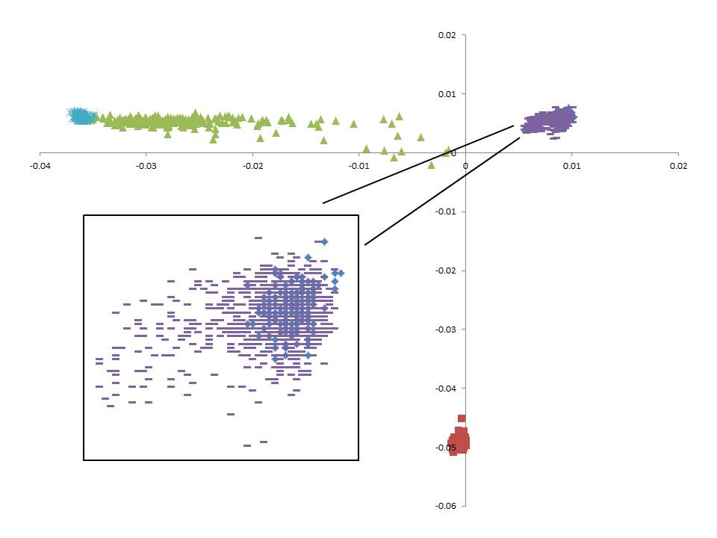

Supplementary Figure 2

