**Supplementary Data 1**: Primers and probes for ddPCR assay

PIK3CA G>A 1624 E542K

Primer F: GCTCAAAGCAATTTCTACACG

Primer R: TCCATTTTAGCACTTACCTGTGAC

WT probe: VIC-TCTCTGAAATCACTGAGCAGGAGAA

Mutant Probe: 6FAM-TCTCTAAAATCACTGAGCAGGAGAA

PIK3CA G>A 1633 E545K

Primer F: GCTCAAAGCAATTTCTACACG

Primer R: TCCATTTTAGCACTTACCTGTGAC

WT probe: VIC-TCTCTGAAATCACTGAGCAGGAGAA

Mutant Probe: 6FAM-TCTCTGAAATCACTAAGCAGGAGAA

TP53 G>A743 R248Q

Primer F: AACTACATGTGTAACAGTTCCTGCAT

Primer R: CCAGTGTGATGATGGTGAGGAT

WT probe: VIC-CATGAACCGGAGGCC

MutantProbe:6-FAM-CATGAACCAGA.

KRAS primers and probes sequences are proprietary to Bio-Rad.

G12V: WT: dHsaCP2000006 Mut: dHsaCP2000005

G12C: WT: dHsaCP2000008 Mut: dHsaCP2000007

G12D: WT: dHsaCP2000002 Mut: dHsaCP2000001

**Supplementary Data 2:** Consort Diagram

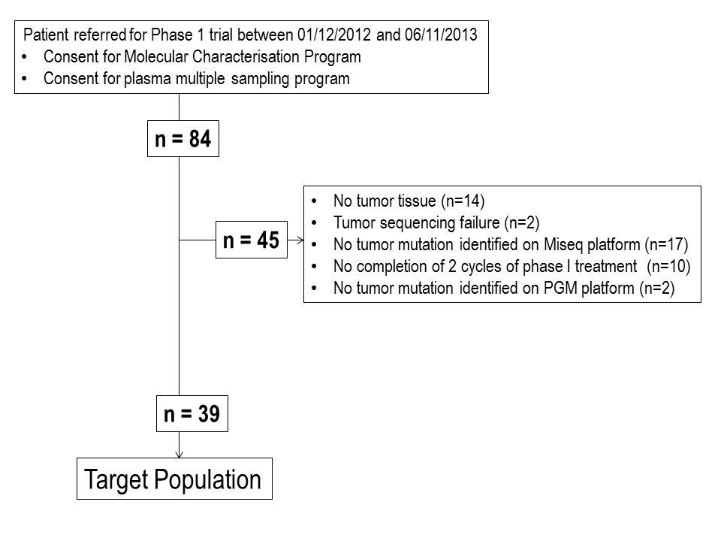

**Supplementary Data 3:** List of drugs

**PI3K-AKT-MTOR pathway**

PI3K inhibitor GSK2636771, INK1117

PI3K inhibitor + MEK inhibitor MEK162/BYL719

TOR kinase inhibitor AZD2014

TOR kinase inhibitor + Taxane AZD2014 + paclitaxel

AKT inhibitor AZD5363

**MEK pathway**

MEK inhibitor + IGF-IR inhibitor MEK162/AMG479

MEK/RAF inhibitor DDU RAF/MEK

**Other**

PARP inhibitor BMN673

PIM kinase inhibitor AZD1208

Analog of Oleic Acid

Androgen receptor inhibitor Abiraterone

AGC kinase inhibitor AT13148

Folate inhibitor Vintafolide

**Supplementary Data 4:** Cross validation of PGM sequencing assay with ddPCR

**A.** Comparison of sequencing results with the ddPCR assay and the PGM platform on 19 randomly selected cfDNA samples with known mutations in tumor tissue. AF: allele frequency; ND: not detected. **B.** Correlation of cfDNA mutation allele frequency (AF) detection by PGM platform and ddPCR assay.

**A**

|  |  |  |  |  |
| --- | --- | --- | --- | --- |
| **Sample** | **Gene** | **Mutation** | **Allele Frequency**  **(ddpcr)** | **Allele Frequency**  **(PGM)** |
| #a | T53 | R248Q | 33.8% | 29.7% |
| #b | KRAS | G12V | 47.6% | 55.7% |
| #c | KRAS | G12C | 41.2% | 37.3% |
| #d | KRAS | G12D | 10.2% | 15.0% |
| #e | PIK3CA | E545K | 6.4% | 7.0% |
| #f | PIK3CA | E545K | 11.9% | ND |
| #g | PIK3CA | E545K | 4.8% | 1% |
| #h | PIK3CA | E545K | 9.8% | 6.9% |
| #i | PIK3CA | E545K | 20.3% | 12.9% |
| #j | PIK3CA | E545K | 4.6% | 2% |
| #k | PIK3CA | E545K | 1.5% | 3.2% |
| #l | PIK3CA | E542K | 0.7% | ND |
| #m | PIK3CA | E542K | 0.9% | ND |
| #n | PIK3CA | E545K | ND | ND |
| #o | PIK3CA | E545K | ND | ND |
| #p | PIK3CA | E545K | ND | ND |
| #q | PIK3CA | E545K | ND | ND |
| #r | PIK3CA | E545K | ND | ND |
| #s | PIK3CA | E542K | 69 | 67.1 |

**B**



Intra class correlation coefficient: 0.98; CI 95% [0,94-0,99], p<0.0001

**Supplementary Data 5**

To test intra-run assay performance, 3 different libraries were prepared using the same plasma cfDNA from a single patient: 1 bladder cancer with a *CDKN2A* plasma cfDNA mutation, 1 breast cancer with a plasma cfDNA *TP53* mutation and 1 colon cancer with 3 plasma cfDNA *PIK3CA*, *FBXW7* and *TP53* mutations. The libraries were indexed with different barcodes, multiplexed and sequenced on an Ion 318 Chip. Five out of five mutations were detected reproducibly with minimal variation in mean AF. The inter-run reproducibility was assessed by sequencing a 4th library with the same cfDNA in an independent run for the 3 different patients. The maximum variability of the test was 12.5% across the experiments.



**Supplementary Data 6:** Monitoring of somatic genomic alterations in plasma during targeted therapy*.* Allele frequencies (AF) of identified mutations are represented on the left Y-axis while the sum of the target lesions on the CT scan, are represented on the right Y-axis. SD: stable disease according to RECIST criteria, PD: progressive disease. The colored box depicts the time on treatment.

**These data are provided in the PPT figure file.**

**Supplementary Data 7**: Time to progression for patients having a 30% decrease in plasma mutation AF, following targeted drug administration, and association with time to progression by RECIST evaluation.

NA: not applicable

|  |  |  |
| --- | --- | --- |
|  | **AF frequency variation after C2D1** | |
|  | ΔAF≥-30% | ΔAF<-30% |
| n | 9 | 14 |
| Time to progression (median) | 111 days | 55 days |
|  | **RECIST after C2D1** | |
|  | Stable disease | Progressive disease |
| n | 9 | 14 |
| Time to progression (median) | 111 days | 42 days |