Supplemental Table 1: Events per person-year of follow-up

 | Treatment Arm |  |  |  |  |  |  |  |  | P-Values from Pairwise Comparisons
 | Sunitinib (386.4 PY) |  |  | Sorafenib (402.3 PY) |  |  | Placebo (519.9 PY) |  |  | Sunitinib vs Placebo | Sorafenib vs Placebo
 | N | Rate/ 100PY | 90% CI | N | Rate/ 100PY | 90% CI | N | Rate/ 100PY | 90% CI
Per Protocol | 9 | 2.3 | 1.2 – 4.1 | 7 | 1.7 | 0.8 – 3.3 | 5 | 1.0 | 0.4 – 2.0 | 0.17 | 0.46
Per protocol at any time | 14 | 3.6 | 2.2 – 5.7 | 10 | 2.5 | 1.3 – 4.2 | 8 | 1.5 | 0.8 – 2.8 | 0.08 | 0.43
Per Protocol incl Other | 30 | 7.8 | 5.6 – 10.5 | 26 | 6.5 | 4.5 – 9.0 | 28 | 5.4 | 3.8 – 7.4 | 0.21 | 0.59
CREC Criteria | 59 | 15.3 | 12.2 – 19.0 | 56 | 13.9 | 11.0 – 17.4 | 48 | 9.2 | 7.2 – 11.7 | 0.01 | 0.05
Absolute reduction in LVEF of >=10% from baseline to <50% | 27 | 7.0 | 4.9 – 9.6 | 24 | 6.0 | 4.1 – 8.4 | 17 | 3.3 | 2.1 – 4.9 | 0.02 | 0.08
Absolute reduction in LVEF >=10% | 84 | 21.7 | 18.0 – 26.1 | 80 | 19.9 | 16.4 – 23.9 | 87 | 16.7 | 13.9 – 20.0 | 0.10 | 0.30
Any Criteria | 99 | 25.6 | 21.5 – 30.3 | 92 | 22.9 | 19.1 – 27.2 | 105 | 20.2 | 17.1 – 23.8 | 0.10 | 0.42

Supplemental Table 2: Event rates among patients randomized to sorafenib or sunitinib who started at reduced vs. full dose

 | Starting Dose
 | Full Dose (n=686) |  |  | Reduced Dose (n=336)
 | N | % | 90% CI | N | % | 90% CI | p
Per Protocol | 12 | 1.7% | 1.0 – 2.8% | 4 | 1.1% | 0.4 – 2.7% | 0.60
Per protocol at any time | 18 | 2.6% | 1.7 – 3.9% | 6 | 1.7% | 0.8 – 3.5% | 0.51
Per Protocol, incl Other | 42 | 6.1% | 4.7 – 7.8% | 14 | 4.1% | 2.5 – 6.4% | 0.24
CREC Criteria | 80 | 11.6% | 9.7 – 13.9% | 35 | 10.4% | 7.8 – 13.6% | 0.60
Absolute reduction in LVEF of >=10% from baseline to <50% | 34 | 4.9% | 3.7 – 6.5% | 17 | 5.0% | 3.2 – 7.5% | 1.00
Absolute reduction in LVEF >=10% | 113 | 16.4% | 14.2 – 19.0% | 51 | 15.1% | 12.0 – 18.8% | 0.65
Any Criteria | 135 | 19.6% | 17.2 - 22.3% | 56 | 16.6% | 13.4 – 20.4% | 0.27

Supplemental Table 3a. Event rates among patients who did or did not discontinue treatment due to adverse events, and among patients with ECOG PS 0 vs. 1

 | Off Treatment due to AE’s
 | No (n=1396) |  |  | Yes (n=206)
 | N | % | 90% CI | N | % | 90% CI | p
Per Protocol | 17 | 1.2% | 0.8 – 1.8% | 4 | 1.9% | 0.7 – 4.4% | 0.34
Per Protocol at any time | 26 | 1.8% | 1.3 – 2.6% | 6 | 2.9% | 1.3 – 5.7% | 0.29
Per Protocol including Other | 59 | 4.2% | 3.4 – 5.2% | 25 | 12.1% | 8.6 – 16.5% | <0.001
CREC Criteria | 139 | 9.9% | 8.7 – 11.4% | 24 | 11.6% | 8.2 – 16.0% | 0.46
Absolute reduction in LVEF of >=10% from baseline to <50% | 56 | 4.0% | 3.2 – 5.0% | 12 | 5.8% | 3.4 – 9.3% | 0.26
Absolute reduction in LVEF >=10% | 221 | 15.8% | 14.2 – 17.5% | 30 | 14.5% | 10.7 – 19.2% | 0.68
Any Criteria | 251 | 17.9% | 16.3 – 19.8% | 45 | 21.8% | 17.2 – 27.1% | 0.18
ECOG PS 0 | 1309 | 78.8% | 77.0 – 80.4% | 220 | 78.3% | 73.9 – 82.3% | 0.87
ECOG PS 1 | 353 | 21.2% | 19.6 – 23.0% | 61 | 21.7% | 17.7 – 26.1%

Supplemental Table 3b: Baseline LVEF and change in LVEF among patients who did or did not discontinue treatment due to adverse events

 |  | Off Treatment for AEs
 |  | No | Yes | Total | P
Baseline LVEF | N | 1657 | 280 | 1937
 | Mean | 61.6 | 62.2 | 61.7 | 0.22
 | Median | 61 | 61 | 61
 | Std Dev | 6.8 | 7.2 | 6.9
 | Range | 46 to 91 | 47 to 85 | 46 to 91
LVEF Decline | N | 1397 | 206 | 1603
 | Mean | -0.1 | 0.5 | -0.03 | 0.26
 | Median | 0 | 0 | 0
 | Std Dev | 7.0 | 6.7 | 6.9
 | Range | -26 to 37 | -20 to 21 | -26 to 37

Supplemental Table 4: Relationship among treatment duration, baseline LVEF by MUGA, and probability of an event by any definition

 | Treated < 12 Months |  |  | Treated >= 12 Months |  |  | Total
Baseline LVEF | Patients | Events | % | Patients | Events | % | Patients | Events | %
< 57% | 136 | 20 | 14.7% | 267 | 24 | 9.0% | 403 | 44 | 10.9%
57 – 61% | 158 | 23 | 14.6% | 275 | 41 | 14.9% | 433 | 64 | 14.8%
61.1 – 66% | 137 | 13 | 9.5% | 264 | 44 | 16.7% | 401 | 57 | 14.2%
> 66% | 161 | 46 | 28.6% | 205 | 85 | 41.5% | 366 | 131 | 35.8%
Total | 592 | 102 | 17.2% | 1011 | 194 | 19.2% | 1603 | 296 | 18.5%

Supplemental Table 5: Relationship among treatment duration, baseline LVEF by MUGA, and probability of an event by the definition “Per Protocol Including Other”

 | Treated < 12 Months |  |  | Treated >= 12 Months |  |  | Total
Baseline LVEF | Patients | Events | % | Patients | Events | % | Patients | Events | %
< 57% | 136 | 16 | 11.8% | 267 | 14 | 5.2% | 403 | 30 | 7.4%
57 – 61% | 158 | 13 | 8.2% | 275 | 18 | 6.6% | 433 | 31 | 7.2%
61.1 – 66% | 137 | 4 | 2.9% | 264 | 8 | 3.0% | 401 | 12 | 3.0%
> 66% | 161 | 6 | 3.7% | 205 | 5 | 2.4% | 366 | 11 | 3.0%
Total | 592 | 39 | 6.6% | 1011 | 45 | 4.5% | 1603 | 84 | 5.2%

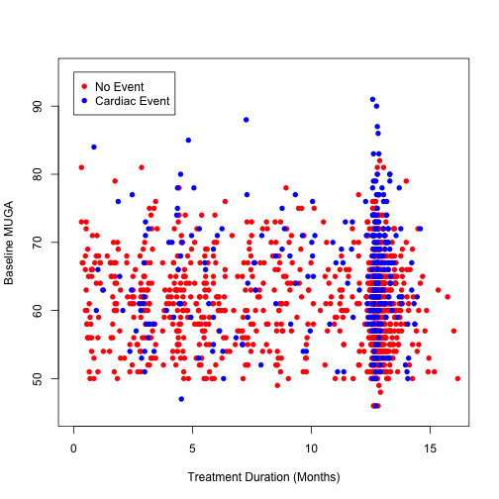
Supplemental Figure 1: Relationship among baseline LVEF by MUGA, treatment duration, and event status, where event is defined by any of the criteria
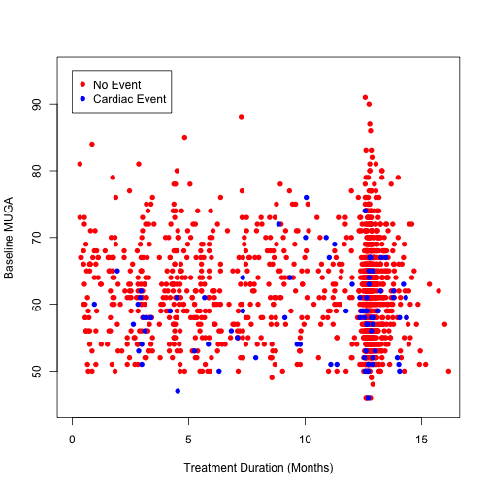
Supplemental Figure 2: Relationship among baseline LVEF by MUGA, treatment duration, and event status, where event is defined as a decline in LVEF of 16% or more to below the lower limit of normal, or a grade 3 or higher cardiac adverse event

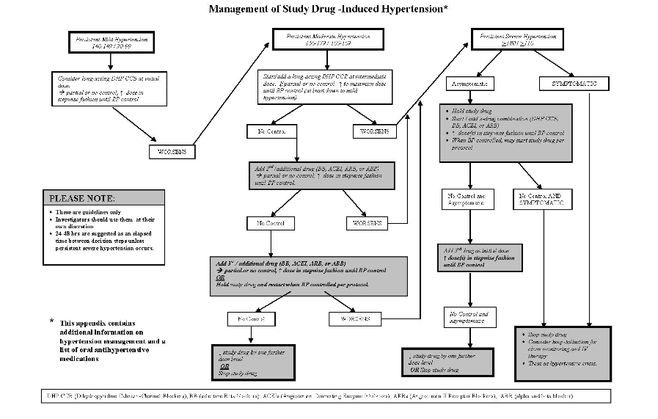
Supplemental Figure 3: Algorithm for management of study drug-induced hypertension

