Supplemental Figure 1
Group Mean Concentration-Time Profiles and the Linear 2-Compartment Model Fit For Weekly Dosing Cohorts
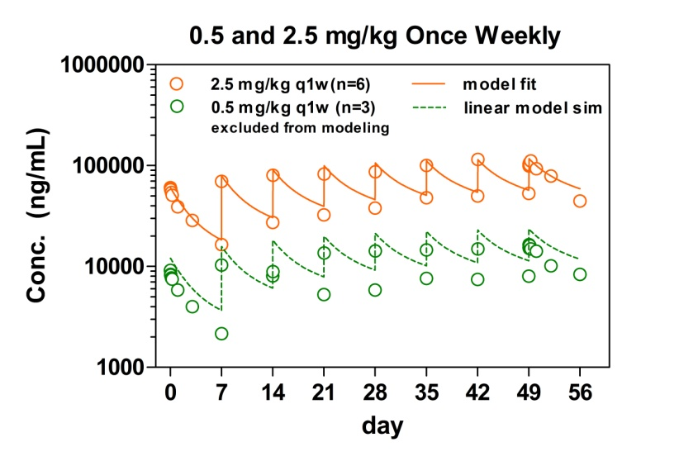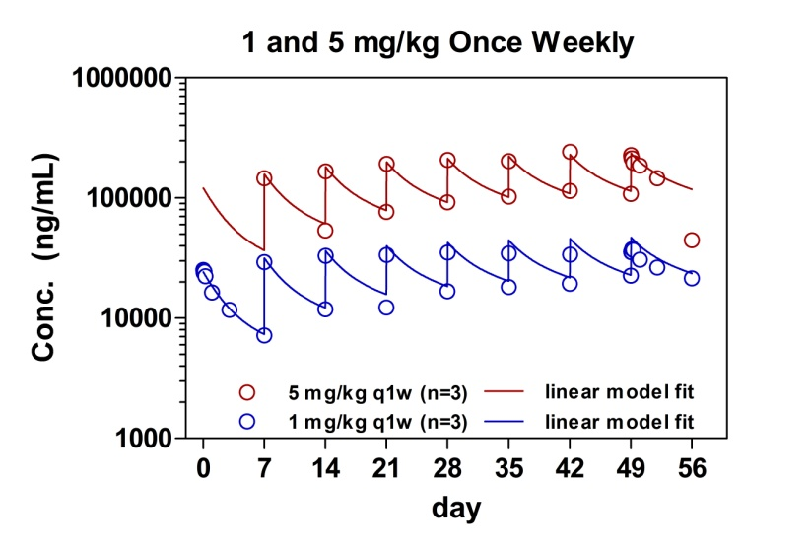

Symbols are the observed concentration-time data, by cohort, averaged over nominal time; solid lines are the model predictions by fitting to all the data except for 0.5 mg/kg q1w; dash line for 0.5 mg/kg q1w is the prediction of the aforementioned model, not the model fit to the 0.5 mg/kg q1w data. PK parameters were estimated by fitting the same model simultaneously to all group mean concentration-time data, except that of the 0.5 mg/kg q1w cohort. At 0.5 mg/kg q1w, there appeared to be faster clearance presumably due to target-mediated drug disposition, which is a typical phenomenon for antibody therapeutics at lower doses. The limited data from this cohort, however, did not support the modeling of the nonlinear target-mediated clearance. Data from the 0.5 mg/kg q1w cohort was included in the graph on the left, along with the model prediction for this dose level had the clearance being linear and equivalent to the rest of the dose levels, to demonstrate faster clearance at this dose level and concentration range

Supplemental Figure 2

Effect of Demcizumab on Hair Follicle Biomarkers

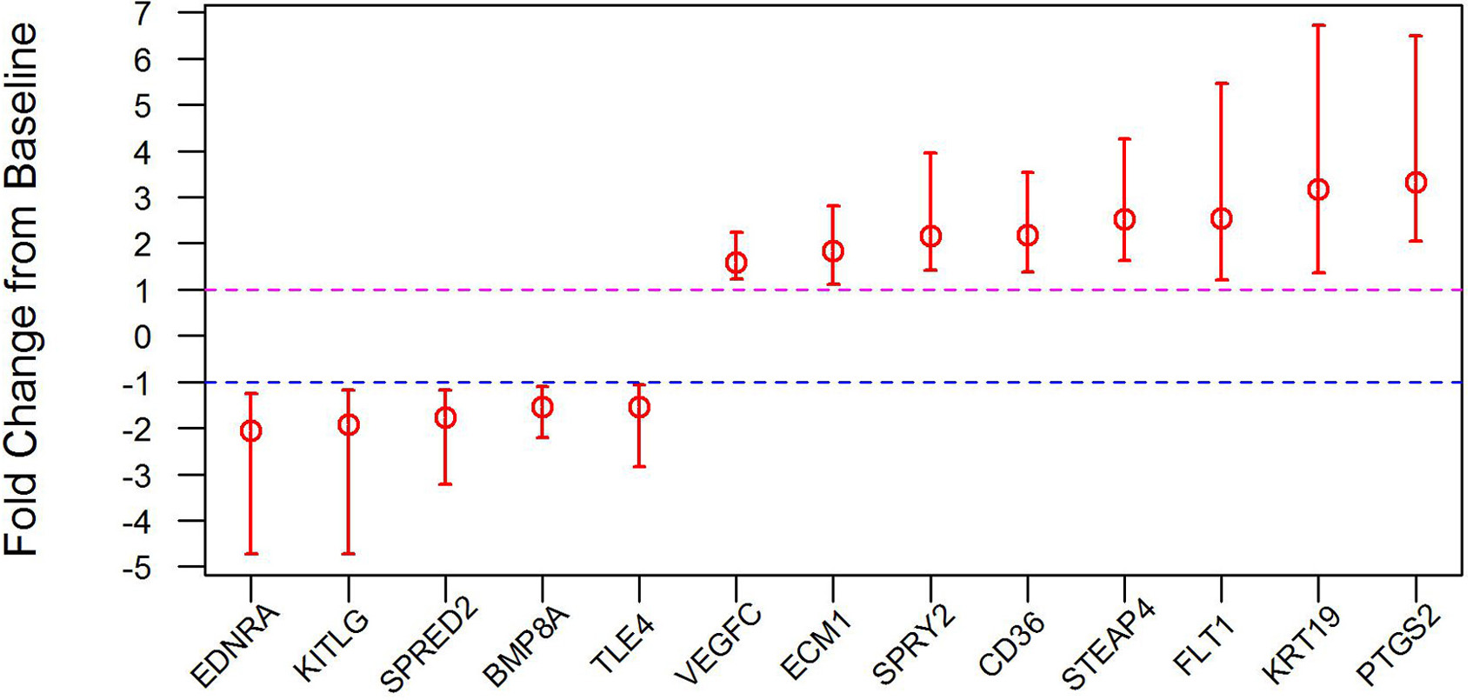
Demcizumab significantly affected gene expression changes of Notch pathway related markers in hair follicles. RNAs were isolated from the hair follicles and gene expression profiles were assayed. The fold-change represents the gene expression ratio comparing post-treatment to pre-treatment (Day 0) samples (n=28 patients). Genes were significant at a 95% confidence interval (CI) and a gene expression change of greater than 1.5-fold.

Supplemental Figure 3
Effect of Demcizumab on Plasma Proteins
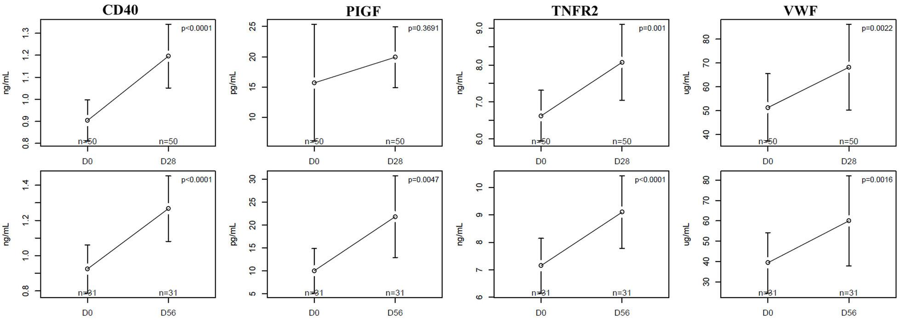
Demcizumab significantly increased vascular-related plasma proteins. Paired-sample student t-tests were used to assess significance comparing each patient post-treatment to its own pre-treatment sample. A p-value <0.05 was considered significant. Post-treatment time points were Day 28 (top figure, n=50) and Day 56 (bottom figure, n=31). These plasma proteins (CD40, PIGF, TNFR2, VWF) were also assayed in control samples not treated with demcizumab and no significant regulation was observed (data not shown).

Supplemental Figure 4
Duration on Study by Patient
