Supplementary Figure 1: Expression of MAM-A and HLA-A2 in breast cancer cell lines. Expression of MAM-A and HLA-A2 was evaluated in breast cancer cell lines by RT-PCR.

Supplementary Figure 2: MAM-A DNA vaccination increases breast cancer-induced TNF-α production by MAM-A-specific CD8 T cells. Purified CD8 T cells from subjects vaccinated with the MAM-A DNA vaccine were stimulated with UACC-812 breast cancer cells at a 50:1 T cell to breast cancer cell ratio (S = stimulated, U = unstimulated). Intracellular expression of TNF-α was measured by immunoblot. Actin expression represents a protein loading control.

Supplementary Figure 3: MAM-A DNA vaccination increases NKG2D expression in MAM-A-specific CD8 T cells. Purified CD8 T cells from subjects vaccinated with the MAM-A DNA vaccine were stimulated with UACC-812 breast cancer cells at a 50:1 T cell to breast cancer cell ratio. NKG2D expression was determined by immunoblot. UACC-812 stimulation was performed in the presence of isotype or NKG2D antibody; control or NKG2D siRNA, as well as antibodies to IFN-γ and TNF-α. Actin expression represents a protein loading control.

Supplementary Figure 4: MAM-A DNA vaccination increases DAP10 adapter protein expression in MAM-A-specific CD8 T cells. Purified CD8 T cells from subjects vaccinated with the MAM-A DNA vaccine were stimulated with UACC-812 breast cancer cells at a 50:1 T cell to breast cancer cell ratio. UACC-812 stimulation was performed in the presence of isotype or NKG2D antibody; control, DAP10 or NKG2D siRNA, as well as antibodies to IFN-γ and TNF-α. (A) DAP10 expression was determined by immunoblot. Actin expression represents a protein loading control. (B) DAP10 expression was determined by qRT-PCR. Actin expression represents an endogenous control to normalize sample RNA.

Supplementary Figure 5: MAM-A DNA vaccination increases perforin expression in MAM-A-specific CD8 T cells. Purified CD8 T cells from subjects vaccinated with the MAM-A DNA vaccine were stimulated with UACC-812 breast cancer cells at a 50:1 T cell to breast cancer cell ratio. UACC-812 stimulation was performed in the presence of isotype or NKG2D antibody; control or perforin siRNA, as well as antibodies to IFN-γ and TNF-α. (A) Perforin expression was determined by immunoblot. Actin expression represents a protein loading control. (B) Perforin expression was determined by qRT-PCR. Actin expression represents an endogenous control to normalize sample RNA.
Supplementary Figure 6: Therapy received by the patients (screen failed and vaccinated).

SUPPLEMENTARY FIGURE 1

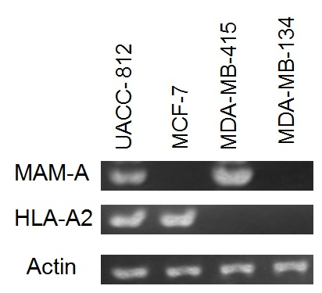

SUPPLEMENTARY FIGURE 2

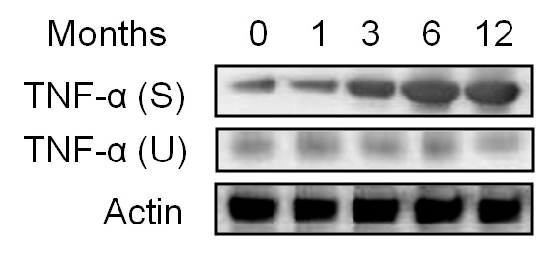

SUPPLEMENTARY FIGURE 3

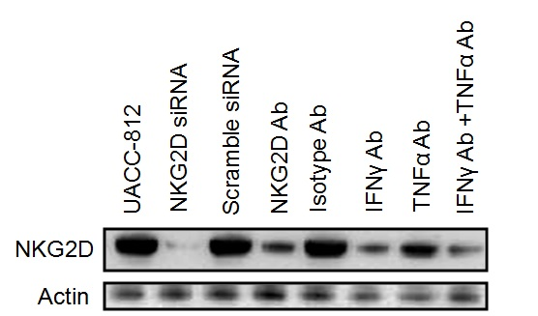

SUPPLEMENTARY FIGURE 4

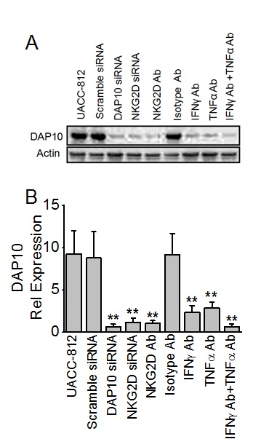

SUPPLEMENTARY FIGURE 5

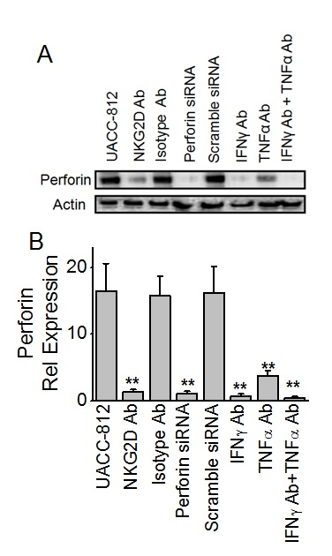

SUPPLEMENTARY FIGURE 6
Screen Fail ID | Therapy received after study consent form signed
SF1 | Intrathecal methotrexate
SF2 | Everolimus, exemestane, letrozole
SF3 | Fulvestrant, everolimus, exemestane, paclitaxel
SF13 | Trastuzumab, anastrozole (continued)
SF15 | Gemcitabine, carboplatin, capecitabine
SF16 | Estradiol (continued), paclitaxel, Tamoxifen, bevacizumab, ixabepilone, gemcitabine, cisplatin
SF21 | Fulvestrant (continued)
SF24 | Letrozole (continued)
SF25 | Continued fulvestrant and anastrozole, capecitabine, exemestane, everolimus
SF26 | Exemestane (continued)
SF28 | Anastrozole (continued)
SF29 | Tamoxifen, leuprolide, letrozole, capecitabine
SF32 | Continued letrozole and trastuzumab, estradiol
SF33 | Paclitaxel, doxorubicin
SF36 | No additional chemotherapy
SF37 | Estradiol (continued), capecitabine, exemestane
SF39 | No additional therapy given
Vaccinated patient ID | Therapy received after study consent form signed
V003 | letrozole (continued); enrolled in CALGB trial (fulvestrant w/ lapatinib or placebo), capecitabine
V005 | goserelin and tamoxifen (continued), letrozole
V006 | letrozole (continued), estradiol
V008 | letrozole (continued),tamoxifen
V013 | letrozole (continued), anastrozole
V023 | goserelin, trastuzumab, and anastrozole (continued)
V025 | exemestane (continued), CALGB study (ixabepilone w/ bevacizumab), fulvestrant, carboplatin, gemcitabine eribulin
V026 | exemestane and trastuzumab (continued)
V030 | anastrozole (continued), letrozole, fulvestrant
V032 | faslodex (continued)
V043 | anastrazole (continued)
V048 | exemestane, progressed and subsequently enrolled in another clinical trial at an OSH comparing afinitor vs. aromasin and Herceptin. Assigned to aromasin and herceptin arm
V053 | Letrozole (continued)
V054 | Letrozole (continued), exemestane

