A)
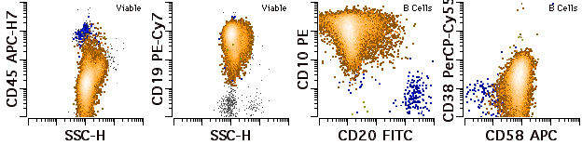
B)
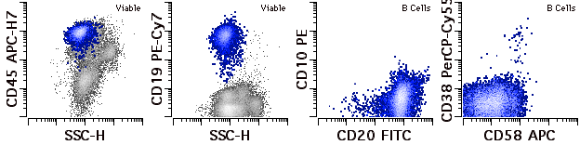
Supplementary Figure 6: Pre-treatment flow cytometry with post-treatment MRD by HTS identified in a triple flow cytometry-sorted fraction of mature B cells.

