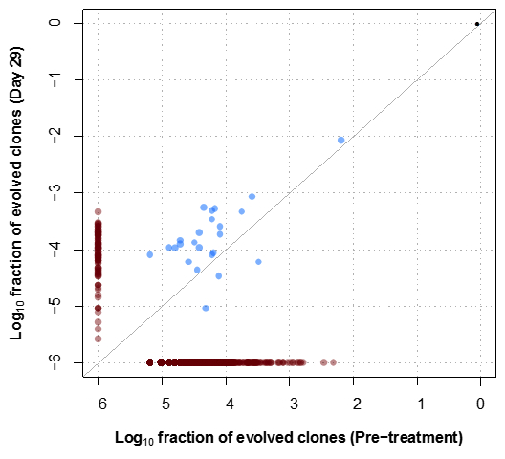

Supplementary Figure 5. Example of evolved clonotypes in one patient.

