Case 1
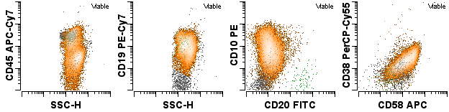
Case 2
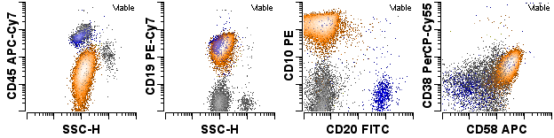
Case 3
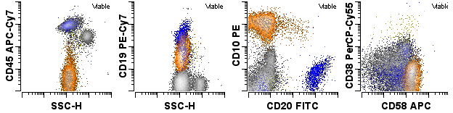
Case 4
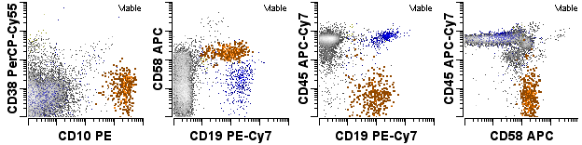
Case 5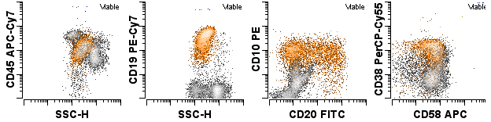

Supplementary Figure 4: Pre-treatment flow cytometry for 5 cases with no clonal rearrangement of IGH, either complete V-DJ or incomplete DJ rearrangements at >10%, by high-throughput sequencing.

