Supplementary Table 11: Comparison of the correlation of biomarker expression by RPPA in CNB and FNA with Central and Peripheral samples based on whether neoadjuvant chemotherapy had been administered.

 | Wilcoxon signed rank test
 | Statistics | P-value | Figure
Central vs. Peripheral | 921 | <0.0001 | 1
Core vs. Central | 3872 | <0.0001 | 2
Core vs. Surgical specimen | 3396 | <0.0001 | 3
FNA vs. Core | 3748 | <0.0001 | 4
FNA vs. Central | 5898.5 | 0.5078 | 5
FNA vs. Peripheral | 7611 | 0.0209 | 6
FNA vs. Surgical specimen | 6556 | 0.6331 | 7

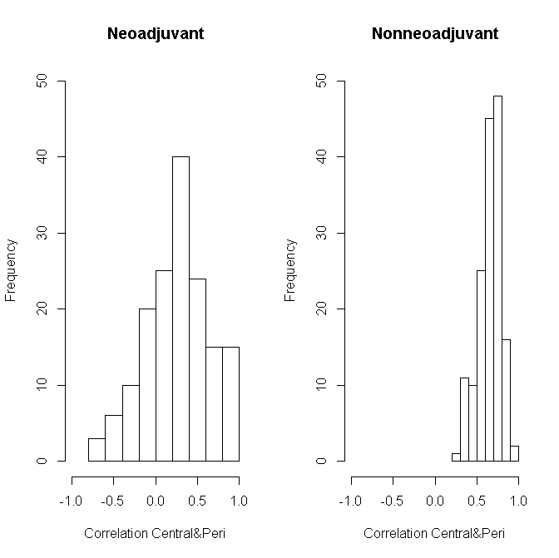
Figure 1: Comparing the correlation of protein expressions in Central and Peripheral samples between neoadjuvant and nonneoadjuvant patients (P<0.0001).
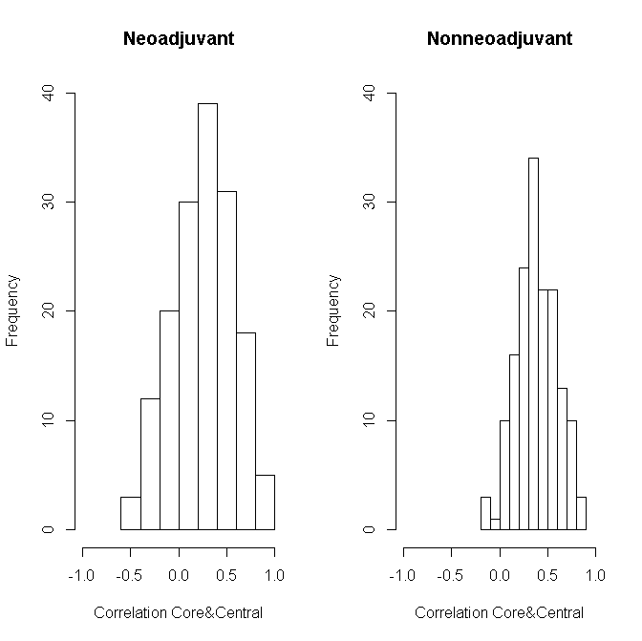
Figure 2: Comparing the correlation of protein expressions in Core and Central samples between neoadjuvant and nonneoadjuvant patients (P<0.0001).
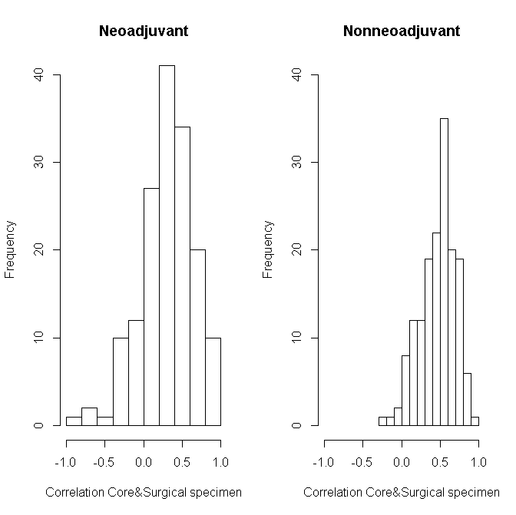
Figure 3: Comparing the correlation of protein expressions in Core and Surgical specimen samples between neoadjuvant and nonneoadjuvant patients (P<0.0001)
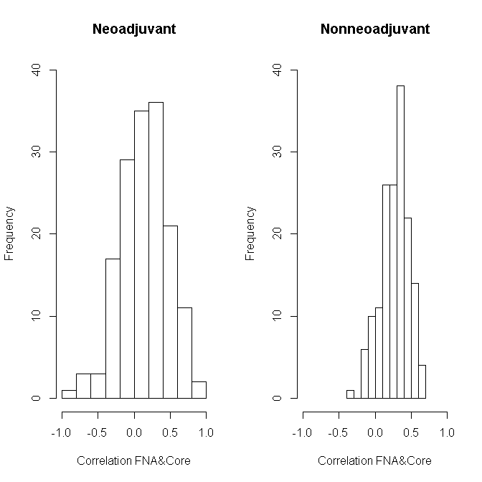
Figure 4: Comparing the correlation of protein expressions in FNA and Core samples between neoadjuvant and nonneoadjuvant patients (P<0.0001).
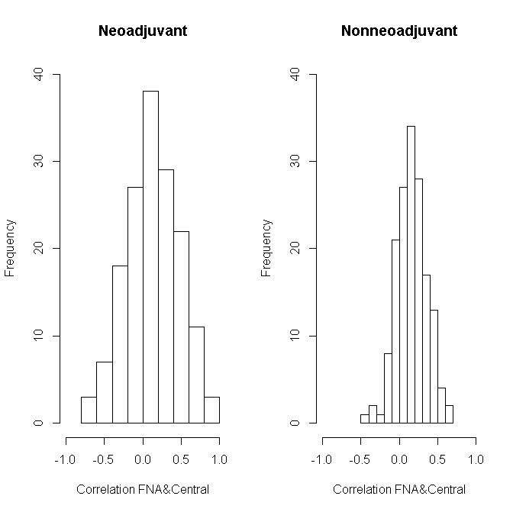
Figure 5: Comparing the correlation of protein expressions in FNA and Central samples between neoadjuvant and nonneoadjuvant patients (P=0.5078).
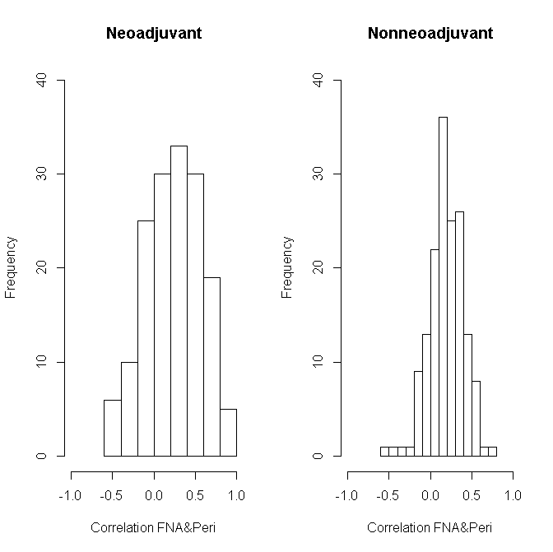
Figure 6: Comparing the correlation of protein expressions in FNA and Peripheral samples between neoadjuvant and nonneoadjuvant patients (P=0.0209).
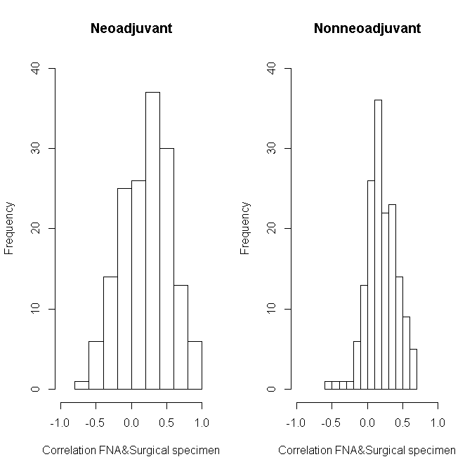
Figure 7: Comparing the correlation of protein expressions in FNA and Surgical specimen samples between neoadjuvant and nonneoadjuvant patients (P=0.6331).

