Supplementary Figures

Supplementary Figures demonstrate the predictive capacity of the risk model PLCOT-1 (Figure S1) and PLCOT-2 (Figure S2) assessed by the synthesized population of Taiwan cancer-free ever-smokers ages 50-74 in 2010.

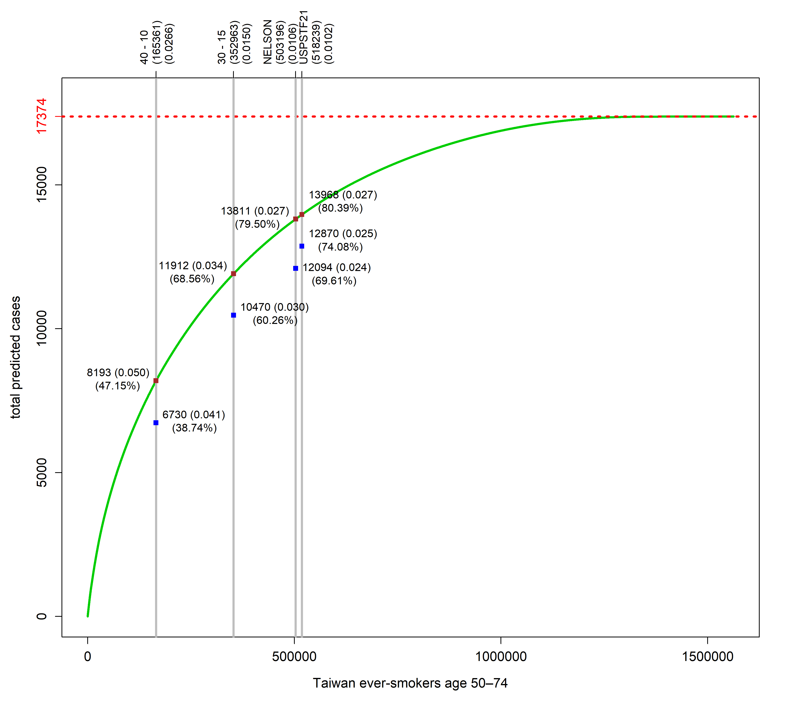
Figure S1. The predictive capacity of the risk model PLCOT-1 assessed by the synthesized population of Taiwan cancer-free ever-smokers ages 50-74 in 2010: the Lorenz curve plots predicted total lung cancer incidence against the numbers of individuals at highest risk based on the PLCOT-1 model.

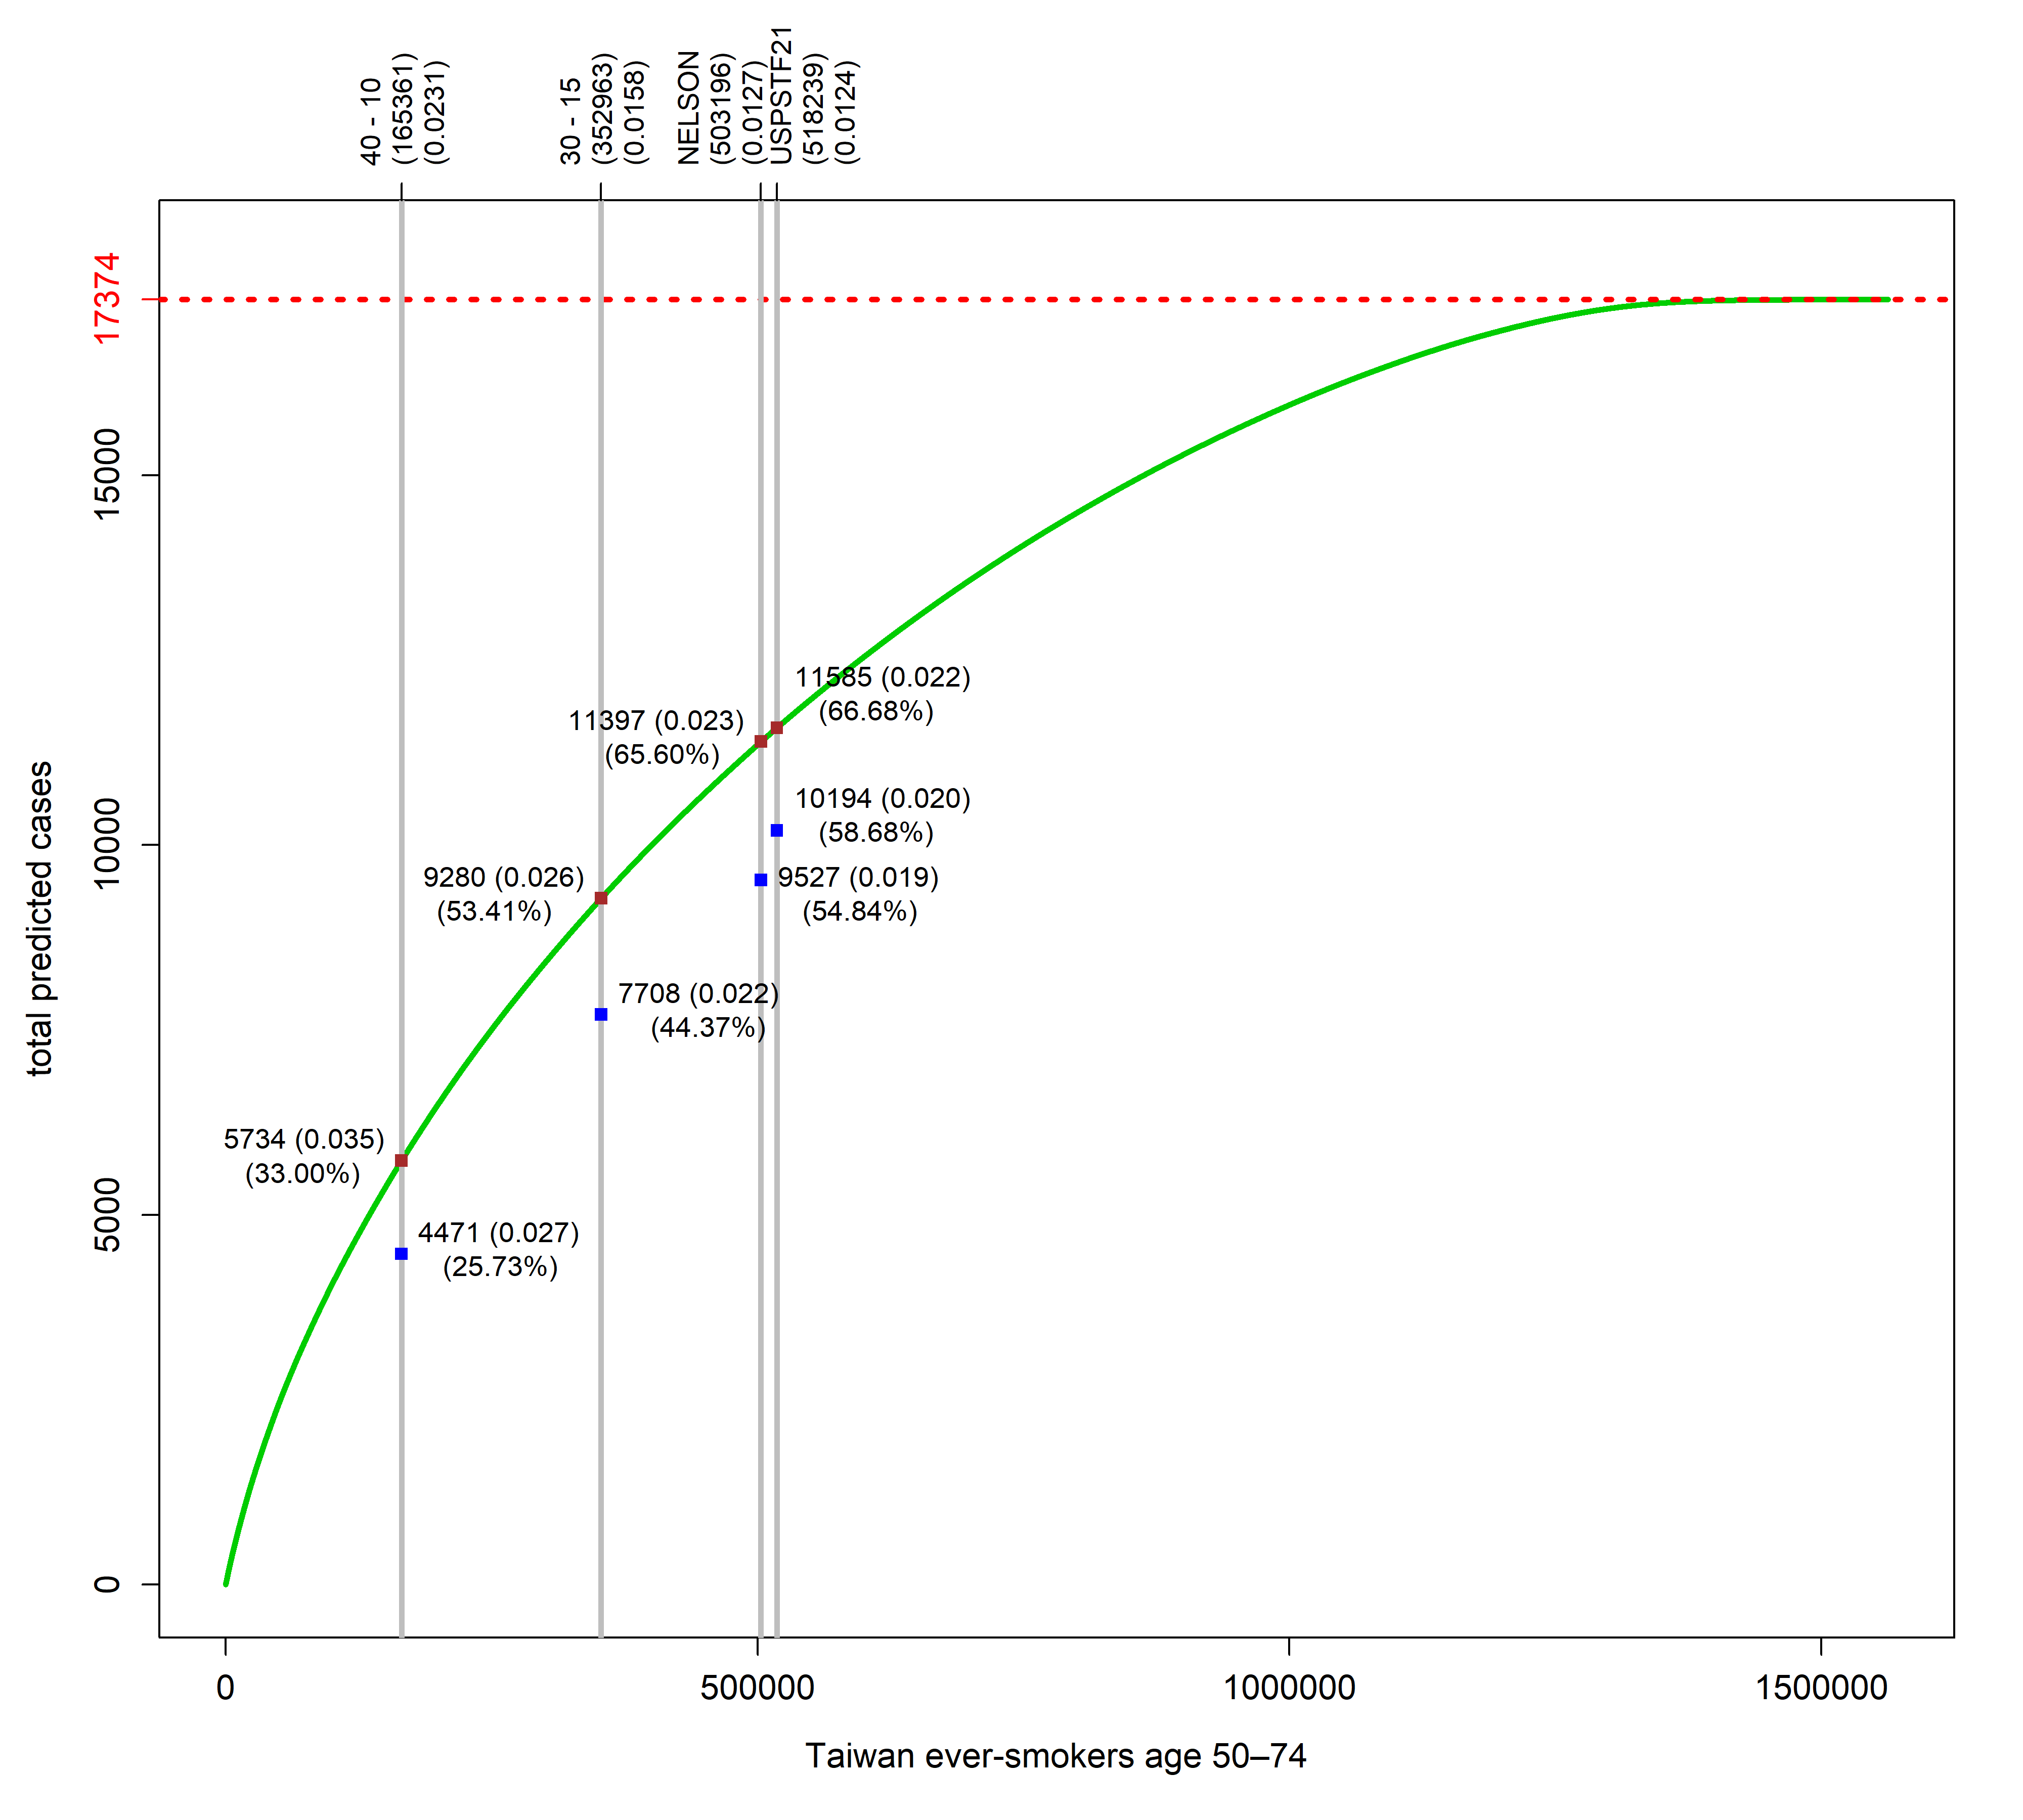
Figure S2. The predictive capacity of the risk model PLCOT-2 assessed by the synthesized population of Taiwan cancer-free ever-smokers ages 50-74 in 2010: the Lorenz curve plots predicted total lung cancer incidence against the numbers of individuals at highest risk based on the PLCOT-2 model.

