SUPPLEMENTARY DATA

Table S1. SNPs genotyped in this study previously associated to CRC genetic susceptibility.
SNP ID | Chr. | Gene | Used OR (95%CI) | Reference
rs6983267 | 8q24.21 | MYC | 1.16 (1.14-1.18) | Huyghe JR, et al. Nat Genet. 2019
rs719725 | 9p24 | TPD52L3-UHRF2 | 1.14(1.05-1.15) | Zanke BW et al. Nature Genetics 2007
rs4939827 | 18q21.1 | SMAD7 | 1.17 (1.15-1.19) | Huyghe JR, et al. Nat Genet. 2019
rs7229639 | 18q21 | SMAD7 | 1.22(1.15-1.29) | Zhang B, et al. Int J Cancer. 2014a
rs16892766 | 8q23.3 | EIF3H | 1.20 (1.17-1.24) | Huyghe JR, et al. Nat Genet. 2019
rs3802842 | 11q23.1 | COLCA2/COLCA1 | 1.12 (1.10-1.14) | Huyghe JR, et al. Nat Genet. 2019
rs4779584 | 15q13.3 | GREM1 | 1.26 (1.19-1.34) | Tomlinson IP, et al. Nat Genet. 2008
rs10795668 | 10p14 | ARN5SP299/GATA3 | 1.09 (1.07-1.12) | Huyghe JR, et al. Nat Genet. 2019
rs4444235 | 14q22.2 | BMP4 | 1.09 (1.07-1.11) | Huyghe JR, et al. Nat Genet. 2019
rs9929218 | 16q22.1 | CDH1 | 1.06 (1.04-1.08) | Huyghe JR, et al. Nat Genet. 2019
rs10411210 | 19q13 | RHNP2 | 1.21 (1.17-1.26) | Huyghe JR, et al. Nat Genet. 2019
rs961253 | 20p12.3 | BMP2 | 1.10 (1.08-1.12) | Huyghe JR, et al. Nat Genet. 2019
rs6691170 | 1q41 | DUSP10 | 1.09 (1.07-1.12) | Huyghe JR, et al. Nat Genet. 2019
rs7136702 | 12q13.13 | LARP4/DIP2B | 1.06(1.04-1.08) | Houlston et al. Nat Genet 2010
rs10936599 | 3q26.2 | TERC | 1.05 (1.03-1.07) | Huyghe JR, et al. Nat Genet. 2019
rs11169552 | 12q13.3 | DIP2B/ATF1 | 1.09 (1.07-1.11) | Huyghe JR, et al. Nat Genet. 2019
rs4925386 | 20q13.33 | LAMA5 | 1.12 (1.10-1.15) | Huyghe JR, et al. Nat Genet. 2019
rs1957636 | 14q22.2 | BMP4 | 1.06 (1.04-1.08) | Huyghe JR, et al. Nat Genet. 2019
rs4813802 | 20p12.3 | BMP2 | 1.07 (1.05-1.09) | Huyghe JR, et al. Nat Genet. 2019
rs2736100 | 5p15.33 | TERT | 1.07 (1.04-1.10) | Kinnersley et al. Br J Cancer 2012
rs1321311 | 6p21 | CDKN1A | 1.06 (1.03-1.08) | Huyghe JR, et al. Nat Genet. 2019
rs3824999 | 11q13.4 | POLD3 | 1.08 (1.07-1.10) | Huyghe JR, et al. Nat Genet. 2019
rs5934683 | Xp22.2 | SHROOM2 | 1.07 (1.04-1.10) | Dunlop et al. Nat Genet. 2012
rs12080929 | 1p33 | SLC5A9 | 0.86 (0.78-0.95) | Fernandez-Rozadilla et al. BMC Genomics 2013
rs11987193 | 8p12 | DUSP4 | 0.78 (0.70-0.87) | Fernandez-Rozadilla et al. BMC Genomics 2013
rs10774214 | 12p13.32 | CCND2 | 1.08 (1.06-1.11) | Huyghe JR, et al. Nat Genet. 2019
rs647161 | 5q31.1 | PITX1 | 1.07 (1.05-1.09) | Huyghe JR, et al. Nat Genet. 2019
rs2423279 | 20p12.3 | HAQ1 | 1.09 (1.07-1.12) | Huyghe JR, et al. Nat Genet. 2019
rs11903757 | 2q32.3 | NABP1 | 1.04 (1.02-1.07) | Huyghe JR, et al. Nat Genet. 2019
rs10911251 | 1q25.3 | LAMC1 | 1.08 (1.06-1.09) | Huyghe JR, et al. Nat Genet. 2019
rs3217810 | 12p13.32 | CCND2 | 1.13 (1.10-1.17) | Huyghe JR, et al. Nat Genet. 2019
rs3217901 | 12p13.32 | CCND2 | 1.10 (1.06-1.14) | Peters et al. Gastroenterology 2013
rs59336 | 12q24.21 | TBX3 | 1.09 (1.06-1.13) | Peters et al. Gastroenterology 2013
rs704017 | 10q22.3 | ZMIZ1-AS1 | 1.08 (1.06-1.10) | Huyghe JR, et al. Nat Genet. 2019
rs11196172 | 10q25.2 | TCF7L2 | 1.06 (1.03-1.08) | Huyghe JR, et al. Nat Genet. 2019
rs174537 | 11q12.2 | MYRF | 1.07 (1.05-1.09) | Huyghe JR, et al. Nat Genet. 2019
rs4246215 | 11q12.2 | FEN1 | 1.15(1.12–1.19) | Zhang et al. Nat Genet. 2014b
rs174550 | 11q12.2 | FADS1 | 1.15(1.12–1.19) | Zhang et al. Nat Genet. 2014b
rs1535 | 11q12.2 | FADS2 | 1.15(1.12–1.19) | Zhang et al. Nat Genet. 2014b
rs10849432 | 12p13.31 | CD9 | 1.07 (1.04-1.09) | Huyghe JR, et al. Nat Genet. 2019
rs12603526 | 17p13.3 | NXN | 1.07 (1.05-1.09) | Huyghe JR, et al. Nat Genet. 2019
rs1800469 | 19q13.2 | TGFB1 | 1.05 (1.03-1.06) | Huyghe JR, et al. Nat Genet. 2019
rs2241714 | 19q13.2 | B9D2 | 1.09(1.06–1.12) | Zhang et al. Nat Genet. 2014b
rs812481 | 3p14.1 | LRIG1 | 1.06 (1.04-1.08) | Huyghe JR, et al. Nat Genet. 2019
rs35360328 | 3p22.1 | CTNNB1 | 1.10 (1.08-1.13) | Huyghe JR, et al. Nat Genet. 2019
rs3184504 | 12q24.12 | SH2B3 | 1.08 (1.06-1.10) | Huyghe JR, et al. Nat Genet. 2019
rs73208120 | 12q24.22 | NOS1 | 1.07 (1.04-1.09) | Huyghe JR, et al. Nat Genet. 2019
rs6066825 | 20q13.13 | PREX1 | 1.07 (1.06-1.09) | Huyghe JR, et al. Nat Genet. 2019
rs11190164 | 10q24.2 | SLC25A28 | 1.08 (1.06-1.10) | Huyghe JR, et al. Nat Genet. 2019
rs1035209 | 10q24.2 | ABCC2/MRP2 | 1.08 (1.06-1.10) | Huyghe JR, et al. Nat Genet. 2019
rs3987 | 4q26 | NDST3 | 1.36 | Real LM et al Plos One 2014
rs72647484 | 1p36.2 | CDC42/WNT4 | 1.05 (1.02-1.08) | Huyghe JR, et al. Nat Genet. 2019
rs16941835 | 16q24.1 | RP11-58A18.1/FOXL1 | 1.05 (1.03-1.07) | Huyghe JR, et al. Nat Genet. 2019
rs10904849 | 10p13 | CUBN | 1.13(1.08-1.19) | Al-Tassan et al. Scientific Reports 2015
rs17094983 | 14q23.1 | RTN1 | 1,09 (1,06-1,12) | Huyghe JR, et al. Nat Genet. 2019
rs12241008 | 10q25.2 | VTI1A | 1.19(1.12-1.26) | Wang H et al. Nat Commun. 2014
rs12970291 | 18q22.3 | TSHZ1 | 1.27(1.16-1.38) | Cheng TH et al Scientific Reports 2015
rs4711689 | 6p21.1 | TFEB | 1.03 (1.01-1.05) | Huyghe JR, et al. Nat Genet. 2019
rs6469656 | 8q23.3 | EIF3H | 1.12(1.07-1.16) | Zeng et al, Gastroenterology 2016
rs11064437 | 12p13.3 | SPSB2 | 1.24 (1.02-1.51) | Huyghe JR, et al. Nat Genet. 2019
rs6061231 | 20q13.3 | RPS21 | 1.19(1.12-1.27) | Zeng et al, Gastroenterology 2016
rs11676348 | 2q35 | CXCR2 | 0.93 (0.89-0.99) | Khalili et al Carcinogenesis 2015
rs2238126 | 12p13.2 | ETV6 | 1.01 (0.99-1.04) | Huyghe JR, et al. Nat Genet. 2019
rs992157 | 2q35 | PNKD/TMBIM1 | 1.06 (1.04-1.08) | Huyghe JR, et al. Nat Genet. 2019
rs3764482 | 18q21.1 | SMAD7 | 1.48 (1.29-1.70) | Li J et al, Mol Carcinog 2017

SNP ID, single nucleotide polymorphism identification. Chr: Chromosome; OR, odds ratio.

Association tests for individual SNPs

Table S2. Case-control association results obtained by logistic regression analyses. Association results for 1,200 cases and 1,629 controls. Results are based on the reported risk allele from previous CRC GWAS.
SNP ID* | Region | Relevant gene | Variant type | Risk  allele | RAF  cases/controls | OR | 95%CI | P-value
rs12080929 | 1p33 | SLC5A9 | intronic variant | T | 0.73/0.73 | 1 | (0.89-1.13) | 0.9984
rs10911251 | 1q25.3 | CDC42/WNT | intergenic variant | A | 0.59/0.59 | 1 | (0.9-1.12) | 0.9507
rs72647484 | 1p36.12 | LAMC1 | intronic variant | C | 0.07/0.07 | 0.97 | (0.78-1.19) | 0.7494
rs6691170 | 1q41 | DUSP10 | intergenic variant | T | 0.37/0.36 | 1.05 | (0.94-1.17) | 0.3685
rs992157 | 2q35 | NABP1 | intergenic variant | A | 0.51/0.52 | 0.98 | (0.88-1.09) | 0.7308
rs11676348 | 2q35 | PNKD/TMBIM1 | intronic variant | T | 0.52/0.52 | 1 | (0.9-1.11) | 0.9823
rs11903757 | 2q32.3 | CXCR2 | intergenic variant | C | 0.14/0.15 | 0.92 | (0.8-1.07) | 0.2917
rs10936599 | 3q26.2 | LRIG1 | intronic variant | C | 0.79/0.76 | 1.16 | (1.02-1.31) | 0.0232
rs35360328 | 3p22.1 | CTNNB1 | intergenic variant | A | 0.16/0.14 | 1.12 | (0.97-1.3) | 0.1154
rs812481 | 3p14.1 | TERC | synonymous variant | G | 0.54/0.52 | 1.08 | (0.97-1.2) | 0.1577
rs7136702 | 4q13.2 | LARP4/DIP2B | intergenic variant | T | 0.38/0.36 | 1.07 | (0.96-1.2) | 0.1928
rs3987 | 4q26 | NDST3 | intergenic variant | G | 0.45/0.44 | 1.01 | (0.91-1.12) | 0.8651
rs2736100 | 5p15.33 | TERT | intronic variant | A | 0.49/0.5 | 0.94 | (0.84-1.04) | 0.2461
rs647161 | 5q31.1 | PITX1 | intronic variant | A | 0.71/0.7 | 1.05 | (0.94-1.17) | 0.3977
rs4711689 | 6p21.1 | CDKN1A | intergenic variant | A | 0.56/0.55 | 1.03 | (0.93-1.15) | 0.5442
rs1321311 | 6p1.2 | TFEB | intronic variant | A | 0.26/0.25 | 1.04 | (0.92-1.17) | 0.537
rs719725 | 8q23.3 | DUSP4 | intergenic variant | A | 0.58/0.58 | 0.97 | (0.87-1.08) | 0.5939
rs16892766 | 8q23.3 | EIF3H | intergenic variant | C | 0.06/0.06 | 1.03 | (0.83-1.27) | 0.8119
rs6983267 | 8q24.21 | EIF3H | intargenic variant | G | 0.54/0.53 | 1.05 | (0.94-1.17) | 0.3843
rs6469656 | 8q23.3 | MYC | non coding transcript variant / intronic variant | A | 0.88/0.88 | 1.04 | (0.88-1.23) | 0.627
rs11987193 | 8p12 | TPD52L3/UHRF2 | intronic variant | C | 0.73/0.74 | 0.94 | (0.84-1.06) | 0.3477
rs10795668 | 10p14 | ARN5SP299/GATA3 | intronic variant | A | 0.3/0.32 | 0.9 | (0.8-1) | 0.0597
rs704017 | 10q22.3 | ZMIZ1-AS1 | intronic variant | G | 0.56/0.52 | 1.2 | (1.08-1.34) | 6,00E-04
rs11196172 | 10q25.2 | ABCC2/MRP2 | intergenic variant | A | 0.14/0.16 | 0.88 | (0.75-1.02) | 0.0836
rs1035209 | 10q24.2 | SLC25A28 | intergenic variant | T | 0.2/0.17 | 1.2 | (1.05-1.38) | 0.0074
rs12241008 | 10q25.2 | TCF7L2 | intronic variant | C | 0.09/0.09 | 0.95 | (0.79-1.15) | 0.6137
rs11190164 | 10q24.2 | VTI1A | intronic variant | G | 0.25/0.23 | 1.12 | (0.99-1.26) | 0.0806
rs4246215 | 11q12.2 | FEN1 | 3'-UTR variant | T | 0.3/0.34 | 0.84 | (0.75-0.95) | 0.0039
rs3802842 | 11q23.1 | MYRF | intronic variant | C | 0.28/0.28 | 1.03 | (0.92-1.16) | 0.607
rs174537 | 11q12.2 | FADS2 | intronic variant | G | 0.7/0.66 | 1.18 | (1.05-1.32) | 0.0043
rs1535 | 11q12.2 | FADS1 | intronic variant | A | 0.69/0.65 | 1.17 | (1.05-1.31) | 0.0061
rs174550 | 11q12.2 | POLD3 | intronic variant | T | 0.7/0.66 | 1.2 | (1.07-1.34) | 0.0016
rs3824999 | 11q13.4 | COLCA1/COLCA2 | intronic variant | G | 0.5/0.5 | 1.04 | (0.93-1.15) | 0.4936
rs73208120 | 12q24.22 | ETV6 | intronic variant | G | 0.06/0.06 | 1.02 | (0.81-1.27) | 0.8886
rs3217901 | 12.13.32 | CD9 | intronic variant | G | 0.36/0.36 | 0.99 | (0.88-1.1) | 0.8354
rs11169552 | 12q13.12 | SPSB2 | splice acceptor variant | C | 0.77/0.76 | 1.04 | (0.92-1.18) | 0.5512
rs59336 | 12q24.21 | CCND2 | intronic variant | T | 0.53/0.51 | 1.07 | (0.96-1.19) | 0.1996
rs10849432 | 12p13.31 | CCND2 | intronic variant | T | 0.87/0.86 | 1.04 | (0.89-1.21) | 0.6366
rs3184504 | 12q24.12 | CCND2 | intronic variant | C | 0.55/0.56 | 0.97 | (0.87-1.07) | 0.5241
rs11064437 | 12p13.31 | DIP2B/ATF1 | intergenic variant | C | 0.99/0.98 | 1.49 | (0.95-2.35) | 0.0859
rs10774214 | 12p13.32 | SH2B3 | missense variant | T | 0.37/0.36 | 1.08 | (0.97-1.2) | 0.1823
rs2238126 | 12p13.2 | TBX3 | intronic variant | G | 0.17/0.17 | 1 | (0.87-1.14) | 0.9638
rs3217810 | 12p13.32 | NOS1 | intronic variant | T | 0.1/0.08 | 1.21 | (1.01-1.46) | 0.0425
rs4444235 | 14q22.2 | BMP4 | intergenic variant | C | 0.55/0.55 | 1.01 | (0.91-1.13) | 0.8243
rs17094983 | 14q23.1 | BMP4 | intronic variant | G | 0.86/0.85 | 1.08 | (0.93-1.25) | 0.3255
rs1957636 | 14q22.2 | RTN1 | intergenic variant | T | 0.42/0.41 | 1.06 | (0.95-1.18) | 0.291
rs4779584 | 15q13.3 | GREM1 | intergenic variant | T | 0.19/0.18 | 1.06 | (0.93-1.22) | 0.3726
rs9929218 | 16q22.1 | CDH1 | intronic variant | G | 0.71/0.69 | 1.12 | (0.99-1.25) | 0.0619
rs16941835 | 16q24.1 | FOXL1 | intergenic variant | C | 0.17/0.18 | 0.95 | (0.83-1.09) | 0.4603
rs12603526 | 17q13.3 | NXN | intron variant | C | 0.01/0.01 | 1.22 | (0.77-1.93) | 0.3991
rs4939827 | 18q21.1 | SMAD7 | intronic variant | T | 0.57/0.53 | 1.17 | (1.05-1.31) | 0.0031
rs12970291 | 18q22.3 | TSHZ1 | intergenic variant | A | 0.03/0.04 | 0.89 | (0.67-1.18) | 0.4007
rs10411210 | 19q13.11 | RHPN2 | intronic variant | C | 0.88/0.88 | 1.04 | (0.88-1.22) | 0.6621
rs2241714 | 19q13.2 | B9D2 | missense variant / 2 kb upstream variant | C | 0.67/0.64 | 1.12 | (1-1.25) | 0.0443
rs1800469 | 19q13.2 | TGFB1 | 2 kb upstream variant / 0.5 kb downstream variant | G | 0.67/0.64 | 1.13 | (1.01-1.27) | 0.0272
rs2423279 | 20p12.3 | HAQ1 | intergenic variant | C | 0.32/0.3 | 1.06 | (0.94-1.18) | 0.3389
rs961253 | 20p12.3 | BMP2 | intergenic variant | A | 0.36/0.32 | 1.16 | (1.04-1.3) | 0.0093
rs6066825 | 20q13.13 | BMP2 | intergenic variant | A | 0.6/0.57 | 1.1 | (0.99-1.23) | 0.0717
rs6061231 | 20q13.33 | PREX1 | intronic variant | C | 0.75/0.72 | 1.19 | (1.06-1.34) | 0.0035
rs4925386 | 20q13.33 | LAMA5 | intergenic variant | C | 0.71/0.67 | 1.18 | (1.05-1.32) | 0.0039
rs4813802 | 20p12.3 | LAMA5 | intronic variant | G | 0.31/0.31 | 1.03 | (0.92-1.16) | 0.5898
rs5934683 | Xp22.2 | SHROOM2 | intronic variant | C | 0.61/0.62 | 0.94 | (0.83-1.06) | 0.3191

*SNPs with genotyping success rate below 90% were removed from subsequent analyses (including rs7229639, rs3764482). We also removed a monomorphic SNP (rs10904849). SNP, single nucleotide polymorphism; RAF, risk allele frequency; OR, odds ratio; 95%CI, 95% confidence interval; UTR, untranslated region; kb, kilobase.

Table S3. Discriminative capacity of predictive models after 10-fold cross-validation using an unweighted PRS and comparing the total number of cases and controls.

Predictive model | AUROC (95%CI) | AUROC improvement | P-value
Sex-age-based | 0.594 (0.573-0.615)
PRS-based | 0.611 (0.590-0.632) | 0.017* | 0.006
FIT-based | 0.623 (0.602-0.644) | 0.028* | 0.0001
FIT and PRS-based | 0.635 (0.615-0.656) | 0.012** | 0.008

AUROC, Area Under de Curve; CI, confidence interval. *Compared to Sex-age-based. **Compared to FIT-based.

Table S4. Discriminative capacity of predictive models comparing extreme phenotypes.

Predictive model | AUROC (95%CI) | AUROC improvement | P-value
Sex-age-based | 0.638 (0.611-0.666)
PRS-based | 0.665 (0.637-0.693) | 0.027* | 0.00025
FIT-based | 0.678 (0.652-0.706) | 0.040* | 0.000014
FIT and PRS-based | 0.698 (0.672-0.725) | 0.019** | 0.0016

AUROC, Area Under de Curve; CI, confidence interval. *Compared to Sex-age-based. **Compared to FIT-based.

Table S5. Discriminative capacity of predictive models after 10-fold cross-validation comparing extreme phenotypes.

Predictive model | AUROC (95%CI) | AUROC improvement | P-value
Sex-age-based | 0.625 (0.596-0.653)
PRS-based | 0.660 (0.632-0.688) | 0.035* | 0.000018
FIT-based | 0.670 (0.642-0.697) | 0.045* | 0.0000048
FIT and PRS-based | 0.693 (0.666-0.720) | 0.023** | 0.00030

AUROC, Area Under de Curve; CI, confidence interval. *Compared to Sex-age-based. **Compared to FIT-based.

Weighted polygenic risk score

The median number of risk alleles in controls, 54, was considered as reference. Cases and controls were grouped considering subjects carrying ≤ 40 risk alleles and ≥ 68 alleles, because of the small number of subjects at these extremes. We detected that the risk score was higher in the cases group compared to the control cohort (OR=1.04; 95%CI 1.02-1.05; P-value= 0.0000). We also observed that there was a 2-fold increase in CRC risk was detected for subjects in the highest decile of risk alleles (≥ 62), compared to those in the first decile (≤ 52)(OR=2.00, 95%CI 1.42-2.81, P-value=0.0001). As shown in Figure S1, the increase in risk per allele was linear, indicating the independent additive contribution of each allele to have a HRL. We also calculated if there was an association between age and sex and PRS but there was none.
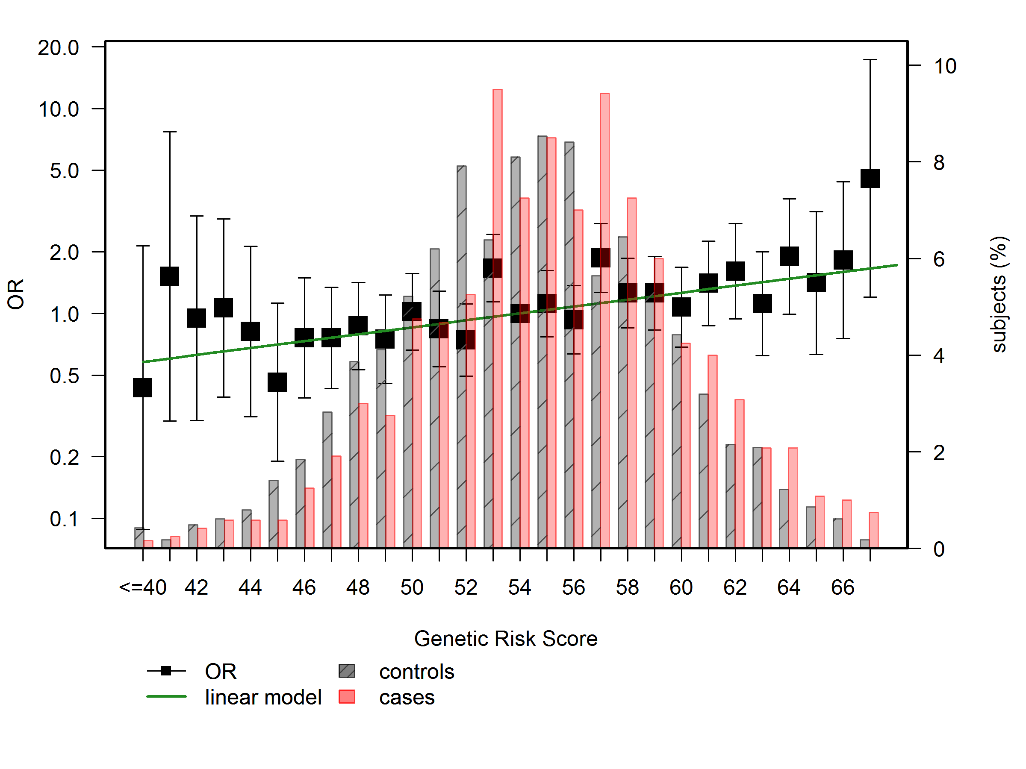
Figure S1. Weighted polygenic risk score. Distribution of risk by allele number for the 62 SNPs genotyped. The presence of multiple CRC risk alleles is displayed for SPS cases (bold bars) and controls (stripped bars). OR, odds ratio.

Polygenic risk score comparing extreme phenotypes

The median number of risk alleles in controls, 56, was considered as reference. Cases and controls were grouped considering subjects carrying ≤ 46 risk alleles and ≥ 67 alleles, because of the small number of subjects at these extremes. We detected that the risk score was higher in the cases group compared to the control cohort (OR=1.05; 95%CI 1.01-1.08; P-value= 0.0146). We also observed that there was a 3-fold increase in CRC risk was detected for subjects in the highest decile of risk alleles (≥ 64), compared to those in the first decile (≤ 51)(OR=3.15, 95%CI 1.06 -9.41, P-value=0.0395). As shown in Figure S2, the increase in risk per allele was linear, indicating the independent additive contribution of each allele to have a HRL. We also calculated if there was an association between age and sex and PRS but there was none.
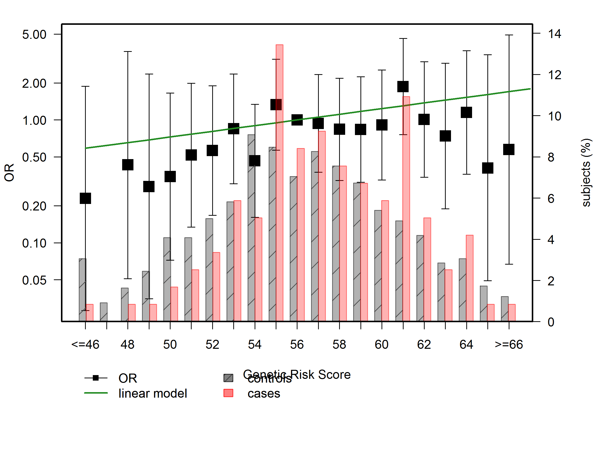
Figure S2. Genetic risk score. Distribution of risk by allele number for the 62 SNPs genotyped comparing extreme phenotypes (negative colonoscopy vs. CRC/HRL). The presence of multiple CRC risk alleles is displayed for SPS cases (bold bars) and controls (stripped bars). OR, odds ratio.

Development and validation of a predictive model for colorectal cancer screening

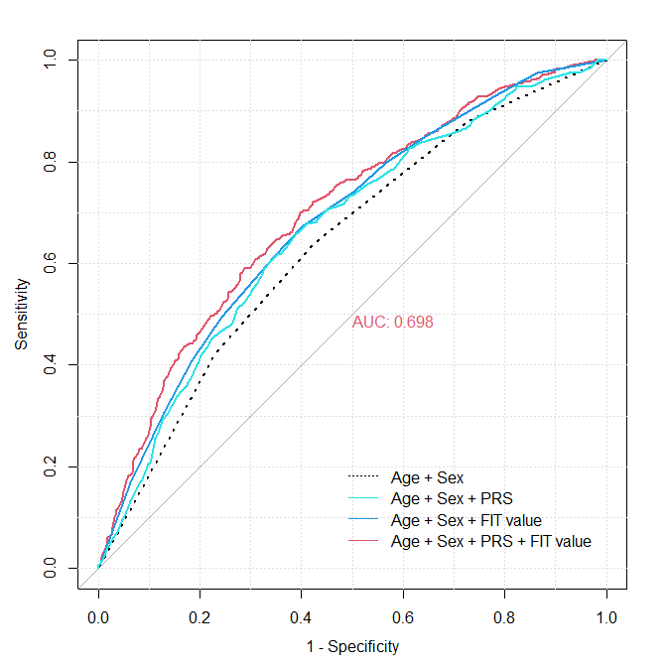
Figure S3. Area under the curve (AUROC) of the different predictive models comparing extreme phenotypes. AUROC, Area Under de Curve; CI, confidence interval.

