Supplementary Data

|  |  |  |  |  |  |  |  |  |  |
| --- | --- | --- | --- | --- | --- | --- | --- | --- | --- |
| Author | Data | Reference period | March | April | May | June | July | August | Sept |
| EHRN (14) | 2.7 million patients from 39 organizations in 23 states | Same months 2017-2019 |  | -86% |  |  |  |  |  |
| EHRN (2) | 9.8 million patients from 60 health care organizations in 28 states | Same months 2017-2019 | -36% | -81% | -56% | -32% |  |  |  |
| London et al. (15) | >28 million patients from 20 health care institutions | Same months 2019 | -39% | -85% |  |  |  |  |  |
| Patt et al. (16) | 5-7% of the Medicare fee-for-service population | Same months 2019 | -41% | -75% | -49% | -25% | -37% |  |  |
| Corley et al. (4) | >11 million patients from 8 large health care systems in 7 states | April-Sept. 2019 |  | -82% |  |  |  |  |  |
| Yekeduz et al. (17) | IQVIA Institute for Human Data Science | February 2020 |  | -90% |  |  |  |  |  |
| Komodo Health (18) | 320 million patients | Same months 2019 |  | -90% |  |  |  |  |  |
| Patel et al. (19) | 90,000 patients, San Francisco Health Network | February 2020 |  | -90% |  |  |  |  |  |
| Chen et al. (20) | HealthCore Integrated Research Database, 60 million patients | Same months 2019 | -33% | -79% | -58% | -15% | -13% |  |  |
| Khan et al. (21) | University of Illinois Hospital & Health Sciences System | January 2020 | -48% | -89% | -80% | -50% | -20% | -4% |  |
| Waclawik et al. (22) | Unknown | July 2019-February 2020 | -50% | -88% | -60% | -27% | -15% | -12% | -12% |
| Calderwood et al. (23) | GI Quality Improvement Consortium (GIQuIC) registry | Same months 2019 | -40% | -92% | -66% | -25% | -17% | -12% | -21% |
| Average | | | -38.8% | -84.8% | -52.5% | -28.5% | -37.0% |  |  |

**Supplementary Table 1.** Published estimates ofthe decrease in CRC screening rates as a result of the COVID-19 pandemic (March-September) identified by our literature search.

**Supplementary Table 2**. Published estimates of the decrease in CRC diagnoses rates as a result of the COVID-19 pandemic (March-September) identified by our literature search. Some studies distinguish between new and all diagnoses.

|  |  |  |  |  |  |  |  |  |  |  |
| --- | --- | --- | --- | --- | --- | --- | --- | --- | --- | --- |
| Author | Data | Reference period | March | April | May | June | July | August | Sept |  |
| Patt et al. (16) | 5-7% of the Medicare fee-for-service population | Same months 2019 | -41%  -36% | -70%  -60% | -54% -43% | -29%  -19% | -37%  -32% |  |  | New  All |
| Kaufman et al. (24) | ~280,000 patients across the US | January 6, 2019-February 29, 2020 | -35% | -47% |  |  |  |  |  | New |
| London et al. (15) | >28 million patients from 20 health care institutions | Same months 2019 | -16%  -18% | -54%  -40% |  |  |  |  |  | New  All |
| Komodo Health (18) | 320 million patient | Same months 2019 |  | -32% |  |  |  |  |  | New |
| Corley et al. (4) | 1 PROSPR site | April-September 2019 |  | -31% |  |  |  |  |  | New |
| Calderwood et al. (23) | GI Quality Improvement Consortium (GIQuIC) registry | Same months 2019 | -25% | -65% | -42% | -19% | -9% | -9% | -11% | All |
|  |  | **Average** | -29.3% | -47.7% | -48.5% | -24% | -34.5% |  |  |  |

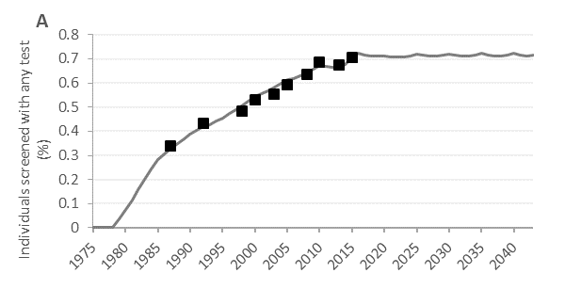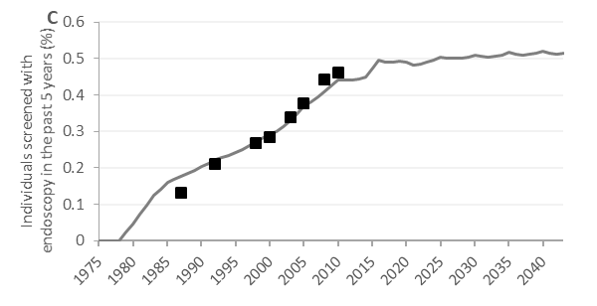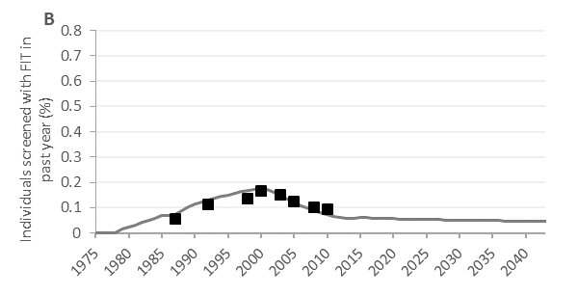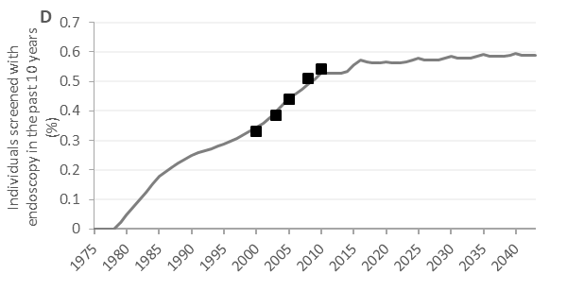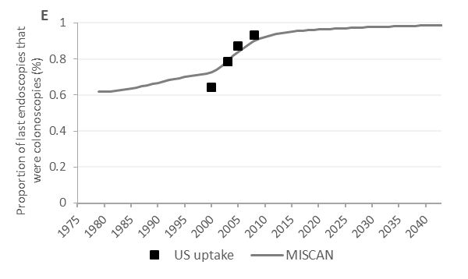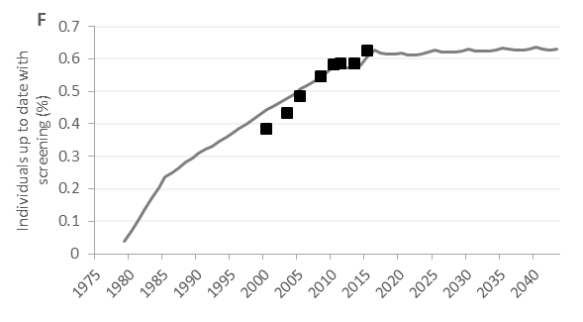

**Supplementary Figure 1.** Simulated screening in MISCAN: screened with any test (A), fecal immunochemical testing in the past year (FIT) (B), endoscopy in the past 5 years (C), endoscopy in the past 10 years (D), proportion of endoscopies that was colonoscopy (E), and percentage up-to-date with screening (F). Age and test-specific screening rates until the start of a hypothetical national screening program in 2014 were based on National Health Interview (NHIS) data from 1987 through 2015 (14). These data were extrapolated to simulate screening till 2045.

**Supplementary Figure 2.** Simulated incidence (A-C) and mortality rates (D-F) for all three recovery periods were smoothed using a logarithmic regression model. We only smoothed incidence rates for the period after the recovery period, and used the actual output rates during the impact and recovery period.

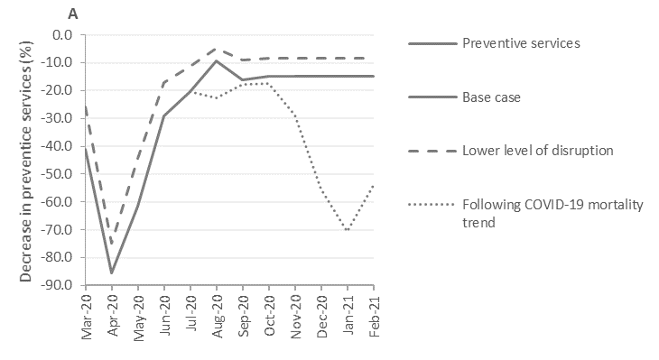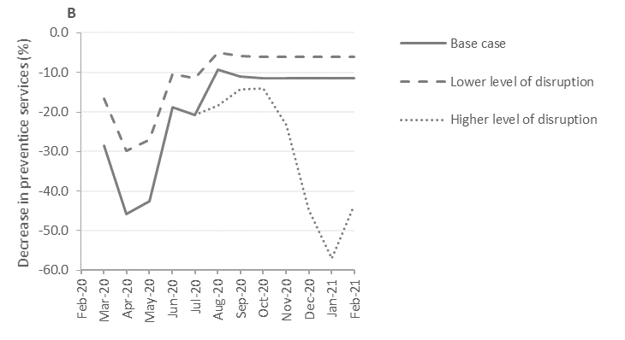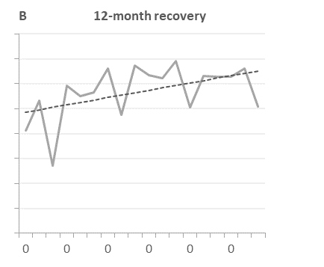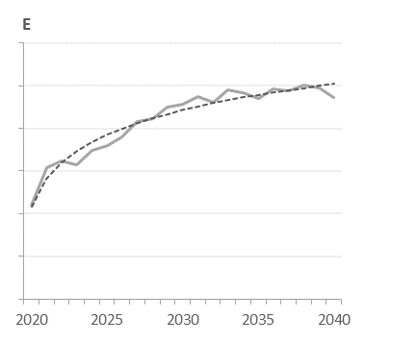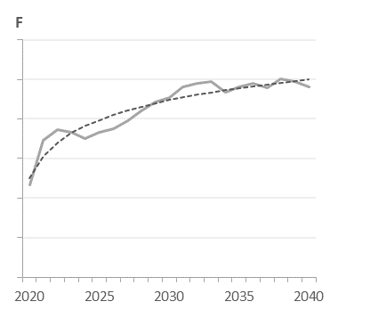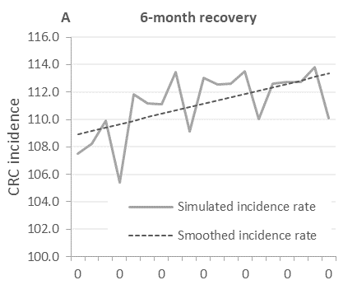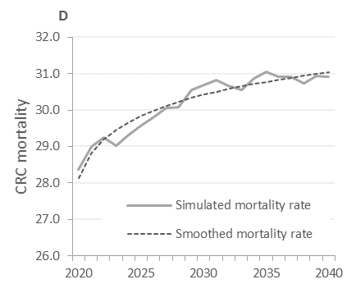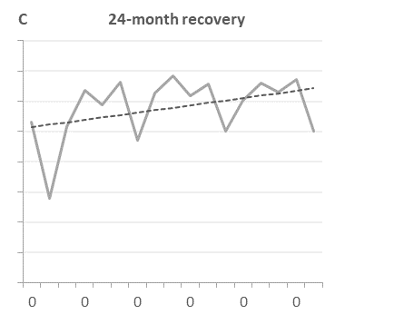

**Supplementary Figure 3.** Severity of disruption in preventive (panel A) and diagnostic (panel B) services during the disruption period. The severity of disruption was varied in sensitivity analysis to a lower and a higher severity.For the lower severity of disruption, we assumed that the odds ratio of the severity of disruption was only one-third of the base case. The higher severity of disruption tracked the COVID-19 mortality rates from August to the end of the disruption (using the ratio of severity of disruption and the COVID-19 mortality between March and September 2020 to extrapolate disruption). For scenarios with a 18-month disruption period, the severity of severity of February 2021 of the base case continued for the remaining 6 months.

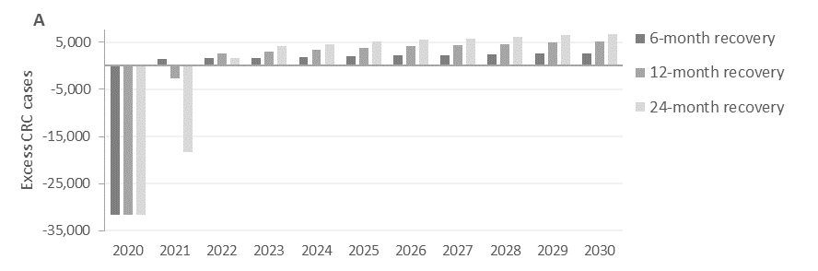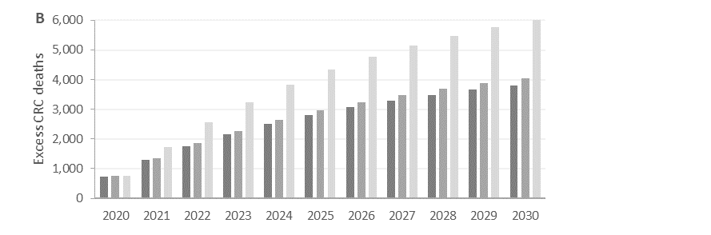

**Supplementary Figure 4.** Cumulative excess CRC cases (A) and deaths (B) compared to a scenario without pandemic-induced delays over time for different recovery scenarios.