Supplementary materials:

Occupational exposure to polycyclic aromatic hydrocarbons and lung cancer risk: results from a pooled analysis of case-control studies (SYNERGY)

Ann Olsson¹, Neela Guha², Liacine Bouaoun¹, Hans Kromhout³, Susan Peters³, Jack Siemiatycki⁴, Vikki Ho⁴,
Per Gustavsson⁵, Paolo Boffetta^{6,7}, Roel Vermeulen³, Thomas Behrens⁸, Thomas Brüning⁸, Benjamin Kendzia⁸, Pascal Guénel⁹, Danièle Luce¹⁰, Stefan Karrasch^{11,12}, Heinz-Erich Wichmann^{12,13}, Dario Consonni¹⁴, Maria Teresa Landi¹⁵, Neil E. Caporaso^{15,} Franco Merletti¹⁶, Dario Mirabelli¹⁶, Lorenzo Richiardi¹⁶, Karl-Heinz Jöckel¹⁷, Wolfgang Ahrens^{18,19}, Hermann Pohlabeln¹⁸, Adonina Tardón²⁰, David Zaridze²¹, John K. Field²², Jolanta Lissowska²³, Beata Świątkowska²⁴, John R. McLaughlin²⁵, Paul A. Demers²⁶, Vladimir Bencko²⁷, Lenka Foretova²⁸, Vladimir Janout²⁹, Tamás Pándics³⁰, Eleonora Fabianova^{31,32}, Dana Mates³³, Francesco Forastiere³⁴, Bas Bueno-de-Mesquita³⁵, Joachim Schüz¹, Kurt Straif^{36,37}
1. International Agency for Research on Cancer (IARC/WHO), Lyon, France
2. Office of Environmental Health Hazard Assessment, California Environmental Protection Agency; Oakland, CA, USA
3. Institute for Risk Assessment Sciences, Utrecht University, Utrecht, The Netherlands
4. Department of Social and Preventive Medicine, University of Montreal, Montreal, Canada.
5. Institute of Environmental Medicine, Karolinska Institutet, Stockholm, Sweden
6. Stony Brook Cancer Center, Stony Brook University, Stony Brook, NY, USA
7. Department of Medical and Surgical Sciences, University of Bologna, Bologna, Italy
8. Institute for Prevention and Occupational Medicine of the German Social Accident Insurance, Institute of the Ruhr University (IPA), Bochum, Germany
9. Center for research in Epidemiology and Population Health (CESP), Exposome and Heredity team, Inserm U1018, University Paris-Saclay, Villejuif, France
10. Univ Rennes, Inserm, EHESP, Irset (Institut de recherche en santé, environnement et travail) - UMR_S 1085, Pointe-à-Pitre, France
11. Institute and Clinic for Occupational, Social and Environmental Medicine, University Hospital, LMU Munich; Comprehensive Pneumology Center Munich (CPC-M), Member of the German Center for Lung Research (DZL), Munich, Germany
12. Institute of Epidemiology, Helmholtz Zentrum München – German Research Center for Environmental Health, Neuherberg, Germany
13. Institut für Medizinische Informatik Biometrie Epidemiologie, Ludwig Maximilians University, Munich, Germany
14. Epidemiology Unit, Fondazione IRCCS Ca’ Granda Ospedale Maggiore Policlinico, Milan, Italy
15. Division of Cancer Epidemiology and Genetics, National Cancer Institute, NIH, Bethesda, MD, USA
16. Cancer Epidemiology Unit, Department of Medical Sciences, University of Turin, Turin, Italy
17. Institute for Medical Informatics, Biometry and Epidemiology (IMIBE), University Hospital Essen, Essen, Germany
18. Leibniz Institute for Prevention Research and Epidemiology - BIPS, Bremen, Germany
19. University of Bremen, Faculty of Mathematics and Computer Science, Institute of Statistics, Bremen, Germany
20. Department of Public Health, University of Oviedo. ISPA and CIBERESP, Oviedo, Spain
21. Department of cancer epidemiology and Prevention, N.N. Blokhin National Research Centre of oncology, Moscow, Russia
22. Roy Castle Lung Cancer Research Programme, Department of Molecular and Clinical Cancer Medicine, University of Liverpool, Liverpool, UK
23. Epidemiology Unit, Department of Cancer Epidemiology and Prevention, M. Sklodowska-Curie National Research Institute of Oncology, Warsaw, Poland
24. Department of Environmental Epidemiology, The Nofer Institute of Occupational Medicine, Lodz, Poland
25. Dalla Lana School of Public Health, University of Toronto, Toronto, Canada
26. Occupational Cancer Research Centre, Ontario Health, Toronto, Canada
27. Institute of Hygiene and Epidemiology, First Faculty of Medicine, Charles University, Prague, Czech Republic
28. Masaryk Memorial Cancer Institute, Brno, Czech Republic
29. Faculty of Health Sciences, Palacky University, Olomouc, Czech Republic
30. National Public Health Center, Budapest, Hungary
31. Regional Authority of Public Health, Banská Bystrica, Slovakia
32. Faculty of Health, Catholic University, Ružomberok, Slovakia
33. National Institute of Public Health, Bucharest, Romania
34. Department of Epidemiology, ASL Roma E, Rome, Italy
35. Former senior scientist, Centre for Nutrition, Prevention and Health Services, National Institute for Public Health and the Environment (RIVM), Bilthoven, The Netherlands
36. ISGlobal, Barcelona, Spain
37. Boston College, MA, USA

Corresponding author: Ann Olsson, Environment and Lifestyle Epidemiology Branch, International Agency for Research on Cancer, 150 cours Albert Thomas, 69372 Lyon CEDEX 08, France. Phone: 33 (0)4-7273-8152; E-mail: olssona@iarc.fr

Supplementary Table S1. Characteristics of studies included in the SYNERGY pooled analysis
Study Acronym | Country | Time period of PAH exposure | Control source | Control (n=20965) | Controls Ever exposed PAH % | Control partici-pation % | Case (n=16901) | Cases Ever exposed PAH % | Case partici-pation %
AUT | Germany | 1932-1994 | P | 3249 | 22.2 | 41 | 3180 | 33.3 | 77
CAPUA | Spain | 1927-2010 | H | 512 | 23.6 | 96 | 559 | 23.3 | 91
EAGLE | Italy | 1931-2005 | P | 2065 | 20.3 | 72 | 1908 | 23.3 | 87
HdA | Germany | 1927-1993 | P | 1002 | 26.2 | 68 | 1004 | 33.6 | 69
ICARE | France | 1941-2007 | P | 3449 | 21.9 | 77 | 2739 | 24.8 | 63
INCO | Czech Republic | 1938-2002 | H | 452 | 24.6 | 80 | 304 | 31.2 | 94
INCO | Hungary | 1938-1999 | H | 305 | 19.0 | 100 | 391 | 17.6 | 90
INCO | Poland | 1940-2001 | H, P | 835 | 19.6 | 88 | 793 | 22.1 | 88
INCO | Romania | 1938-2002 | H | 225 | 24.4 | 99 | 179 | 26.8 | 90
INCO | Russia | 1937-2000 | H | 580 | 37.6 | 90 | 599 | 33.1 | 96
INCO | Slovakia | 1942-2002 | H | 285 | 21.1 | 84 | 345 | 29.0 | 90
INCO/LLP | United Kingdom | 1934-2004 | P | 916 | 34.1 | 84 | 441 | 38.3 | 78
LUCA | France | 1927-1992 | H | 282 | 33.0 | 98 | 280 | 32.5 | 98
LUCAS | Sweden | 1924-1990 | P | 2307 | 14.9 | 85 | 1014 | 18.3 | 87
MONTREAL | Canada | 1937-2002 | P | 1505 | 20.5 | 69 | 1176 | 27.6 | 85
MORGEN | Netherlands | 1947-1994 | P | 115 | 14.8 | N/A | 43 | 27.9 | N/A
PARIS | France | 1924-1992 | H | 227 | 22.9 | 95 | 169 | 23.1 | 95
ROME | Italy | 1927-1995 | H | 321 | 17.4 | 63 | 326 | 15.3 | 74
TURIN/  VENETO | Italy | 1922-1994 | P | 1489 | 31.2 | 80 | 1086 | 34.4 | 79
TORONTO | Canada | 1933-2001 | H, P | 844 | 14.1 | 71 | 365 | 16.2 | 62
Abbreviations: P, population-based controls; H, hospital-based controls;
Supplementary Table S2. Overall lung cancer risk associated with various metrics of occupational PAH exposure, without adjustment for List A-
 | Men |  |  |  |  |  | Women
PAH exposure | Cases | % | Controls | % | OR | 95% CI | Cases | % | Controls | % | OR | 95% CI
Occupational exposure
Never | 9584 | 70.4 | 12374 | 75.2 | 1.00 | Ref | 2678 | 81.2 | 3878 | 85.9 | 1.00 | Ref
Ever | 4021 | 29.6 | 4077 | 24.8 | 1.11 | 1.05-1.18 | 618 | 18.8 | 636 | 14.1 | 1.21 | 1.05-1.39
Duration (years) among exposed
1-9 | 1671 | 12.3 | 1759 | 10.7 | 1.06 | 0.98-1.15 | 323 | 9.8 | 359 | 8.0 | 1.19 | 0.99-1.43
10-19 | 846 | 6.2 | 832 | 5.1 | 1.17 | 1.05-1.31 | 157 | 4.8 | 157 | 3.5 | 1.21 | 0.93-1.57
20-29 | 613 | 4.5 | 602 | 3.7 | 1.13 | 0.99-1.29 | 81 | 2.5 | 69 | 1.5 | 1.28 | 0.88-1.85
30+ | 891 | 6.5 | 884 | 5.4 | 1.14 | 1.02-1.27 | 57 | 1.7 | 51 | 1.1 | 1.23 | 0.79-1.91
Test for trend, p-value§ |  |  |  |  | 0.0004 |  |  |  |  |  | 0.016
Test for trend, p-value (exposed only) § |  |  |  |  | 0.43 |  |  |  |  |  | 0.99
Cumulative exposure [(BaP) µg/m3-years] among exposed
<0.10 | 859 | 6.3 | 950 | 5.8 | 1.01 | 0.90-1.12 | 199 | 6.0 | 214 | 4.7 | 1.24 | 0.98-1.55
<0.24 | 967 | 7.1 | 984 | 6.0 | 1.10 | 0.99-1.22 | 177 | 5.4 | 207 | 4.6 | 1.10 | 0.87-1.40
<0.52 | 1021 | 7.5 | 1024 | 6.2 | 1.18 | 1.07-1.31 | 172 | 5.2 | 155 | 3.4 | 1.27 | 0.98-1.64
0.52-1.83 | 1174 | 8.6 | 1119 | 6.8 | 1.14 | 1.04-1.26 | 70 | 2.1 | 60 | 1.3 | 1.31 | 0.88-1.96
Test for trend, p-value§ |  |  |  |  | <0.001 |  |  |  |  |  | 0.012
Test for trend, p-value (exposed only) § |  |  |  |  | 0.15 |  |  |  |  |  | 0.81
Abbreviations: PAH, polycyclic aromatic hydrocarbons; BaP, benzo[a]pyrene; OR, odds ratio; CI confidence intervals; Ref, reference category.
OR adjusted for study, age-group, cigarette pack years, time since quitting smoking
§ p-value obtained using the ordinal variable for respective exposure index

Supplementary Figure S1. Bar plots showing the additive interaction between tobacco smoking and occupational PAH exposure on the risk of lung cancer, overall and by histological subtype, by sex
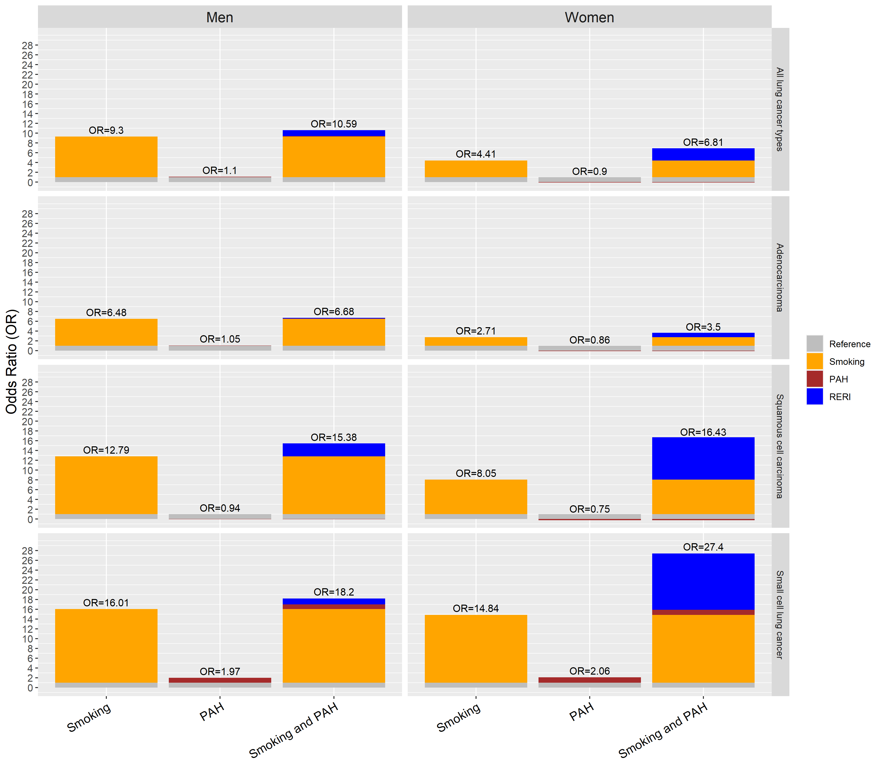
Reference = never smokers and never exposed to PAH; RERI = Relative excess risk due to interaction.

