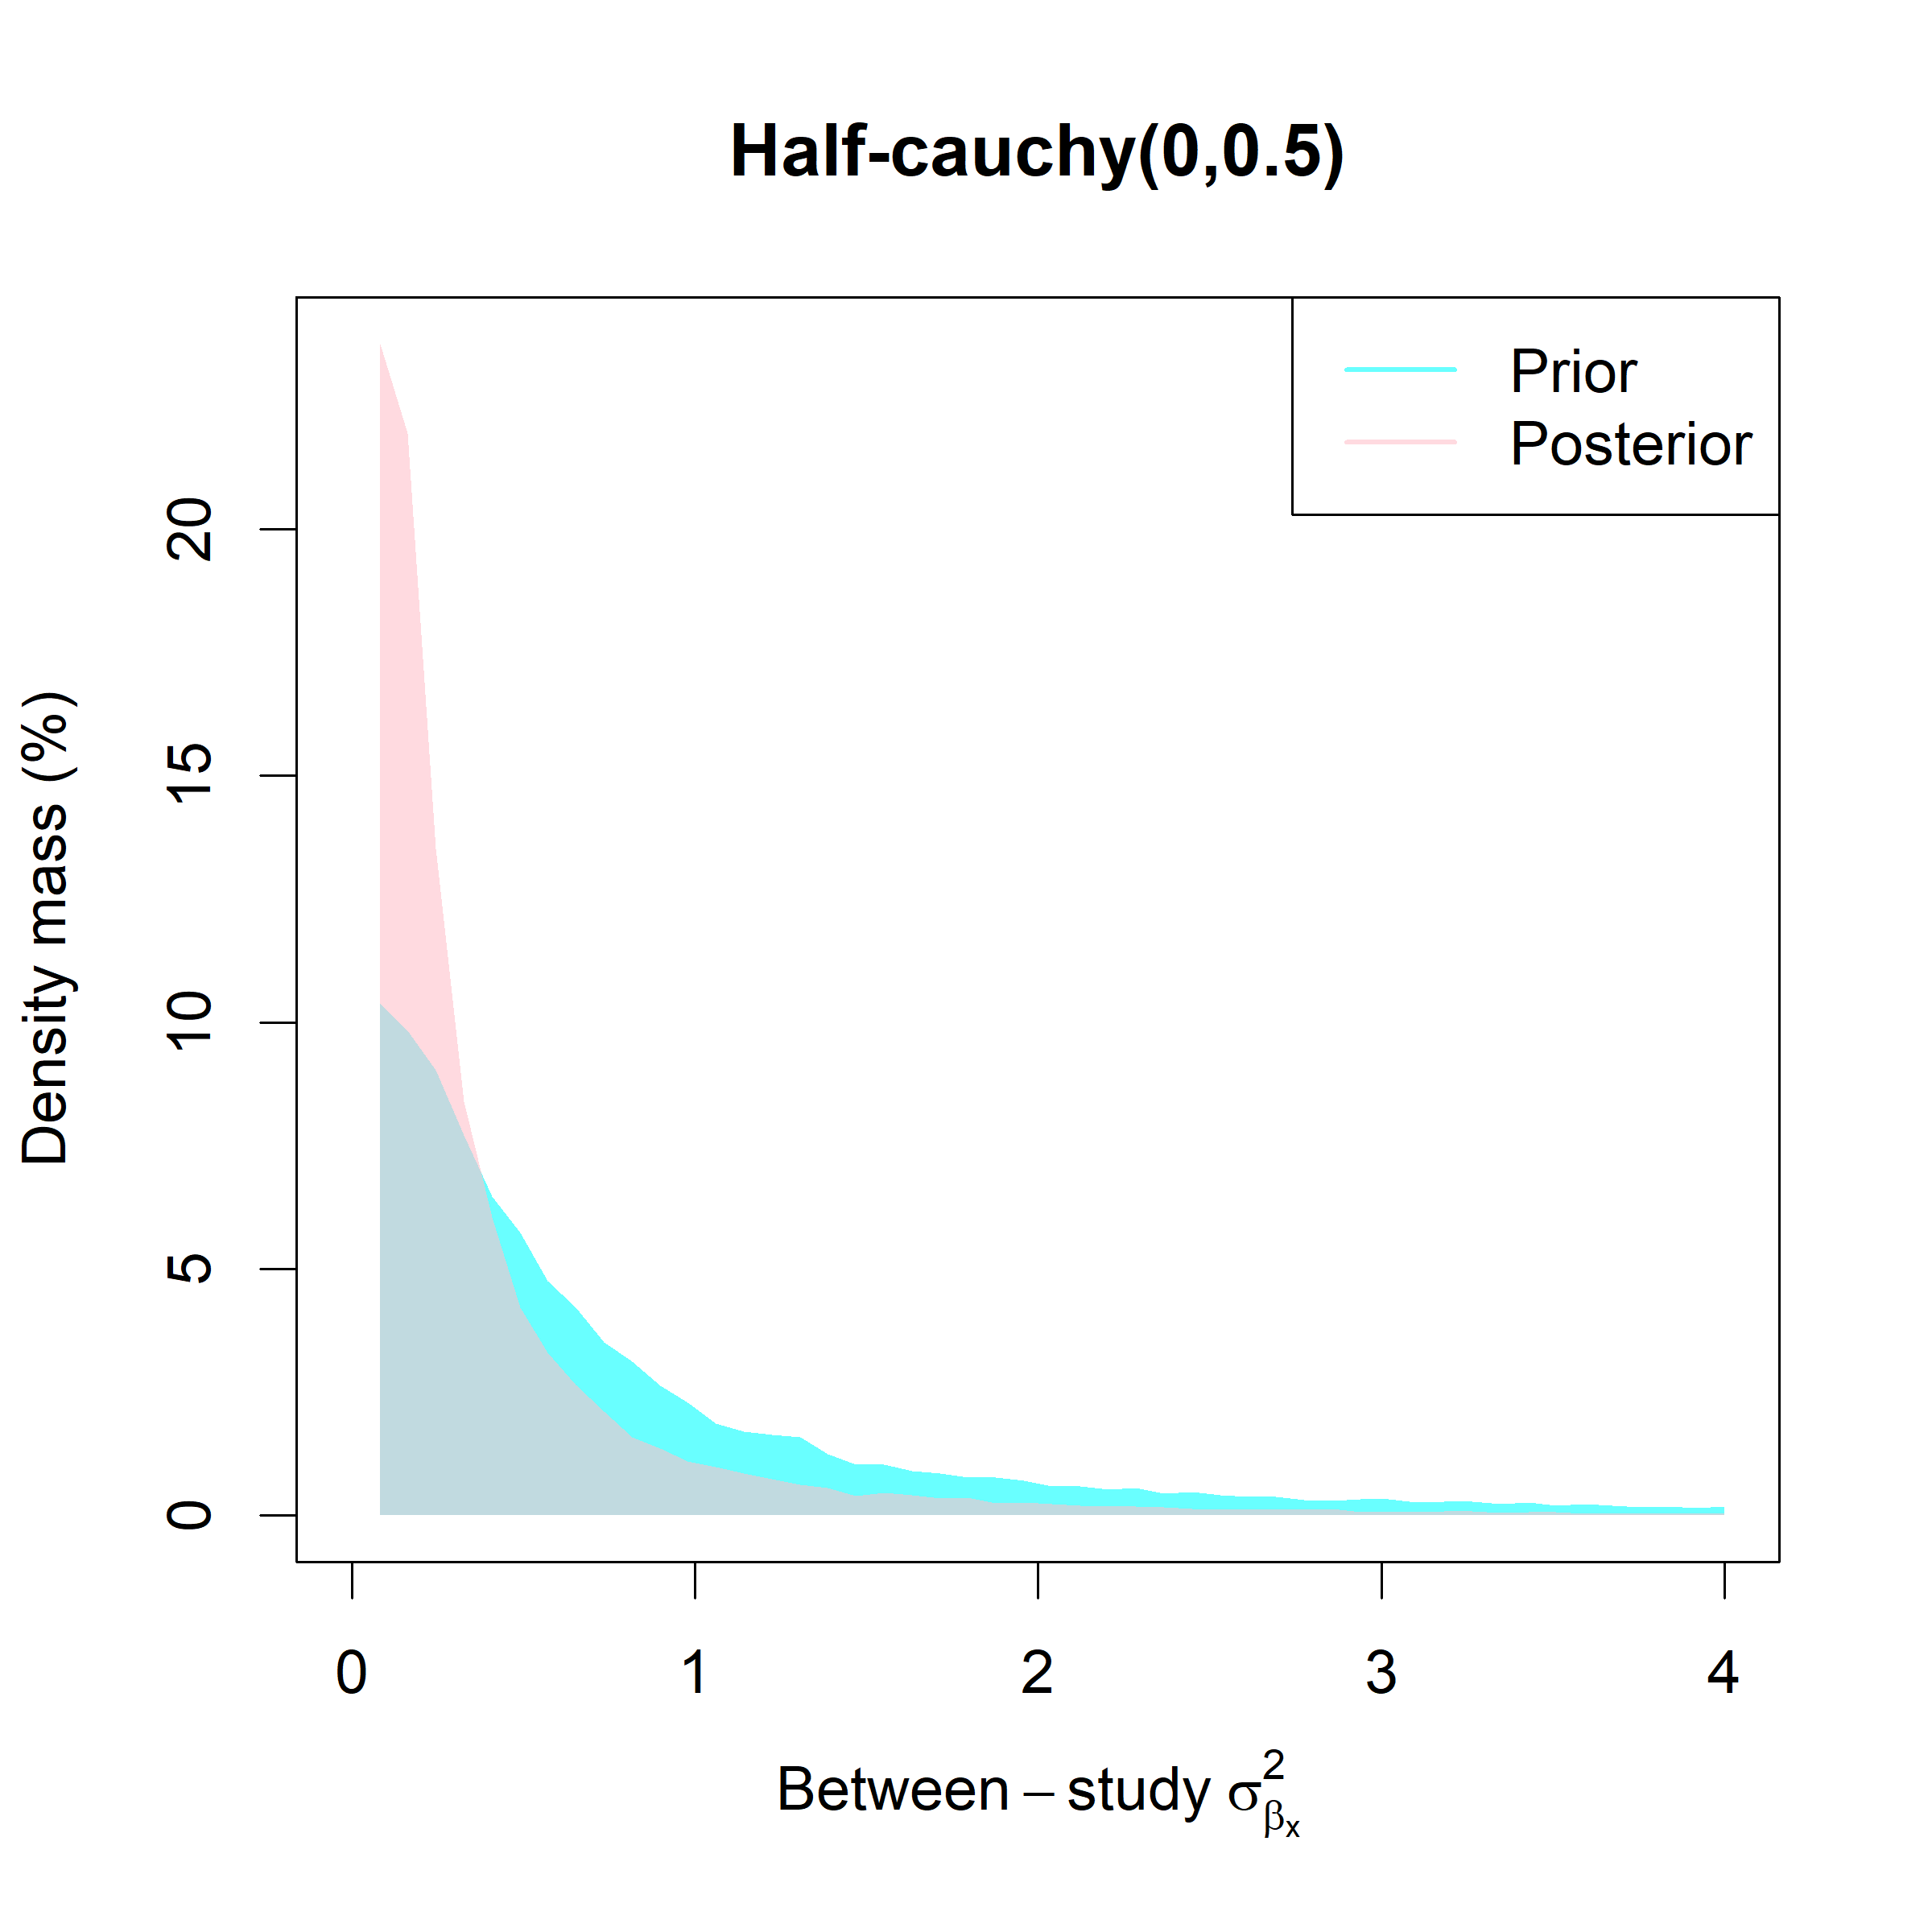 | 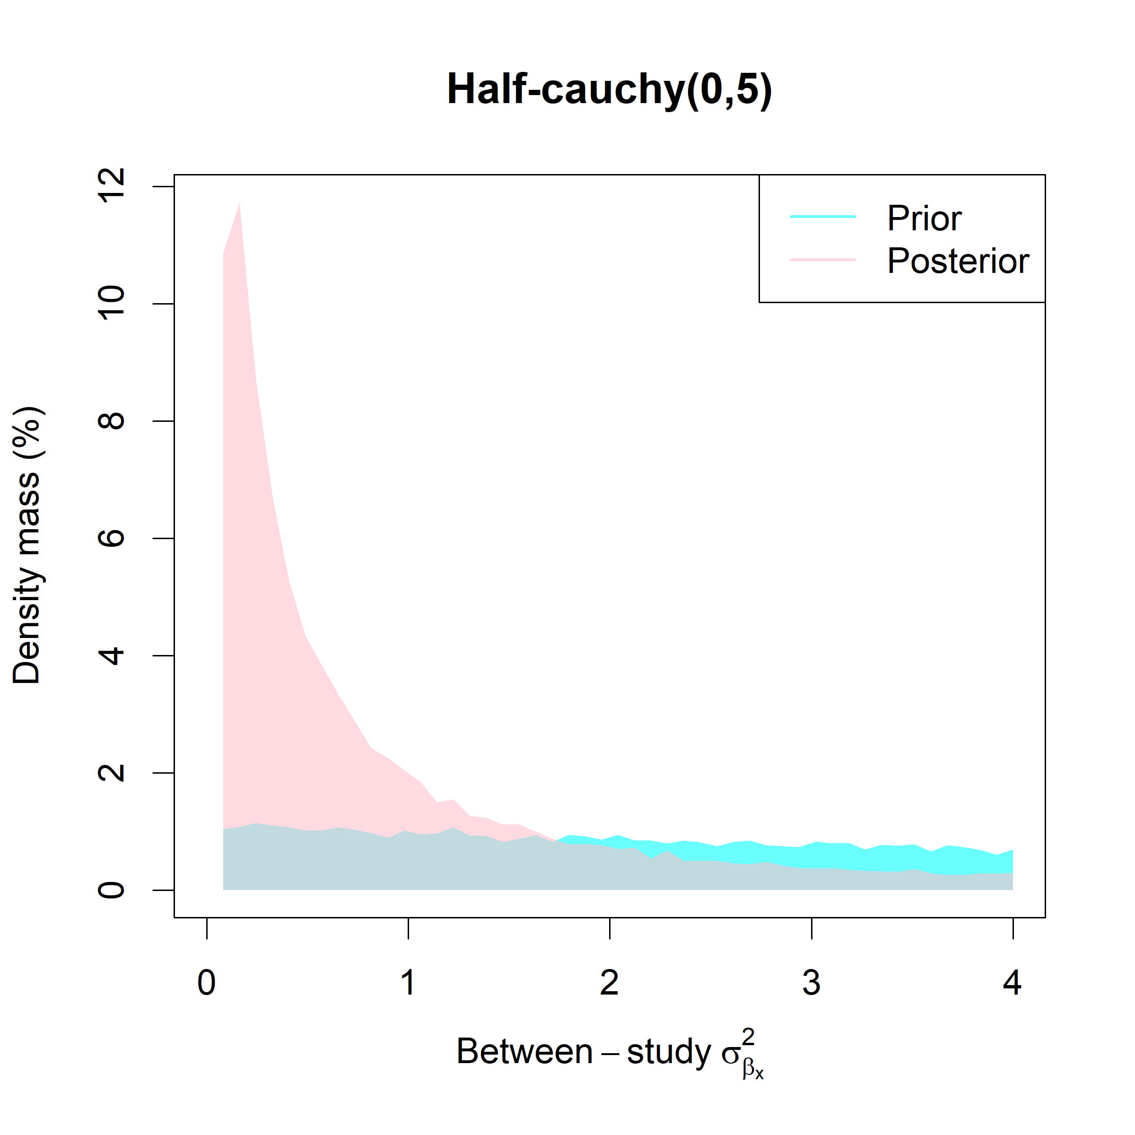  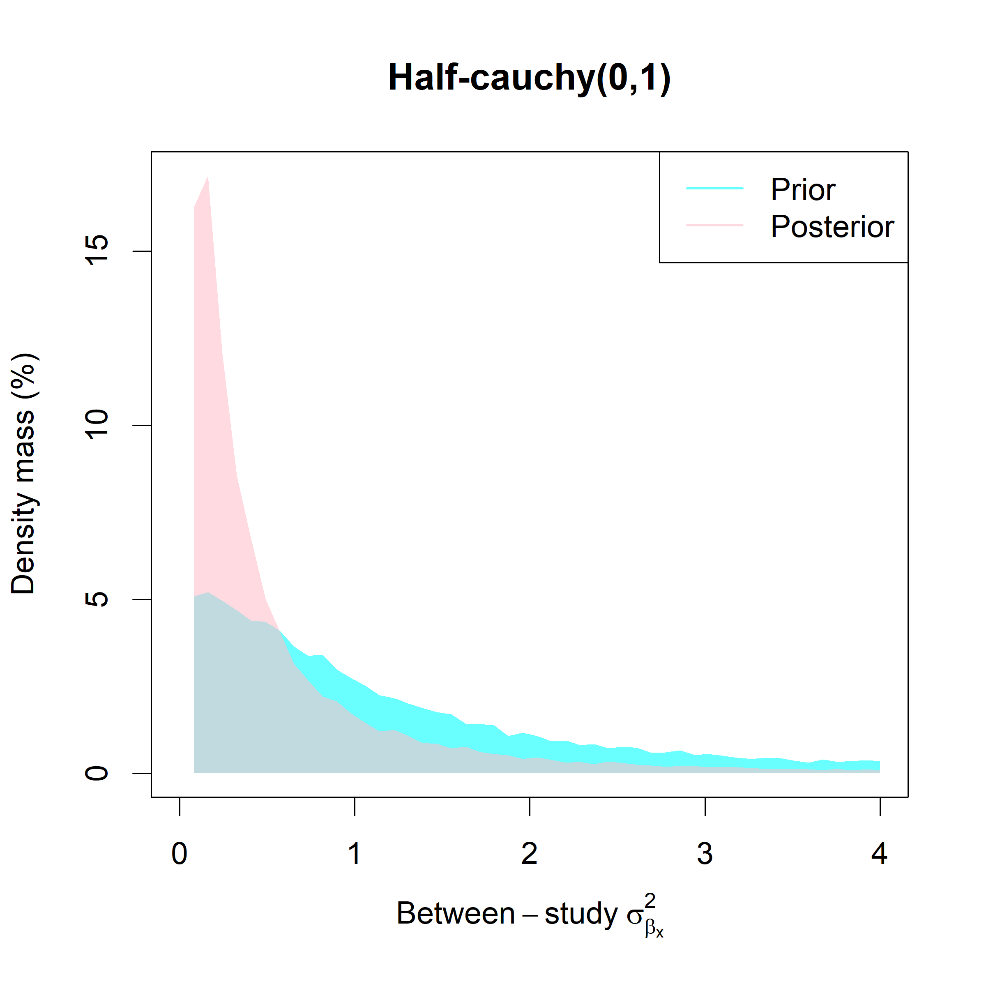
Figure s1. Prior-posterior plots for the estimated between-study variation, for a linear model with intercept, fitted using only the AML data.
We see that the use of the default prior used in our analyses (i.e. a Half-Cauchy of 1) is sufficient to cover the posterior estimates. However, a value of 0.5 would have also been an option. A Half-Cauchy of 5 is virtually uninformative.

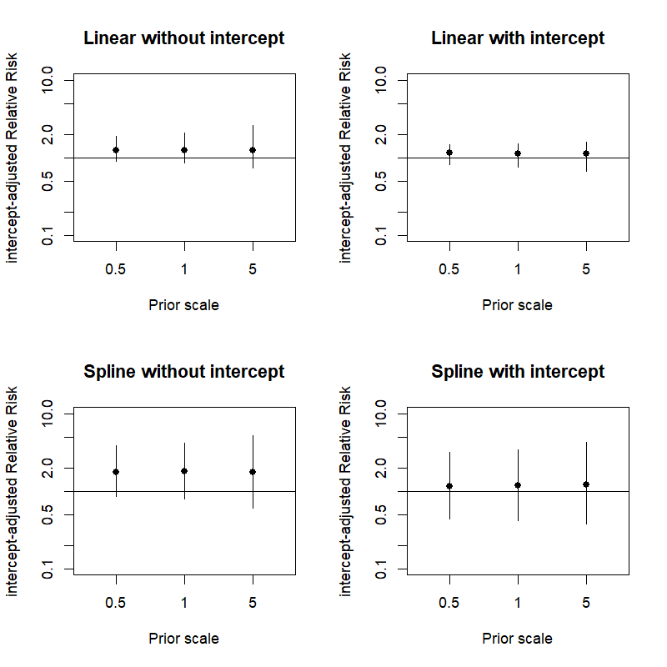
Figure S2. Estimated intercept-adjusted relative risks and 95%CI from models fitted to the AML dataset only, and using different scales for the half-Cauchy prior.

