Supplemental Methods and Figures

Table of Contents

Institutional Review Board Disclosure…………………………………………………………………… Page 2

Histologic/Anatomic Site Coding…………………………………………………………....……………. Page 3

Registries……………………………………………………………………………………………………... Page 4

SEER*Stat Parameters………………...……………………………………………………...................... Page 5

Supplemental Table 1………………………………………………………………………………………. Page 6

Supplemental Table 2………………………………………………………………………………………. Page 7

Supplemental Table 3………………………………………………………………………………………. Page 8-9

Supplemental Table 4………………………………………………………………………………………. Pages 10-11

Supplemental Table 5………………………………………………………………………………………. Pages 12-13

Supplemental Table 6………………………………………………………………………………………. Page 14-15

Supplemental Table 7………………………………………………………………………………………. Pages 16-17

Supplemental Table 8………………………………………………………………………….…………… Pages 18-19

Supplemental Figure 1……………………………………………………………………………………… Page 20

Supplemental Figure 2……………………………………………………………………………………… Pages 21-22

Institutional Review Board Disclosure
The study was reviewed by the Tulane University Biomedical Institutional Review Board and considered exempt given its use of deidentified data.

Histologic/Anatomic Site Coding

Histologic/Anatomic Site Coding

The Recode ICD-O-3 site/histology codes and behavior codes were used to define adenocarcinomas. The in situ cases (behavior code=2) and invasive/malignant cases (behavior code=3) only were included. To make the eligibility criteria clearer, we included the ICD-O-3 topographic (anatomic site) codes [C180-C189, C199, C209, and C260, excluding C181 (appendix)] that we used to define colorectal cancer case sites as defined in Fritz A, Percy C, Jack A, et al. Eds., International Classification of Diseases for Oncology, 3rd ed., Geneva: World Health Organization, 2000.

The colorectal, colon-only, and rectal-only cancers were defined by the ICD-O-3 codes C180-C189, C199, C209, and C260. Adenocarcinoma coding 447 included 8140/3, 8141/3, 8143/3, 8144/3, 8210/3, 8211/3, 8213/3, 8220/3, 8221/3, 8260-8265/3, 448 8255/3, 8260-8263/3, 8310/3, 8323/3, 8440/3, 8460/3, 8470/3, 8472/3, 8480-8482/3, 8570/3, 449 8574/3, 8576/3. In situ cases were included in our study.

SEER 18 Registries

SEER 18 database consists of 18 specific regional registries: Alaska Native Tumor Registry, Connecticut, Detroit, Georgia Center for Cancer Statistics (Atlanta, Greater Georgia, Rural
Georgia), Greater Bay Area Cancer Registry (San Francisco-Oakland and San Jose-Monterey), Greater California, Hawaii, Iowa, Kentucky, Los Angeles, Louisiana, New Mexico, New Jersey,
Seattle-Puget Sound, and Utah.
SEER*Stat/ Joinpoint Parameters
SEER*Stat Parameters:

SEER*Stat version | SEER*Stat 8.3.8
Data Tab | Incidence- SEER 18 Regs Research Data+ Hurricane Katrina Impacted Louisiana Cases, Nov 2018 Sub (2000-2016) <Katrina/Rita Population Adjustment>
Statistic Tab | Rates (Age-adjusted)
 | Parameters: P-values: 0.05; Standard population: 2000 US Std Population (19 age groups- Census P25-1130); Age variable: Age recode with <1 year olds
 | Show standard Errors and confidence intervals (use Tiwari et al. 2006 modification for CIs)
Selection Tab | select only: cases in research database
Other (case files):
{Site and Morphology. Site recode ICD-O-3/WHO 2008} = 'Colon and Rectum'
AND Not {Site and Morphology.Site recode ICD-O-3/WHO 2008} = ' Appendix'
AND (({Site and Morphology.Histologic Type ICD-O-3} = 8140-8147,8210-8213,8220-8221,8260-8265,8440,8480-8481,8490,8510,8560-8562,8570-8576))
Table Tab  Output Tab | Page: age group (20-29 years, 30-39 years, 40-49 years, 50-54 years);  Colorectal cancer vs. colon cancer vs. rectal cancer (colon cancer includes cecum, appendix, ascending colon, hepatic flexure, transverse colon, splenic flexure, descending colon, sigmoid colon, large intestine, NOS; rectal cancer includes rectosigmoid junction, rectum)
 | Row: cancer stage (in situ, localized, regional, distant, unknown); year of diagnosis (2000, 2001, 2002, 2003, 2004, 2005, 2006, 2007, 2008, 2009, 2010, 2011, 2012, 2013, 2014, 2015, 2016)
Display rates as cases per: 100,000;
number of decimal places for rates/trends: 0.01
SEER*Stat version | SEER*Stat 8.3.8

Supplemental Table 1
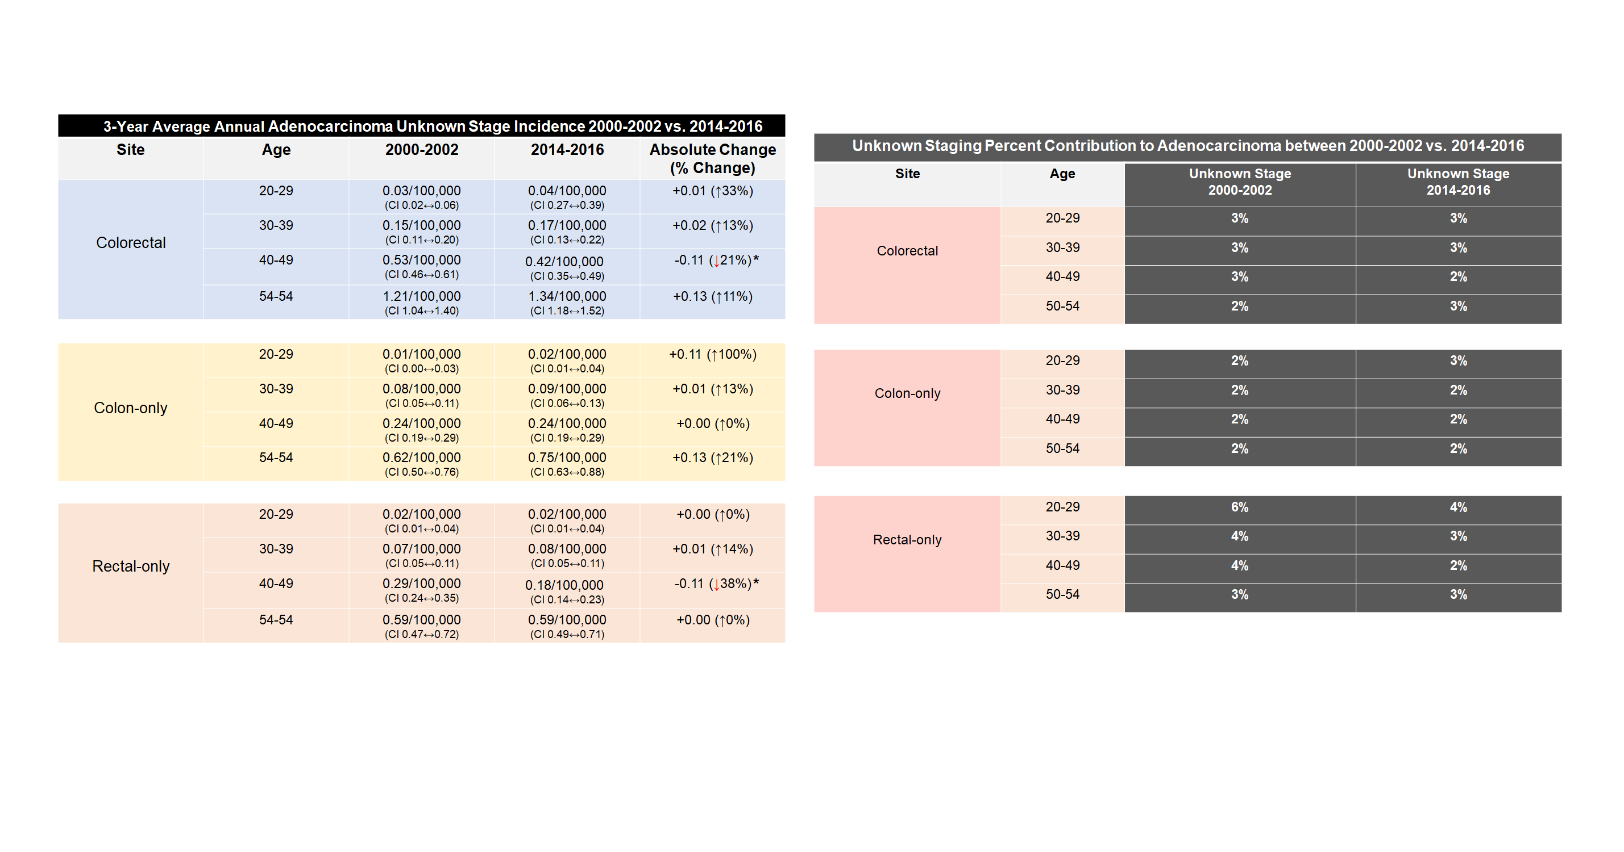

Supplemental Table 1. Unknown Stage Adenocarcinoma Analysis of 3-Year Average Annual Incidence and Staging Percent Contribution in 2000-2002 vs. 2014-2016 (All Races/Ethnicities Combined). Confidence intervals (CI95%) are provided for each rate ratio. *2014-2016 value significantly changed from 2000-2002 value to p<0.05.

Supplemental Table 2

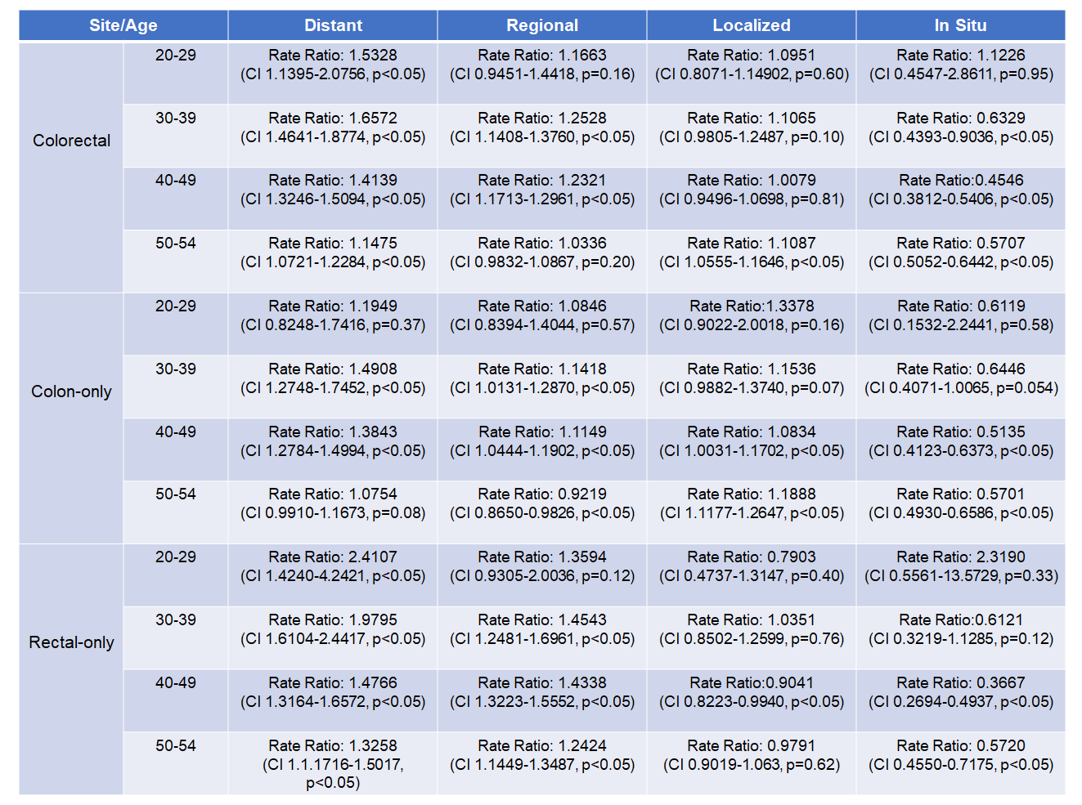

Supplemental Table 2. SEER 18 Rate Ratios of 2014-2016 to 2000-2002 Adenocarcinoma Incidence Rates by State, Site, and Age. Confidence intervals (CI) and p-values are provided for each rate ratio.

Supplemental Table 3
Non-Hispanic White 3-Year Average Annual Adenocarcinoma
In Situ Incidence 2000-2002 vs. 2014-2016

Site | Age | 2000-2002 | 2014-2016 | Absolute Change  (% Change)
Colorectal | 20-29 | 0.04/100,000  (CI 0.02↔0.08) | 0.04/100,000  (CI 0.02↔0.09) | +0.00 (↑0%)
 | 30-39 | 0.28/100,000  (CI 0.21↔0.36) | 0.19/100,000  (CI 0.13↔0.26) | -0.09 (↓32%)
 | 40-49 | 1.17/100,000  (CI 1.04↔1.32) | 0.58/100,000  (CI 0.48↔0.70) | -0.59 (↓50%)*
 | 50-54 | 4.34/100,000  (CI 3.95↔4.76) | 2.31/100,000  (CI 2.03↔2.61) | -2.03 (↓47%)*
Colon-only | 20-29 | 0.03/100,000  (CI 0.01↔0.07) | 0.02/100,000  (CI 0.00↔0.05) | -0.01 (↓33%)
 | 30-39 | 0.16/100,000  (CI 0.11↔0.22) | 0.12/100,000  (CI 0.07↔0.18) | -0.04 (↓25%)
 | 40-49 | 0.70/100,000  (CI 0.60↔0.81) | 0.36/100,000  (CI 0.28↔0.46) | -0.34 (↓49%)*
 | 50-54 | 3.00/100,000  (CI 2.68↔3.35) | 1.57/100,000  (CI 1.35↔1.83) | -1.43 (↓48%)*
Rectal-only | 20-29 | 0.01/100,000  (CI 0.00↔0.04) | 0.03/100,000  (CI 0.01↔0.06) | +0.02 (↑200%)
 | 30-39 | 0.12/100,000  (CI 0.08↔0.17) | 0.07/100,000  (CI 0.04↔0.12) | -0.05 (↓42%)
 | 40-49 | 0.47/100,000  (CI 0.39↔0.57) | 0.22/100,000  (CI 0.16↔0.30) | -0.25 (↓53%)*
 | 50-54 | 1.34/100,000  (CI 1.13↔1.58) | 0.73/100,000  (CI 0.58↔0.91) | -0.61 (↓46%)*

Non-Hispanic White 3-Year Average Annual Adenocarcinoma
Localized Incidence 2000-2002 vs. 2014-2016

Site | Age | 2000-2002 | 2014-2016 | Absolute Change  (% Change)
Colorectal | 20-29 | 0.22/100,000  (CI 0.16↔0.30) | 0.30/100,000  (CI 0.23↔0.39) | +0.08 (↑36%)
 | 30-39 | 1.53/100,000  (CI 1.31↔1.70) | 1.81/100,000  (CI 1.67↔2.03) | +0.28 (↑18%)*
 | 40-49 | 6.35/100,000  (CI 6.03↔6.67) | 6.82/100,000  (CI 6.45↔7.21) | +0.47 (↑7%)
 | 50-54 | 19.13/100,000  (CI 18.31↔19.99) | 20.68/100,000  (CI 19.83↔21.56) | +1.55 (↑8%)*
Colon-only | 20-29 | 0.13/100,000  (CI 0.08↔0.19) | 0.21/100,000  (CI 0.15↔0.29) | +0.08 (↑62%)
 | 30-39 | 0.89/100,000  (CI 0.77↔1.02) | 1.04/100,000  (CI 0.89↔1.21) | +0.15 (↑17%)
 | 40-49 | 3.53/100,000  (CI 3.29↔3.77) | 3.90/100,000  (CI 3.62↔4.20) | +0.37 (↑10%)*
 | 50-54 | 11.62/100,000  (CI 10.98↔12.29) | 13.21/100,000  (CI 12.53↔13.91) | +1.59 (↑14%)*
Rectal-only | 20-29 | 0.09/100,000  (CI 0.05↔0.15) | 0.09/100,000  (CI 0.05↔0.14) | +0.00 (↑0%)
 | 30-39 | 0.64/100,000  (CI 0.50↔0.66) | 0.77/100,000  (CI 0.52↔0.68) | +0.13 (↑4%)
 | 40-49 | 2.82/100,000  (CI 2.61↔3.04) | 2.92/100,000  (CI 2.68↔3.18) | +0.10 (↑4%)
 | 50-54 | 7.51/100,000  (CI 7.00↔8.06) | 7.48/100,000  (CI 6.97↔8.01) | -0.03 (↓0%)

Supplemental Table 3. SEER 18 In Situ and Localized 3-Year Average Annual Adenocarcinoma Incidence Rate Comparisons from 2000-2002 to 2014-2016 in Non-Hispanic Whites. Confidence intervals (CI95%) are provided for each rate ratio. *2014-2016 value significantly changed from 2000-2002 value to p<0.05. Relative percent change of 2000-2002 IR to 2014-2016 IR are provided in parentheses in rightmost column.

Supplemental Table 4
Non-Hispanic White 3-Year Average Annual Adenocarcinoma
Regional Incidence 2000-2002 vs. 2014-2016

Site | Age | 2000-2002 | 2014-2016 | Absolute Change  (% Change)
Colorectal | 20-29 | 0.50/100,000  (CI 0.40↔0.61) | 0.65/100,000  (CI 0.54↔0.78) | +0.15 (↑30%)
 | 30-39 | 2.22/100,000  (CI 2.02↔2.43) | 3.00/100,000  (CI 2.74↔3.27) | +0.78 (↑35%)*
 | 40-49 | 7.74/100,000  (CI 7.39↔8.10) | 10.13/100,000  (CI 9.68↔10.61) | +2.39 (↑31%)*
 | 50-54 | 17.97/100,000  (CI 17.17↔18.80) | 19.30/100,000  (CI 18.48↔20.15) | +1.33 (↑9%)*
Colon-only | 20-29 | 0.34/100,000  (CI 0.25↔0.43) | 0.42/100,000  (CI 0.33↔0.53) | +0.08 (↑24%)
 | 30-39 | 1.34/100,000  (CI 1.19↔1.51) | 1.56/100,000  (CI 1.38↔1.76) | +0.22 (↑16%)
 | 40-49 | 4.77/100,000  (CI 4.49↔5.05) | 5.56/100,000  (CI 5.22↔5.91) | +0.79 (↑17%)*
 | 50-54 | 11.36/100,000  (CI 10.73↔12.03) | 10.95/100,000  (CI 10.33↔11.59) | -0.41 (↓4%)
Rectal-only | 20-29 | 0.16/100,000  (CI 0.11↔0.23) | 0.23/100,000  (CI 0.16↔0.31) | +0.07 (↑44%)
 | 30-39 | 0.88/100,000  (CI 0.76↔1.01) | 1.44/100,000  (CI 1.26↔1.63) | +0.56 (↑64%)*
 | 40-49 | 2.98/100,000  (CI 2.76↔3.21) | 4.58/100,000  (CI 4.28↔4.90) | +1.60 (↑54%)*
 | 50-54 | 6.61/100,000  (CI 6.13↔7.12) | 8.35/100,000  (CI 7.82↔8.92) | +1.74 (↑26%)*

Non-Hispanic White 3-Year Average Annual Adenocarcinoma
Distant Incidence 2000-2002 vs. 2014-2016

Site | Age | 2000-2002 | 2014-2016 | Absolute Change  (% Change)
Colorectal | 20-29 | 0.24/100,000  (CI 0.17↔0.32) | 0.34/100,000  (CI 0.26↔0.44) | +0.10 (↑42%)
 | 30-39 | 1.13/100,000  (CI 0.99↔1.28) | 2.10/100,000  (CI 1.89↔2.33) | +0.97 (↑86%)*
 | 40-49 | 3.85/100,000  (CI 3.61↔4.11) | 6.64/100,000  (CI 6.27↔7.02) | +2.79 (↑72%)*
 | 50-54 | 9.19/100,000  (CI 8.62↔9.79) | 10.89/100,000  (CI 10.28↔11.53) | +1.70 (↑18%)*
Colon-only | 20-29 | 0.18/100,000  (CI 0.12↔0.25) | 0.23/100,000  (CI 0.17↔0.31) | +0.05 (↑28%)
 | 30-39 | 0.75/100,000  (CI 0.64↔0.88) | 1.21/100,000  (CI 1.05↔1.38) | +0.46 (↑61%)*
 | 40-49 | 2.56/100,000  (CI 2.36↔2.77) | 4.20/100,000  (CI 3.91↔4.51) | +1.64 (↑64%)*
 | 50-54 | 6.46/100,000  (CI 5.98↔6.96) | 7.35/100,000  (CI 6.84↔7.87) | +0.89 (↑14%)*
Rectal-only | 20-29 | 0.06/100,000  (CI 0.03↔0.11) | 0.11/100,000  (CI 0.07↔0.17) | +0.05 (↑83%)
 | 30-39 | 0.37/100,000  (CI 0.30↔0.47) | 0.89/100,000  (CI 0.76↔1.05) | +0.52 (↑135%)*
 | 40-49 | 1.29/100,000  (CI 1.15↔1.44) | 2.43/100,000  (CI 2.21↔2.67) | +1.14 (↑88%)*
 | 50-54 | 2.73/100,000  (CI 2.43↔3.07) | 3.55/100,000  (CI 3.20↔3.92) | +0.82 (↑33%)*

Supplemental Table 4. SEER 18 Regional and Distant 3-Year Average Annual Adenocarcinoma Incidence Rate Comparisons from 2000-2002 to 2014-2016 in Non-Hispanic Whites. Confidence intervals (CI95%) are provided for each rate ratio. *2014-2016 value significantly changed from 2000-2002 value to p<0.05. Relative percent change of 2000-2002 IR to 2014-2016 IR are provided in parentheses in rightmost column.

Supplemental Table 5
Non-Hispanic Black 3-Year Average Annual Adenocarcinoma
In Situ Incidence 2000-2002 vs. 2014-2016

Site | Age | 2000-2002 | 2014-2016 | Absolute Change  (% Change)
Colorectal | 20-29 | 0.00/100,000  (CI 0.00↔0.00) | 0.06/100,000  (CI 0.01↔0.17) | +0.06 (N/A)
 | 30-39 | 0.21/100,000  (CI 0.09↔0.39) | 0.16/100,000  (CI 0.06↔0.33) | -0.05 (↓24%)
 | 40-49 | 1.45/100,000  (CI 1.10↔1.87) | 0.55/100,000  (CI 0.35↔0.82) | -0.90 (↓62%)*
 | 50-54 | 5.83/100,000  (CI 4.70↔7.16) | 3.25/100,000  (CI 2.54↔4.11) | -2.58 (↓44%)*
Colon-only | 20-29 | 0.00/100,000  (CI 0.00↔0.09) | 0.04/100,000  (CI 0.00↔0.14) | +0.06 (N/A)
 | 30-39 | 0.18/100,000  (CI 0.08↔0.36) | 0.16/100,000  (CI 0.06↔0.33) | -0.02 (↓11%)
 | 40-49 | 1.03/100,000  (CI 0.74↔1.39) | 0.44/100,000  (CI 0.26↔0.69) | -0.59 (↓57%)*
 | 50-54 | 4.87/100,000  (CI 3.84↔6.10) | 2.42/100,000  (CI 1.81↔3.17) | -2.45 (↓50%)*
Rectal-only | 20-29 | 0.00/100,000  (CI 0.00↔0.09) | 0.02/100,000  (CI 0.00↔0.11) | +0.02 (N/A)
 | 30-39 | 0.02/100,000  (CI 0.00↔0.12) | 0.00/100,000  (CI 0.00↔0.09) | -0.02 (↓100%)
 | 40-49 | 0.42/100,000  (CI 0.24↔0.67) | 0.11/100,000  (CI 0.04↔0.27) | -0.31 (↓74%)*
 | 50-54 | 0.96/100,000  (CI 0.54↔1.59) | 0.84/100,000  (CI 0.50↔1.32) | -0.12 (↓43%)

Non-Hispanic Black 3-Year Average Annual Adenocarcinoma
Localized Incidence 2000-2002 vs. 2014-2016

Site | Age | 2000-2002 | 2014-2016 | Absolute Change  (% Change)
Colorectal | 20-29 | 0.34/100,000  (CI 0.19↔0.57) | 0.14/100,000  (CI 0.0.05↔0.28) | -0.20 (↓59%)
 | 30-39 | 1.68/100,000  (CI 1.31↔2.11) | 1.53/100,000  (CI 1.17↔1.95) | -0.15 (↓9%)
 | 40-49 | 6.57/100,000  (CI 5.80↔7.40) | 6.78/100,000  (CI 6.02↔7.62) | +0.21 (↑3%)
 | 50-54 | 22.62/100,000  (CI 20.32↔25.11) | 24.08/100,000  (CI 22.05↔26.25) | +1.46 (↑6%)
Colon-only | 20-29 | 0.19/100,000  (CI 0.08↔0.38) | 0.10/100,000  (CI 0.03↔0.23) | -0.09 (↓47%)
 | 30-39 | 1.12/100,000  (CI 0.83↔1.49) | 1.17/100,000  (CI 0.86↔1.55) | +0.05 (↑4%)
 | 40-49 | 4.60/100,000  (CI 3.96↔5.31) | 5.48/100,000  (CI 4.80↔6.24) | +0.88 (↑19%)
 | 50-54 | 16.73/100,000  (CI 14.76↔18.88) | 18.18/100,000  (CI 16.42↔20.07) | +1.45 (↑19%)
Rectal-only | 20-29 | 0.15/100,000  (CI 0.05↔0.32) | 0.04/100,000  (CI 0.00↔0.14) | -0.11 (↓73%)
 | 30-39 | 0.55/100,000  (CI 0.35↔0.82) | 0.36/100,000  (CI 0.20↔0.59) | -0.19 (↓35%)
 | 40-49 | 1.97/100,000  (CI 1.56↔2.45) | 1.30/100,000  (CI 0.98↔1.69) | -0.67 (↓34%)*
 | 50-54 | 5.90/100,000  (CI 4.75↔7.23) | 5.90/100,000  (CI 4.92↔7.02) | +0.00 (↑0%)

Supplemental Table 5. SEER 18 In Situ and Localized 3-Year Average Annual Adenocarcinoma Incidence Rate Comparisons from 2000-2002 to 2014-2016 in Non-Hispanic Blacks. Confidence intervals (CI95%) are provided for each rate ratio. *2014-2016 value significantly changed from 2000-2002 value to p<0.05. Relative percent change of 2000-2002 IR to 2014-2016 IR are provided in parentheses in rightmost column.

Supplemental Table 6
Non-Hispanic Black 3-Year Average Annual Adenocarcinoma
Regional Incidence 2000-2002 vs. 2014-2016

Site | Age | 2000-2002 | 2014-2016 | Absolute Change  (% Change)
Colorectal | 20-29 | 0.42/100,000  (CI 0.24↔0.67) | 0.39/100,000  (CI 0.24↔0.60) | -0.03 (↓7%)
 | 30-39 | 2.63/100,000  (CI 2.17↔3.16) | 3.37/100,000  (CI 2.83↔3.98) | +0.74 (↑28%)
 | 40-49 | 9.33/100,000  (CI 8.42↔10.32) | 10.44/100,000  (CI 9.49↔11.47) | +1.11 (↑12%)
 | 50-54 | 26.60/100,000  (CI 24.10↔29.28) | 20.41/100,000  (CI 18.54↔22.41) | -6.19 (↓23%)*
Colon-only | 20-29 | 0.29/100,000  (CI 0.15↔0.51) | 0.27/100,000  (CI 0.15↔0.46) | -0.02 (↓7%)
 | 30-39 | 2.10/100,000  (CI 1.70↔2.58) | 2.41/100,000  (CI 1.96↔2.93) | +0.31 (↑15%)
 | 40-49 | 6.68/100,000  (CI 5.91↔7.52) | 7.35/100,000  (CI 6.55↔8.22) | +0.67 (↑10%)
 | 50-54 | 20.70/100,000  (CI 18.50↔23.09) | 14.23/100,000  (CI 12.68↔15.91) | -6.47 (↓31%)*
Rectal-only | 20-29 | 0.12/100,000  (CI 0.04↔0.28) | 0.12/100,000  (CI 0.04↔0.25) | +0.00 (↑0%)
 | 30-39 | 0.53/100,000  (CI 0.34↔0.79) | 0.96/100,000  (CI 0.68↔1.30) | +0.43 (↑81%)*
 | 40-49 | 2.65/100,000  (CI 2.18↔3.20) | 3.09/100,000  (CI 2.59↔3.67) | +0.44 (↑17%)
 | 50-54 | 5.90/100,000  (CI 4.75↔7.23) | 6.18/100,000  (CI 5.18↔7.33) | +0.28 (↑5%)

Non-Hispanic Black 3-Year Average Annual Adenocarcinoma
Distant Incidence 2000-2002 vs. 2014-2016

Site | Age | 2000-2002 | 2014-2016 | Absolute Change  (% Change)
Colorectal | 20-29 | 0.12/100,000  (CI 0.04↔0.28) | 0.39/100,000  (CI 0.24↔0.60) | +0.27 (↑225%)*
 | 30-39 | 1.35/100,000  (CI 1.03↔1.74) | 2.14/100,000  (CI 1.72↔2.64) | +0.79 (↑59%)*
 | 40-49 | 8.17/100,000  (CI 7.32↔9.10) | 7.51/100,000  (CI 6.70↔8.39) | -0.66 (↓8%)
 | 50-54 | 15.00/100,000  (CI 13.14↔17.05) | 16.32/100,000  (CI 14.66↔18.12) | +1.32 (↑9%)
Colon-only | 20-29 | 0.12/100,000  (CI 0.04↔0.28) | 0.22/100,000  (CI 0.11↔0.39) | +0.10 (↑83%)
 | 30-39 | 1.03/100,000  (CI 0.75↔1.38) | 1.41/100,000  (CI 1.07↔1.82) | +0.38 (↑37%)
 | 40-49 | 6.18/100,000  (CI 5.44↔7.00) | 6.03/100,000  (CI 5.31↔6.83) | -0.15 (↓2%)
 | 50-54 | 11.98/100,000  (CI 10.33↔13.83) | 11.58/100,000  (CI 10.18↔13.11) | -0.40 (↓3%)
Rectal-only | 20-29 | 0.00/100,000  (CI 0.00↔0.09) | 0.18/100,000  (CI 0.08↔0.33) | +0.13 (N/A)
 | 30-39 | 0.32/100,000  (CI 0.17↔0.53) | 0.73/100,000  (CI 0.50↔1.04) | +0.41 (↑128%)*
 | 40-49 | 1.99/100,000  (CI 1.58↔2.47) | 1.48/100,000  (CI 1.13↔1.89) | -0.51 (↓26%)
 | 50-54 | 3.01/100,000  (CI 2.21↔4.01) | 4.74/100,000  (CI 3.87↔5.76) | +1.73 (↑57%)*

Supplemental Table 6. SEER 18 Regional and Distant 3-Year Average Annual Adenocarcinoma Incidence Rate Comparisons from 2000-2002 to 2014-2016 in Non-Hispanic Blacks. Confidence intervals (CI95%) are provided for each rate ratio. *2014-2016 value significantly changed from 2000-2002 value to p<0.05. Relative percent change of 2000-2002 IR to 2014-2016 IR are provided in parentheses in rightmost column.

Supplemental Table 7
Hispanic 3-Year Average Annual Adenocarcinoma
In Situ Incidence 2000-2002 vs. 2014-2016

Site | Age | 2000-2002 | 2014-2016 | Absolute Change  (% Change)
Colorectal | 20-29 | 0.02/100,000  (CI 0.00↔0.08) | 0.01/100,000  (CI 0.00↔0.05) | -0.01 (↓50%)
 | 30-39 | 0.19/100,000  (CI 0.10↔0.32) | 0.10/100,000  (CI 0.05↔0.19) | -0.09 (↓47%)
 | 40-49 | 0.76/100,000  (CI 0.54↔1.04) | 0.41/100,000  (CI 0.28↔0.57) | -0.35 (↓46%)*
 | 50-54 | 2.71/100,000  (CI 1.99↔3.61) | 2.03/100,000  (CI 1.59↔2.57) | -0.68 (↓25%)
Colon-only | 20-29 | 0.02/100,000  (CI 0.00↔0.08) | 0.00/100,000  (CI 0.00↔0.03) | -0.02 (↓200%)
 | 30-39 | 0.15/100,000  (CI 0.08↔0.27) | 0.06/100,000  (CI 0.02↔0.14) | -0.09 (↓60%)
 | 40-49 | 0.45/100,000  (CI 0.28↔0.67) | 0.29/100,000  (CI 0.18↔0.43) | -0.16 (↓36%)
 | 50-54 | 1.96/100,000  (CI 1.36↔2.74) | 1.45/100,000  (CI 1.08↔1.92) | -0.51 (↓26%)
Rectal-only | 20-29 | 0.00/100,000  (CI 0.00↔0.04) | 0.01/100,000  (CI 0.00↔0.05) | +0.01 (N/A)
 | 30-39 | 0.04/100,000  (CI 0.01↔0.12) | 0.04/100,000  (CI 0.01↔0.11) | +0.00 (↑0%)
 | 40-49 | 0.31/100,000  (CI 0.18↔0.50) | 0.12/100,000  (CI 0.06↔0.22) | -0.19 (↓61%)*
 | 50-54 | 0.75/100,000  (CI 0.40↔1.28) | 0.58/100,000  (CI 0.35↔0.90) | -0.17 (↓23%)

Hispanic 3-Year Average Annual Adenocarcinoma
Localized Incidence 2000-2002 vs. 2014-2016

Site | Age | 2000-2002 | 2014-2016 | Absolute Change  (% Change)
Colorectal | 20-29 | 0.21/100,000  (CI 0.12↔0.33) | 0.24/100,000  (CI 0.25↔0.35) | +0.03 (↑14%)
 | 30-39 | 1.05/100,000  (CI 0.83↔1.32) | 1.30/100,000  (CI 1.08↔1.55) | +0.25 (↑24%)
 | 40-49 | 4.45/100,000  (CI 3.89↔5.06) | 4.47/100,000  (CI 4.03↔4.95) | +0.02 (↑0%)
 | 50-54 | 12.00/100,000  (CI 10.42↔13.74) | 16.50/100,000  (CI 15.17↔17.92) | +4.50 (↑38%)*
Colon-only | 20-29 | 0.10/100,000  (CI 0.05↔0.20) | 0.16/100,000  (CI 0.09↔0.26) | +0.06 (↑60%)
 | 30-39 | 0.65/100,000  (CI 0.48↔0.86) | 0.91/100,000  (CI 0.73↔1.12) | +0.26 (↑40%)
 | 40-49 | 2.51/100,000  (CI 2.10↔2.98) | 3.10/100,000  (CI 2.73↔3.50) | +0.59 (↑24%)
 | 50-54 | 6.69/100,000  (CI 5.53↔8.03) | 10.87/100,000  (CI 9.79↔12.03) | +4.18 (↑62%)*
Rectal-only | 20-29 | 0.11/100,000  (CI 0.05↔0.20) | 0.07/100,000  (CI 0.03↔0.15) | -0.04 (↓36%)
 | 30-39 | 0.40/100,000  (CI 0.27↔0.58) | 0.39/100,000  (CI 0.27↔0.54) | -0.01 (↓2.5%)
 | 40-49 | 1.94/100,000  (CI 1.58↔2.35) | 1.37/100,000  (CI 1.13↔1.65) | -0.57 (↓29%)*
 | 50-54 | 5.31/100,000  (CI 4.28↔6.51) | 5.64/100,000  (CI 4.87↔6.49) | +0.33 (↑6%)

Supplemental Table 7. SEER 18 In Situ and Localized 3-Year Average Annual Adenocarcinoma Incidence Rate Comparisons from 2000-2002 to 2014-2016 in Hispanics. Confidence intervals (CI95%) are provided for each rate ratio. *2014-2016 value significantly changed from 2000-2002 value to p<0.05. Relative percent change of 2000-2002 IR to 2014-2016 IR are provided in parentheses in rightmost column.

Supplemental Table 8
Hispanic 3-Year Average Annual Adenocarcinoma
Regional Incidence 2000-2002 vs. 2014-2016

Site | Age | 2000-2002 | 2014-2016 | Absolute Change  (% Change)
Colorectal | 20-29 | 0.40/100,000  (CI 0.28↔0.56) | 0.46/100,000  (CI 0.34↔0.61) | +0.06 (↑15%)
 | 30-39 | 1.83/100,000  (CI 1.53↔2.17) | 2.49/100,000  (CI 2.18↔2.83) | +0.66 (↑36%)*
 | 40-49 | 5.27/100,000  (CI 4.67↔5.93) | 7.34/100,000  (CI 6.77↔7.94) | +2.07 (↑39%)*
 | 50-54 | 13.61/100,000  (CI 11.93↔15.47) | 16.13/100,000  (CI 14.81↔17.53) | +2.52 (↑19%)*
Colon-only | 20-29 | 0.28/100,000  (CI 0.18↔0.42) | 0.30/100,000  (CI 0.21↔0.43) | +0.02 (↑7%)
 | 30-39 | 1.22/100,000  (CI 0.98↔1.50) | 1.61/100,000  (CI 1.36↔1.88) | +0.39 (↑32%)*
 | 40-49 | 3.42/100,000  (CI 2.94↔3.96) | 4.17/100,000  (CI 3.75↔4.64) | +0.75 (↑22%)*
 | 50-54 | 8.13/100,000  (CI 6.85↔9.59) | 9.33/100,000  (CI 8.33↔10.41) | +1.20 (↑15%)
Rectal-only | 20-29 | 0.12/100,000  (CI 0.06↔0.21) | 0.16/100,000  (CI 0.09↔0.26) | +0.04 (↑33%)
 | 30-39 | 0.61/100,000  (CI 0.44↔0.82) | 0.88/100,000  (CI 0.70↔1.09) | +0.27 (↑44%)
 | 40-49 | 1.85/100,000  (CI 1.50↔2.26) | 3.16/100,000  (CI 2.79↔3.57) | +1.31 (↑71%)*
 | 50-54 | 5.48/100,000  (CI 4.43↔6.70) | 6.80/100,000  (CI 5.96↔7.73) | +1.32 (↑24%)

Hispanic 3-Year Average Annual Adenocarcinoma
Distant Incidence 2000-2002 vs. 2014-2016

Site | Age | 2000-2002 | 2014-2016 | Absolute Change  (% Change)
Colorectal | 20-29 | 0.21/100,000  (CI 0.13↔0.33) | 0.32/100,000  (CI 0.22↔0.45) | +0.11 (↑52%)
 | 30-39 | 1.03/100,000  (CI 0.81↔1.29) | 1.48/100,000  (CI 1.24↔1.75) | +0.45 (↑44%)*
 | 40-49 | 3.40/100,000  (CI 2.92↔3.94) | 4.69/100,000  (CI 4.24↔5.18) | +1.29 (↑38%)*
 | 50-54 | 7.90/100,000  (CI 6.64↔9.34) | 9.33/100,000  (CI 8.33↔10.41) | +1.43 (↑18%)
Colon-only | 20-29 | 0.12/100,000  (CI 0.06↔0.22) | 0.14/100,000  (CI 0.08↔0.23) | +0.02 (↑17%)
 | 30-39 | 0.59/100,000  (CI 0.43↔0.79) | 0.90/100,000  (CI 0.72↔1.12) | +0.31 (↑53%)*
 | 40-49 | 2.33/100,000  (CI 1.93↔2.78) | 3.03/100,000  (CI 2.67↔3.43) | +0.70 (↑30%)*
 | 50-54 | 5.08/100,000  (CI 4.07↔6.25) | 5.78/100,000  (CI 5.01↔6.64) | +0.70 (↑14%)
Rectal-only | 20-29 | 0.09/100,000  (CI 0.04↔0.18) | 0.18/100,000  (CI 0.11↔0.28) | +0.09 (↑100%)
 | 30-39 | 0.44/100,000  (CI 0.30↔0.62) | 0.58/100,000  (CI 0.43↔0.75) | +0.14 (↑32%)
 | 40-49 | 1.07/100,000  (CI 0.81↔1.40) | 1.66/100,000  (CI 1.39↔1.96) | +0.59 (↑55%)*
 | 50-54 | 2.83/100,000  (CI 2.09↔3.74) | 3.54/100,000  (CI 2.94↔4.23) | +0.71 (↑25%)

Supplemental Table 8. SEER 18 Regional and Distant 3-Year Average Annual Adenocarcinoma Incidence Rate Comparisons from 2000-2002 to 2014-2016 in Hispanics. Confidence intervals (CI95%) are provided for each rate ratio. *2014-2016 value significantly changed from 2000-2002 value to p<0.05. Relative percent change of 2000-2002 IR to 2014-2016 IR are provided in parentheses in rightmost column.

Supplemental Figure 1
Supplemental Figure 1. CONSORT Diagram. † Unknown cases were included for proportional analysis.

Supplemental Figure 2 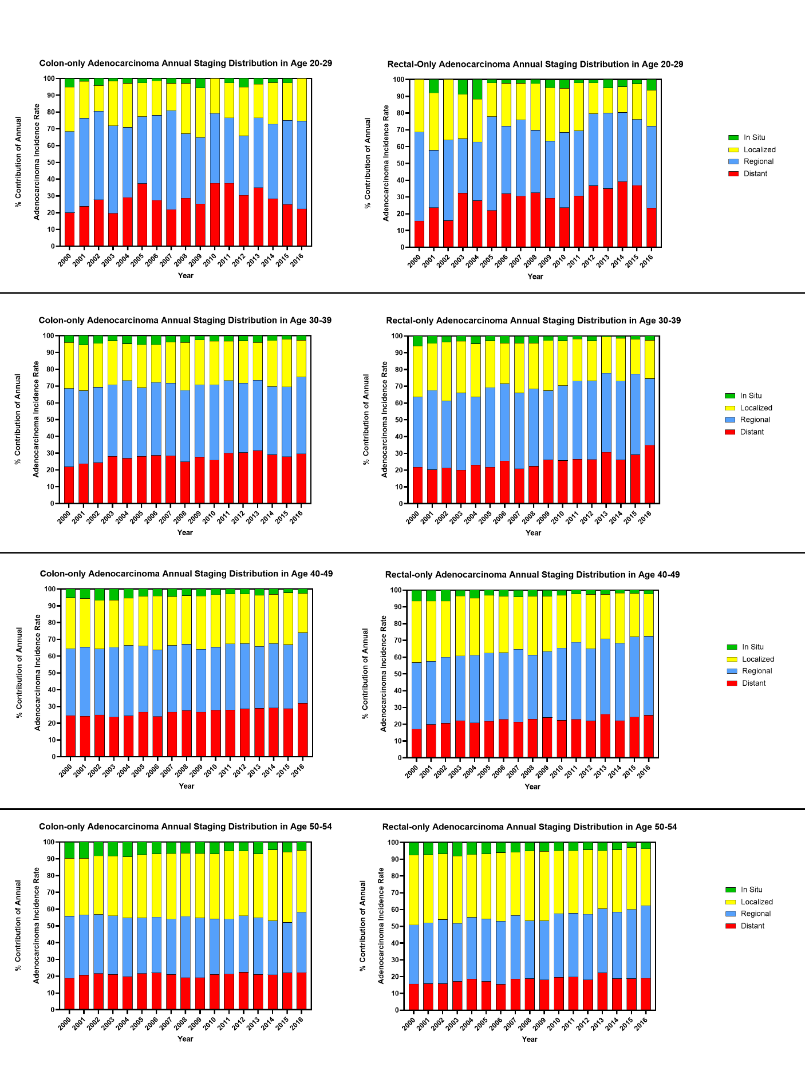
Supplemental Figure 2. SEER 18 Individual Stage Percent Contributions to Overall Annual Adenocarcinoma from 2000-2016 in Colon and Rectal Subsites. Colon-only (left) and rectal-only (right) are displayed individually for each age group. Within each year, colored bars are stacked to total 100% of adenocarcinomas.

