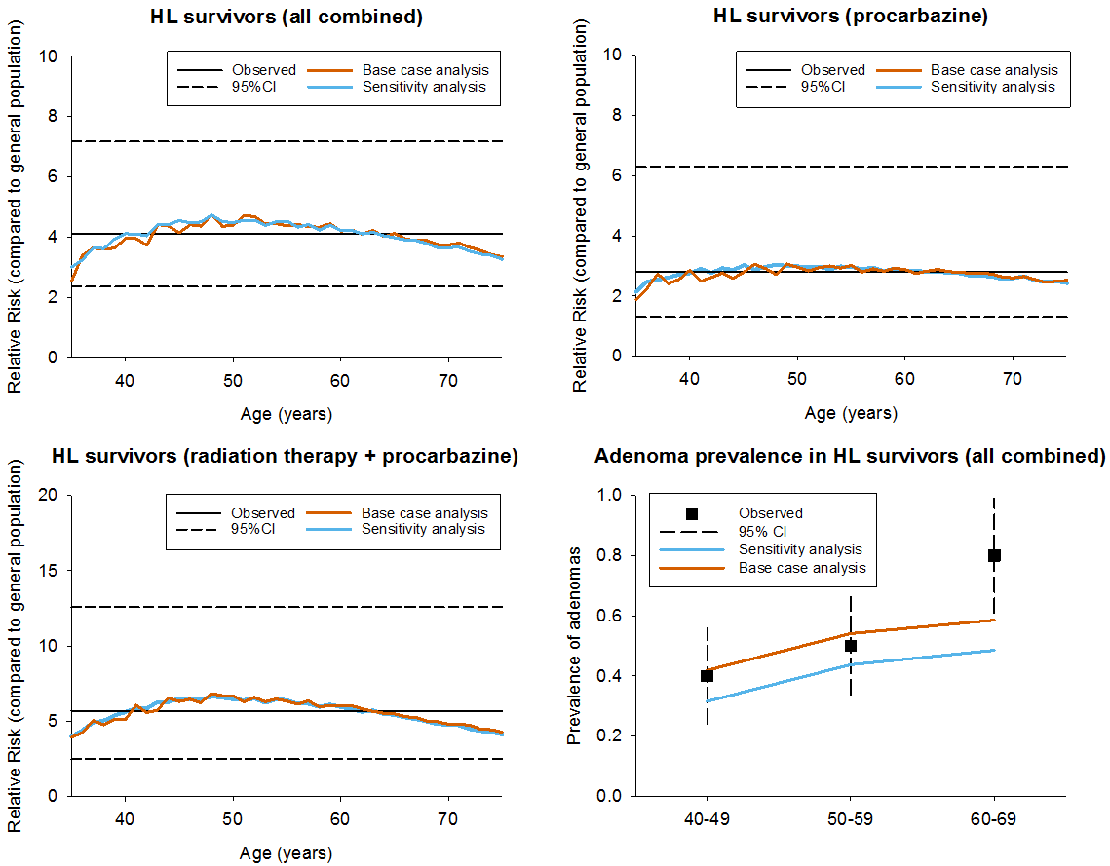

Supplementary Figure 2.
The simulated and expected adenoma prevalence and relative risks for colorectal cancer (compared to average risk individuals) among the entire cohort of Hodgkin Lymphoma (HL) survivors (A). Relative risks were also computed per primary cancer treatment (procarbazine-containing chemotherapy without infradiaphragmatic radiotherapy (IRT, B) or combination of IRT and procarbazine chemotherapy(C)). Simulated outcomes were computed assuming no surveillance. Observed results were collected from Rigter et al (2019).

