Excess mortality in a nationwide cohort of cancer patients during the initial phase of the COVID-19 pandemic in Belgium

Geert Silversmit, Freija Verdoodt, Nancy Van Damme, Harlinde De Schutter, Liesbet Van Eycken

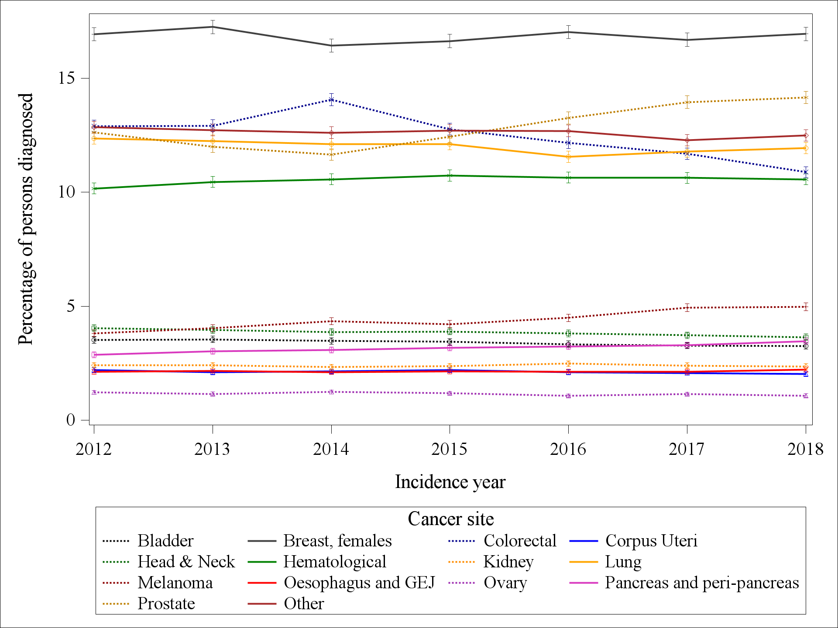
Figure S4: Cancer site distribution versus incidence year for the 2012-2018 cancer cohort.

