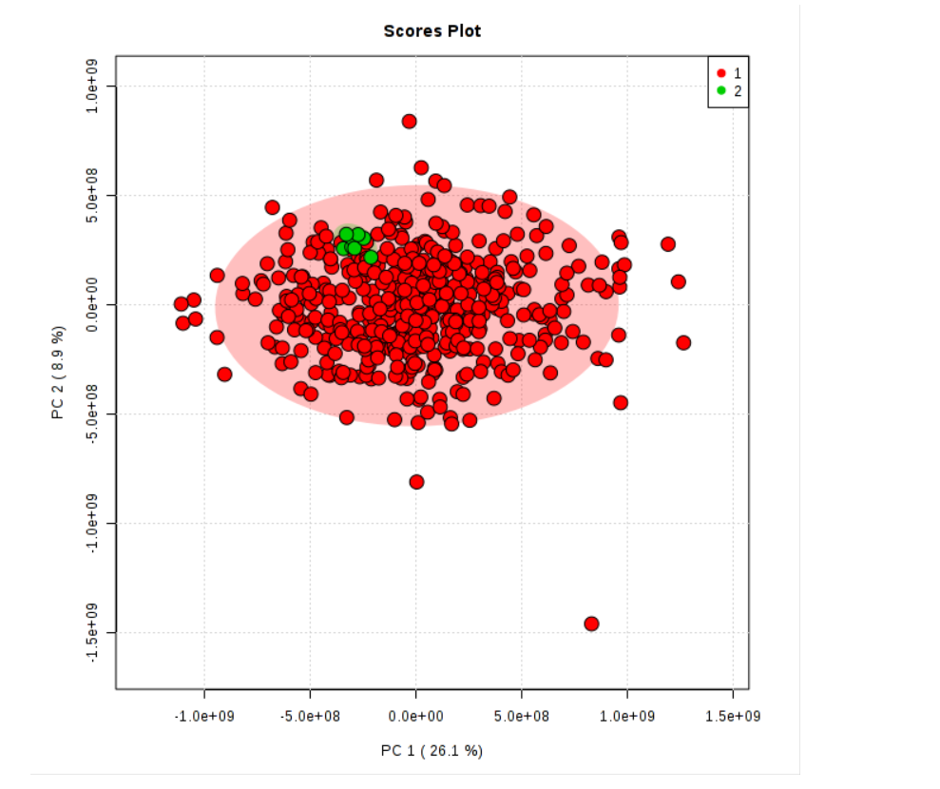

Supplementary Figure 1. Scores plot for first two PCs calculated from metabolomics data. Green dots represent QC samples. Red dots represent study samples.

