SUPPLEMENTAL MATERIALS

Cytokine levels at birth in children who developed acute lymphoblastic leukemia

*Todd P. Whiteheadª, *Joseph L. Wiemels^{b}, Mi Zhou^{c}, Alice Y. Kangª, Lucie McCoy^{c}, Rong Wang^{d}, Briana Fitch^{c}, Lauren M. Petrick^{e}, Yukiko Yanoª, Partow Imaniª, Stephen M. Rappaportª, Gary V. Dahl^{f}, Scott C. Kogan^{c}, Xiaomei Ma^{d}, and Catherine Metayerª

*Joint first authors
ª School of Public Health; University of California, Berkeley; Berkeley, CA USA
^{b} Keck School of Medicine; University of Southern California; Los Angeles, CA USA
^{c} School of Medicine; University of California, San Francisco; San Francisco, CA USA
^{d} School of Medicine; Yale University; New Haven, CT USA
^{e} Icahn School of Medicine; Mount Sinai; New York City, NY USA
^{f} Lucile Salter Packard Children’s Hospital; Stanford University; Palo Alto, California

RUNNING TITLE
Neonatal cytokines and childhood ALL

KEYWORDS
Acute lymphoblastic leukemia; Cytokines; Prenatal exposure delayed effects; Biomarkers; Children’s health

CORRESPONDING AUTHOR
Todd Whitehead
1995 University Ave. Suite 460
Berkeley CA 94704
p: (510)643-2404
e: toddpwhitehead@berkeley.edu

CONFLICT OF INTEREST STATEMENT
The authors declare no potential conflicts of interest.

Supplemental Figure S1. SCONE diagnostics. Figure S1 Diagnostics for SCONE normalization using IL-8 as an example.

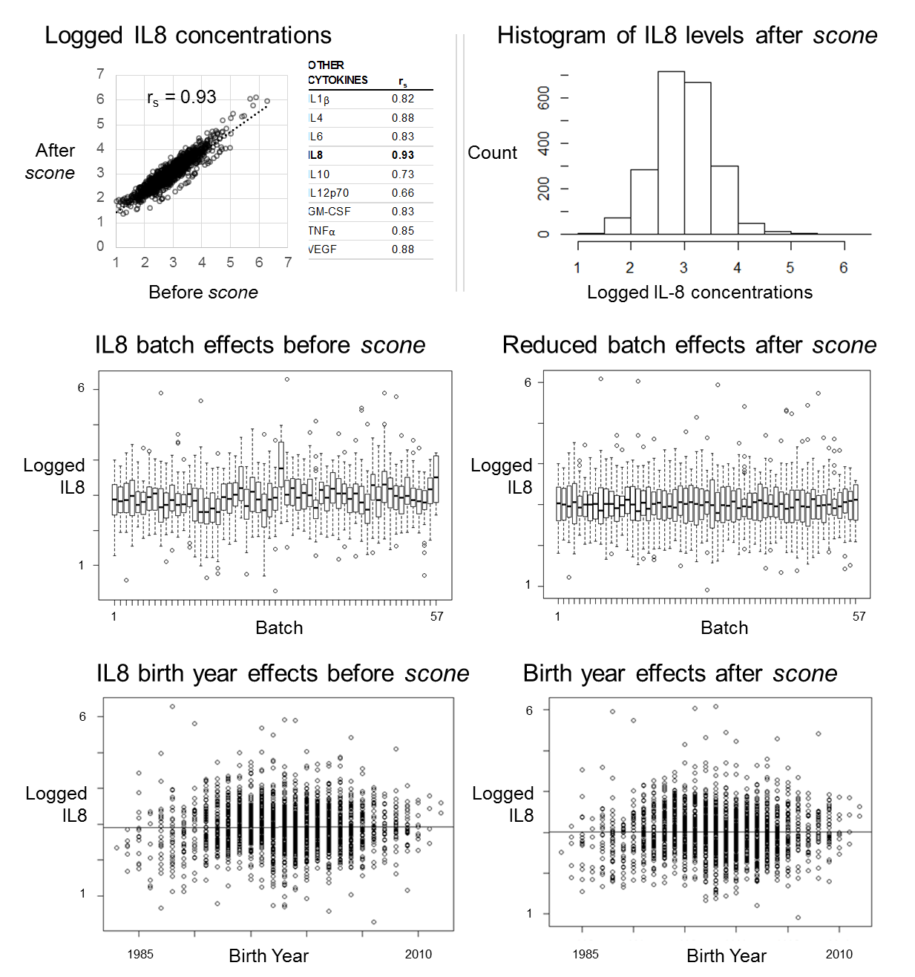
Supplemental Table S1. Prenatal exposures that are putative risk factors for childhood acute lymphoblastic leukemia.
 | Assessment | Group | Exposure
 | Neonatal blood spots | Endogenous metabolites at birth (36) | Tetracosadienoic acid, hexadecadienoic acid, linolenic acid, linoleic acid, 3 phosphaditylcholines and 2 lysophosphaditylcholines, 2 lysophosphatidylethanolamines, 2 phosphatidylserines, a sphingomyelin, C₆₄H₁₀₂O₆, C₃₆H₇₁NO₃, C₂₆H₄₄O₂, and 11 unknown compounds
 | Neonatal blood spots | Serum albumin adducts at birth (35) | Additions of acrolein, crotonaldehyde and cysteine
 | Settled home dust | Polychlorinated biphenyls (14) | PCBs 105, 118, 138, 153, 170, 180
 | Settled home dust | Polycyclic aromatic hydrocarbons (13) | Benzo(a)anthracene, chrysene, benzo(b)fluoranthene, benzo(k)fluoranthene, benzo(a)pyrene, indeno(1,2,3-cd)pyrene, dibenzo(a,h)anthracene, dibenzo(a,e)pyrene, Coronene
 | Settled home dust | Polybrominated diphenyl ethers (15) | BDEs 28, 47, 99, 100, 153, 154, 183, 196, 197, 203, 206, 207, 209
 | Questionnaire | Maternal infections (44) | Cold, pneumonia, flu, sexually-transmitted disease, or infections during pregnancy
 | Questionnaire | Maternal smoking (43) | No. of cigarettes smoked before and during pregnancy
 | Questionnaire | Pesticide use at home (42) | Use of any pesticides or insecticides during pregnancy
 | Questionnaire | Paint use at home (45) | Any paint use in the home or paint use during the first 3 years of life
REFERENCES
13. Deziel NC, Rull RP, Colt JS, Reynolds P, Whitehead TP, Gunier RB et al. Polycyclic aromatic hydrocarbons in residential dust and risk of childhood acute lymphoblastic leukemia. Environ Res 2014; 133:388-95.
14. Ward MH, Colt JS, Metayer C, Gunier RB, Lubin J, Crouse V et al. Residential exposure to PCBs and organochlorine pesticides and risk of childhood leukemia. EHP 2009; 117(6):1007-1013.
15. Ward MH, Colt JS, Deziel NC, Whitehead TP, Reynolds P, Gunier RB et al. Residential levels of PBDEs and risk of childhood acute lymphoblastic leukemia in California. EHP 2014; 122(10):1110-1116.
35. Yano Y, Schiffman C, Grigoryan H, Hayes J, Edmands W, Petrick LM et al. Untargeted adductomics of newborn dried blood spots identifies modifications to HSA associated with childhood leukemia. Leuk Res 2020; 88:106268.
36. Petrick LM, Schiffman C, Edmands W, Yano Y, Perttula K, Whitehead TP et al. Metabolomics of neonatal blood spots reveal distinct phenotypes of pediatric acute lymphoblastic leukemia and potential effects of early-life nutrition. Cancer Lett 2019; 452:71-78.
42. Ma X, Buffler PA, Gunier RB, Dahl G, Smith MT, Reinier K et al. Critical windows of exposure to household pesticides and risk of childhood leukemia. EHP 2002; 110(9):955-960.
43. Chang JS, Selvin S, Metayer C, Crouse V, Golembesky A, Buffler PA. Parental smoking and the risk of childhood leukemia. Am J of Epidemiol. 2006; 163(12):1091-1100.
44. Kwan ML, Metayer C, Crouse V, Buffler PA. Maternal illness and drug/medication use during the period surrounding pregnancy and risk of childhood leukemia among offspring. Am J of Epidemiol 2007; 165(1):27-35.
45. Scélo G, Metayer C, Zhang L, Wiemels JL, Aldrich MC, Selvin S, et al. Household exposure to paint and petroleum solvents, chromosomal translocations, and the risk of childhood leukemia. EHP 2009, 117(1):133-139.

Supplemental Figure S2. Diagram of mediation analysis comparing the total effect between endogenous metabolites and cancer versus the direct effect between endogenous metabolites and cancer after adjusting for cytokine levels as a potential mediator.

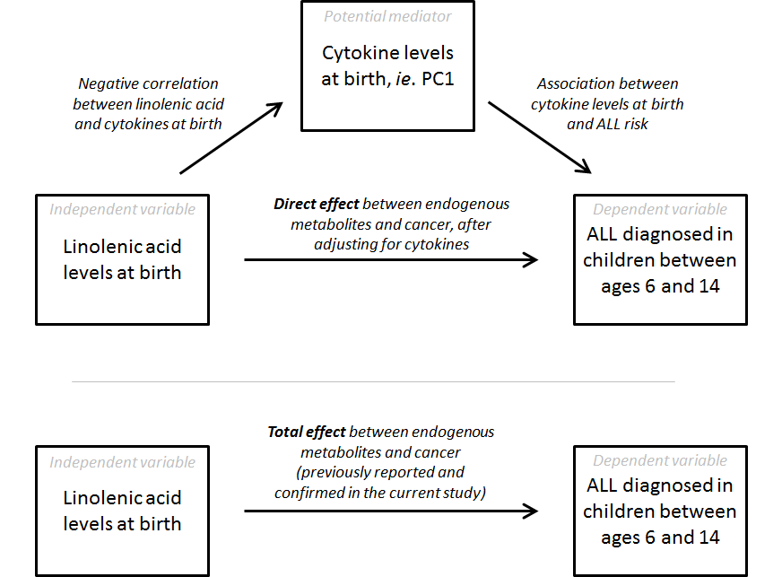
Supplemental Table S2. Childhood acute lymphoblastic leukemia (ALL) odds ratios associated with an interquartile range increment in cytokine levels at birth among participants of the California Childhood Leukemia Study (1995-2015); stratified by age at diagnosis date (or corresponding reference age for healthy control children).

 |  |  | Under age 2; 96 cases and 118 controls |  | Ages 2 to 5; 538 cases and 569 controls |  | Ages 6 to 14; 386 cases and 316 controls
 | Single-cytokine models
 | IL1β |  | 1.27 (0.91, 1.92) |  | 1.16 (0.98, 1.38) |  | 1.20 (0.98, 1.49)
 | IL4 |  | 1.32 (0.96, 1.85) |  | 1.14 (0.97, 1.34) |  | 0.83 (0.68, 1.01)
 | IL6 |  | 1.02 (0.80, 1.30) |  | 0.91 (0.82, 1.00) | * | 1.10 (0.98, 1.23)
 | IL8 |  | 1.14 (0.75, 1.73) |  | 1.09 (0.91, 1.31) |  | 1.33 (1.07, 1.67) | *
 | GM-CSF |  | 1.01 (0.66, 1.55) |  | 1.15 (0.96, 1.37) |  | 0.77 (0.63, 0.95)
 | TNFα |  | 1.03 (0.73, 1.45) |  | 1.19 (1.00, 1.41) | * | 1.14 (0.95, 1.38)
 | VEGF |  | 0.88 (0.61, 1.24) |  | 1.21 (1.02, 1.44) | * | 1.22 (0.99, 1.51)
 | Two PCs in one model
 | PC1 |  | 1.19 (0.79, 1.79) |  | 1.19 (0.99, 1.44) |  | 1.12 (0.90, 1.40)
 | PC2 |  | 1.07 (0.77, 1.48) |  | 1.12 (0.96, 1.32) |  | 0.74 (0.62, 0.89)

* Association between cytokine levels and case/control outcome is significant in logistic regression, p-value < 0.05 (highlighted with bold font)
Model includes covariates: case/control outcome as a function of cytokine levels mutually adjusted for child’s sex, mother’s race/ethnicity, household annual income, mother’s age at birth, delivery method, gestational age at birth, birth weight, breastfeeding, and blood spot collection time

Supplemental Table S3. Childhood acute lymphoblastic leukemia (ALL) odds ratios associated with an interquartile range increment in cytokine levels at birth among participants of the California Childhood Leukemia Study (1995-2015); stratified by year of birth.

 |  |  | 2000 or later; 407 cases and 232 controls |  | 1995 to 2000; 388 cases and 488 controls |  | Before 1995; 225 cases and 283 controls
 | Single-cytokine models
 | IL1β |  | 1.22 (0.96, 1.56) |  | 1.19 (1.00, 1.44) | * | 1.12 (0.88, 1.43)
 | IL4 |  | 1.03 (0.84, 1.27) |  | 1.00 (0.85, 1.18) |  | 1.03 (0.80, 1.33)
 | IL6 |  | 1.02 (0.89, 1.18) |  | 0.95 (0.85, 1.05) |  | 1.04 (0.91, 1.18)
 | IL8 |  | 1.36 (1.05, 1.79) | * | 1.06 (0.87, 1.28) |  | 1.30 (1.01, 1.69) | *
 | GM-CSF |  | 0.88 (0.67, 1.15) |  | 0.99 (0.83, 1.19) |  | 0.88 (0.69, 1.12)
 | TNFα |  | 1.22 (0.97, 1.55) |  | 1.12 (0.94, 1.33) |  | 1.15 (0.92, 1.43)
 | VEGF |  | 1.29 (1.03, 1.64) | * | 1.08 (0.90, 1.30) |  | 1.13 (0.88, 1.46)
 | Two PCs in one model
 | PC1 |  | 1.27 (0.97, 1.67) |  | 1.09 (0.90, 1.32) |  | 1.14 (0.88, 1.47)
 | PC2 |  | 0.89 (0.72, 1.11) |  | 0.98 (0.84, 1.15) |  | 0.86 (0.68, 1.08)

* Association between cytokine levels and case/control outcome is significant in logistic regression, p-value < 0.05 (highlighted with bold font)
Model includes covariates: case/control outcome as a function of cytokine levels mutually adjusted for child’s sex, mother’s race/ethnicity, household annual income, mother’s age at birth, delivery method, gestational age at birth, birth weight, breastfeeding, and blood spot collection time

Supplemental Table S4. Childhood acute lymphoblastic leukemia (ALL) odds ratios associated with an interquartile range increment in cytokine levels at birth among participants of the California Childhood Leukemia Study (1995-2015); stratified by child’s sex.
 |  |  | Boys; 586 cases and 574 controls |  | Girls; 434 cases and 429 controls
 | Single-cytokine models
 | IL1β |  | 1.21 (1.03, 1.43) | * | 1.15 (0.97, 1.38)
 | IL4 |  | 1.10 (0.94, 1.27) |  | 0.98 (0.83, 1.16)
 | IL6 |  | 0.97 (0.89, 1.05) |  | 0.99 (0.88, 1.12)
 | IL8 |  | 1.19 (1.01, 1.40) | * | 1.16 (0.94, 1.44)
 | GM-CSF |  | 0.98 (0.84, 1.15) |  | 0.96 (0.79, 1.17)
 | TNFα |  | 1.15 (0.99, 1.34) |  | 1.10 (0.93, 1.31)
 | VEGF |  | 1.09 (0.93, 1.28) |  | 1.21 (1.00, 1.47)
 | Two PCs in one model
 | PC1 |  | 1.15 (0.98, 1.36) |  | 1.16 (0.94, 1.43)
 | PC2 |  | 0.98 (0.85, 1.14) |  | 0.94 (0.79, 1.11)

* Association between cytokine levels and case/control outcome is significant in logistic regression, p-value < 0.05 (highlighted with bold font)
Model includes covariates: case/control outcome as a function of cytokine levels mutually adjusted for mother’s race/ethnicity, household annual income, mother’s age at birth, delivery method, gestational age at birth, birth weight, breastfeeding, and blood spot collection time

Supplemental Table S5. Childhood acute lymphoblastic leukemia (ALL) odds ratios associated with an interquartile range increment in levels of endogenous metabolites among participants of the California Childhood Leukemia Study (1995-2015); with or without adjustment for levels of cytokines found in the dried blood spots and stratified by age at diagnosis.
 | Accurate mass, m/z | Endogenous metabolite  name† | Total Effect |  |  | % Direct | % Mediated
 | Diagnosed at Ages 2 to 5
 | 363.3263 | Tetracosadienoic acid | 0.84 (0.64, 1.10) |  |  | 100.0 | 0.0
 | 431.3151 | Unknown | 1.35 (0.99, 1.84) |  |  | 100.0 | 0.0
 | 570.3401 | Unknown | 1.29 (0.94, 1.78) |  |  | 100.0 | 0.0
 | 604.3610 | Lysophosphatidylcholine (20:3) | 1.23 (0.93, 1.64) |  |  | 100.0 | 0.0
 | 638.2760 | Unknown | 1.40 (1.02, 1.93) |  | * | 100.0 | 0.0
 | 696.3573 | Unknown | 1.24 (0.94, 1.66) |  |  | 100.0 | 0.0
 | 766.5589 | Phosphatidylserine (16:0/16:0) | 1.36 (1.02, 1.82) |  | * | 100.0 | 0.0
 | 775.2985 | Unknown | 1.32 (0.97, 1.82) |  |  | 100.0 | 0.0
 | 884.6004 | Phosphaditylcholine (18:0/20:4(OH)) | 1.29 (1.01, 1.67) |  | * | 99.9 | 0.1
 | Diagnosed at Ages 6 to 14
 | 251.2011 | Hexadecadienoic acid | 0.70 (0.45, 1.09) |  |  | 100.0 | 0.0
 | 277.2170 | Linolenic acid | 1.46 (1.07, 2.01) |  | * | 99.6 | 0.4
 | 279.2329 | Linoleic acid | 1.37 (1.02, 1.87) |  | * | 100.0 | 0.0
 | 377.1419 | Unknown | 1.36 (0.96, 1.95) |  |  | 99.2 | 0.9
 | 387.3264 | C₂₆H₄₄O₂ | 1.94 (1.24, 3.09) |  | * | 100.0 | 0.0
 | 449.3629 | Unknown | 0.65 (0.44, 0.93) |  | * | 100.0 | 0.0
 | 476.2778 | Lysophosphatidylethanolamine (18:2) | 1.41 (0.98, 2.06) |  |  | 100.0 | 0.0
 | 500.2782 | Lysophosphatidylethanolamine (20:4) | 1.57 (1.07, 2.35) |  | * | 99.7 | 0.3
 | 530.3234 | Unknown phosphatidylethanolamine | 1.47 (0.99, 2.20) |  |  | 100.0 | 0.0
 | 552.2956 | Unknown | 0.56 (0.37, 0.85) |  | * | 99.8 | 0.2
 | 564.5344 | Putative ceramide, C₃₆H₇₁NO₃ | 0.67 (0.43, 1.02) |  |  | 100.0 | 0.0
 | 578.3458 | Lysophosphatidylcholine (18:2) | 1.46 (0.98, 2.20) |  |  | 99.6 | 0.4
 | 592.3238 | Unknown | 0.50 (0.31, 0.79) |  | * | 100.0 | 0.0
 | 760.5126 | Phosphatidylserine (16:0/18:1) | 1.50 (1.03, 2.22) |  | * | 99.6 | 0.4
 | 789.6123 | Sphingomyelin (d16:1/20:4) | 0.64 (0.43, 0.96) |  | * | 100.0 | 0.0
 | 824.5793 | Phosphaditylcholine (P16:0/20:4) | 1.63 (1.14, 2.37) |  | * | 100.0 | 0.0
 | 844.6069 | Phosphaditylcholine (18:0/18:2) | 1.51 (1.04, 2.25) |  | * | 100.0 | 0.0
 | 897.6298 | Unknown | 0.65 (0.44, 0.95) |  | * | 100.0 | 0.0
 | 965.7627 | C₆₄H₁₀₂O₆ | 1.41 (0.94, 2.15) |  |  | 100.0 | 0.0
† Names refer to putative annotations described by Petrick et al. (2017) in the format of the bCommon names used in the Human Metabolome Database (HMDB)
* Association between endogenous metabolite levels and case/control outcome is significant in logistic regression, p-value < 0.05
Model includes covariates: case/control outcome as a function of endogenous metabolite evels mutually adjusted for child’s sex, mother’s race/ethnicity, household annual income, mother’s age at birth, delivery method, gestational age at birth, birth weight, breastfeeding, and blood spot collection time.

Supplemental Table S6. Comparison of three studies that have evaluated the relationship between cytokine levels at birth and childhood acute lymphoblastic leukemia (ALL) risk.
 | Study characteristics | Current Study | Chang et al. (11) | Soegaard et al. (12)
 | No. of participants | 1,020 cases, 1,003 controls | 116 cases, 116 controls | 178 cases, 178 controls
 | Ethnicity of participants | ALL risk observed among Latinos only | Predominately Latino or white, analyzed together | Predominately white
 | Study location | California, USA | California, USA | Denmark
 | Birth years | 1984-2012 | 1995-2006 | 1995-2008
 | Type of childhood  leukemia to which the  cytokine levels were linked | Any ALL,  especially ALL with  high hyperdiploidy | Any ALL | B-cell ALL
 | Cytokine assay | Luminex magnetic beads | Luminex polystyrene beads | Meso-scale multiplex sandwich
 | Antibody brand | R&D Systems | Bio-Rad | R&D Systems
 | Median DBS storage time | 21 years | 8 years | ~17 years
 | Typical DBS collection time | 1 to 2 days after birth | 1 to 2 days after birth | 7 days after birth
 | ALL associated with... | Higher levels of  IL1β, IL8, TNFα, VEGF | Lower levels of  IL4, IL6, IL10, IL13 | Higher levels of IL6, lower levels of IL8

References:
11. Chang JS, Zhou M, Buffler PA, Chokkalingam AP, Metayer C, Wiemels JL. Profound deficit of IL10 at birth in children who develop childhood acute lymphoblastic leukemia. Cancer Epidemiol Biomark Prev 2011; 20(8): 1736-1740.

12. Søegaard SH, Rostgaard K, Skogstrand K, Wiemels JL, Schmiegelow K, Hjalgrim H. Neonatal Inflammatory Markers Are Associated with Childhood B-cell Precursor Acute Lymphoblastic Leukemia. Canc Res 2018; 78(18): 5458-5463.

