Supplementary Table ST1 Correlation matrix of anthropometric measurements among non-smoking and non-alcohol drinking women (1996–2016)ª
Anthropometrics | Height | Weight | BMI | Height at age 20 | Weight at age 20 | BMI at age 20 | WC | HC | WHR | WHtR | WC_{adj}^{b} | HC_{adj}^{b} | WHR_{adj}^{b} | WHtR_{adj}^{b}
Height | 1.000
Weight | 0.328 | 1.000
BMI | -0.137 | 0.870 | 1.000
Height at age 20 | 0.928 | 0.363 | -0.060 | 1.000
Weight at age 20 | 0.312 | 0.328 | 0.189 | 0.342 | 1.000
BMI at age 20 | -0.104 | 0.177 | 0.240 | -0.108 | 0.878 | 1.000
WC | -0.026 | 0.772 | 0.831 | 0.071 | 0.168 | 0.151 | 1.000
HC | 0.094 | 0.792 | 0.786 | 0.165 | 0.218 | 0.157 | 0.806 | 1.000
WHR | -0.148 | 0.377 | 0.477 | -0.069 | 0.030 | 0.071 | 0.721 | 0.214 | 1.000
WHtR | -0.309 | 0.625 | 0.829 | -0.196 | 0.067 | 0.176 | 0.951 | 0.730 | 0.730 | 1.000
WC_{adj}^{b} | 0.171 | 0.097 | 0.020 | 0.229 | 0.018 | -0.093 | 0.531 | 0.269 | 0.587 | 0.451 | 1.000
HC_{adj}^{b} | 0.340 | 0.164 | <0.001 | 0.351 | 0.110 | -0.055 | 0.232 | 0.576 | -0.272 | 0.118 | 0.433 | 1.000
WHR_{adj}^{b} | -0.092 | -0.024 | 0.026 | -0.044 | -0.067 | -0.049 | 0.372 | -0.171 | 0.868 | 0.383 | 0.665 | -0.318 | 1.000
WHtR_{adj}^{b} | -0.361 | -0.161 | 0.015 | -0.271 | -0.174 | -0.054 | 0.444 | 0.137 | 0.595 | 0.531 | 0.825 | 0.216 | 0.676 | 1.000
a Spearman's rank correlation coefficient.
b Adjusted for BMI using residual method.

Supplementary Table ST2 multivariable-adjusted HRs for anthropometric measurements and liver cancer risk among non-smoking and non-alcohol drinking women (1996–2016)
Extra effect of fat distribution | Conventional methodª | Residual method^{b} |  | Mutual adjustment^{c} | HR for BMI | HR for fat distribution measurements
WC / WC_{adj} |  |  |  | WC_{adj} & BMI
Q1 | 1.00 (Reference) | 1.00 (Reference) |  | Q1 | 1.00 (Reference) | 1.00 (Reference)
Q2 | 1.00 (0.63, 1.57) | 1.03 (0.67, 1.56) |  | Q2 | 1.08 (0.72, 1.63) | 1.06 (0.69, 1.61)
Q3 | 0.90 (0.56, 1.44) | 1.21 (0.82, 1.81) |  | Q3 | 1.12 (0.75, 1.67) | 1.26 (0.85, 1.87)
Q4 | 1.29 (0.75, 2.20) | 1.38 (0.94, 2.02) |  | Q4 | 1.53 (1.05, 2.23) | 1.42 (0.97, 2.08)
HC / HC_{adj} |  |  |  | HC_{adj} & BMI
Q1 | 1.00 (Reference) | 1.00 (Reference) |  | Q1 | 1.00 (Reference) | 1.00 (Reference)
Q2 | 0.97 (0.61, 1.55) | 0.90 (0.59, 1.36) |  | Q2 | 1.09 (0.72, 1.64) | 0.92 (0.61, 1.39)
Q3 | 1.04 (0.64, 1.69) | 1.49 (1.04, 2.15) |  | Q3 | 1.13 (0.76, 1.69) | 1.52 (1.06, 2.19)
Q4 | 1.43 (0.84, 2.43) | 1.32 (0.92, 1.90) |  | Q4 | 1.52 (1.04, 2.22) | 1.33 (0.93, 1.92)
WHR / WHR_{adj} |  |  |  | WHR_{adj} & BMI
Q1 | 1.00 (Reference) | 1.00 (Reference) |  | Q1 | 1.00 (Reference) | 1.00 (Reference)
Q2 | 1.16 (0.77, 1.75) | 1.39 (0.95, 2.02) |  | Q2 | 1.09 (0.72, 1.64) | 1.42 (0.98, 2.08)
Q3 | 0.93 (0.61, 1.42) | 0.98 (0.66, 1.45) |  | Q3 | 1.13 (0.75, 1.68) | 1.00 (0.68, 1.49)
Q4 | 1.13 (0.75, 1.70) | 1.12 (0.77, 1.63) |  | Q4 | 1.53 (1.05, 2.23) | 1.16 (0.80, 1.68)
WHtR / WHtR_{adj} |  |  |  | WHtR_{adj} & BMI
Q1 | 1.00 (Reference) | 1.00 (Reference) |  | Q1 | 1.00 (Reference) | 1.00 (Reference)
Q2 | 1.03 (0.64, 1.65) | 1.13 (0.73, 1.75) |  | Q2 | 1.09 (0.73, 1.65) | 1.17 (0.76, 1.82)
Q3 | 1.15 (0.70, 1.87) | 1.32 (0.87, 1.99) |  | Q3 | 1.14 (0.76, 1.70) | 1.37 (0.91, 2.08)
Q4 | 1.17 (0.65, 2.13) | 1.08 (0.70, 1.65) |  | Q4 | 1.54 (1.05, 2.25) | 1.13 (0.74, 1.74)
a HR for fat distribution measurements. BMI (continuous) and each fat distribution measurement (quartiles) were put in the same model.
b HR for fat distribution measurements. Fat distribution measurements were adjusted for BMI by residual methods.
c BMI (quartiles) and each fat distribution measurement (quartiles) were put in the same model.

Supplementary Table ST3 Exploratory analyses for the associations between anthropometric measurements and liver cancer risk among non-smoking and non-alcohol drinking women (1996–2016)
 | Excluded the first-two-years' cohort observation | Postmenopausal participants | No history of T2DM | No history of chronic hepatitis | No history of cholelithiasis | No family history of liver cancer
BMI (kg/m²)
Cases | 211 | 184 | 217 | 206 | 192 | 216
HRª (95%CI) | 1.57 (1.05, 2.35) | 1.50 (0.98, 2.29) | 1.41 (0.95, 2.10) | 1.59 (1.04, 2.43) | 1.61 (1.06, 2.45) | 1.43 (0.96, 2.13)
BMI at 20 years old (kg/m²)
Cases | 156 | 125 | 162 | 147 | 144 | 158
HRª (95%CI) | 1.23 (0.79, 1.92) | 1.55 (0.92, 2.59) | 1.30 (0.84, 2.03) | 1.26 (0.79, 2.00) | 0.98 (0.62, 1.54) | 1.14 (0.75, 1.75)
Adult weight gain (kg)
Cases | 175 | 144 | 179 | 166 | 159 | 175
HRª (95%CI) | 2.06 (1.29, 3.28) | 1.96 (1.19, 3.24) | 1.61 (1.02, 2.56) | 1.70 (1.06, 2.73) | 2.04 (1.26, 3.30) | 1.69 (1.07, 2.68)
Annual average weight gain (kg/year)
Cases | 175 | 144 | 179 | 166 | 159 | 175
HRª (95%CI) | 2.32 (1.40, 3.83) | 1.88 (1.11, 3.19) | 1.95 (1.19, 3.19) | 2.09 (1.25, 3.48) | 2.34 (1.39, 3.95) | 1.77 (1.08, 2.93)
WC (cm)
Cases | 211 | 184 | 217 | 206 | 192 | 216
HRª (95%CI) | 1.76 (1.14, 2.71) | 1.74 (1.13, 2.70) | 1.49 (0.97, 2.30) | 1.40 (0.91, 2.15) | 1.85 (1.16, 2.95) | 1.44 (0.96, 2.17)
HC (cm)
Cases | 211 | 184 | 217 | 206 | 192 | 216
HRª (95%CI) | 1.88 (1.19, 2.97) | 1.42 (0.95, 2.12) | 1.59 (1.03, 2.44) | 1.62 (1.03, 2.57) | 1.71 (1.09, 2.67) | 1.47 (0.96, 2.25)
WHR
Cases | 211 | 184 | 217 | 206 | 192 | 216
HRª (95%CI) | 1.32 (0.87, 1.99) | 1.09 (0.71, 1.68) | 1.14 (0.77, 1.70) | 1.26 (0.83, 1.94) | 1.34 (0.88, 2.06) | 1.26 (0.84, 1.89)
WHtR
Cases | 211 | 184 | 217 | 206 | 192 | 216
HRª (95%CI) | 1.85 (1.14, 2.99) | 1.63 (1.05, 2.53) | 1.54 (0.97, 2.43) | 1.52 (0.93, 2.49) | 1.66 (1.02, 2.71) | 1.47 (0.93, 2.34)
a HRs for the highest quartile versus the lowest quartile. Adjusted for age, education, income, menopausal status, age at menarche, history of chronic hepatitis, history of cholelithiasis, family history of liver cancer, total energy intake and total physical activity, except for the one of interest. Analyses of adult weight gain and annual average weight gain were further adjusted for weight at 20 years old.

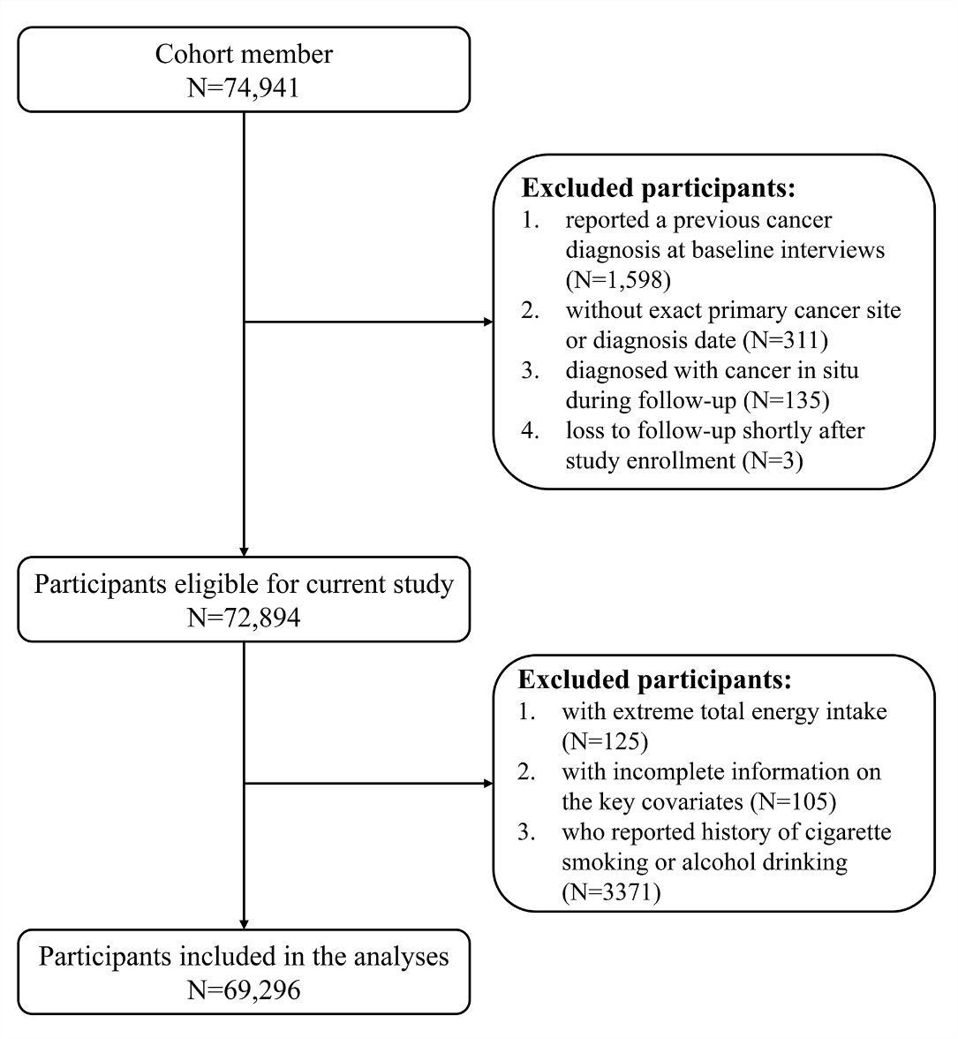
Supplementary Figure SF1 Flow diagram of the participants selection process

