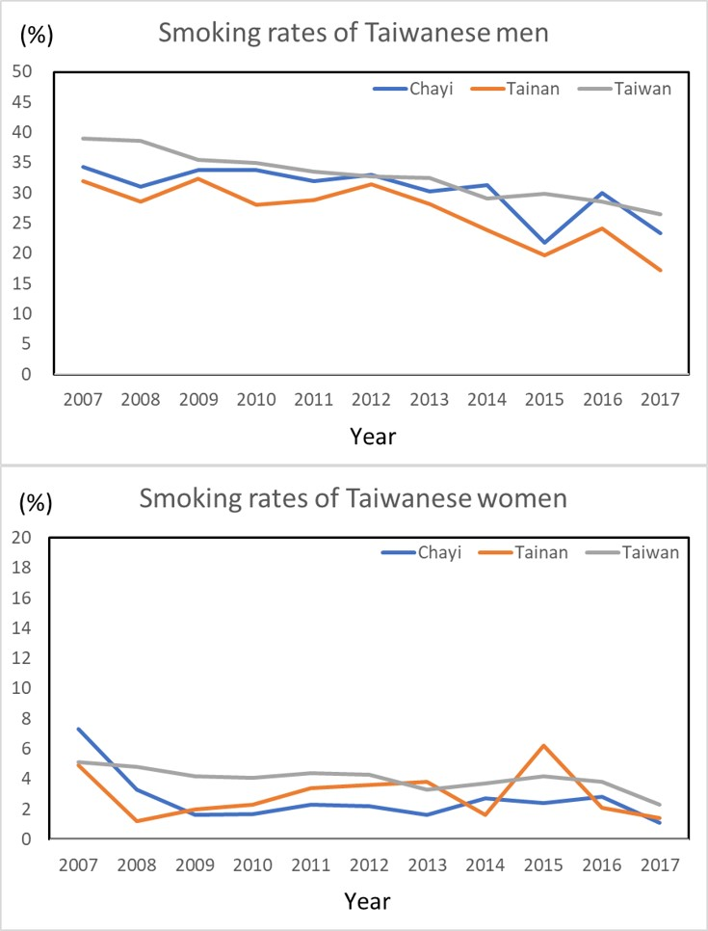
Supplementary Figure 3. Smoking rates in the Taiwanese population. Chiayi and Tainan are the two major counties with arseniasis-endemic areas. The information was obtained from published online data from the Health Promotion Administration, Ministry of Health and Welfare, Taiwan.

