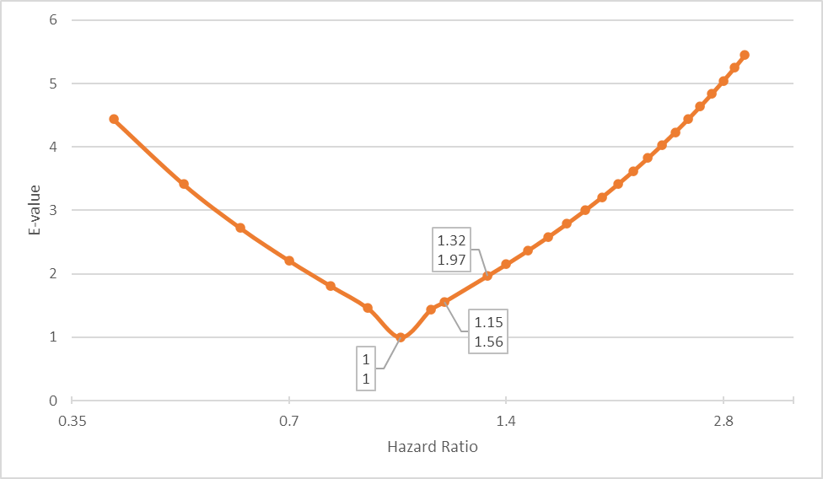
Figure S5. The E-value is a function of the hazard ratio (HR) of the association of exposure (severe obstructive sleep apnea [OSA]) and outcome (incident cancer).

The E-value represents the minimum strength of association, on the risk ratio scale, that an unmeasured confounder would need to have with both the treatment [exposure] and outcome to fully explain away a specific treatment [exposure]–outcome association, conditional on the measured covariates¹. We used the formula which applies to a risk ratio greater than 1: E-value = RR + sqrt (RR X (RR-1)); CI = LL + sqrt (LL X (LL-1)) where RR = risk ratio and LL = lower limit of the CI. This formula can be used for HRs when the outcome is relatively rare (e.g., <15%) by the end of follow-up, which applicable for our study². The marked dots reflect the correspondence between HR and the E-value for the particular exposure: severe OSA (apnea-hypopnea index >30) compared to no OSA - HR = 1.15; E-value = 1.56; severe nocturnal hypoxemia (spent >30% of sleep with SaO₂<90% vs. not) - HR = 1.32; E-value = 1.97. The lowest possible E-value is 1 (that is, no unmeasured confounding is needed to explain away the observed association). The higher the E-value, the stronger the confounder associations must be to explain away the effect. Importantly, a small E-value does not mean that there is evidence for no effect; it implies only that the evidence for an effect is itself weak. However, weak evidence for an effect does not imply evidence that the effect is absent. The E-value results also do not guarantee that if a confounder with parameters of a particular strength existed, then it necessarily would explain away the effect, only that it is possible to construct scenarios in which it could ². In the context of biomedical and social sciences research, effect sizes ≥2- or 3-fold occasionally occur but are not particularly common; a variable that affects both treatment and outcome each by 2- or 3-fold would likely be even less common¹.

References
1. VanderWeele TJ, Ding P. Sensitivity Analysis in Observational Research: Introducing the E-Value. Ann Intern Med. 2017;167: 268-274.
2. Ding P, VanderWeele TJ. Sensitivity Analysis Without Assumptions. Epidemiology. 2016;27: 368-377.

